2023 Student Experience Survey
November 6th 2023, 11:16 am EST
Q2 - Where do you live?
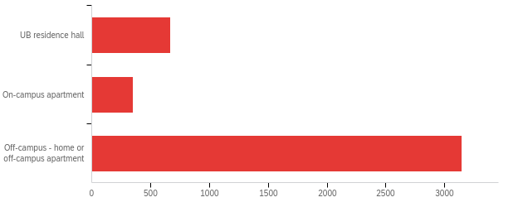

# | Field | Minimum | Maximum | Mean | Std Deviation | Variance | Count
1 | Where do you live? | 1.00 | 3.00 | 2.60 | 0.75 | 0.56 | 4159

# | Answer | % | Count
1 | UB residence hall | 15.99% | 665
2 | On-campus apartment | 8.37% | 348
3 | Off-campus - home or off-campus apartment | 75.64% | 3146
 | Total | 100% | 4159

Q3 - In which UB College or School are you enrolled?
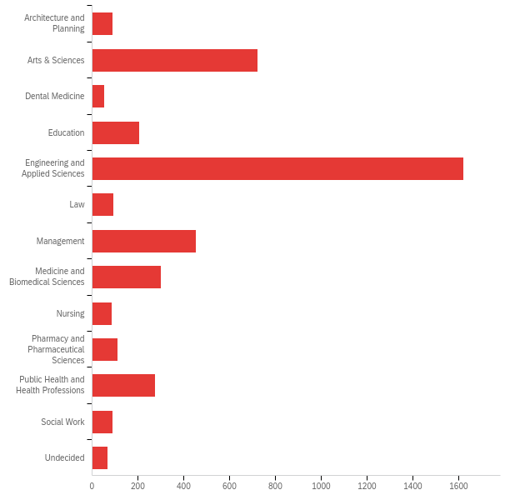

# | Field | Minimum | Maximum | Mean | Std Deviation | Variance | Count
1 | In which UB College or School are you enrolled? | 1.00 | 13.00 | 5.66 | 2.85 | 8.10 | 4168

# | Answer | % | Count
1 | Architecture and Planning | 2.11% | 88
2 | Arts & Sciences | 17.35% | 723
3 | Dental Medicine | 1.30% | 54
4 | Education | 4.94% | 206
5 | Engineering and Applied Sciences | 38.92% | 1622
6 | Law | 2.23% | 93
7 | Management | 10.87% | 453
8 | Medicine and Biomedical Sciences | 7.25% | 302
9 | Nursing | 2.09% | 87
10 | Pharmacy and Pharmaceutical Sciences | 2.64% | 110
11 | Public Health and Health Professions | 6.60% | 275
12 | Social Work | 2.11% | 88
13 | Undecided | 1.61% | 67
 | Total | 100% | 4168

Q4 - In which department/major are you enrolled?

# | Field | Minimum | Maximum | Mean | Std Deviation | Variance | Count
1 | In which department/major are you enrolled? | 1.00 | 89.00 | 33.87 | 21.62 | 467.39 | 3894

# | Answer | % | Count
1 | Accounting and Law | 2.75% | 107
2 | Africana and American Studies | 0.10% | 4
3 | Anesthesiology | 0.31% | 12
4 | Anthropology | 0.31% | 12
5 | Architecture | 1.54% | 60
6 | Art | 0.74% | 29
7 | Biochemistry | 0.54% | 21
8 | Biological Sciences | 4.52% | 176
9 | Biomedical Engineering | 2.16% | 84
10 | Biomedical Informatics | 0.39% | 15
11 | Biostatistics | 0.74% | 29
12 | Biotechnical and Clinical Laboratory | 0.26% | 10
13 | Chemical and Biological Engineering | 1.36% | 53
14 | Chemistry | 0.85% | 33
15 | Civil, Structural & Environmental Engineering | 2.95% | 115
16 | Classics | 0.05% | 2
17 | Communication | 0.82% | 32
18 | Communicative Disorders and Sciences | 0.62% | 24
19 | Community Health and Health Behavior | 1.46% | 57
20 | Comparative Literature | 0.03% | 1
21 | Computer Science and Engineering | 20.78% | 809
22 | Dermatology | 0.00% | 0
23 | Educational Leadership and Policy | 0.69% | 27
24 | Economics | 1.21% | 47
25 | Electrical Engineering | 2.47% | 96
26 | Emergency Medicine | 0.08% | 3
27 | Engineering Education | 1.85% | 72
28 | English | 0.85% | 33
29 | Environment and Sustainability | 1.10% | 43
30 | Epidemiology and Environmental Health | 1.16% | 45
31 | Exercise and Nutrition Sciences | 2.05% | 80
32 | Family Medicine | 0.05% | 2
33 | Finance | 3.06% | 119
34 | Geography | 0.51% | 20
35 | Geology | 0.18% | 7
36 | Global Gender & Sexuality Studies | 0.13% | 5
37 | History | 1.05% | 41
38 | Indigenous Studies | 0.00% | 0
39 | Industrial and Systems Engineering | 2.82% | 110
40 | Information Science | 2.95% | 115
41 | Jewish Thought | 0.05% | 2
42 | Learning and Instruction | 1.57% | 61
43 | Linguistics | 0.69% | 27
44 | Management Science and Systems | 3.65% | 142
45 | Marketing | 1.41% | 55
46 | Materials Design and Innovation | 0.39% | 15
47 | Mathematics | 1.00% | 39
48 | Mechanical and Aerospace Engineering | 6.91% | 269
49 | Media Study | 0.72% | 28
50 | Medicine | 3.31% | 129
51 | Microbiology and Immunology | 0.15% | 6
52 | Music | 0.31% | 12
53 | Neurology | 0.49% | 19
54 | Neurosurgery | 0.21% | 8
55 | Nuclear Medicine | 0.18% | 7
56 | Obstetrics and Gynecology | 0.00% | 0
57 | Operations Management and Strategy | 0.28% | 11
58 | Ophthalmology | 0.00% | 0
59 | Oral and Maxillofacial Surgery | 0.00% | 0
60 | Oral Biology | 0.10% | 4
61 | Oral Diagnostic Sciences | 0.05% | 2
62 | Organization and Human Resources | 0.10% | 4
63 | Orthodontics | 0.10% | 4
64 | Orthopaedics | 0.08% | 3
65 | Otolaryngology | 0.00% | 0
66 | Pathology and Anatomical Sciences | 0.08% | 3
67 | Pediatric and Community Dentistry | 0.03% | 1
68 | Pediatrics | 0.08% | 3
69 | Periodontics and Endodontics | 0.03% | 1
70 | Pharmaceutical Sciences | 1.34% | 52
71 | Pharmacology and Toxicology | 0.54% | 21
72 | Pharmacy Practice | 1.41% | 55
73 | Philosophy | 0.26% | 10
74 | Physics | 0.77% | 30
75 | Physiology and Biophysics | 0.10% | 4
76 | Political Science | 0.90% | 35
77 | Psychiatry | 0.10% | 4
78 | Psychology | 3.13% | 122
79 | Radiation Oncology | 0.00% | 0
80 | Radiology | 0.03% | 1
81 | Rehabilitation Science | 1.21% | 47
82 | Restorative Dentistry | 0.28% | 11
83 | Romance Languages and Literatures | 0.13% | 5
84 | Sociology | 1.26% | 49
85 | Structural Biology | 0.10% | 4
86 | Surgery | 0.03% | 1
87 | Theatre and Dance | 0.33% | 13
88 | Urban & Regional Planning | 0.62% | 24
89 | Urology | 0.03% | 1
 | Total | 100% | 3894

Q5 - Do you own a laptop?
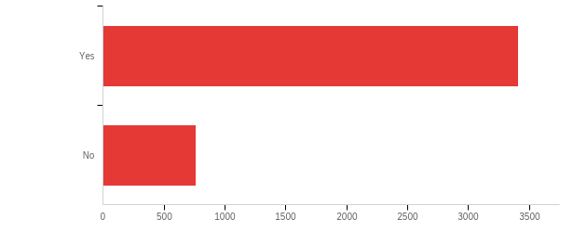

# | Field | Minimum | Maximum | Mean | Std Deviation | Variance | Count
1 | Do you own a laptop? | 1.00 | 2.00 | 1.18 | 0.39 | 0.15 | 4170

# | Answer | % | Count
1 | Yes | 81.77% | 3410
2 | No | 18.23% | 760
 | Total | 100% | 4170

Q6 - How old is your laptop?
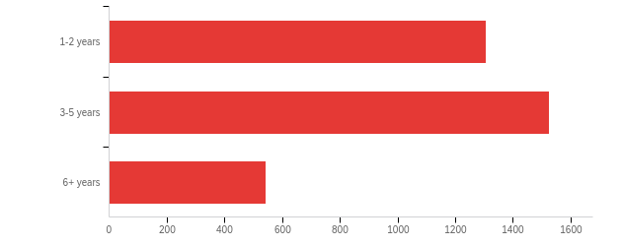

# | Field | Minimum | Maximum | Mean | Std Deviation | Variance | Count
1 | How old is your laptop? | 1.00 | 3.00 | 1.77 | 0.71 | 0.50 | 3376

# | Answer | % | Count
1 | 1-2 years | 38.71% | 1307
2 | 3-5 years | 45.17% | 1525
3 | 6+ years | 16.11% | 544
 | Total | 100% | 3376

Q7 - Is your laptop working well enough to meet the needs of your coursework at UB?
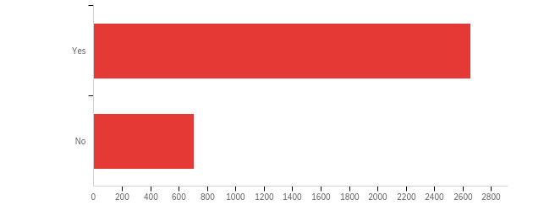

# | Field | Minimum | Maximum | Mean | Std Deviation | Variance | Count
1 | Is your laptop working well enough to meet the needs of your coursework at UB? | 1.00 | 2.00 | 1.21 | 0.41 | 0.17 | 3360

# | Answer | % | Count
1 | Yes | 79.02% | 2655
2 | No | 20.98% | 705
 | Total | 100% | 3360

Q8 - Most UB students use a personal laptop for their coursework. What is the reason you haven't purchased one?
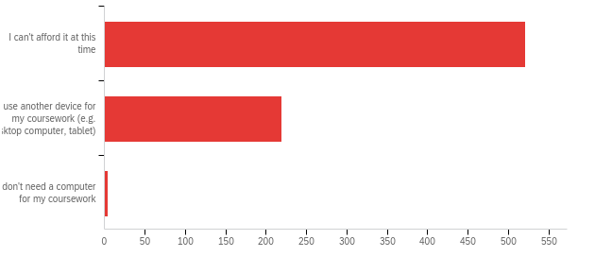

# | Field | Minimum | Maximum | Mean | Std Deviation | Variance | Count
1 | Most UB students use a personal laptop for their coursework. What is the reason you haven't purchased one? | 1.00 | 3.00 | 1.31 | 0.47 | 0.22 | 744

# | Answer | % | Count
1 | I can't afford it at this time | 70.03% | 521
2 | I use another device for my coursework (e.g. desktop computer, tablet) | 29.44% | 219
3 | I don't need a computer for my coursework | 0.54% | 4
 | Total | 100% | 744

Q10 - What other devices do you own? (Select all that apply.)
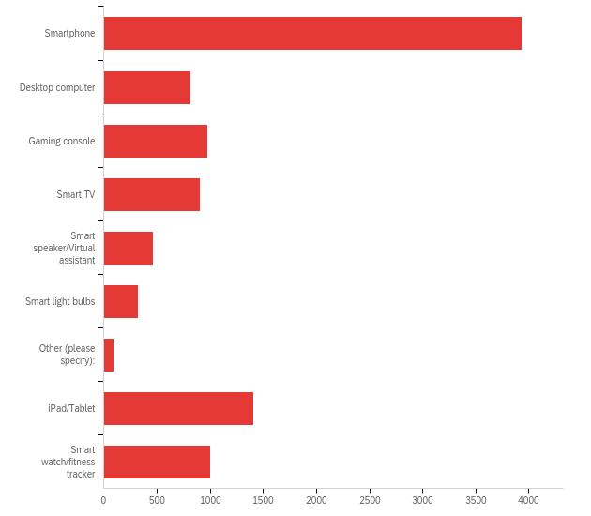

# | Answer | % | Count
1 | Smartphone | 39.68% | 3934
2 | Desktop computer | 8.27% | 820
3 | Gaming console | 9.82% | 974
4 | Smart TV | 9.11% | 903
5 | Smart speaker/Virtual assistant | 4.69% | 465
6 | Smart light bulbs | 3.21% | 318
7 | Other (please specify): | 0.90% | 89
8 | iPad/Tablet | 14.18% | 1406
9 | Smart watch/fitness tracker | 10.14% | 1005
 | Total | 100% | 9914

Q7_7_TEXT - Other (please specify):
Other (please specify): - Text
gaming laptop
chromebook
Surface
A friends computer
Kindle
Quest 3
Kindle
Nest
Another Laptop
N/A
camera DSLR
Contact phone
A mechanical canine
Kindle
Borrowed a laptop from UB.
Ub laptop loan
I need a monitor because the laptop screen is broken
older laptop (6 years), not able to handle UB requirements
another newer laptop
laptop
schools computers
MacBook
Bluetooth Speaker
Second laptop
monitor， external data storage
External monitor
Airpods
Cybeernetic Implant (Whalen Corp Mk. 5)
Kindle
Laptop
I use library computers I don't even have a smartphone now
Bluetooth headphones
drawing tablet
E reader
Keyboard, Handheld Video Game Consoles
AirPods
work laptop
AirPods
smart garage door opener
Android Phone
14 yo laptop
A gaming laptop
None of these
kindle
Borrowed Laptop
I was using a MacBook but its faulty. Not functioning properly
kindle reader
Kindle
University Loan Laptop
Laptop provided by the college
Boundless ambition.
Work computer that I do not own but am permitted to do schoolwork on
Headphones
I currently have a laptop from the ub loan program!
Iphone
smart plug
I borrowed a laptop from my friend
Alexa
laptop
monitor
Monitor
airpods
Monitor
Second Laptop
University laptop
Alexa
Gaming pc
2 other laptops (much older)
Gaming Laptop
Kindle
Bluetooth Speakers/AirPods
Kindle
Earbuds
gaming laptop
none :(
Oculus Pro VR headset
TV
I have borrowed my friends old laptop for the current semester.
Monitor
I have a laptop from UB laptop loan program
gaming laptop
Roku for streaming
UB library laptop
Lending my brother’s laptop
iPhone
e-reader
Computer Monitor

Q11 - From the list of technology services below, please indicate your level of satisfaction with each:
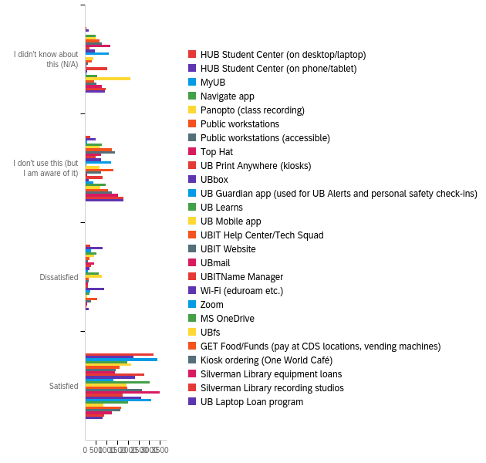

# | Field | Minimum | Maximum | Mean | Std Deviation | Variance | Count
1 | HUB Student Center (on desktop/laptop) | 0.00 | 3.00 | 2.76 | 0.65 | 0.42 | 3761
2 | HUB Student Center (on phone/tablet) | 0.00 | 3.00 | 2.39 | 0.87 | 0.76 | 3730
3 | MyUB | 0.00 | 3.00 | 2.87 | 0.44 | 0.20 | 3749
4 | Navigate app | 0.00 | 3.00 | 2.07 | 1.11 | 1.24 | 3737
5 | Panopto (class recording) | 0.00 | 3.00 | 2.12 | 1.13 | 1.28 | 3752
6 | Public workstations | 0.00 | 3.00 | 1.74 | 1.19 | 1.41 | 3739
7 | Public workstations (accessible) | 0.00 | 3.00 | 1.60 | 1.19 | 1.42 | 3743
8 | Top Hat | 0.00 | 3.00 | 1.56 | 1.27 | 1.62 | 3744
9 | UB Print Anywhere (kiosks) | 0.00 | 3.00 | 2.50 | 0.92 | 0.85 | 3747
10 | UBbox | 0.00 | 3.00 | 2.19 | 1.12 | 1.26 | 3745
11 | UB Guardian app (used for UB Alerts and personal safety check-ins) | 0.00 | 3.00 | 1.44 | 1.24 | 1.55 | 3746
12 | UB Learns | 0.00 | 3.00 | 2.78 | 0.49 | 0.24 | 3756
13 | UB Mobile app | 0.00 | 3.00 | 2.14 | 1.04 | 1.09 | 3752
14 | UBIT Help Center/Tech Squad | 0.00 | 3.00 | 2.02 | 1.09 | 1.19 | 3744
15 | UBIT Website | 0.00 | 3.00 | 2.44 | 0.93 | 0.87 | 3743
16 | UBmail | 0.00 | 3.00 | 2.89 | 0.45 | 0.20 | 3745
17 | UBITName Manager | 0.00 | 3.00 | 1.70 | 1.31 | 1.71 | 3727
18 | Wi-Fi (eduroam etc.) | 0.00 | 3.00 | 2.61 | 0.69 | 0.47 | 3736
19 | Zoom | 0.00 | 3.00 | 2.69 | 0.71 | 0.50 | 3745
20 | MS OneDrive | 0.00 | 3.00 | 1.97 | 1.19 | 1.41 | 3735
21 | UBfs | 0.00 | 3.00 | 0.92 | 1.22 | 1.50 | 3731
22 | GET Food/Funds (pay at CDS locations, vending machines) | 0.00 | 3.00 | 1.93 | 1.09 | 1.19 | 3702
23 | Kiosk ordering (One World Café) | 0.00 | 3.00 | 1.82 | 1.15 | 1.31 | 3699
24 | Silverman Library equipment loans | 0.00 | 3.00 | 1.49 | 1.16 | 1.35 | 3694
25 | Silverman Library recording studios | 0.00 | 3.00 | 1.23 | 1.08 | 1.18 | 3689
26 | UB Laptop Loan program | 0.00 | 3.00 | 1.24 | 1.06 | 1.12 | 3689

# | Question | I didn't know about this (N/A) |  | I don't use this (but I am aware of it) |  | Dissatisfied |  | Satisfied |  | Total
1 | HUB Student Center (on desktop/laptop) | 1.68% | 63 | 6.59% | 248 | 6.22% | 234 | 85.51% | 3216 | 3761
2 | HUB Student Center (on phone/tablet) | 4.32% | 161 | 12.87% | 480 | 21.90% | 817 | 60.91% | 2272 | 3730
3 | MyUB | 0.59% | 22 | 2.21% | 83 | 7.26% | 272 | 89.94% | 3372 | 3749
4 | Navigate app | 12.63% | 472 | 20.55% | 768 | 13.67% | 511 | 53.14% | 1986 | 3737
5 | Panopto (class recording) | 13.38% | 502 | 18.44% | 692 | 11.09% | 416 | 57.09% | 2142 | 3752
6 | Public workstations | 17.63% | 659 | 33.75% | 1262 | 5.30% | 198 | 43.33% | 1620 | 3739
7 | Public workstations (accessible) | 20.46% | 766 | 37.22% | 1393 | 3.74% | 140 | 38.58% | 1444 | 3743
8 | Top Hat | 30.93% | 1158 | 20.17% | 755 | 11.27% | 422 | 37.63% | 1409 | 3744
9 | UB Print Anywhere (kiosks) | 5.50% | 206 | 13.42% | 503 | 6.83% | 256 | 74.25% | 2782 | 3747
10 | UBbox | 11.91% | 446 | 19.60% | 734 | 5.77% | 216 | 62.72% | 2349 | 3745
11 | UB Guardian app (used for UB Alerts and personal safety check-ins) | 29.68% | 1112 | 31.87% | 1194 | 3.10% | 116 | 35.34% | 1324 | 3746
12 | UB Learns | 0.59% | 22 | 1.46% | 55 | 17.31% | 650 | 80.64% | 3029 | 3756
13 | UB Mobile app | 10.37% | 389 | 17.38% | 652 | 20.28% | 761 | 51.97% | 1950 | 3752
14 | UBIT Help Center/Tech Squad | 7.83% | 293 | 35.20% | 1318 | 4.46% | 167 | 52.51% | 1966 | 3744
15 | UBIT Website | 3.58% | 134 | 20.25% | 758 | 4.73% | 177 | 71.44% | 2674 | 3743
16 | UBmail | 0.99% | 37 | 2.16% | 81 | 3.74% | 140 | 93.11% | 3487 | 3745
17 | UBITName Manager | 27.82% | 1037 | 21.68% | 808 | 3.14% | 117 | 47.36% | 1765 | 3727
18 | Wi-Fi (eduroam etc.) | 2.62% | 98 | 3.88% | 145 | 23.63% | 883 | 69.86% | 2610 | 3736
19 | Zoom | 1.34% | 50 | 10.25% | 384 | 6.25% | 234 | 82.16% | 3077 | 3745
20 | MS OneDrive | 15.37% | 574 | 25.94% | 969 | 5.41% | 202 | 53.28% | 1990 | 3735
21 | UBfs | 56.39% | 2104 | 18.57% | 693 | 2.04% | 76 | 23.00% | 858 | 3731
22 | GET Food/Funds (pay at CDS locations, vending machines) | 11.53% | 427 | 28.47% | 1054 | 15.05% | 557 | 44.95% | 1664 | 3702
23 | Kiosk ordering (One World Café) | 14.06% | 520 | 33.87% | 1253 | 7.76% | 287 | 44.31% | 1639 | 3699
24 | Silverman Library equipment loans | 21.41% | 791 | 42.01% | 1552 | 2.79% | 103 | 33.78% | 1248 | 3694
25 | Silverman Library recording studios | 26.19% | 966 | 48.41% | 1786 | 1.65% | 61 | 23.75% | 876 | 3689
26 | UB Laptop Loan program | 24.78% | 914 | 48.82% | 1801 | 4.20% | 155 | 22.20% | 819 | 3689

Q12 - If you use clicker response technology in your classes, which tools(s) are you currently using? (Select all that apply.)
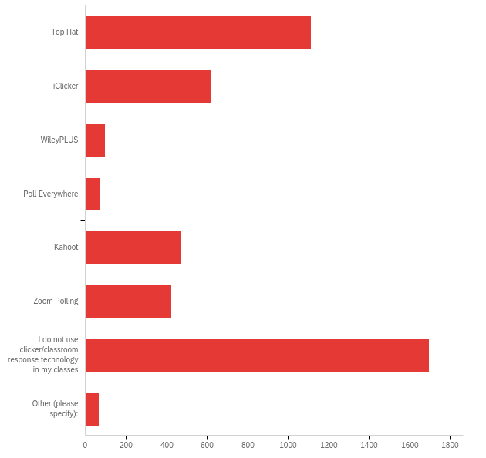

# | Answer | % | Count
1 | Top Hat | 24.36% | 1112
2 | iClicker | 13.56% | 619
3 | WileyPLUS | 2.13% | 97
4 | Poll Everywhere | 1.67% | 76
5 | Kahoot | 10.36% | 473
6 | Zoom Polling | 9.27% | 423
7 | I do not use clicker/classroom response technology in my classes | 37.16% | 1696
8 | Other (please specify): | 1.49% | 68
 | Total | 100% | 4564

Q12_8_TEXT - Other (please specify):
Other (please specify): - Text
We did use TopHat in D3, It was ok
Slido
Online system that uses smartphones
Slido
google sruvey forms
Norton Inquizitive
I don't know yet
Did not start classes yet
Mentimeter
Slido
UBLearns
Mentimeter
Cengage
ELI Review
google Docs, discord
pearson
Discord
cengage
Inquizitive
Used Tophat in the past. It sucked because it charged when free alternatives exist.
Webassign
Webassign (cenage)
Raised appendage or psuedopod
mentimeter
Class Question
Codio
SOCRATIVE
I have not taken my visa yet. Which I can tell you.
socrative
I'm not sure.
Piazza
My Math Lab
pearson
Elireview
Pearson
What is "clicker response technology", exactly?
Menti
draw.io
Piazza
Autolab
AutoLab
Slido
Respondus Lockdown Browser & Examplify/ExamSoft
inquizitive
none this semester, tophat, iclicker, wileyPlus in prior semesters
panopto
I'm not taking/teaching classes
MentiMeter
I am no longer taking classes and I am no longer a TA.
inquizitive
Menti.com
Examsoft
Codio
Socrative
AutoLab
kritik
Microsoft Fourms
Tunrpoint
Miro
Socrative
Kritik, Piazza
Not sure
Menti
McGraw Hill Connect for $100+
menti
None
AutoLab
QR Code

Q13 - Have you set your security questions and registered your cell or non-UB email to reset your UBITName password 24/7 using the UBITName Manager?
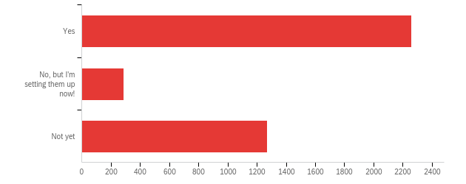

# | Field | Minimum | Maximum | Mean | Std Deviation | Variance | Count
1 | Have you set your security questions and registered your cell or non-UB email to reset your UBITName password 24/7 using the UBITName Manager? | 1.00 | 3.00 | 1.74 | 0.93 | 0.86 | 3818

# | Answer | % | Count
1 | Yes | 59.17% | 2259
2 | No, but I'm setting them up now! | 7.57% | 289
3 | Not yet | 33.26% | 1270
 | Total | 100% | 3818

Q14 - Have you had any significant problems with the Wi-Fi (eduroam) this semester?
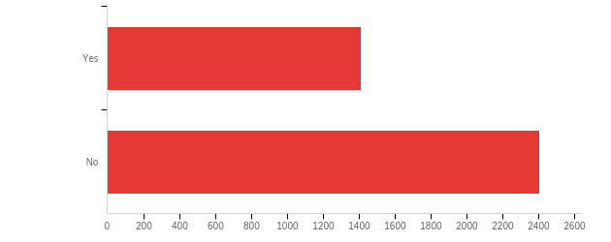

# | Field | Minimum | Maximum | Mean | Std Deviation | Variance | Count
1 | Have you had any significant problems with the Wi-Fi (eduroam) this semester? | 1.00 | 2.00 | 1.63 | 0.48 | 0.23 | 3819

# | Answer | % | Count
1 | Yes | 37.03% | 1414
2 | No | 62.97% | 2405
 | Total | 100% | 3819

Q15 - What were you doing when you experienced Wi-Fi problems? (Select all that apply.)
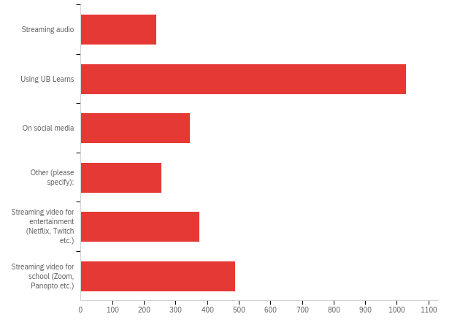

# | Answer | % | Count
1 | Streaming audio | 8.78% | 240
2 | Using UB Learns | 37.64% | 1029
3 | On social media | 12.62% | 345
4 | Other (please specify): | 9.33% | 255
5 | Streaming video for entertainment (Netflix, Twitch etc.) | 13.75% | 376
6 | Streaming video for school (Zoom, Panopto etc.) | 17.89% | 489
 | Total | 100% | 2734

Q12_4_TEXT - Other (please specify):
Other (please specify): - Text
Logging in
In class
wi-fi was down campus wide
Can't login in first place
I have a hard time simply connecting to the wifi. When I do I find it rarely works.
Opening (or failing to open) class lectures on UB box.
MAC IP ban
Connecting smart-devices like Cameras and bulbs
In lecture attempting iclicker
using UBMail, Teams
Working on campus
I don't remember
only have experienced issues in large classrooms (100+ students) but usually they are severe enough to halt the class
Google Scholar Searches
I was trying to work on my research
working
can't use at all on mylaptop
Using TopHat
Event check in and sign up on UBLinked
Just using google
nothing specific
just getting connected
downloading mods on nexusmods with vortex mod manager
On face time
slow
Bad wi-fi signal at Furnas Hall 4th floor inside the office/lab
face time calls
just normal use of internet to study/look up info
All of the above at some point
trying to use TopHat while in class
in some rooms i don’t have internet during class so i have use my limited hotspot from data
Top hat does not load fast enough in time for me to answer questions from my professor in class. I often miss the questions and lose points for it.
Just trying to access the internet in general on my cellphone; for whatever reason, Eduroam works on my laptop but not on my smartphone
accessing MyUB
video games
Connecting to wifi
using Kronos
I didn’t work for hours
It keeps disconnecting often
Gaming
I have been unable to submit answers to iClicker in class and in return risked losing credit
Couldn't go on any websites
exam
in class trying to do tophat
Doing research on the internet
some times wifi doesn't connected
in a virtual meeting, and gaming
Class
During calls
Construction caused a fiber optic cable to be cut which left us without wifi for a while.
Reading academic articles online
during career fair, to register the evet
Other websites
Internet in general has been slow
connecting to clicker websites/apps
The only time I experienced significant wifi problems was when the WiFi was down a couple weeks ago.
The network is slower than UB Secure
Browsing websites
Whenever there is a required session when the whole class is using the wifi, I’m unable to access any websites, the webpage for pathology lab will never load and I’m unable to follow along during class. I have to go home and use my wifi to reteach myself what was said in class because I can’t follow along if the required webpage won’t load. During this time it’s not just the required website for class, it’s my email, ublearns, any website I try to reach. The WiFi is just overwhelmed.
home
Got a new laptop, so unable to set it up again really
It had problems during the day, not with a specific activity.
Connection issues
WiFi does not reach my studio space
Research
Opening a search engine
General web browsing (email, news, research)
Loading websites e.g. pubmed
General connection issues, as well as stuttering/weak connection
Trying to Download Class Files and Upload them to my Ipad
Taking exam using Examplify
Checking email
Overall internet connection
Browsing internet
Trying to connect
Iclicker
Complete loss of wifi (schools probable, it was fixed the next day)
In a discord call
Accessing TopHat and just using the internet in general in larger lecture halls. Lots of students had issues.
Using TopHat
Trying to print documents (especially in NSC)
in lecture
There were a few days towards the beginning of the semester when the Wi-Fi croaked and didn't work at all.
gaming
Taking notes during class
It seem that if you have a android you can't have wi-fi at UB
wiley plus, achieve, and labflow
factime and video call in general
The whole power was gone and wifi was not working for a while
Doing research for a paper
I think twice this semester the wifi has gone down and reports became inaccessible
Just in class
Wifi texting/calling
sometimes when opening computer, the computer would disconnect from the wifi and i would have to reconnect it manually
just getting online
doing practice questions
WI-FI refusing to connect
Setting up eduroam
Basically it just cuts out randomly, including in the middle of exams, when the professor is trying to show videos, etc. (I assume the professors are connected via ETHERNET! Wtf?)
working at steam job fair/ frequently while working at Career Design Center
Not able to use at all
All internet access
Classwork at classes
About to take an exam
General everyday use (searching publications, checking e-mail, etc.); WiFi randomly drops out multiple times throughout day and disrupts connection momentarily
accessing the internet/web browsing
Research
using a search engine
Online games
Hard time connecting to it via laptop
Gaming and browsing the web in general, the connection will stop midway so I’m guessing it dropping packets
Have to log in again for setup every couple of weeks
Using Examplify/Examsoft and being unable to upload exam due to no internet connectivity in Deifendorf and Farber Hall
It would just kick off my device
Used to have to restart my laptop every other day to get wifi to work
Just like, using the internet and doing homework
gaming console
That time that wifi and the signal went down for almost a whole day and no one could use the internet
Sometimes refuses to work via smart phone
Working on assignments
Top hat and browsing
Leading Lab Exam for CSE 220
I cannot access the internet when I am in the parking lots of slightly away from the buildings, and it is very frustrating. My whole connection is like on lockdown in those edge-of-campus zones.
research computation
Loading learning modules when in a very crowded lecture space.
Does not matter what I'm doing, WiFi is poor regardless
Couldn't connect for the first week of school - wasn't included on the network member list - since corrected.
downloading
Using Xpra
The WiFi just never works for me
Accessing online homework
It’s always on TopHat
Doing RA work
My chromebook would not connect to eduroam without help from UBIT in SIlverman
Wegmans/Instacart websites really don’t like eduroam for some reason.
Taking an Exam, using lockdown browser
Gaming
taking a quiz
using tophat in class
Trouble connecting on my phone
I sometimes cannot load the page, or it is very slow in some office in basement Sherman Hall.
Loading anything in the apartment is slow
On a Call
Taking exams and doing hw
Research
signal dropping
doing lab work and data analysis
accessing google drive, email
When outdoors
Simply does not connect. Needs reauthentification every time.
examlify exam upload
Searching for sources on the internet
Doing homework on my laptop
I never have wifi problem
Trying to take an exam, but wi-fi failed and we needed to reschedule
Bell Hall has some dead zones and I disconnect completely from wifi
Wifi was down multiple times in my office.
I use my spouse PC.
Accessing the internet for class
Using any wifi service. Outages
Uploading an Exam on Examplify
Low network in Parking Areas and bus stops
I don't remember
Connection
Opening UB IT Email
Research
browsing and basic mobile application usage
Online gaming
Just connecting, my UB login doesn’t work half the time so I have to use my login from another institution. And it randomly logs me out, at which point I will either try to use my UB login or if that doesn’t work use the other one
Campus Wide Outage
Scrolling through the internet
Often unable to use internet when on eduroam , have to disconnect from it and use Verizon cellular network.
Doing shool work
wifi doesnt work. it will say connected but my phone will only allow 911 calls, my laptop wont load, ipad wont load
Just trying to connect to the internet on my smartphone.
Schoolwork
just trying ot use the internet
Using ExamSoft
top hat
connecting to wifi
Top hat will take ages to load up the course
accessing UB email
Connecting devices other than laptop or smartphone
Using the UB mobile app
It wouldn't let me connect to eduroam for the first couple weeks of class
Course work
General connectivity is bad, some times the eduroam network is indiscoverable, and at other times I can connect to eduroam but it has no connectivity to the internet.
Accessing UBBox
Loading Google Forms
misc. web browsing
On basic webpages (google etc)
Writing Exam
Completing work for the course I TA, sending email, preparing course materials
Phone fails to connect
Google searching
Simply trying to use wifi
Resetting certificate
Playing on my game console
Working on campus
tophat
Examplify
My friend faced issue while writing mid term exam
Setting up new phone
Trying to sign in for teach-in
During mandatory class sessions
Use of Internet in general
Connection
Doing my research
Using UB websites
Downloading software suggested by professor
Just didn't work at all
in class taking notes
when the power goes out wifi goes bad
using apps that are not social media on my phone, problems with connecting
Trying to access internet at all
Trying to do hw
Setting Wi-Fi up
My daughter tablet
Using internet, trying to connect to wifi
Accessing the internet, had outages
Math Parking Lot, Kettering Parking Lot, Hochstetter Parking Lot
Just on my phone on the main page
Using the classroom screen projector
Examsoft
later the issue was solved by resetting my mobile
Anything really
Just working, writing
also uploading exams via examplify
Everything
Staying in apartment, and the wifi would randomly drop, or in NSC classroom, unable to connect. Also a few dead spots in Baldy 2nd walkway tables
Top hat, downloading/uploading with examsoft
I couldn't connect at all until last week. The setup just never let me through
Attending steam job fair
Connecting on Linux. I don’t know what a Certificate Authority is, and I can’t be bothered to find out.
internet browsing
It just went down
Sites not loading
Trying to look anything up on my phone
internet down
Talking to parking people inside capen
taking a quiz
Video games
using the computer for school work, google, internet browsing
Can’t hook up my fire stick to Wi-Fi
Just using internet browser
Misc work
Couldn't connect to wifi using chromebook
All of the above

Q16 - Have you used the Level Up gaming site in Lockwood?
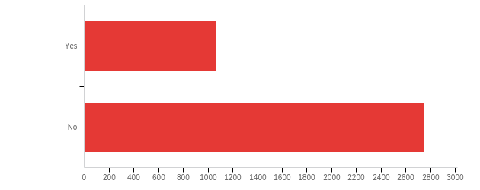

# | Field | Minimum | Maximum | Mean | Std Deviation | Variance | Count
1 | Have you used the Level Up gaming site in Lockwood? | 1.00 | 2.00 | 1.72 | 0.45 | 0.20 | 3817

# | Answer | % | Count
1 | Yes | 28.03% | 1070
2 | No | 71.97% | 2747
 | Total | 100% | 3817

Q17 - Which areas of Level Up have you used? (Select all that apply.)
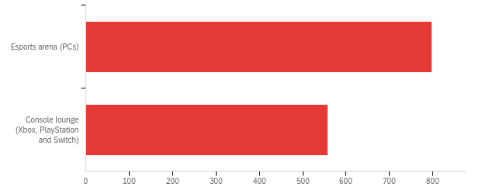

# | Answer | % | Count
2 | Esports arena (PCs) | 58.85% | 798
3 | Console lounge (Xbox, PlayStation and Switch) | 41.15% | 558
 | Total | 100% | 1356

Q18 - Overall, how would you rate your experiences in Level Up?
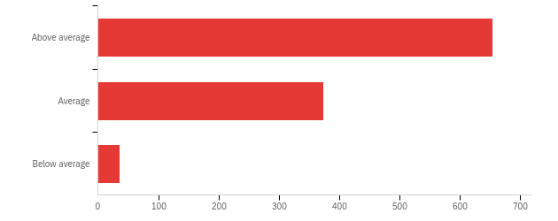

# | Field | Minimum | Maximum | Mean | Std Deviation | Variance | Count
1 | Overall, how would you rate your experiences in Level Up? | 1.00 | 3.00 | 1.42 | 0.56 | 0.31 | 1064

# | Answer | % | Count
1 | Above average | 61.47% | 654
2 | Average | 35.15% | 374
3 | Below average | 3.38% | 36
 | Total | 100% | 1064

Q19 - Have you used the UltraWide (widescreen) monitors in Silverman?
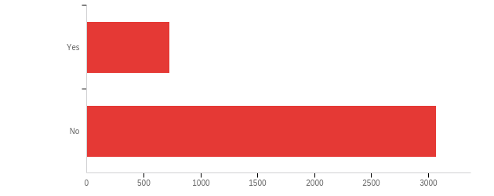

# | Field | Minimum | Maximum | Mean | Std Deviation | Variance | Count
1 | Have you used the UltraWide (widescreen) monitors in Silverman? | 1.00 | 2.00 | 1.81 | 0.39 | 0.15 | 3798

# | Answer | % | Count
1 | Yes | 19.12% | 726
2 | No | 80.88% | 3072
 | Total | 100% | 3798

Q20 - What size UltraWide (widescreen) monitors would you prefer to use in public computing sites?
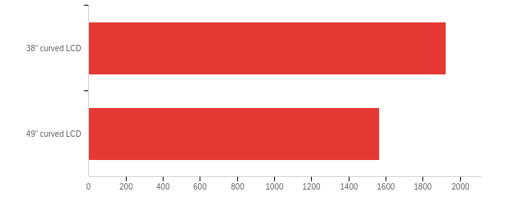

# | Field | Minimum | Maximum | Mean | Std Deviation | Variance | Count
1 | What size UltraWide (widescreen) monitors would you prefer to use in public computing sites? | 1.00 | 2.00 | 1.45 | 0.50 | 0.25 | 3486

# | Answer | % | Count
1 | 38” curved LCD | 55.16% | 1923
2 | 49” curved LCD | 44.84% | 1563
 | Total | 100% | 3486

Q21 - Do you use the remote VDI service to connect to a virtual machine?
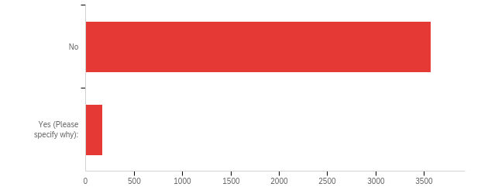

# | Field | Minimum | Maximum | Mean | Std Deviation | Variance | Count
1 | Do you use the remote VDI service to connect to a virtual machine? - Selected Choice | 1.00 | 2.00 | 1.05 | 0.21 | 0.04 | 3745

# | Answer | % | Count
1 | No | 95.41% | 3573
2 | Yes (Please specify why): | 4.59% | 172
 | Total | 100% | 3745

Q21_2_TEXT - Yes (Please specify why):
Yes (Please specify why): - Text
Not on campus
Stats package
I have a Mac and need to use it sometimes for certain programs that can only run on Windows
Training
Clinical records access
Vr
For my IT course
To acces SAS and minitab on my macbook
to work from home during late nights
used to connect with cedar servers during my assistantship
I used its a bit for minitab access
MS access as I currently use MAC
I don’t know what that is
Use older/different operating systems
To use Microsoft Access on my Macbook
It helps in accessing my files. Currently I use loaned laptop from UB. In case I forget to bring that to college, I can have the copy at VDI service. So it would helpful
required in computer security course projects
My previous employer had data restriction for security reasons. We had to use Citrix virtualization solution to connect with remote desktops
Because I have a Mac and some classes require PC only software
Needed microsoft database making software, have a mac, remote online student
My apple laptop cpuld not run the macros for an excel file and i had to use it for some courses.
Coding related work
To study with a group
To use ArcGIS
Since I have a Macbook i'm unable to use some software so using vdi help me remotely access the softwares
So I can use Microsoft access for my mgs351 class
Emulate different oS
I can't access MyUb from home otherwise
Remote access to solidworks
SAS
LIN Remote is hosted virtually
MGS Access
Dual boxing off machine applications but it is incredibly slow
Tried to use in order to open newer version InDesign files not supported by my version of the software; no luck.
Protected HIPAA info
Cadence virtuoso software
Research lab, for computing and transferring data files
Emon
MGS
Job purpose
Remote desktop connection
Research
During our MGS 101 lab sessions
I am a PhD graduate student and research assistant so I have to have access to my virtual desktop.
I'm not sure about the technology
CSE courses
For my assignments
Necessary for MGS101 lab activities
for classes CDA101 and CDA215
Computer security labs purpose
Occasionally need access to OS specific software.
I am also a staff member, I use it for work. But, would use it to remote in to use Minitab for class.
For my coursework in MGS650
I didnt have a laptop for the first few weeks of class
For MGS 101
CSE 220 class and render things because my laptop can't handle the heat very well
Home network vm
but i cannot access some apps in it
MGS 351
Virtual GIAL for lab work using ENVI and ARCGIS
Required to Run Linux
CSE 220
To use the softwares
CS classes
For the tasks related to computer security coursework
I think you are talking about the study rooms in silverman I use them to connect my laptop to the screen for group projects or practice problems
My coursework demands use of different OS and servers to understand better!
Cisco
ccr
virtual computing lab
Graduate Assistant Work, SAS for classes
Computer security labs
For my lab work.
for my MGS 351 class
access axium, dolphin, and files
vsphere
research
Access research documents from home
Emon
I have some programs I need to access for my research
CSE365
To use SAS from home
for some courses
To present my screen when working on a project with my team mates
i use them for personal purposes, and havent ever used it for homeworks, academic projects and stuffs
I have a mac
I have a Mac
I had been using UBVDI because of my ITM 101 class which requires students to log into VDI .
My laboratory work
I used it for my mnc assignment
I have a Mac.
Mgs101 class
Virtual software
To run statistical software
ARC GIS LAB
I used it back when my laptop wasn't powerful enough for certain tasks.
I run a mac and had to use Microsoft Access for a homeowork assignment
these awesome
To access jsmbs contact/class lists from home
I need it for my database courses, in order to use microsoft acces
MGS 351 course requires a website that is not accessible on a Mac
For editing my personal webpage from off campus
For CSE220 to code C
class
School Work
My computer at home from school
Course work
I need it to access certain programs (e.g., SPSS), but it doesn't work well so I rarely use it.
remote research
For class
My PC cannot run programs due to licensing and also processing power
To use SAS
Class project
I did for access
Our department has licenses to use some software for our research. Other things I do them on my laptop
Vpn to access the dental health record system (axium)
For windows OS
For class
To use for my classes because my macbook does not allow me to do certain things
To access files only available on medical school network as part of GA position
Class
I tried this when I needed SAS for a course and it was too clunky
Parallels
for SPSS
Need to run pharmacometric programs
For IT class

Q22 - Do you use computers in the public computing sites?
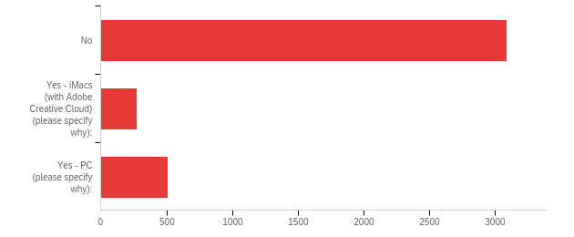

# | Answer | % | Count
1 | No | 79.89% | 3087
2 | Yes - iMacs (with Adobe Creative Cloud) (please specify why): | 7.01% | 271
4 | Yes - PC (please specify why): | 13.10% | 506
 | Total | 100% | 3864

Q22_2_TEXT - Yes - iMacs (with Adobe Creative Cloud) (please specify why):
Yes - iMacs (with Adobe Creative Cloud) (please specify why): - Text
I have found IMacs to be easier to use than PC
for homework
mac and PC
They’re very smooth and easy to access.
I feel safer
I don't have a laptop
Sas
homework
For a second screen when I am doing work
Yes - google docs
Made a power point for one of my classes
Digital Art Course
for class
To use Adobe software
Keyboards are nice to use, and bigger displays
No
For course work
I use Adobe for school
For adobe photoshop and lightroom
i dont have my own computer
For class projects
to complete any assignments, works faster than my laptop
iMac
For my classes
Editing with Adobe Premiere
Using Adobe light-room classic
the pcs are very slow.
for classwork
For work
Hws and coding projects
Cause I don’t have it
I didn’t have my laptop one day and decided to use one of the iMacs available.
For class
multiple user options
Easier to use
for the adobe stuff
School work
Used when I had a class that required Respondus LockDown.
School work because I don’t have a reliable laptop
need certain softwares and more familiar with mac
For video editing, photo editing and project completion
Academic use
Premiere Pro
as additional screen with laptop
Prefer bigger screen sometimes for work
Only in the CFA's photo lab - used for editing photos.
because I don't have a personal laptop
general
to learn editing
More accessible
the iMacs are good for helping me update my LinkedIn profile
It has Adobe License and is much better than the PCs
easy to use
My system was crashing, so I had to use this to access the resources. Specially Codio
For homework and quizzes
When my computer died, I have to go to the library to finish my work
Working with peers
I use them to access Adobe Creative Cloud for my major related courses.
For group projects
Administration work, Homework, and projects
To learn the basics of working with Macintosh (I use Linux, formerly windows).
I have had to use photoshop once in Silverman for my DMS 121 class
I wanted to use xcode on the macs but you do not have it.
Photoshop access, as it’s not available to me at home
Occasionally need to edit lab videos.
Adobe
To get work done
for my ART220 projects
ub learns
For Everything because my laptop is very slow.
Adobe Suite
they're pretty
I'm a fool for technology.
I use photoshop and premiere pro in the computer labs at center for the arts for some of my classes because its free.
Art Major (photography)
Classes
Germs and convince
For assignments and extended screens
Classwork
The screens are bigger than the PC computers and in Silvermann the Mac area is less crowded
It has very good screen
For assignments as my current laptop is not good enough
I’m
Laptop couldn’t run adobe
Sometimes I will use Premiere Pro for personal projects
Adobe Creative Cloud
Sometimes my laptop does not have enough charge so I use the iMacs instead.
To use photoshop
Editing pictures for photo club using adobe lightroom
I used them before getting a laptop in the laptop loan program
for homework
Sometimes I do not bring my laptop to the campus.
To work on homework assignments
In class
Complete Photoshop assignments for photography class
Ease of connecting my AirPods,
I used iMacs to edit my videos
Photoshop personal stuff
I like them
I use adobe creative suite for my classes
to do coursework outside of my dorm
It came with free airpods, but not satisfied with the computer.
To do my work for Photoship
for a bigger screen
They are newer
work edits
To use adobe after effects
Class projects
Complete ting assignment, study
Photoshop
i like macos better
Its just a different place to work to spice things up and I save my laptop battery
To do graphic illustration for classes and personal projects
Use photoshop occasionally
To complete my project
I like Apple products
Homework
For the Adobe Creative Cloud
Software that I don’t want to buy
Printing and finishing some work
To do work
Laptop was not working
hw
I use it for my art classes, I need Adobe Photoshop
Hw
I use iMacs because I am comfortable with macOS. I also use the Adobe Creative Cloud a lot for photoshop and illustrator . But I am disappointed that there is no Xcode in our library iMacs
to get some research done on my work
to sometimes do work
To access Adobe products like Premiere and Photoshop
Hw
Double screen for schoolwork
no computer of my own
I just like the iMacs
Convenient
I like to have an e xtra computer running along side my laptop occasionally
School work
To create media content
Homework
Because I’m used to use iMac back home
I use iMacs to upload my course work.
For assignments
They are faster
Feels slicker
Photo wditing
For project works when my laptop is slow
school work
I prefer IMac computers but can't afford them
for days when i don’t carry my laptop
To get work done
Sometimes my laptop is unreliable
I have a mac laptop and I prefer mac to windows
To help take notes, watch lecture videos, etc.
I hade to design a website and the tools like adobe photoshop are only available on those iMacs
I'm comfortable with macos
for studying
To get challenging work done or if I can’t load things on my tablet
home work

Q22_4_TEXT - Yes - PC (please specify why):
Yes - PC (please specify why): - Text
The software Solidworks crashes quite often in my laptop so I use public computers for my homework.
I don’t enjoy the MacOS; I’ve always been much more comfortable using PCs
There are PCS there to use
availability
to study
computing class
The required software for my courses favor PC
The mode to work is high on PC
Because my laptop has so bad condition
My laptop was stolen. So I don't have a laptop thus I use PCs at silverman to submit homeworks.
more familiar with windows
I use the PCs in Hayes Hall occasionally.
I prefer it
If I leave laptop or charger at home
Theyre closer to the entrance, it doesnt really make a difference to me
I am used to using PCs
To watch lectures while notetaking
for college work, assignments, course content and gaming
When i didnt bring my computer with me to school
To utilize required software for courses
photoshop or other softwares for design assignments
I feel safer
For academic purposes and printing use
I dont have access to my a PC that I own.
LG gram for study
Homework
Yes, Don't own a laptop
Bigger screens and better keyboard than my laptop
Excel short cuts
HW
Easier access to softwire with all my preferences and presets making course work more efficient.
when I work on campus
To do homework
coding and minitab for class assignments
improve study efficiency
homework
for homework when I need another screen, or if I need to do multiple computing tasks at oncew
printing
My laptop broke earlier this semester and I needed to use a computer
Yes - microsoft suite
to study, work on assignments etc
Had to use the SAS program for my statistics class
I don’t have a computer
my laptop is currently broken
using architectural programs
Ketter 208
I use them to print slides for classes
To print stuff and have double screens going
to do homework etc
easy to use
I’ve used only windows
This is what I am most familiar with and I like the controls
I dont have a PC but classes are requiring PC only programs
For class
My laptop is currently inaccessible; the spacebar and backspace keys aren't functioning properly. I could have them repaired by the same IT service that's repaired the laptop in the past, but considering I've spent almost two months completing my assignments and trivial activities without it, I feel it's best to wait until I return home for winter break to have it repaired.
I prefer PC
When I have to do work but cannot use my laptop
i dont have my own computer
for schoolwork when I don't have my laptop
To do homework
When i forget my laptop at home
Stats software
more than 1 screen
my coursework is on my laptop, easier to just use hdmi cable to connect to big screens and put everything out in easy to view manner
AutoCAD, SAP2000
It is useful if I am on campus and do not have a device.
sometimes
Use for openroads software in Ketter lab
some times to work
I'm used to this system
My laptop cannot be used to run the programs I need to use for different classes.
Save laptop battery life
I used to before I got a laptop, and I preferred to use a pc as I just find them easier to deal with compared to macs in terms of messing with files and all that
for specific software packages (SPSS)
School
more screen space, runs more effectively, more reliable
For architecture course work
I dont have a laptop and some assingments i like to work on between classes require a pc
In the clinic for report writing
Extra monitor
architecture
to view some files real quick
For some architecture classes in the computer lab or for printing to the architecture plotters
When I'm in Capen library, I use the PC in the 3rd floor as they are faster than my laptop. I use the PC's because I prefer it over then iMacs.
To do work on UB Learns primarily
Homework, online assignments and exams
to connect to a larger monitor
Solidworks doesn't run well on my personal laptop
For study purposes
Because my laptop crashed and I need it to do my course work
emergency use when my laptop was in repair
Didn’t bring laptop
I have a non-Apple laptop and the experience is more streamline to use the PCs
For Microsoft access
I prefer word.
Schoolwork
More familiar network and system(never used MAC)
These were available
coding and working on homework
For my academics, for applications like colab
SPSS
SAS
For GIS course work
If my PC is having issues/I forgot a charger
Need to use certain software for classes
I have Pc but it produces a lot of noise. Also, it's laggy because it's old so I like to use the public iMacs because it's faster and looks nice
Projects and work
You don't offer Linux
I'm more familiar with PC than Apple products due to their increase of expense. I used the computer la because I don't always carry my laptop but needed to look thinks up.
I do not bring my laptop to campus everyday so I use the PC’s to print off things as needed and answer emails.
School work
Hayes Hall PCs with Adobe for studio projects
engineering coursework
Homework, MatLab
School work because I don’t have a reliable laptop
I need it for 3D modeling softwares and adobe creative cloud
I have a class in a computer lab. The software is preloaded on the computers.
Allows for certain programs not available on Macs
My laptop was not working that day
that is what is available at the medical school campus
I am a pc girl
I need to do assignments on programs such as SAS
Easiest to use for me
need stats softwares that are easier to use on PC
When I want to use a wider screen
for send emails and homeworks
I would like to but half of them were turned off
larger display than laptop + kb/m
Data entry, data analysis, researching for classes and assignments
Access to database
Academic use
Arch print lab
My laptop doesn't support some softwares or have troubles installing. For a week my laptop was not working so was using UB pcs.
I like windows 100x better
AutoCAD
to print
as additional screen with laptop
No laptop.
School exams on occasion
Need it for class use
Comfortable with HUI
Same thing as above
Apple's overrated
My laptop broke earlier this semester and needed to use a computer
When I do not need files or programs off of my laptop, it is easier to leave my laptop at home when I travel to school.
because I don't have a personal laptop
Good work environment
for clas
for class
for listening to classes
sometimes, to do some research
print, google, reading
I like the UX better
prefer this interface
to have two computers screen
helps me studying
Even though I have an apple laptop I prefer PCs on campus. Easier to navigate as PC desktops.
To do my homework or watch lecture videos to save time.
When my Laptop acts up, I go to the Buffalo public library to study.
Most comfortable, only using basic functions (library search)
To print documents I need printed
it is a lot easier to code with multiple monitors and I have a PC, not an Mac
laboratory computers
To do homework
sometimes when i don't have my laptop with me
Occasionally if I forget my laptop and need to edit a document/print it. They are gross and unsanitary and there are lots of rude chattering people around though, so I try not to.
i love how PCs work far better than any tablet or cellular device to effectively load, navigate the web, and complete assignments on time thanks to the programs and efficiency
convenient enough
To take some print outs sometimes
Use windows software
mac sucks
To have access to software used for coursework
for SPSS
No laptop
No laptop with me
Because I am more familar with it
for unreal engine
Administrative Work, Homework, and Projects
They're convenient. Sometimes I don't bring my laptop to campus.
GIS Lab
class work, better than my computer
GIS
I don’t want to install Lockdown browser on my laptop.
Homework
fits my academic needs
printing
Using SAS software
Occasionally need to use Windows specific computers/Forgot laptop at home.
Forgot my laptop at home once and needed to get work done
Microsoft
I don’t have a laptop so some of my assignments require programs I can only use well on a computer.
I prefer a computer that isn't a mac. I don't like the restrictions.
Sometimes my laptop is not working as well, so I use public computers when I have assignments to do.
i pefer the computer layout of UB websites
ub learns
To do classwork
Used to
To do all my coursework
Sometimes my laptop would die and I don’t have my charger. Or I would leave my laptop at home.
Ease of use
I need multiple screens so i can follow along with lectures while I work. There is NO WHERE on campus to accomplish this. Silverman has docking stations but the tables are too small to fit any material, notebooks, laptops, etc. Not that convenient!!! In the working world an employer gives you two monitors and a desk. Im at the point where I should rent office space to get my work done. Grades are suffering due to lack of workspace on south campus.
Ultrawide monitors allow me pull up the lab, Excel, MATLAB, and Word at the same time without switching windows and tabs.
For homework
I'm more familiar with PCs so I use them in the public computing sites for homework and class work.
Sometimes when I don’t have my laptop or iPad
they run some software better than my laptop can
I like having larger screens to display my work
MGS351
When my laptop dies.
For my schoolwork
I'm a fool for technology.
I use photoshop and premiere pro in the computer labs at center for the arts for some of my classes because its free.
I used to have alaptop before with same
When my laptop doesn’t work I use them for typing or research
I like to preserve my laptop life
excel runs better on it
Doing coursework, accessing UBlearns
Sometimes I forget my laptop
There is a desktop computer I can use on campus for when I absolutely have to do homework on a PC. I have to leave my dorm room and it's in public. I cannot take the desktop with me to classes so it's harder to take notes, especially when I have difficulty writing but my average typing speed is 120+ WPM. I also have an Accommodation Memo with recording, but I can't use it because I don't have a laptop to use it with and my phone doesn't have enough storage.
Because PC's are recommend for the software I use for my classes and many of programs used aren't even available on macOS
Classes
Those are available
Doing school work and printing documents
For assignments and extended screens
Classwork
homework
For a computer science personal project
I’m used to using PC equipment
They are in the library I go to most
Gaming/homework
For assignments as my current laptop is not good enough
Those are the ones i use for my assignments
for TA job
For any work regarding courses
Sometimes I prefer linux but have no personal machine to install it on
To do homework
For Studying
To do schoolwork when I am not in my dorm
Basically use it as an over-glorified second monitor for my laptop.
More suitable to run software for projects
Creativity increases
i have no laptop
Easier to do practice parallely while listening to lectures
imacs are confusing to operate
For coursework
Some class require programs to complete homework, most of the computers on campus have the required programs needed.
iPad limits drawing abilities on certain websites
I prefer Windows for coding
For my homeworks.
I find PCs easier to use.
Large printing services
School work
I prefer Microsoft on PC
printing and research
What i’m used to
Mostly for printing or using Rhino for classes
when I do not have access to an iMac
When my laptop was broken
Convenient and possesses the operating system I understand
Nice to have an extra screen when doing work
certain software
I am more used to using PCs rather than iMacs
to use Microsoft access/excel
To access desktop Word or make printing easier
In the libraries to complete school work.
working on treatment plans, look at schedules, and working on homework
Some time it is more convenience to complete web work using PC
I’m more comfortable with yhis
Accessing UBmail, Courses,and more
Windows is what I am familar with
As I don't know own one I have to use the ones available in the library and other computer labs like the one downtown if I want to generate word docs or presentations or even if I have to run softwares
multiple screans
For coursework, when I was in a computational class
For statistics class
work excel
Easy to use
That is what is in HSL
for accessing course material
To watch lectures
Class projects
sometimes easier to print work from
my laptop broke down
I have a mac
Running SAS programs
For GIS
Work
To print in the department
I find it convenient to do work
I like PC over iMacs since I have a Windows laptop
I have a Mac and I can’t run a lot of the programs we use in our classes. Also it doesn’t support multiple programs at the same time or rendering.
coursework
Sometimes my pc is way too slow or I can’t load up specific sites due to a cookies error
Printing, computer lab
my computer has not always been reliable (my current one is), so i have used these.
schoolwork
I just know how to navigate them better.
For SPSS software in the previous semester
I like the ui
I like windows more than mac
Laptop broke last year I needed something do run solidworks
more familiar with it
It keeps me focused on my schoolwork more than my laptop.
They are more reliable, Macs can not run GIS, Excel, nor AutoCad sufficiently for architecture or planning. In the field thos either Apple are encouraged to sue loaner PC's in order to work with hockey's and to have a better overall program layout.
printing
For classes where the software is too advanced for my laptop
Sometimes my battery is dead, so I have to use public computers to do homework.
Practice & Class Assignment
Research/homework purposes
I do CAD modeling. So intially I used to do it with my laptop and PC, but now it got broken and was unable to do it
Windows OS is preferable. Computers have SOLIDWORKS installed.
to write documents
sometimes i need to open multiple screens
Run software
My files are only in my laptop
Assignments
More familiar to me
I’m not familiar with Mac
Its faster than my laptop so i login to read my pdf assignments or sometimes just use it as second screen
Printing and study
Need computers
I like it more
To do work
Laptop was not working
hw
to do homework, study
usage is convenient
that's what Hayes Hall has
As I cannot navigate through my phone and PC simultaneously
for editing for media studies classes
i don’t have a computer
MGS 351 course
I am more comfortable with PC than Mac
Fixing homework
For hw
video editing and school work
To do work because the software, I don't have in my labtop
For research help
If I forget my laptop then to do some work.
When I didn't bring my own laptop.
Windows
To do my work
For coding and assignments
To use free software and better than UB Loaned Laptop
For carrying out day to day activities including but not limited to assignment completions on ub learns, internship searches, resume creation etc.
for using large screen while studying etc.
Yes, sometimes for class projects.
Hw
Coursework
I need to us ethe PC at Hayes to access the architecture printer
Study
Connection to printers
lab
I used it before I borrowed a laptop from UB
Exams for one class
no computer of my own
I am able to access the statistical programming software, SAS, on the PCs.
Use it for school work.
I am more used to the layout. The service is really quick compared to my own laptop and I also like using the mouse
Printing
only use them when my lap runs out of charge and i dont have my charger
Projects and Homework
I’m way more familiar with PC’s than Macs
I like to have an e xtra computer running along side my laptop occasionally
SAS
to View class materials only available through the computers.
yes for college work submission and browsing the slides of lecture
to print in my department
it's what i'm used to
To do hw/ catch up on emails and check grades
For work
To do assignment and send documents to the printer
Printing
I'm familiar and use pc exclusively at home
Doing homework
Furnas 1018
To work on assignments
Only occasionally, when laptop is charging
The large monitors in Silverman Library are nice for extra screen space.
Class work
I don't own a laptop of my own so whenever I need to study (and I am unable to borrow any laptop from my friends) I use the PC.
I have a Mac and some things you have to do on a PC
For homework and class that need Microsoft
Better quality
For programs my laptop can't run
In between classes, when I don't wanna go home
for contributing to open source project
Better performance than my laptop
gaming
There’s seating by the computers usually
Yes
Certain programs (NodeXL) are not available on a macbook
To complete homework and assignments.
for class
To run macros on excel and to use access
Had required statistical programs for coursework that were only available for purchase for personal computer
As My laptop does not support all the softwares I have to use
Personally use PC, MS apps more familiar
Cause I get a bigger screen size this way
Printing
To research about my projects
My Laptop was having keyboard issues and I needed to do work on campus
My personal computer doesn’t work for certain lab websites I need
Need it for specific software
If I need processing power exceeding what my laptop can provide. Like for running FEA analysis or matlab scripts which are CPU intensive.
For School Work
To use cadence virtuoso in lab
South campus computer labs for architecture students
Just to get assignments and stuff done since my laptop is old and heavy
To run large programming software that would take up too much space on my own personal computer. To use UBBox. To have a designated work session/focus better.
For ub learns
Printing
I am used to pc
class home work
They are what are available in the grad office
They're what are available at Abott
My laptop doesnt work well

Q23 - How would you like to use virtual reality at UB?
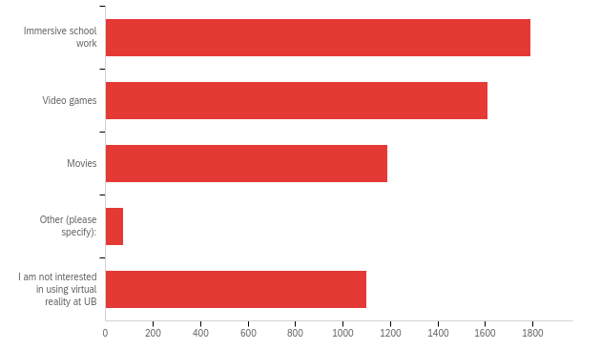

# | Answer | % | Count
1 | Immersive school work | 31.08% | 1792
2 | Video games | 27.96% | 1612
4 | Movies | 20.62% | 1189
5 | Other (please specify): | 1.27% | 73
6 | I am not interested in using virtual reality at UB | 19.06% | 1099
 | Total | 100% | 5765

Q23_5_TEXT - Other (please specify):
Other (please specify): - Text
To see the interior and exterior view of the designed building in reality
Virtual school trips, i.e virtual visit to a lab or company
Simulation
Did not know about virtual reality at UB
Research
that would be funny do it.
Virtual lectures / labs. Real time or not would be cool.
I want to have a virtual reality party on Chippewa
All of the above
I never tried it. So I am not sure what to do
Curious about other applications outside of video games and movies
Who do you know with a PhD that used VR for anything other than playing around
Research studies
To try it out
All
Revit/rendering programs
For research
Just to test it out
I would need to know more about this to answer this question
Neat idea, but I can't see a great use case.
Group activities, or small group activities, that are more interpersonal and connected, allow for more specific reflections/opinions to be formed surrounding usage
Training and development
Research
Augmented reality features as well.
Live action games for fitness
Maybe a virtual tour
Didn't know it existed
I want to use VR to create large scale and accessible artwork.
Remotely accessing Food Menus at the eating outlets on campus
It’s not valuable. How about use this to increase the salary of TA?
As an adjunct in gross anatomy
I would like to do research on Unreal Engine in the school of architecture. So useful in our real estate program!
If it can erase bad grade outcome, I'm all ears. I'm for it.
learning through game
Navigate
Viewing 3d structures from a virtual view
Visual aid learning in engineering and applied sciences.
No I haven't used yet
All the above
No idea we have VR at UB
Attending class room lectures remotely, remote group studying
I would love to, but I am physically unable
I just want any device to study not sure about these questions
Virtual UB tour
Honestly these all sound cool, just whatever you can figure out im cool with
just to know how the tech is in quality.
virtual experiments
None
No experience with this tech
Medical simulation labs
for games
Not sure
Ive never used it
Yes! I wish UB had a digital twin so I felt like I was attending class on campus!
A small fee to watch the live performances where all the clubs perform in CFA
sports
I have my own headset for my desktop computer. I'm only bummed I can't use it for school work.
As supplemental for gross anatomy lab, an accurate cadaver
For academic research
Anatomy please dear god
I haven't used
N/A
research! put participants in virtual reality and survey them to see if different responses result

Q24 - How can we support the use of virtual reality at UB? (Select all that apply)
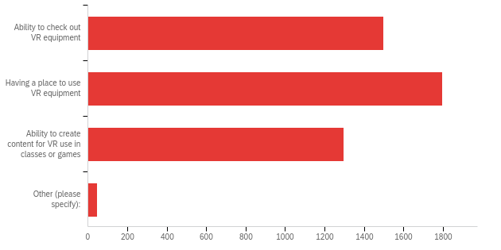

# | Answer | % | Count
1 | Ability to check out VR equipment | 32.31% | 1499
2 | Having a place to use VR equipment | 38.74% | 1797
4 | Ability to create content for VR use in classes or games | 27.98% | 1298
5 | Other (please specify): | 0.97% | 45
 | Total | 100% | 4639

Q24_5_TEXT - Other (please specify):
Other (please specify): - Text
Create a course on VR game/world/experience programming
Advertise more so people finds out how to use and where to use
researching what VR is and if it is actually part of our future?
As an online student, have option of purchasing or just send VR supplies to students. Include price in tuition
teach how to do it for beginners
ability to learn how to use it
Having vr available in residential halls
All are good uses
would be amazing in architecture classes
UB Gaming Rentals
I would need to know more about this to answer this question
Making considering hand coordination skills in games that require fine motor and quick reaction. And acknowledge them as somewhat beneficial skills for schools like dentistry. I don't know how this could be incorporated, but some awareness about this might help.
especially for classes
Signing up or onine sign up/booking of usage to the VR set, or small group activities to be booked/scheduled with VR
To view the theory to get virtual idea of course
Keeping track of if the lot has any parking spots before getting into the parking lot. That will save student a lot of time because usually the wander around to look for a parking.
implementing VR based School-work
All of the above
Not interested
Ability to use VR equipment as online student or obtain from other SUNY campuses
N/A, online student
In the classroom for gross anatomy
Unreal Engine! Game Development Club. Online learning. cutting edge stuff!
Subsidized equipment for purchase at discount retail
Host demos for people to try it out in a casual way
educate me on how to do it
Not sure
Having workshops for informing interested students about virtual reality
Not sure
N/A
Ability attend many campus events
unknown
Let departments decide
VR specific to medical school/labs
Class at home would be cool
Teaching about VR in a VR Club
The ability to attend classes in VR or use multiple monitors in VR/AR. I love using Horizon Workrooms for classwork because I can throw up 3 monitors at the same time.
Gaming
Having an area like Level up but dedicated to VR would be amazing.
NA

Q25 - Which of the following productivity software titles do you use for your studies or coursework at UB? (Select all that apply.)
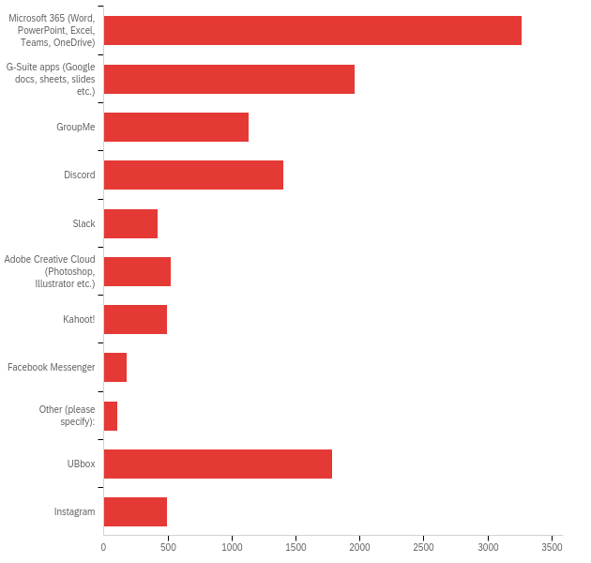

# | Answer | % | Count
1 | Microsoft 365 (Word, PowerPoint, Excel, Teams, OneDrive) | 27.74% | 3267
2 | G-Suite apps (Google docs, sheets, slides etc.) | 16.63% | 1959
3 | GroupMe | 9.61% | 1132
4 | Discord | 11.91% | 1403
5 | Slack | 3.60% | 424
6 | Adobe Creative Cloud (Photoshop, Illustrator etc.) | 4.46% | 525
7 | Kahoot! | 4.19% | 494
8 | Facebook Messenger | 1.55% | 183
9 | Other (please specify): | 0.93% | 109
10 | UBbox | 15.15% | 1784
11 | Instagram | 4.23% | 498
 | Total | 100% | 11778

Q18_9_TEXT - Other (please specify):
Other (please specify): - Text
What’s app
Miro
overleaf
Graphpad Prism
Teams for work/school
WhatsApp
Canva
Adventures in Commercial Real-estate Accelerator
I don't know yet
LibreOffice
youtube
Notion, Youtube
Whatsapp
Brave Browser
Mattermost
SAS, SPSS, OneDrive
Wolfram Mathematical 13
VDI
Snapchat
None
iMessages
Autocad, rhino, grasshopper
Zoom
Mat lab and solid works
Remind app
Photoshop, Autocad
Canva, WhatsApp, Apple's Suite (pages, numbers, etc)
Whatsapp
Apple office
Linkedin, Handshake
Reddit
Google docs and drive
Canva for designing slides.
flix
Tophat, Figma
WhatsApp
FlipGrid and Canva
canva
SPSS, Stata
Iphone messeges
Telegram
Cisco Connect & Remote Desktop
Zotero, Obsidian, Raindrop.io
LibreOffice, pandoc
WhatsApp
Microsoft teams
Samsung Notes
Origin, Matlab, Blender, various analysis/scientific software
Open
Canva
Canva
WhatsApp
Minitab
CANVA, CMAP
Apache OpenOffice.
Matrix
OneDrive (my savior)
padlet
Grammarly
ReadAloud
Notion
zotero
Whatsapp
iMessage
linkedin
Rhino
Canva
phone number
art softwares like clip art studio
linux/ open office
CCR
Miro, WhatsApp
Notion
Quizlet
Notion
GitHub
Visual Studio Code
Teams
Notion
snapchat
LibreOffice
Origin, chemdraw, matlab, blender, 3ds max
Asana
zoom
ClickUp
Goodnotes
MATLAB, vs code
R Studio, Jupyter Notebooks
Rhino, AutoCAD, Revit
Matlab
WhatsApp
Canva
Whatsapp
SPSS, R
Notion
Onedrive
iMessage
zoom
Notion
Canva
Notion
Todoist
Notion
AutoCAD, Rhino
WhatsApp
Whatsapp
Whatsapp

Q26 - Which academic website have you signed up for during your academic career at UB? (Select all that apply.)
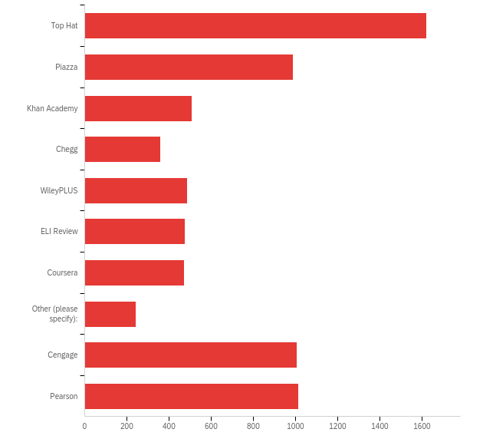

# | Answer | % | Count
1 | Top Hat | 22.62% | 1620
2 | Piazza | 13.81% | 989
3 | Khan Academy | 7.08% | 507
4 | Chegg | 4.98% | 357
5 | WileyPLUS | 6.80% | 487
6 | ELI Review | 6.62% | 474
7 | Coursera | 6.59% | 472
8 | Other (please specify): | 3.35% | 240
10 | Cengage | 14.02% | 1004
11 | Pearson | 14.14% | 1013
 | Total | 100% | 7163

Q19_8_TEXT - Other (please specify):
Other (please specify): - Text
Norton Textbooks
Acheive
PackBack
google scholar; chatgpt
udemy
TRU Way ASL, Labster.
Achieve
Dental school bootcamp
No
Non
None
Inquizative
web assign
????
Quimbee
Quizlet plus
Don't know yet
lingrolearning
None
Have not started classes yet but I am familiar with these sites
Quimbee
Codio
Udemy
Noodletools
Webassign
none
Nothing
NA
Norton InQuizitive
LinkedIn Learning, ESRI
kami
iClicker
Udemy
BrightSpace
Na
Quizlet
Blink Learning
MacMillan
Achieve
geeksforgeeks, leetcode
achieve, iclicker
Macmillan Achieve
Perusall
Achieve, Connect, iClicker
iClicker, Achieve
Amboss, bootcamp, scholarrx
Mc Graw Hill
none
achieve
Nature, Elsevier
InQuizitive
webassign
I think it was called McGraw Hill for Organic Chemistry
Zybooks
MacMillan Learning / Achieve
No
None
None
None
Udemy
Academia, ResearchGate, YouTube for software tutorials
mybusinesscourse
LexisNexis; WestLaw Academic
None
USMLErx
Kanopy, Cengage
lingrolearning
Elsa, Duolingo , canvas, Edpuzzle, etc.
Kritik, zotero
Nothing
None
none
does PubMed count
Uworld
Gartner
Kritik
Quizlet
None
Mylab
None
Webassign
Acheive, labflow
I do not understand this question.
Codio
N/A
Inquizitive (Norton)
youtube
N/A
connect
none
Quimbee
youtube/tiktok
Codio, gradescope
Achieve
LingroLearning
Udemy
Mcgraw Hill Connect
Not sure if this counts, but I sign up for research resources via the library (i.e., Wall Street Journal, HathiTrust).
StockTrak
Connect
Inquisitive
Achieve and labflow
Quizlet
labflow, achieve
Achieve
Zybook
none
Codio
Codecademy (C++, SQL) - simple and free
Harvard Course Pack
BlinkLearning, Webwork
The Organic Chemistry Tutor on YouTube
Achieve
N/A
None
mybusinesscourse
None
NA
amboss, uworld
Perusall
Inquisitive
Udemy, LinkedIn learning
none
Wolter Klutz
Leetcode
MacMillan and labflow
Geeksforgeeks, leetcode
NA
Gartner
Achieve
N/A
Codio
None
DAT Bootcamp
Labflow
Macmillan (for chem)
Achieve, LabFlow
Evolve elsevier, Master clinician, Simucase
Perusall
iClicker
InQuizitive
labflow
None of the above
Quimbee
Achieve, Labflow
Kritik
N/a
Grammerly
Kritik
Noodle Tools citation
Codio
None
Norton/Inquizitive
none
Quizlet
NA
sciencedirect
MentiMeter
None
none
lingro learning
Macmillanlearning
ATI
None as of now
None of these
Quimbee
NA
Codio
WebWork
EDX
not signed up
To be honest You tube has almost every content to study. I use Youtube thr most
tryexponent
Codio
Achieve
UWorld
EndNote
Labflow
Law School: Casebook Connnect, West Academic E books
bookshare
Udemy
Macmillan
Achieve
Mcgraw hill
GitHub
None of these
Achieve
Kritik
Achieve
Codio
McGraw Connect
Udemy, Leetcode
iClicker
GradeScope
perusall
None
Macmillan and IClicker
Achieve
None of them
YouTube is the real MVP
LabFlow, InQuisitive
Perusall
None
N.A.
Maximillian
none
Sketchy, Bootcamp med,
Data Camp, EdX
Codio
None
Achieve, Inquizitive
None
none
Udemy
iClicker
Achieve
Connect
Exam soft
West Academic
Udemy
ResearchGate
None
N/a
None
GradeScope
None: I don't know we could have access to some with our UB profile
Examplify
Quimbee
none
None
Norton
None
W. W. Norton
Macmillan

Q27 - For the Fall 2023 semester, which of the following brands of eTextbooks have you had to purchase? (Select all that apply.)
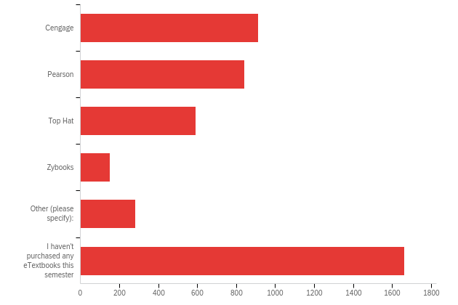

# | Answer | % | Count
1 | Cengage | 20.55% | 912
2 | Pearson | 18.95% | 841
3 | Top Hat | 13.34% | 592
4 | Zybooks | 3.40% | 151
5 | Other (please specify): | 6.31% | 280
6 | I haven't purchased any eTextbooks this semester | 37.46% | 1663
 | Total | 100% | 4439

Q20_5_TEXT - Other (please specify):
Other (please specify): - Text
VHL Learning
lippincott
ati
Macmillan
Don't know the brands
Mcgraw hill
VIews
I use lexis digital learning textbooks and casebook connect
a professors specific workbook that they wrote
redshelf, macmillian
Achieve
Achieve
Flatworld
Vitalsource Bookshelf
Jones and Bartlett
Jider Shop
True Way
West Academic
ByteWire
Redshelf
Amazon
there was a link, dont remember from what
lingrolearning
Have not started classes yet but I am familiar with these sites
Achieve
West Academic
Bookshelf
amazon kindle cloud
Webassign
Norton
Ati
Eli review and connect
mcgraw hill
achieve and norton (eco182 and soc101)
lippincott
WW Norton
MyBusiness Course
Blink Learning
Kindle
achieve
Elsevier ebook
chegg
Achieve
Achieve
Macmillan
Achieve
Achieve
MacMillan
Psychology 101 book
McGraw
Norton publishers, Kindle
webassign
I haven't purchased any eTextbooks but have free access to the ones needed for my major through the UB Library and Access Pharmacy
MacMillan Learning / Achieve
Genuinely no idea. I got it off the kindle store
Macmillian
Webassign
Macmillon
achieve
Brytespace
Norton books
Acheive
brytewave
Connect
Writing for health sciences for Bonk. Google e-book.
I did have to buy an E-book from Springer for research purposes
Amazon kindle app
None
WileyPLUS
redshelf
Norton field guide
macmillian
norton review
VitalSource
McGraw Hill
Macmillan achieve
Elsevier, Wolters-Kluwer
Achieve
the library
Norton
WileyPlus
MacMillan
Mcgraw Hill
Achieve
Norton
vital souce
Macmillan, wiley
I had to puchase a few books, but I do not understand the termonology mention above.
Mcgrill
MacMillan Achieve
I finished my major in 3 years and am currently taking pathway/internship courses
Inquizitive norton
wwnorton
MyBusinessCourse
Lippincott
Connect for Anatomy
connect
Norton
McGraw Hill Connect
CasebookConnect
Eli review
acheive
Achieve
Perusall
LingroLearning (Contraseña)
Amazon
mybusiness course, AIS on textbook media
Flatworlds
Flatworlds
Mcgraw Hill Connect
I don't remember
Tornasol
Harvard
BlinkLearning
WWNorton
Achieve
Archive
Achieve
Macmillan
Wiley
MacMillan/Achieve and Norton
Everyones and author and 2 other e textbooks
McGraw Hill, myBusinessCourse, Harvard Business School
MacMillan Learning (Achieve)
McGraw Hill
McGraw Hill
Professor Made Textbooks
McGraw Hill
macmillian
I have found a few free e-versions of required textbooks.
Mybusinesscourse
Klett World Languages
WileyPLUS
I'll be a textbook purchasing fool, come the Winter Term.
Barnes and Noble ebook
Norton: Views
MacMillan
Norton Online
McGraw Hill, mybusinesscourse
McGraw Hill
Wiley
harvard business
Achive Chem E-book
BVT Publishing
Norton
Wolter; ATI
Views
Macmillan
McGraw Hill
Inquizitave
PayPal a professor for his ebook
Redshelf
Connect
Inquisitive
Aspen, west academic
Hayden-McNeil
Achieve
Views 3e
Achieve macmillan etexbook for chemistry
iClicker
W.W Norton & Company
Access Pharmacy
Arihant
Gordis epidemiology
VHL, Acheive
eli review
Achieve
norton , bookshelf
norton
Eli Review, Nortan, Achieve
MacMillan
In oerson
Vital Source and Red Shelf
Norton
Achieve
O’Reilly, Packt
McGrawHill
Achieve
Access Pharmacy
wileyplus
Views
perusall
mcgraw hill, lingro learning
macmillan
McGraw Hill Connect
Achieve
Coursepoint
Norton views
labflow and Achieve
McGraw Hill
amazon
W.W. Norton
Norton
inquizitive and bookshelf
Achieve
Redshelf
Macmillian
I don't know
I was unable to buy any e text books because those are expensive. I used to buy used hard copies.
McMillan
nortron
Macmillan
Macmillan unfortunately
Macmillan
macmillan
Perusall
Aspen Casebook, West Academic
McGrawHill
Macmillian
Achieve
McMillan Learning: Achieve Course
Vital Source
Labflow
n/a
Macmillian
Achieve 😔
Achieve
Macmillan
Kindle
Views
McGraw Connect
Amazon/Kindle
Macmillan
BIO 200 MANUAL
McGraw Hill
Macmillan
Achieve
Amazon
Achieve
Amazon
Amazon Kindle / UB Bookstore
none
Lippincott
Mybusinesscourse
Macmillan
macmillian
Achieve Macmillan
MacMillan
McGrawhill
McGraw Hill Connect
Achieve
Achieve / macmillian
Archieve
Achieve
WestAcademic (Law School)
Norton, wiley plus
Achieve
Amazon, UB Library
W.W. Norton Company
Please discontinue Cengage. Openstax's content is of higher quality, and it's free as well, allowing students of all financial backgrounds to learn.
McGraw Hill connect
Views for English class on a site that I don't remember the name of.
mybusinesscourse
Norton
Vitalsource
Foundation Press
Mcgraw hill
Wiley, Hayden McNeil
Macmillan
redshelf
Rented through Amazon, not sure of brand
McGraw Hill Connect
Wiley
Flatworld and Norton
Kindle
Spanish supersite
My course doesn't require any text books. All the material is provided to us.
Intro to stat and prob
Macmillan
Macmillan
Barnes & Noble
W. W Norton, MacMillan, Labflow
Achieve
macmillan
Macmillan

Q28 - How did you find out about UB collaboration tools and free software, such as Microsoft Office? (Select all that apply.)
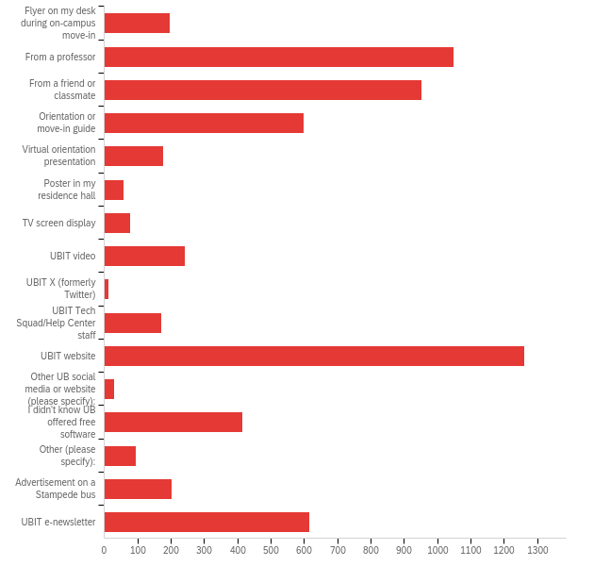

# | Answer | % | Count
1 | Flyer on my desk during on-campus move-in | 3.21% | 198
2 | From a professor | 17.02% | 1048
3 | From a friend or classmate | 15.47% | 953
4 | Orientation or move-in guide | 9.73% | 599
5 | Virtual orientation presentation | 2.86% | 176
6 | Poster in my residence hall | 0.94% | 58
7 | TV screen display | 1.28% | 79
8 | UBIT video | 3.91% | 241
9 | UBIT X (formerly Twitter) | 0.21% | 13
10 | UBIT Tech Squad/Help Center staff | 2.79% | 172
11 | UBIT website | 20.47% | 1261
12 | Other UB social media or website (please specify): | 0.50% | 31
13 | I didn't know UB offered free software | 6.74% | 415
14 | Other (please specify): | 1.56% | 96
15 | Advertisement on a Stampede bus | 3.28% | 202
16 | UBIT e-newsletter | 10.02% | 617
 | Total | 100% | 6159

Q21_12_TEXT - Other UB social media or website (please specify):
Other UB social media or website (please specify): - Text
Twitter
Based on my experiences at other campuses.
UB reddit
had to sort this out myself
insta
had to use it for homework
Instagram
UB Spectrum
Web search
ub accounts like ubstudentlife or the official ub account
emails sent to students
Msw students face book
Emails from UB
instagram
MYUB free website page
I found it out by myself.
UBIT website
It just worked
I have known about it
UB website
Instagram
Instagram pages of UB Student Ambassadors

Q21_14_TEXT - Other (please specify):
Other (please specify): - Text
Searched it up.
I assumed it would be available
By just clicking around and exploring
All universities offer this
google search
i guessed
I assumed UB offered free software.
I assumed
Mostly by myself except ubbox which was during orientation
Posters around campus (not in residence hall)
I am also an adjunct instructor.
All my classes posted word docs and my computer took them in and asked me to sign in and I tried my UB login and it worked
Google search
Searched for them (went to Buff State for undergrad)
I received an email about the free software through Outlook email.
Evolutionary Biology TA in my lab
already assumed UB had this
From previous colleges
They were just downloaded on my computer so I used them. And I had to use them for school anways.
ArcGIS from the Library
My mother, who works in UBIT
Professor freshman year
I guessed?
I bought Microsoft Office before coming to UB and learned that it was free to UB students.
My RA!!!!!!
Assumption
I assumed they would
I am aware that all universities offer free software.
Just figured
I just stumbled upon it
I researched on my own
I'm a grad student. My undergrad school had discount/free programs so I assumed UB would, too
google
out of necessity
I was previously aware about Microsoft student accounts and just tried to sign in and it worked?
Family
I Googled "Free software UB" my first week.
I knew about schools offering Microsoft office for free when I was in undergrad at a different institution
I guess I'd say I learned about it 2 ways: they automatically pop up when I sign in to email etc. And from other students: when other students share a document with me on OneDrive, I see it is automatically saved to my OneDrive (which I previously didnt know existed)
standard issue software.
Just assumed that UB offered the service. It would be baffling if UB didn't offer them.
Campus Tour
Knew universities typically offered this
What, precisely, is UBIT X?
Every institute has this
I figured my UB Email would work with Microsoft for logging into a Microsoft account for MS Office.
I just had it automatically on my computer
I google searched it
Signing up for them and realizing they were free lol
Myself
Laptop Loan Login
From the Social Work department
Most colleges have them so I assumed UB did too
My Dad
from undergrad
Figured it out myself
I assumed the university might offer it for free and googled it
Googling and working as UBIT Staff
I usually use G-suite
I was already familiar with Office 365, and assumed that Buffalo offered it for free.
I looked it up myself
Had it at my undergraduate institution so I figured UB had to have it
I just expected software from the start
I don't remember. Website surfing, maybe?
I Googled it
my previous college had them so I assumed UB had them as well
I don't remember. Generally clicking around websites?
I signed in to word with my UB credentials and it worked
myself
The accessibility office
From a senior
Just by using and exploring
My Older Brother
Looked it up myself
Looked it up myself
Co-worker
I was curious if UB offered it and looked it up online myself.
Working for Res Life
From my seniors
I signed up for Microsoft office applications with my UB email and found out about the free software
i sort of just learned of it from exploring my email and then going through all the things that came with it.
Browsing the UB website
Assumption
I just googled it, duh?
I looked it up
I already knew from my undergrad studies at UB
I looked it up
Browsing the UB Website
Discovered by myself
Someone told me
I don't remember.

Q29 - How well does the technology in UB classrooms assist in your learning?
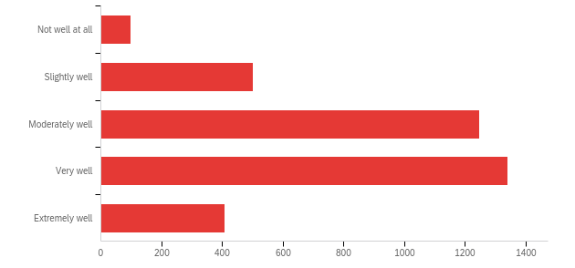

# | Field | Minimum | Maximum | Mean | Std Deviation | Variance | Count
1 | How well does the technology in UB classrooms assist in your learning? | 1.00 | 5.00 | 3.41 | 0.95 | 0.91 | 3593

# | Answer | % | Count
1 | Not well at all | 2.73% | 98
2 | Slightly well | 13.92% | 500
3 | Moderately well | 34.71% | 1247
4 | Very well | 37.29% | 1340
5 | Extremely well | 11.36% | 408
 | Total | 100% | 3593

Q30 - What technology improvement would you most like to see in UB classrooms?
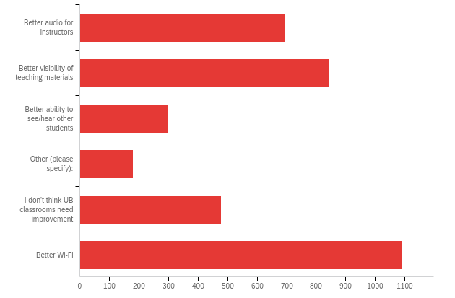

# | Field | Minimum | Maximum | Mean | Std Deviation | Variance | Count
1 | What technology improvement would you most like to see in UB classrooms? - Selected Choice | 1.00 | 6.00 | 3.60 | 1.99 | 3.97 | 3588

# | Answer | % | Count
1 | Better audio for instructors | 19.43% | 697
2 | Better visibility of teaching materials | 23.55% | 845
3 | Better ability to see/hear other students | 8.31% | 298
4 | Other (please specify): | 4.99% | 179
5 | I don't think UB classrooms need improvement | 13.35% | 479
6 | Better Wi-Fi | 30.38% | 1090
 | Total | 100% | 3588

Q23_4_TEXT - Other (please specify):
Other (please specify): - Text
More user friendly, use of back buttons, no excessive clicking to find your documents
better access to smartboards
Classrooms not in central scheduling are usually pretty outdated like those in Fronczak
Smart Whiteboard
More detailed instructions after applying those new technologies. Some professors struggle with those.
More consistent and staff accessible video recording
no log in for aobe suite evrytime i log in / faster computers, current desktops in computer lab are hella slow and i didnt pay 16k for such PCs
Too many of the same assignments can be linked in different places on Bright space
I am an online student. In class lectures, I always had a hard time hearing and following instructors.
Some classrooms don't have power outlets near the student desks. In bigger classrooms there should be a system to hear other students answer better.
free textbooks
better visibility/audio when they record for zoom/panopto
Teaching software that requires no payment on the student’s behalf
Consistent recording of lectures. Frequently lectures are not recorded when they are supposed to be at the medical school
record the lessons to review for later classes
Better homework reminders
Make instructors louder
I would say all of the above + helping professors transfer material easily from Blackboard
more electrical outlet at computer stations for other devices and a second PC or Laptop
Better connectivity of laptop to screen in some classrooms
Not Applicable
All of the above
A poster for quick operation of the devices if they are unfamiliar to you.
I have virtual classes
Outlets in more classrooms, like those in O’Brien
Make sure the clocks are set right. Also having enough batteries/ charging for the microphones
Get rid of brightspace. It is awful, impossible to stay organized, and grading.communication systems often disappear or are impossible to track. Professors all use it differently and poorly as well.
remote online student, haven't used classrooms at all
better,wifi because it lags sometimes, better visibility for course work add screen in lecture hall, better audio for student when ansring question, teahch professor how to use the tech in classroom
UB's own software for taking notes
The projector sometimes are out of focus making it hard to see for people who wear glasses
Availability of plug in outlets for each student so they can charge and use their laptop or electronic device
Doesn't apply to me
Newer technology to bolster the use of learning materials.
Use of more blind-friendly technology
Stop using Zoom as it has horrible privacy standards
The microphones don't work
More audio-book options, I would love if Brightspace had an option to read passages that are uploaded by the professor
Better accessibility features (subtitles for videos, zoom features, etc)
Affordability. Remove any programs that charge.
All of the above
I am not in classrooms
I’m off campus
An interactive polling system that is free for students and instructors
If we can make it mandatory to record almost every class. That would be great. And to make sure people attend, they can put attendance policies. Also, we need to hear other students questions
Could use all of these improvements to be honest
Outlets
NA
ability to use the microphones in the classrooms
Recordings
Better accessibility/availability of working outlets in classrooms
Better captioning on classroom recordings
Lecture recordings made accessible to everyone
battery packs for professors often run out of batteries mid class - if they don't change them then the recording of class has no audio
More outlets in lectures; none of my classes have accessible outlets
Fine turning of Panopto cameras to show the screen or presenter rather than moving around to follow any movement during the lecture
Wireless microphone coupled with area mics
All of the above
N/A
I attend fully online so don’t attend classrooms physically.
Better Accustic. Because od hard srface the signals resounds. In big theratrical halls signl dampers are needed.
Ability to zoom on the boards, when the professor is writing on them
Professors that teach in big lecture halls need equipment that can be heard by all students but also that allow students to give feedback. Desks with microphones or something for effective teaching
Please go back to UB Blackboard, UB Brightspace is a nightmare to navigate as a student and as a TA (I'm sure as a professor also).
The student microphones in our lecture halls at the school of medicine don’t work!
Recording capability and quality in all classes
Better way to record the lectures, there some student like me who wants to go home and reflect on what they learnt in a difficult class like Calculus. My professor goes so fast that we barely can keep up with the materials, we cant even jot the whole question down, i wish the lectures where recorded, it doesnt do antthing but helps the students in my perspective .
Better Wi-Fi, better audio, and a chat box on the side of some lecture halls so if the professor doesn’t see the student with their hand up they can ask it there
I want recordings for all m lectures in all classes
more outlets, better wifi
More charging desks on south campus
subscriptions to Datacamp or Coursera
Better document sharing/ notetaking apps
This is a small, weird thing, but the cords which attach a personal device to the projector are often inconveniently short. Everything else works great.
The actual facility
I’d like more legroom between seats. Some lecture halls have seats that can’t open without hitting the other person’s legs.
Probably just teaching professors how to use the projectors. They always have some issue with them. Maybe they need to be more uniform?
For baldy to have a little more room in the smaller classes
Updating more classrooms to be technologically advanced as NSC.
More outlets for charging devices
N/A online student
Room on desks for tech
online student
I am a virtual student and do not visit campus
All 3 options above
have technology used more
Not paying that much for TopHat
None of my professors have podiums. They cannot see the smartboards that slides are on. It causes constant disruptions to the class. If you give an instructor a smart board give them a podium so they can see whats going on. They constantly turn their back to the class and say "wheres my cursor i cant see anything."
I think a lot of classrooms need more outlets so that students can charge their devices during class.
Better projector
Make recording the lectures normal
Warmer climate control especially is NSC
Recorded lectures that I could back to
smaller class sizes in rooms or larger classrooms, dry erase markers
Instructors able to be listened to, via headphones, and on-screen (with and without closed captions.
More outlets for students to use during class for laptops/devices, especially in the smaller classrooms where the only outlets are located in the front of the room or away from the seating.
need more wall outlets
For some (not all) classrooms, better ability to charge a device. While I don't have a laptop, if my phone needs to be charged, it's difficult in some classes to find an outlet for it. I also used to have a laptop that I used at the beginning of the semester, but it suddenly broke without me doing anything to it and I don't know why. When my laptop was working, however, it was difficult in some classrooms to find an outlet if it wasn't a lecture hall with an outlet built into the table/desk.
More power outlets!
Easier connections/accessibility
More/larger chalk boards and whiteboards
Good classrooms
1) Live Recording Setup for Online Classes.
Mostly everything is fine.
Better Wifi In certain classrooms(mostly large lecture halls in NSC)
Brightspace - download materials to iPad (Goodnotes) as we were able to do easily on blackboard
VR Headset classrooms
dual screens
Not every lecture hall has the mics at the student's desk
Update older equipment
Would prefer different homework/etextbook services for students
I am an online student
Making sure all the classes are recorded in real time & then uploaded.
Give adobe for free
UBIT PONAPTO VIDEO RECORDING FOR EVERY CLASS
Updating seating in some of the smaller classrooms.
I would like to be able to make Panopto content downloadable at least in order to review when not connected to internet
Ad-free Youtube (for professors)
Some of the desks dont have working electricity to charge devices (norton)
Would be better to know of all the UB tools and free softwares in advance.
Easier AV connection for the professor
GO BACK TO BLACKBOARD
Recordings for all classes regardless if attendance is required or not
Chairs
Flipped classroom learning
Better slides from the professors.
Hold classes in classrooms which have the ability to record lectures. Whats the point of us paying so much if we can't use a 100% of the facilities provided to us
The lighting in many rooms is tough on the eyes
some subtitles on projector
better chairs in lab rooms
better cameras that can capture writings on board
required recordings
option to record class lectures in all rooms , example Clemens all rooms.
Better microphones in recorded lectures.
Not use bright space
The projectors in my classes are undermaintained. I hope they can be regularly checked up and improved
Projectors in Hayes Hall are not bright or vibrant enough as they are on north campus
I mean better audio isn't needed, just making it easier for them to use it. Watching older professors struggle gets old real quick.
Option to connect earbuds to professors microphone for disability/accessable services
More interactive tools like kahoot etc
Glare on screens
Professors actively writing notes in class to be viewed on projectors. NOT reading from a PowerPoint.
More power outlets
Working microphones in lecture hall
Better captions
More charging port availability in desk style class rooms (not talking about lecture halls)
More decentralization
I want recordings of classes so that I can use it later for my studies
less students in class. So, that interaction with professors will be easy during class
Better and cleaner chairs.
More outlets for student laptops/devices - I have a hard time seeing the board and need my laptop but often do not have an outlet available
In class recording, access to materials written on the board during the lecture will be great
More charging outlets in class rooms when assigning classes of programming whuch definitely requires use of laptop.
Everyone using the same system
You desperately need to improve in all of these areas.
Recorded lectures in all rooms
Better projector connections in some classrooms
more emphasis on 3D physical examples.
networking changes so the classrooms are usable after a power outage.
Smart board so professors can work on the board and everyone can see their work on the projector
Better knowledge of how to use equipment
Better/Faster wifi, as well as ensuring outlets are working. Ratio of outlets to classroom size is at a deficit. Better seating would be awesome.
Not sure if this counts, but I'd like for more outlets in some classrooms, like in Cooke/Hochstetter.
All of the above suggestions
A lot of teachers just aren't good teachers sadly
need more chargin stations in class rooms
Recording of lecture and mics in all classrooms
More extensive application of tech resources by faculty
I don't believe any thing but the desks need to be improved
n/a I am in an online program
All of these; audio doesn’t work properly in half the classrooms in clemens
Apple pencil-like devices for instructors to write efficiently in real time on projected slides
Make programs more widely accessible on public computers (PSS, Rstudio, etc.)
we need more outlets in classrooms- we are all required to have computers but we often cant all plug them in
Better captions for videos.

Q31 - Regarding your answers to the previous question, please select the building where you would most like to see improvements in the classroom(s)?
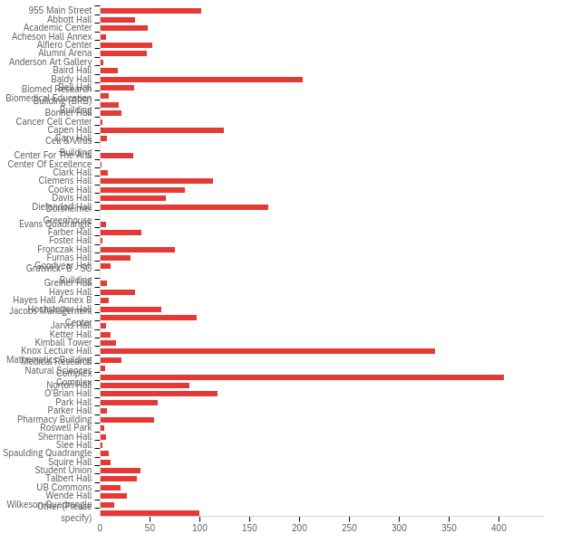

# | Field | Minimum | Maximum | Mean | Std Deviation | Variance | Count
1 | Regarding your answers to the previous question, please select the building where you would most like to see improvements in the classroom(s)? - Selected Choice | 4.00 | 63.00 | 34.36 | 16.62 | 276.27 | 2972

# | Answer | % | Count
4 | 955 Main Street | 3.40% | 101
5 | Abbott Hall | 1.18% | 35
6 | Academic Center | 1.62% | 48
7 | Acheson Hall Annex | 0.20% | 6
8 | Alfiero Center | 1.75% | 52
9 | Alumni Arena | 1.58% | 47
10 | Anderson Art Gallery | 0.10% | 3
11 | Baird Hall | 0.61% | 18
12 | Baldy Hall | 6.83% | 203
13 | Bell Hall | 1.14% | 34
14 | Biomed Research Building (BRB) | 0.30% | 9
15 | Biomedical Education Building | 0.64% | 19
16 | Bonner Hall | 0.71% | 21
17 | Cancer Cell Center | 0.07% | 2
18 | Capen Hall | 4.17% | 124
19 | Cary Hall | 0.24% | 7
20 | Cell & Virus Building | 0.00% | 0
21 | Center For The Arts | 1.11% | 33
22 | Center Of Excellence | 0.03% | 1
23 | Clark Hall | 0.27% | 8
24 | Clemens Hall | 3.80% | 113
25 | Cooke Hall | 2.86% | 85
26 | Davis Hall | 2.22% | 66
27 | Diefendorf Hall | 5.69% | 169
28 | Dorsheimer Greenhouse | 0.00% | 0
29 | Evans Quadrangle | 0.20% | 6
30 | Farber Hall | 1.38% | 41
31 | Foster Hall | 0.07% | 2
32 | Fronczak Hall | 2.52% | 75
33 | Furnas Hall | 1.01% | 30
34 | Goodyear Hall | 0.34% | 10
35 | Gratwick- B - SC Building | 0.00% | 0
36 | Greiner Hall | 0.24% | 7
37 | Hayes Hall | 1.18% | 35
38 | Hayes Hall Annex B | 0.30% | 9
39 | Hochstetter Hall | 2.05% | 61
40 | Jacobs Management Center | 3.26% | 97
41 | Jarvis Hall | 0.20% | 6
42 | Ketter Hall | 0.34% | 10
43 | Kimball Tower | 0.54% | 16
44 | Knox Lecture Hall | 11.31% | 336
45 | Mathematics Building | 0.71% | 21
46 | Medical Research Complex | 0.17% | 5
47 | Natural Sciences Complex | 13.63% | 405
48 | Norton Hall | 3.03% | 90
49 | O'Brian Hall | 3.97% | 118
50 | Park Hall | 1.95% | 58
51 | Parker Hall | 0.24% | 7
52 | Pharmacy Building | 1.82% | 54
53 | Roswell Park | 0.13% | 4
54 | Sherman Hall | 0.20% | 6
55 | Slee Hall | 0.07% | 2
56 | Spaulding Quadrangle | 0.30% | 9
57 | Squire Hall | 0.34% | 10
58 | Student Union | 1.35% | 40
59 | Talbert Hall | 1.24% | 37
60 | UB Commons | 0.67% | 20
61 | Wende Hall | 0.91% | 27
62 | Wilkeson Quadrangle | 0.47% | 14
63 | Other (Please specify) | 3.36% | 100
 | Total | 100% | 2972

Q31_63_TEXT - Other (Please specify)
Other (Please specify) - Text

Q32 - In which of the following computer-related areas do you feel confident in your abilities? (Select all that apply.)
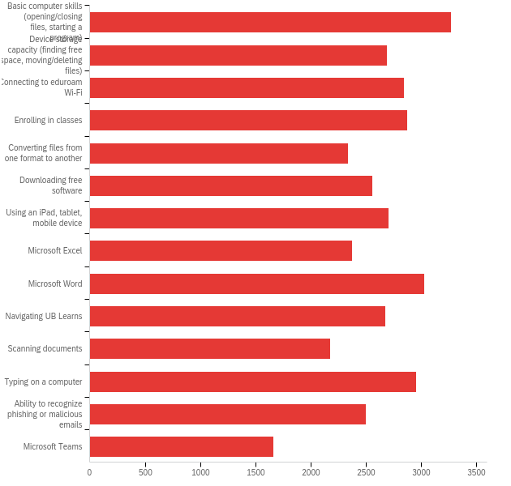

# | Answer | % | Count
1 | Basic computer skills (opening/closing files, starting a program) | 8.92% | 3275
2 | Device storage capacity (finding free space, moving/deleting files) | 7.35% | 2696
3 | Connecting to eduroam Wi-Fi | 7.77% | 2850
4 | Enrolling in classes | 7.83% | 2875
5 | Converting files from one format to another | 6.38% | 2341
6 | Downloading free software | 6.98% | 2561
7 | Using an iPad, tablet, mobile device | 7.38% | 2707
8 | Microsoft Excel | 6.48% | 2378
9 | Microsoft Word | 8.26% | 3030
10 | Navigating UB Learns | 7.31% | 2683
11 | Scanning documents | 5.94% | 2180
12 | Typing on a computer | 8.05% | 2956
13 | Ability to recognize phishing or malicious emails | 6.81% | 2500
14 | Microsoft Teams | 4.54% | 1668
 | Total | 100% | 36700

Q33 - What social media platforms do you utilize most frequently? (Select all that apply.)
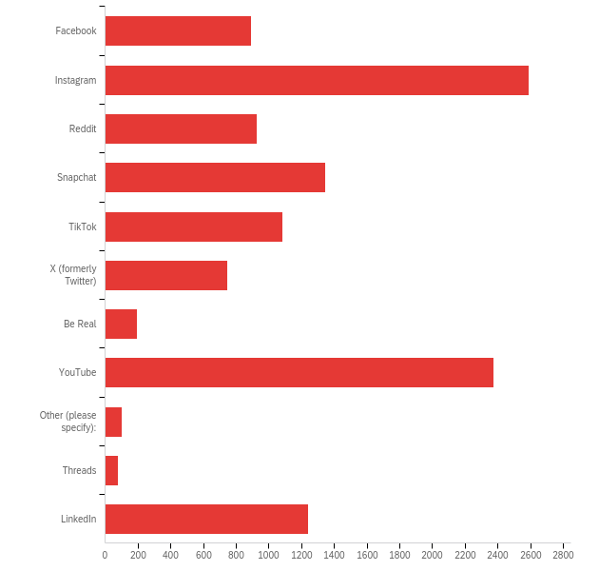

# | Answer | % | Count
1 | Facebook | 7.68% | 890
2 | Instagram | 22.36% | 2590
3 | Reddit | 8.02% | 929
4 | Snapchat | 11.60% | 1344
5 | TikTok | 9.37% | 1086
6 | X (formerly Twitter) | 6.47% | 749
7 | Be Real | 1.69% | 196
8 | YouTube | 20.52% | 2377
9 | Other (please specify): | 0.86% | 100
10 | Threads | 0.69% | 80
11 | LinkedIn | 10.74% | 1244
 | Total | 100% | 11585

Q26_9_TEXT - Other (please specify):
Other (please specify): - Text
Discord
I don't use social media
Kakao talk
no
Imgur
Wechat
none
I am chronically online so I have every popular app
I don't use social media
Discord
i don't use social media.
Rumble, and Telegram
discord
Discord
bilibili
Discord
tumblr
Handshake
tik tok
discord
WhatsApp
wechat
Bluesky
Pinterest
Stop calling X "(Formerly Twitter)" please it only keeps it relevant and it shouldn't be
Discord
Discord
WhatsApp
None
None
Pixiv, furaffinity, deviant art
Whatsapp
Mastodon
discord
WeChat
None
n/a
Discord
tumblr
I do not use them
WhatsApp
pinterest
Telegram
N/A
Post
Tumblr (yes, in 2023)
Don't use social media much. Use YouTube just for music to help sleep at night.
I don't use social media
UB could utilize more video editors. Once a video is on youtube in runs 24/7. Valuable for recruitment. Hiring outside video editors with a business development professional would result in an astronomical ROI for the university. YouTube gets BILLIONS of users every day. The 2nd largest search engine behind Google
Discord, and Patreon.
Twitch, Discord
WeChat
Whatsapp
RED(小红书) and DouYin(抖音)
Whatsapp
Discord
Goodreads
Discord
Tumblr
discord
WeChat
Wechat
Discord
discord
Bluesky
Discord
Discord
Strava
Netflix
Discord
discord
Discord
Discord
I do not use social media due to New York's policy of using it to infringe upon civil rights
Discord
Discord
wechat
Discord
Discord
Peach
Spotify
Discord
Discord
Whatsapp
pinterest
Discord
Handshake
Discord
Discord
Discord, Twitch
Discord
Discord
Bluesky, Discord, Steam
Discord
Discord
None
none

Q34 - What platforms do you rely on to get the following types of UB news and updates? (Select all that apply for each category.)
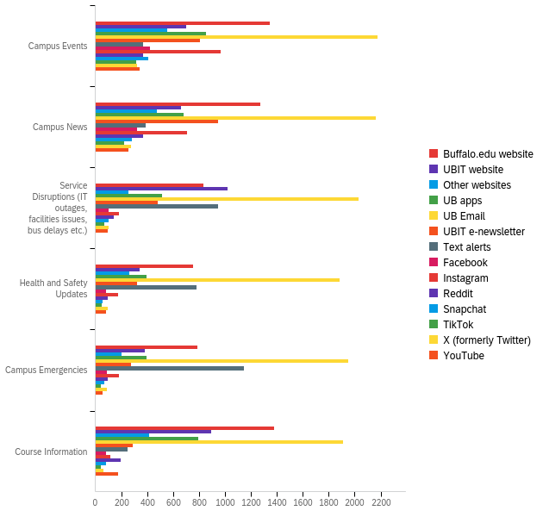

# | Question | Campus Events |  | Campus News |  | Service Disruptions (IT outages, facilities issues, bus delays etc.) |  | Health and Safety Updates |  | Campus Emergencies |  | Course Information |  | Total
1 | Buffalo.edu website | 21.12% | 1345 | 19.96% | 1271 | 13.05% | 831 | 11.87% | 756 | 12.33% | 785 | 21.68% | 1381 | 6369
2 | UBIT website | 17.51% | 702 | 16.49% | 661 | 25.52% | 1023 | 8.56% | 343 | 9.58% | 384 | 22.35% | 896 | 4009
3 | Other websites | 25.72% | 556 | 21.92% | 474 | 11.84% | 256 | 12.21% | 264 | 9.25% | 200 | 19.06% | 412 | 2162
4 | UB apps | 23.44% | 852 | 18.79% | 683 | 14.14% | 514 | 10.89% | 396 | 10.84% | 394 | 21.90% | 796 | 3635
5 | UB Email | 17.97% | 2177 | 17.86% | 2164 | 16.75% | 2030 | 15.52% | 1881 | 16.10% | 1951 | 15.79% | 1913 | 12116
6 | UBIT e-newsletter | 25.73% | 804 | 30.37% | 949 | 15.36% | 480 | 10.40% | 325 | 8.90% | 278 | 9.25% | 289 | 3125
7 | Text alerts | 9.47% | 368 | 10.06% | 391 | 24.38% | 947 | 20.18% | 784 | 29.58% | 1149 | 6.33% | 246 | 3885
8 | Facebook | 38.52% | 423 | 29.60% | 325 | 9.20% | 101 | 7.38% | 81 | 7.92% | 87 | 7.38% | 81 | 1098
9 | Instagram | 41.30% | 964 | 30.33% | 708 | 7.84% | 183 | 7.67% | 179 | 7.75% | 181 | 5.10% | 119 | 2334
10 | Reddit | 28.94% | 367 | 28.86% | 366 | 11.28% | 143 | 7.73% | 98 | 7.65% | 97 | 15.54% | 197 | 1268
11 | Snapchat | 40.54% | 407 | 28.39% | 285 | 10.16% | 102 | 5.78% | 58 | 7.17% | 72 | 7.97% | 80 | 1004
12 | TikTok | 42.19% | 316 | 29.37% | 220 | 9.61% | 72 | 6.94% | 52 | 5.87% | 44 | 6.01% | 45 | 749
13 | X (formerly Twitter) | 34.14% | 324 | 28.98% | 275 | 11.06% | 105 | 10.01% | 95 | 9.27% | 88 | 6.53% | 62 | 949
14 | YouTube | 33.90% | 339 | 25.50% | 255 | 9.70% | 97 | 8.00% | 80 | 5.40% | 54 | 17.50% | 175 | 1000

Q35 - What assistive technology do you use, if any? Assistive technology is technology that maintains or improves functional capabilities for people with disabilities. (Select all that apply.)
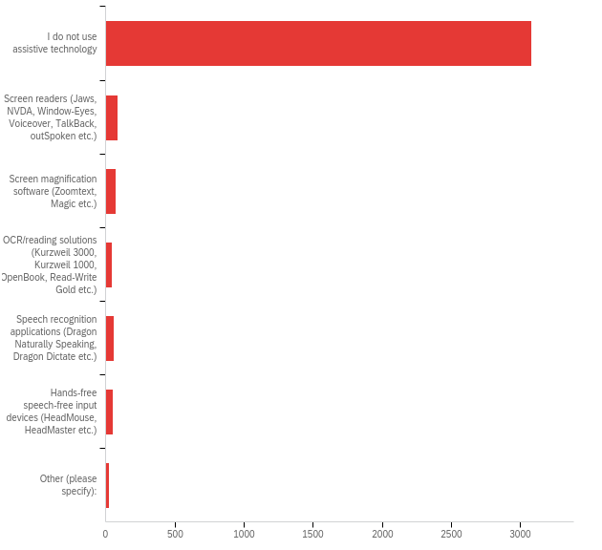

# | Answer | % | Count
1 | I do not use assistive technology | 90.19% | 3081
2 | Screen readers (Jaws, NVDA, Window-Eyes, Voiceover, TalkBack, outSpoken etc.) | 2.58% | 88
3 | Screen magnification software (Zoomtext, Magic etc.) | 2.05% | 70
4 | OCR/reading solutions (Kurzweil 3000, Kurzweil 1000, OpenBook, Read-Write Gold etc.) | 1.26% | 43
5 | Speech recognition applications (Dragon Naturally Speaking, Dragon Dictate etc.) | 1.70% | 58
6 | Hands-free speech-free input devices (HeadMouse, HeadMaster etc.) | 1.43% | 49
7 | Other (please specify): | 0.79% | 27
 | Total | 100% | 3416

Q28_7_TEXT - Other (please specify):
Other (please specify): - Text
Glean
Glean and Echo pen
Glean
Glean
reMarkable to convert my handwriting to text and to annotate PDFs
Glean an scribe pen
glean
Glean (note taking software)
live recording/playback linked to written/typed information/notes
Mostly captioned or hard of hearing/Deaf friendly programs and softwares
Glean Notetaking
read and write
Recorders
Glean
Equatio
multiple screens
I would use but they all are quite difficult
Read&write but it's not great.
word, read and write
Glean
Glean
Q37 - Have you experienced any other issues with assistive technology that was not covered? Please explain:

Have you experienced any other issues with assistive technology that was not covered? Please explain:
No
N/A
no
Nope
It is a note-taking software so none of these are really applicable
No
no
No
Nope
no
N/A
I would recode some of our loveliest UB sites and would do it for free in a heartbeat just to make them more accessible, and easier to follow through as lots of click-through links just begin in a new tab or part of the site and have loads of empty text.
No
Material needed to use the assistive technology such as PDFs and presentations not given or incorrectly posted prior to class.
no
no
No as of yet
The elevators in O'Brien are not ADA compliant wheelchair accessible. They are too narrow. I don't use the wheelchair tho.
No
no
No
Much of the assistive technology does not fully work (Read & Write) forcing reliance on web-based assistive tech (microsoft edge).
NO
No
N/A
No
NA
NA
some of my readings for class have needed effort to work
Could use a better TTS I find I am often doing a lot of work to convert text so that it can be read clearly.
No
No issues
nope
No
My course requirements for my JD never show up on UBHub when im selecting classes for the next semester
Na
I have not
No
Not much
Nope

Q38 - What technology information did you learn about before arriving on campus? (Select all that apply.)
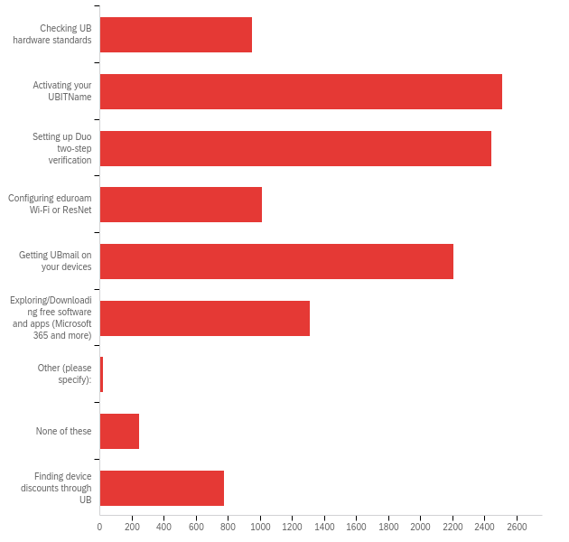

# | Answer | % | Count
1 | Checking UB hardware standards | 8.27% | 950
2 | Activating your UBITName | 21.87% | 2512
3 | Setting up Duo two-step verification | 21.30% | 2447
4 | Configuring eduroam Wi-Fi or ResNet | 8.81% | 1012
5 | Getting UBmail on your devices | 19.24% | 2210
6 | Exploring/Downloading free software and apps (Microsoft 365 and more) | 11.43% | 1313
7 | Other (please specify): | 0.19% | 22
8 | None of these | 2.16% | 248
10 | Finding device discounts through UB | 6.73% | 773
 | Total | 100% | 11487

Q31_7_TEXT - Other (please specify):
Other (please specify): - Text
I started undergrad in 2011 so I really don't remember
Off campus student
I have been attending before Duo
again, still haven't "arrived on campus" as a online student
Use of software and JAWS and Kertzweil 1000
PC/laptop only for UBmail
Access to UBUnix.
n/a
I am a virtual student only. I have not been to the campus
What does "arriving on campus" mean for Covid. I started at UB during Covid. Is this referring "arriving to campus" referring to the start of the semester or physically setting foot on campus.
Don't remember
Using UB learns and UB mobile
Making school ID photo
before this semester, I already knew about these services due to prior graduate semesters, and attending UB for undergrad

Q39 - What technology steps did you complete before arriving on campus? (Select all that apply.)
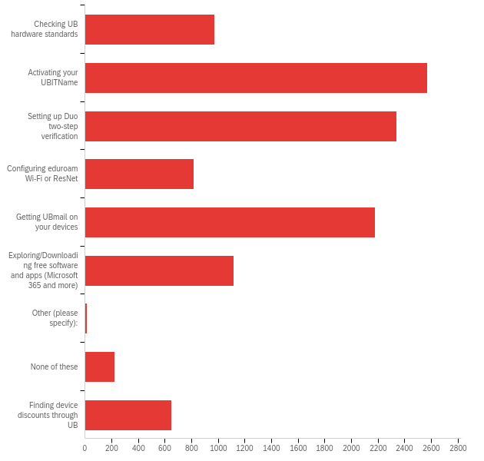

# | Answer | % | Count
1 | Checking UB hardware standards | 8.92% | 970
2 | Activating your UBITName | 23.65% | 2571
3 | Setting up Duo two-step verification | 21.50% | 2338
4 | Configuring eduroam Wi-Fi or ResNet | 7.49% | 814
5 | Getting UBmail on your devices | 20.02% | 2177
6 | Exploring/Downloading free software and apps (Microsoft 365 and more) | 10.26% | 1115
7 | Other (please specify): | 0.13% | 14
8 | None of these | 2.06% | 224
10 | Finding device discounts through UB | 5.97% | 649
 | Total | 100% | 10872

Q32_7_TEXT - Other (please specify):
Other (please specify): - Text
Same as previous response
I am not on campus.
Use of software and JAWS and Kertzweil 1000
PC/Laptop only for UBmail
I arrived in 2016 most of these things came online or changed significantly since
Na
n/a
Orientation.
Laptop loan
I don't live on campus
Setting up UB ID photo

Q40 - Where did you learn about UB technology information before arriving on campus? (Select all that apply.)
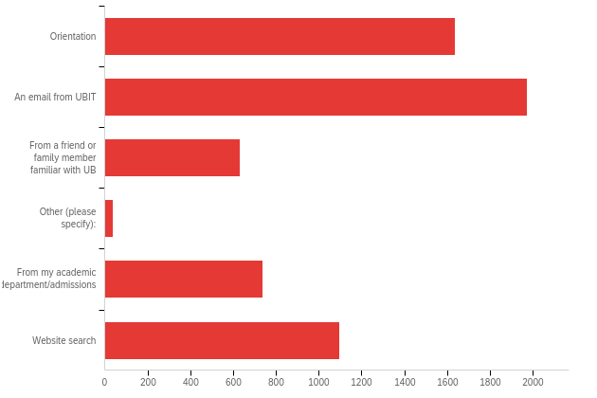

# | Answer | % | Count
1 | Orientation | 26.81% | 1637
2 | An email from UBIT | 32.31% | 1973
3 | From a friend or family member familiar with UB | 10.32% | 630
4 | Other (please specify): | 0.59% | 36
5 | From my academic department/admissions | 12.07% | 737
6 | Website search | 17.91% | 1094
 | Total | 100% | 6107

Q33_4_TEXT - Other (please specify):
Other (please specify): - Text
No one
Previous college
N/A didn’t hear a peep about this
I've been here a long time
none
I did not
I don't remember
Transferred from down south so I had duo installed automatically then a classmate on the first day helped
Walking around
Eop
EOP program
piece of paper
Covid year so we found everything out via UB Websites or through current UB students mainly RAs
EOP
n/a
your ..." So I followed those steps. I called the mail number for campus when I had a problem, asked to be connected to technical help, and the operator probably sent me to UBIT. rar, saying: "go here for more info on setting upi As I needed access to emails, etc
Generation Honors
None
3 Time Previous Student
SONIT dept
A phonecall to UBIT staff
I had to figure it out myself
Website when i was setting up Duo
Part of intro materials or something
Other students in my lab
Myself
I learnt it on my own
Previously from my undergrad at UB
Doing stuff as I was required or recommended during registration

Q41 - Are there any other technology services that you would like to see UB provide?

Are there any other technology services that you would like to see UB provide?
NO
no
Tiered technology fees. It seems that students in online graduate programs supplement services provided on campus to students. I'd love to see my print allotment as a tech fee rebate. More maker spaces available on campus.
Not at this time, microsoft suite is the most utilized on my laptop and covers my needs at this time
Technology that shows how many empty spaces are available in a parking lot. Trying to park at North campus is a most frustrating day ruiner
Yes. the device for AR and VR for the library.
My power point slides in bright space keeps jamming and unable to open up class weekly presentation! I need help w that
A specification of which virus blocker we can use.
wifi pls
I know my message will not be seen or bothered but with a small hope I'm trying all the problems I faced. 1. Transportation frequency during vacations. 2. And more part time options. I haven't been offered a part-time in my entire course work and it made me so difficult to handle my expenses as an international student. I don't have an SSN too.
I do use Adobe to edit, sign, and print PDFs. While I can use it to do these things in the free version, it does prompt constantly for a subscription and I will have to fight with it sometimes because it will mislead you into thinking you need the paid version. So possibly that.
Yes, I would appreciate UB providing laptops to international architecture students to work on in campus. I recently started getting problems with my laptop.
laptops
Widely used academic access, such as ieee, ACM
The Silverman pcs are terrible, only good services are the Macs and the monitors.
Better internet speed
add printers in kimball tower
PLEASE let us have access to classroom projectors and microphones. It’s extremely frustrating that we need a TA or a professor to allow us to use the projectors because they’re passcode protected. I don’t understand why students can’t access them. We shouldn’t have to book it or go through someone else to have access to this. We’re paying so much for it. It’s crazy.
Not really
No
Just better wifi
None that I can think of they have been nothing but amazing to me!!
na
I would like if ub would give students laptops to those who do not have one. Even if the pc is crappy.
Access to few more teaching websites like Udemy and others
faster computers top configuration laptops on loan for architecture students for rendering softwares printing and plotting from personal laptop, helping students set it up on their laptops
please include the Adobe software in the UBIT free software system, really need it!
Better services for conferences and recordings for exclusively online programs.
No
Not particularly
I think VR and microphones for students in large classrooms would be GREAT.
I would like a specific service focused on video games as it's now a very popular esport and is a great stress reliever for students.
No
I would like to see higher end public computers. I feel the ones now are not used because they lack in certain capabilities that most modern laptops offer.
:)
Pretty good I'd say. Haven't had much of a problem and when I did, tech support is pretty quick.
Just fix the Wi-Fi. Please.
More working public PC stations.
Plese remove TopHat from the UB curriculum. It always glitches and does not provide accurate grades especially with extra credit. Also, improve the Wi-Fi.
adobe apps like photoshop
No
Not that I can think of
N/A
I would like to see better utilization of bright space. It is a hell of a program and I feel that many classes are not using it to it's full potential. Or maybe move to a different program with better integrations with programs like Panopto, Cengage, or even Pearson. All I want is to be able to more easily access my school materials without having to find them like I've lost my wedding ring in the ocean.
Printing could be cheaper.
Adobe as a free program download, more free assistive program downloads without needing an accommodation memo, more interactive smart classrooms for humanities programs & not just STEM/engineering
Brightspace could be optimized to sort through documents faster, but I know it takes time to improve things like brightspace.
I would like to see ub provide access to gaming consoles such as the Xbox and PS4
more activity
Public printing access in all the libraries, more number of technology for rentals, better technology training for professors
n/a
In Furnas Hall the HDMI for Mac constantly did not work.
I am an online student. Some IT stuff I hardly use.
bus tracking app/shuttle bus
I don't even know which services to ask for.
An accurate and live tracking bus for the stampede and shuttle. An upgrade to the Navigate platform (the Mobile app often freezes) With the GET app (option to order ahead similar to the service offered during Covid hopefully better) There’s no need for people to stand on line to order especially in the atrium on Ellicott.
Nah, in my humble opinion everything is fine except for the wifi in large lecture halls. Top hat often doesn’t load questions fast enough for me to answer them, which affects my grade as I can’t submit answers late at all.
A quick computer repair or diagnostic center. I understand that liability for emanates to laptops attached from the moment one agrees to repair a laptop, but perhaps a center employee could determine whether or not they can fix it or if I have to take it elsewhere for repair.
Adobe Acrobat PDF creator/editor. Video editing software that is user-friendly and not too basic.
Virtual counselling sessions if possible for international students.
no
ADA-compliant sound-proof study booths. Not for me though, but I've seen them elsewhere and they work well.
More tech support dedicated to online graduate students/professors - my entire information science program is online and there have been many tech struggles that would require a dedicated resource.
More charging ports in some classrooms
More printers
N/A
A better way to find course descriptions to figure out what classes you want to take. Sometimes cource descriptions are missing when looking for courses to register for.
A different learning platform, and effective training for faculty and staff on how to present information on that platform.
Adobe Creative Cloud for personal computers
wireless charging stations
The infrastructure for the students using basic computing and necessary technological products is available at UB. As per my exploration on technology in UB. i haven't had a chance to experience various technological products that is available in UB for any student, which i feel is essential for any student to know before hand to have a various resource they can use it from UB. Providing Some flashcards showing the various Tech products/resources available for students to experience and utilize for their education or research. Providing a Workshop every month on the usage of each tech products, like the unknown features or better feature of those products in the session and creating better understanding on those products and as well creating awareness on ethical usage of the products in the student mindset. Increasing the available tech resources would be a suggestion as well. with respect to software apps, i understand the number of users utilizing the apps and benefiting out of it. but, for the improvement i would request to hold a feedback survey during each semester completion to get the feedback on the UB Apps. and coming up with the top priority change request raised by the students, faculty and researchers and updating the application with the support of interested and skilled student as a project work with a decent incentive and certification would create a healthy team effort to make the UB Apps and tech products better by the student community itself. Latest VR and 3D printing are very less in UB. i would suggest increasing those numbers
N/A
Cooke has rooms with TVs that share the screen of the computer station that the professors use. This is great, but some classes don't use computers to teach. My calculus classes in the natural sciences complex used the white board/chalk board to teach. If a camera could be pointed at these boards, a TV could then show what the camera is picking up and the people in the back of the lecture room could see what is happening on the board.
I think instructions in the rooms on how to use the technology would be great. I would also like to see more loan availability at 955 Main St (loaning chargers, VR equipment for virtual anatomy for example).
No
None that I can think of currently.
Better wifi access in basement classrooms, especially clemens
no
Maybe recordings of lectures in classrooms.
please fix the wifi it is so bad this year
I think it would be great if UB could provide ordering kiosks for some of the food on campus to reduce some of the lines for some of the places without the get app.
No
please give us free top hat, since we have professors who likes to use it sometimes.
FREE IPAD WOOHOO
1. More available workshops or training for basic literature tools like Endnote. 2. More discounts info for the laptop which students need. 3. More charging station in all the buildings.
Nah
N/A
If you started to provide access to adobe products that would be very beneficial to students who want to pursue more art focused endeavors.
More laptops for MS thesis and PhD students
Google Mail over Microsoft Outlook
No I think UB is doing a great job of showing and providing resources to students.
Rental Umbrellas maybe or purchasable rain coat temporary ones or recyclable ones
Improved wifi
Improvement in cybersecurity
documentation on how to connect devices in rentable rooms.
Not really, UB has a Lot of the technology needed for different majors
Updating existing computers in classrooms and public computers departmentally for departmental use.
Not at the moment.
To make photocopiers accessible by installing JAWS on them.
I would have said more access to free programs, although it seems I have been missing out and using a pirated version of 2007 Microsoft word for no reason.
n/a
No
None for now.
no
Adobe Acrobat please, please, please, please, please.
No! but also i dont know all of them so i dont know what exactly we do or dont have exactly.
more outlets needed in classrooms desperately! PARTICULARLY in diefendorf hall. Would also be nice to have a printer kiosk in BEB connected to Cary Hall
Just better/faster wifi
Not that I can think of.
Easier way to change name on ub email account to preferred name
No
Bluetooth device variety
High end laptops. Tuition is very expensive and yet we don't get a laptop when it is necessary for the majority of classes here for lots of different things- attendance, recorded lectures, discussions, assignments, and exams
Software subscriptions should be free of cost to use in classwork during the course of study instead of paying for each individual one.
The new pulse mobile app. It doesn't let me print any files from the app. I need to log into brightspace on safari and then I can print from safari.
No, I feel like UB is already more advanced than a lot of other academic environments that I have witnessed.
Student access to IMAP or POP for getting UB email on local email clients
I feel like in is well equipped with equipment
Nothing
please keep everything in good condition， like a technology group just for maintain the condition
I can’t think of any at the moment.
I really don't like when Tech says We don't help with that or I know, but I can't tell you. Then when you say let me speak to a manager they suddenly help you
VR technology to test out latest technologies and learn better
input the option to submit work using “Kami” in UBLearns. The most accessible way shows a button next to the attached pdf by the professor that says “Open in Kami”, which does exactly that, and allows editing in all forms (annotation, typing, hand writing, comments, etc). By doing this, it allows Kami to submit the assignment by clicking said button within kami, and it transfers the edited pdf back to UBLearns via pdf and link to see it in Kami. Overall this allows for a simple, easy way to open a pdf without needing to necessarily download it (but it is possible) or save a second, edited copy to them search for in our files and submit to UBLearns.
Not at this time.
Possibly general access to remote devices for all students that enable high computing power
One free software: Stata
maybe several wifi connections each providing stable connection
no
N/a
Provide internet hotspot dongles.
n/a
UB Box is often down for hours at a time. When completing research, we are only allowed to store our data and study trackers on Box. We are not allowed to back anything up on any other device. This often causes problems because we then need to run study visits with no study tracker to confirm what subject we are running and no where to back-up data. When I call UBIT, they tell me I need to wait and they cannot provide a time when Box will be running again.
Loan iPads
Better equipment at Clark Hall gym area.
n/a
Better wifi please
No
I would like UBIT to notify Principal Investigators when their recently graduated students' UBBox data is about to be erased (perhaps a one week notice). While it should be understood already that graduated students will lose their UBIT accounts, this notice may help prevent significant losses in research works or data that my lab has experienced in the past.
I feel that the semester laptop loan program could be improved. As I could see that the students with laptop were able to get additional laptop and the students without the laptop were not able to receive it.
Nope
Adobe Acrobat Pro Comsol
No
Free polling for students (no need to pay for a top hat subscription) dissertation data storage solutions
Not specific
n/a
No
no.
N/A
Streaming Services.
Professional Software Linceses like Snowflake, AWS, Hostinger etc.
I would love to see the capabilities of the virtual machine ramped up to where they provide satisfactory performance for more of the higher processing load onboard software. I would also like to see the ability to export work off of and datasets into the virtual machine more easily. Thank you for all the help you provide to the student body of the University. Without you guys we would be living in the analog age still and nobody has space for that many reel to reel supercomputers :)
Cheaper, but non-subscription based alternatives to software such as Adobe and Microsoft products, so that students could retain access after graduation.
none
Update the unlearns or bright space website so that I don’t have to refresh or close off a window multiple times to sign back in to the page.
Providing courses that could teach people the basics of Microsoft and so on for those that come to the university unsure how they work.
Faster wifi and better audio with regard to the classroom teaching stations
- Adobe Creative Cloud on all workstations, if not on personal devices. - Better accessibility of Outlook UBMail on third-party clients – I have never been able to make it work with Apple Mail.
Better wifi or monitor
no
No
Ub can provide cloud with more bandwith, usually it is slower than expected. Also UB has a lot of different websites which is difficult to track. Try to build a centralized system where all the information could be obtained. I would suggest a parking system should be made on digital app, I already tried to built the app, which helps users to get a parking in nearby houses if available, with minimal charges.
Nope, I'd say I'm content
A parking app with lot statuses
Better desktops at hayes Annex B
Free textbooks
no
Better audio quality for lecture halls in 955 Main Street
I genuinely think UB does a great job of making technology accessible to all students.
Absolutely. The WiFi needs a complete overhaul. I find it to be outrageously slow at times when it’s needed the most.
Please provide more WEPA printers in south campus, especially for Squire hall for dental students. Also a place to loan a laptop would be great in case if dental students laptop have issues right before exams or projects. Thank you!
No
Please have someone help professors teaching online to improve audio quality and caption accuracy.
no
More levelup PC’s
I think that more creative technology would be nice to see.
Animation services
No.
Better IT security to manage the excess cyber crime occurring from students with access to student emails and credentials, etc
courses that teach adobe softwares like photoshop
No
No
At present nothing.
Please put white boards in classes instead of chalk boards so teachers can write on what they project on the board.
We have loads of technology, now find ways to integrate usage for students with professors in an actually interactive and conducive to learning format, then applying the technologies to social aspects of students lives or encouraging it to be used in more group settings would be nice, as well as small groups.
No
MacBook
In real time availability and on-route shuttle buses, constant trackers that are resistible to failure and are literally consistent by the second, by the inch.
It would be very helpful and also super cool of you to install the Lumion program on all of the south campus computer labs, or at least let us download it at all (it's FREE).
Really nothing I can think of. Being an international student I have not seen so many services and facilities in another campuses where I have been. I am quite satisfied with each and every services UB is currently providing.
Update your computers in capen and abbott library, they are extremely old and it's ridiculous. I feel that you guys spend too much time shifting to apple, we need better windows computers.
Providing recorded lectures for every classroom and lecture
Windows Software & Parallels for Mac users. This way I can use PC programs that I'm required to use for engineering classes.
No
I'd like to see them update the capabilities of UBBox a lot. I'd like the ability as a co-owner of a folder I didn't create, to be able to move that folder around in any one of my personal directories without disturbing things for anyone else. Right now you can only do this if you're the owner. Also, I'd like to know how to request both unlimited space in Box, as well as backup physical hard drives for research purposes. Much appreciated.
Industry-oriented courses that are linked with MNC companies will be very useful for the students to learn what different things and can be applied when they go out to real world
Nothing
Not rn
No
More stanpede stops especially at student living places for eg Springville Ave
Charging stations ,
Loan Ipads n Surface tablets Loan macbooks Loan Monitors All for semester or an year
audiobook services
shared GPU services for remote ML model training
Use of VR for education purposes.
n/a
No
Free e-learning licenses
While in lecture, a lot of times a professor faces difficulties in accessing the horizontal text written on a vertical page in an article in a pdf. I would like to see it improved.
VR and more PC's in lvl up
A request page for software could be useful
No. Thank you for everything!
no
Let people who use androids access the wi-fi
Yes Coursera student memberships for continuous improvement.
More emphasis on implementing Virtual Reality.
Na
It’s already providing almost everything
No
organized reach and better notification management from partner companies
nope
Macs in Lockwood. The computers there are somewhat outdated and slow
Maybe more interactive services that let students anonymously participate in class (UB Health Promotions uses these in their events!) but also technology directories on campus that serve as almost a GPS for newer students/ visitors to know where they are
None that I can think of
no
N/a
no
WIFI keeps disconnecting even though eduroam software was downloaded
It would b great id UB could offer free Adobe softwares (Photoshop, Lightroom, etc) for students, since these softwares are widely used in both course study and research. Thank you.
WiFi on bus
No
N/A
Dimmable window opacity in the JSMBS for conference rooms where lectures are help as it allows to block out the people constantly walking by and distracting the class.
UB should make it easy for us to see if a parking lot has any parking space available before even getting in the parking lot and spending minutes looking for a parking lot. UB is pretty updated so I think they should have some weather-resistant screen that would tell us, the status is 50/50 or 49/50.
No
Better WiFi that doesn’t drop all the time
It would be nice if we could have access to usb ports in lecture halls, so we can charge our phones and other devices without need a power brick.
Prezi
I think it is already providing many better services when compared to others
None
VR
Ethernet everywhere. Oh my god the wifi is so bad. I mean, sometimes I can not watch videos even at 144p. You've heard of 2g, 3g, 4g, here we have 0.01g.
no
VR would be a very cool addition
Improving the WiFi
Yes, any coding platform for students that need not to be purchased, so that international student can easily avail that and submit their codes for assignments or practices.
I wish we were able to access UB’s programs and licenses like Adobe Creative Cloud on devices other than campus powered desktops in the CFA and Silverman. In times like the winter, it makes it super difficult to make it to campus to work on projects however that is the only way I can access creative cloud for my major.
I think what we have now is pretty good
Vr
Qualitative data analysis software (eg. NVivo)
No, we get everything what we need from UB
Vr
N/A
Ability to change dpi in game lounges and to see the refresh rate
No.
I would like to have access to google maps and google earth pro on UB computers. Specifically for the CSEE department I'd like to see HydroCAD, Trimble, and construction related softwares such as Primavera installed on computers in the Ketter 206 computer lab.
Sale of computer and gaming accessories
VR services
Mainly just the wifi in certain buildings such as greiner and knox
N/a
VR Gaming in LevelUp sounds amazing!
I get that it's probably prohibitively expensive, but free access to Adobe Acrobat (not DC) on personal devices would be a godsend.
I would appreciate more outlets and plugs around campus to charge devices (all the tables in the libraries for example), other than that the campus is pretty good
Please provide linkedin premium for UB Faculty and students.
Easy library rooms reserving app
EBT being taken in dining halls
NA
Photobooths for passport photos
No
Adobe software. Especially adobe acrobat.
No
I would like some newer games in the Gaming lounge as well as faster wifi in governor's hall
I would like to see UB provide Virtual Reality equipment, even if itis only for classes. It is an interesting tool that I am sure people would love to use.
No, there are too many apps already
Probably a chat and file distribution service for the students.
Cloud Storage: A secure and easily accessible cloud storage solution for data backup and sharing. Advanced Cybersecurity: Enhanced protection measures against online threats and data breaches.
A UBIT wiki/knowledge base.
Close captioning on Panopto— I’m hard of hearing so it takes a while for me to understand professors
Wifi, Reducing Technological Distractions in the Classroom
Access to more softwares needed for industry as a student member
n/a
A Microsoft office course or crash course for those of us who either are not familiar with Microsoft office or those who lost touch with it and it's updates!
Not really no. It is difficult to connect a VR headset to the wifi though (Oculus)
None besides Virtual Reality.
Better technology in the CFA, hard to present projects because the apple tvs do not connect to most students with pcs. Difficult with audio sometimes. Basement wifi is inadequate, can never complete assignments in the common study spaces there.
adobe cloud
Map of UB? First year students have trouble finding classes. So I think an app than can locate the student and assist them with directions on how to get to their classes would be really helpful.
no
Better more accessible access to programs. Using UB virtual lab (is that the correct name?), it was difficult to use, difficult to figure out how to save your work/access previous work. I ended up having to buy programs in order to complete my work.
Access to statistical softwares like SAS, Stata
n/a
Every one worked so hard to make campus better, appreciated!
UB Laptop Loan Program does not have enough laptops for students to borrow. The Program needs more laptops for loan, so there are enough laptops for students who need them.
I cant think of any at the moment
Subscription for high end softwares like Snowflake, AWS, Hostinger, etc.
VR gaming places to play VR games.
Can you increase the number of laptops/ ipads that can be rented? I know most of UB staff/ faculty/ offcies can rent a Microsoft Surface suddenly for events/ lectures. Why do you limit the number of devices that open for students to rent?
G suite
None
More docking stations! There are none - its very difficult to work. Abbott library is okay if you are reading a book. If you have to work on spreadsheets and documents you might have 9 programs open and need multiple monitors. Since this is how the working world operates I feel this should be the standard. I don't need a docking station everyday but when I need to post up and work its impossible to find space. I end up leaving campus to get work done. I want to stay on campus with students while I do school work - but I get pushed out by lack of docking stations and desk space. The current attitude is "Eh Ive got work to do today so I have to go home" instead of "I have work to do, its going to be great to enjoy all these resources around me at the university." Modern office layouts (outside of the university) are starting to look pretty cool! I would like to see Schools, Departments, Clubs, Organizations have A LOT more access to YouTube. Each department should have its own PROFFESSIONAL media content production team. Clubs will spend $100 on a pizza party, instead of hiring a video editor that will increase recruitment for years to come. A social media officer of an organization doesn't provide much value to an employer if their resume states they were just posting pictures to instagram for their club. If there are involved in the production process and can design and coordinate a production team, and document results, they will be 10x more attractive to an employer. Just having a title on your resume doesn't mean anything. The content should be funded and screened by the University for brand management. A good Key Performance Indicator for this could be the Pizza Production Ratio (PPR). Each organization should keep their PPR spending under 10%. For example, every $1 spent on Pizza, $10 should be spent on content production. $1 million in content production would probably generate 1,000 + hours of YouTube content for the university (that lives online forever!!). If the videos are geared toward international students that pay $10,000 per year in tuition, the program would break even if 100 additional students are enrolled in this scenario. With 1,000 hours of content on youtube I would guess over 10,000 applications per year could be derived from the funnel.
There are no other services.
Node graph visualization software
No
I think this survey did a great job of encapsulating all aspects of UB technology services!
Video Editing
Access/ support for digital text book and quality text to speech options
No
no
Apple Pencil and other technology rentals at south campus
VR Learning
Better ability for trans people to change their UBIT name and/or email
Internet discounts for those commuting... A wider variety of free software applications.
N/A
no
Yes. I would love to see UBIT conduct coding, developer, and "other" variety of classes. I would also greatly appreciate if personnel from UBIT could function as a Faculty Mentor, in situations where these Category In Humanity are "necessary and needed", by we students.
I would like if UB offered free cable for students or some streaming services like Netflix.
To be honest, the app printers were great, really was a life saver, I think an improvement that a lot of students would like was if we had more of them near the dorms, would really make those late-night essays easier.
No, thank you!
no :)
Currently nothing
better wifi!!!
N/A
A proper plagiarism tool for students will help. Most of the good plagiarism websites charge a lot of money.
More curved screens in silver man
Keep up the good work!
the touchless doors to open faster, but I still like them
Better tech support
More access to outlets in study areas would be great, sometimes in the library or One World it can be difficult to find a spot for a laptop charger.
I would like to see hardware security key support for mobile devices. For example, I'm able to use a YubiKey to log into UBIT on a computer when I do get access to a computer, but I can't use the NFC function of my YubiKey on my phone when logging into UBIT. This has required me to allow Duo push notifications, which is technically less secure.
Yes, it would be great to have reservation-based lounges in public areas in the academic spine with TVs and a couch and a door that can be sound yet see-through, just like study spaces in Silverman can be reserved and how they are somewhat soundproofed and see-through. This would be a great way for students to have a place to relax and socialize, especially for those who don't live in dorms, or apartments or for those who just down own TVs. It would also be a great place for students to meet up with friends, hook up their gaming console, watch movies with a large group of friends, or simply socialize. The location can even be one of the libraries, Lockwood would make the most sense since there is more space available or wherever the university decides to have them within the academic spine. Students would be able to plug and play their gaming system, computer, or desired streaming device via HDMI. All that would be needed is a TV, a couch for each room, and soundproof see-through rooms.
Wider range for wi-fi. There's no mobile data signal (Verizon) or wi-fi signal in the parking lots which could be a hazard in an emergency.
Professors often run out of battery on the mic during lecture recording. Sometimes recordings have missing audio because of that.
Why is everything on ten different websites and five different apps and I need to go through a maze of links and website that half the "how to" guides are already outdated for. It's a mess. Can we have just one website for everything. Navigate, myUB, HUB, why.
N/A
Not for me, as I am a remote student
Brightspace assistance
NA
Campus maps and parking information
None
Free adobe products
Please consider adding a scanner to 955 Main Street. Also I think a lot of students would benefit from having Adobe (just so we can convert different files to PDFs, merge PDFs etc).
More free software. SPSS and adobe suite pleeeaaase
No
I would like zoom options during class lecture time to be an option for students so they are able to attend class remotely (on zoom) instead of watching the recorded lecture later if they need to miss due to a sickness, etc. Having a zoom option does not promote students to not go to class it provides an alternate option to watch the lecture during the dedicated time and not feel overwhelmed with watching 4+ lectures everytime they are sick or cant make it to class.
Updates to the Pulse App! I love being able to check my grades and assignments, but it is not fully compatible with Brightspace
Nope
I borrowed a laotop once from silverman
More statistical programming and software program support. More computational resources would be helpful as well.
more wide monitor in library and any study buildings. Consider about block the sun light that straightly pour on the screens, this is really annoying
A uniformed platform instead of having many different websites for different course and to Complete different UB related tasks
Classrooms in Baird building are very outdated, not good screens, bad audio, adaptors not available, old technology. Printing for professors is also bad, too restricted.
FL Studio and Ableton
More computers with SOLIDWORKS downloaded on it
Classrooms should have multiple monitors around the room to see the professors screen from. It can be hard to see the screen in the front middle sometimes when your off to the side and/or in the back.
Nothing as of now. But, if possible it would be really great if UB could sponsor for some reimbursement for online courses or websites that have subscriptions like Leetcode, Algoexpert etc..
N/A
Mice and/or keyboard loans for those who prefer a mouse over a trackpad
VR headset for project
No
Better virtual machine support. UB could also outsource their VR machines from a company like NVIDIA. Also UB could then use these machines to also offer remote machine gaming, which could allow more students to access games on their personal computers rather than using the physical space and electronic equipment of a high powered PC.
None at the moment.
I think UB is using technology to a good extent and needs improvement in very few areas like providing microphones at every student desks, that will make professor and students listen to other students better and keep the class engaging, although good no of lecture halls already have them.
Laptop loan program would include more laptops.
No I am all set!
Not that I can think of
None that I am aware of
No
Ebooks that the lecturers/instructor uses in class or for course that could be available in the library website!
No, but please boost the WiFi signal in the basement (ground) of Sherman Hall. I cannot even load UB Learns in some rooms.
no
We need virtual reality labs for the engineering and applied sciences labs. It would be great to have virtual assisted field trips for the geology and environmental science department.
no
Computers in classrooms
wifi throughout the campus should be more reliable
More free software.
Have a site where technological aid and services or provided, or a forward-link that would take them there without having confusion or wasting time searching for it.
I would like to see this questionnaire remade with online students in mind. Not everyone attends a campus!
None !
maybe a technology that shows how many people are in a library?
no :)
Free portable charger
Access to Netflix would be nice.
Better monitors for the Level Up gaming center. The current monitors are 60 hertz so no matter how good the alienware computer's are... the games will always appear as 60 fps on the screen. It would also be great if there are digital art software and tools for students to use.
I just want better WIFI please
This semester I had to pay extra for the piazza software for my coursework as recommended by the professor. Hoping that UB can provide this software for free in future.
Nothing off the top of my head.
Adobe products
Expanded free/discounted access to subscription services like Codecademy, Brilliant, Coursera, etc. (if possible)
More desktops
I would like to see UB provide some video editing apps for students to use.
A Laptop to everyone/ Or Atleast a tablet to everyone.
Many of the computers in Level Up glitch due to the OS installed on them. I would like to see the OS on the computers updated please. Additionally, the LevelUp keyboard keys are mismatched a lot and the chairs are broken (missing parts, wont move up or down). And sometimes the computers display and error preventing us from logging on, claiming “No hard drive can be found”.
Free Laptop give away those who don't have any during Exam times
Access to music production/DJ'ing software such as Ableton, FL Studio, Serato Pro, Rekordbox, Vital Synth, etc. Also access to electronic music equipment such as speakers, DJ Controllers, Launchpad, MIDI controllers, etc.
no
please just improve the wifi.
none
no
Along with advancement in virtual reality, augmented reality can also be used for navigation.
just begging for better wifi
Give back the Lockwood computer spots. Everything in the Silverman library is a pain!
Yes. I think UB should provide access to plagiarism checkers or a software to check plagiarism. The websites available online are not full proof. So yes access to that. The print cash is not useful for everyone which should be converted to campus cash.
My department does not offer class recordings, it would be helpful to students, if class recordings are also provided.
Virtual machines for training models for Machine Learning
The bus scheduling/tracking on both the ubmobile app and the website sucks. The tracker doesn't track half of the buses, you've used different colors to map different routes — despite the fact that many buses overlap one another, and the app doesn't mark where UB bus stops are (there are only eight, between north and south campus, there's no excuse). For differentiating different overlapping routes, the different routes will probably need to be represented as running next to one another, kind of like the NYC or London subway maps. Finally, the website design of the "Buses and Shuttles" page is absolute garbage. You've got an "on this page" table of contents-type section that is not visually distinguished from the page's contents, which is incredibly confusing; you've foregrounded the bus tracking section, despite the fact that it's useless, and even if it weren't, its use cases aren't as wide as you'd think; I have to find a non-foregrounded link to get to the schedules (despite the fact that it's just a table); once I've clicked on the schedules link I'm not actually taken to the schedules, but to another page where I have to figure out which of a handful of other links will take me to the schedules. Absolute garbage ux design.
Faster loanable laptops
More charging stations on campus.
Connecting to Wifi. A holistic site to which suggests all the steps to complete before arriving on campus -- IT related
No,
I would like to see that more loan laptops are given out throughout the semester as they get taken up quite quickly and some who need to use those laptops for specific courses can't.
no
I would like the UB website to be a bit easier to understand and navigate
For printing, I think that since its not free printing after a certain amount they should increase the amount of money you get to print. On several semesters multiple professors have you print out their notes and you run out of money on your account. I don't think UB should advertise to new students free printing because it is not free printing. Maybe stations (Ipads built to a wall) where you can find information on UB directory and ask questions on technology like where are printers, how to find a class, what times student union food open and closes etc.
Photoshop
N/A
No
Please provide better adobe features
Big led screens, not just projectors and more technology
techlonogy funds that you apply for to get the tecnologies you need for completing college with the right resources
N/A
Free adobe suite, very useful for class and extracurricular activities
I don't know if there's one already, but a UBIT Instagram page that shares tips regularly for Excel, Word, and other apps/programs that students use. Could we also get a Pixton discount?
Nope. I think UB has its IT services well rounded from what I know for now.
I am generally satisfied; I would appreciate the inclusion of STATA in UB-supported software, but MATLAB is typically sufficient.
No, UB has pretty much everything I can think of in terms of technology and how up to date everything is.
Printers seem too complex to use!
Better virtual microscopy programs for pathology. ARC is terrible. I recommend looking into Biolucida.
Fix the outlets that are broken in Baldy
reference managers, classroom softwares like top hat
Provide laptops to the students in need
No
access to rent out chargers for iphones, tablets or different types of laptops for a day
More personal storage options for large datasets
No, I do not have any suggestions.
As a PhD student in engineering, it would be nice to have access to grammerly for my writing.
Personal cubicles with ultra wide monitors for private studying
Maybe some VR headsets
More information about how to use bright space
None
UB should support its own implementation of software similar to tophat. It's egregious that students are paying $25 each per semester to access a question-answer service. By putting the burden on the students, tophat has encouraged universities to ignore this issue, but it is in bad faith to do so.
Class Recording and AI assistant booths
Adobe free service - PDFs are often used in my program and cannot perform various functions without paying for an Adobe service. Would also like to see superior antivirus software offered by UB rather than generic Microsoft antivirus.
Cloud and Analytics and AI Softwares Guided Projects so that students can learn about the common skills required for the Job.
no
No
VR studio for gaming
no
Virtual Reality, Engineering specific softwares like SolidWorks, ANSYS Workbench, Primavera P6, Power BI Professional, Tableau Professional, Carrier HAP v5.1, etc.
Private testing areas with webcams on campus for online exams.
Hologram projector or generator would be a cool way to upgrade the technology at UB
No
Wifi working.
I think all classes should be recorded and posted for the students to review at later dates while studying
need access to research papers in a easier way
Expand subscriptions to services such as Fusin 360 or Blender for students that request for it and are outside of the relevant majors.
You are doing good!
Free HW Service accounts, shouldn't have to pay $100+ just to do my HW.
N/A
no
Different UBlearns platform - Brightspace is not good, and much worse than blackboard. The design might be a little more visually appealing, but the dropdown menus and click-throughs make it harder to access class resources. The extra clicks to access anything are compounded by the huge wait times - I just tried and it took 10 seconds to load the page and login, and between 5-10 seconds to load each further page, meaning it took over 30 seconds to access a single resource which is unacceptable for a website in 2023.
JetBrains IDE, SSH servers, VR technology
no, from my knowledge UB has provided with all the services students need in order to success.
Nothing really comes to mind at this moment.
I'm not sure if they exist, but it would be really interesting to be able to check out AAC tech devices for the speech and hearing students to learn how to navigate them before entering grad school/job field. These may include the Tobii Dynavox devices or other related technologies.
No.
Adobe
I’m really grateful they have provided everything I needed until now.
The technology services that UB provides are very comprehensive and allow for a more engaging learning experience. The Wi-Fi is intermittent and cuts out more often than should be understandable. Otherwise, I have no further issues with UB technology. I make use of UB Box primarily and it has been a fantastic tool to be used at my disposal. The same goes for Microsoft 365.
Apple TV/Google Chromecast connectivity
Free TopHat
n/a
A way to see all the websites and what they are used for in one area. (Dining, housing, academics, Microsoft 365, Navigate, UB Learns, etc.)
Undergraduate music recording studio
n/a
Email compatibility with third party clients (Thunderbird, K-9 Mail, FairMail, etc)
No
no
I think there are many students that cannot afford to buy a good laptop and are left out in the lottery provided by UB for laptop. If the administration can increase the number of laptops being given that would be a huge help for the students. Thank you!
More workable public PC's to use in libraries.
Not that I can think of right now
Nope
Better accessibility for things like Canva, it’s used for classes and clubs and would be useful to have full access to an app like Canva at the ready.
no
Ensuring professors uploads are accessible
Looking forward to set up free professional photoshoot set up and better career fair department wise
No
No
Free streaming services
Not at this time.
I would want to see a better campus navigating app for students.
N/A
Really just having a stronger more reliable wi-fi connection and better filters for spam emails
stackoverflow or Quora like q&a site just for UB to increase knowledge base of UB
Kurzweil for all students.
NA
Excel training classes for beginners
N/A
None
Adobe Acrobat
More instructional sessions for specialized softwares
Better WiFi and faster email
Currently, phone data can't be used in many classrooms and I would like that changed.
Some technology services similar to TOPHAT because I had to pay for TOPHAT several times.
More printing kiosks (1 per building such as if in Bonner Hall I have to walk to Knox Hall or Davis Hall), and more charging ports in desk style class rooms so that I can sit in the front still and charge my tablet when I have classes for 6 hours in a row without a break (specifically NSC and Talbert Hall this semester)
N/a
More electrical engineering software tools/ software licenses and proper download links such as psse, etap, homerpro etc
Better wifi, more items available for rent at capen (more calculators)
online tutoring services
HDMI cords
N/A
Classroom record please.
Renting headphones
Virtual Reality Experience Center
Better Wi-Fi that’s it
Better panopto compatability on mobile devices. Linked sources to available software accounts on hub
No
Free or discounted access to more streaming services like YouTube, HBO Max, Hulu, Disney+, etc. and also stronger Wifi in general.
Na
I think UB should offer rentable tvs
More access to learning platforms such as coursera, LinkedIn learning or data camp would be nice
N/a
I would like UB to make better Campus navigation app for students.
Abbot computers - can't login most of the time.
I face issues in listening to professors in some lecture halls like Fronczak Hall and O'Brian Hall. Improving the quality of audio in such Halls is the only technological update I could use.
A bigger level up cafe with more PCs.
No
adobe creative cloud
N/A
UB should consider offering high-end laptops equipped with advanced GPUs and superior graphics cards for loan. Such resources should be made available to students upon receiving approval from their professors. During my tenure as a Master's student specializing in Robotics and AI, I experienced firsthand the challenges of insufficient computing power. Core subjects such as Deep Learning, Reinforcement Learning, and Robotics demand intensive processing capabilities, which only high-end computers can provide. The current laptops from the library service fall short in meeting these requirements. I'm confident that many graduate students share this sentiment.
Being able to use adobe on your personal device
N/A
Bigger storage for one drive, better security from phishing and spam emails, better wifi coverage and speeds
Better specs laptops on semester loan.
Not applicable
Better navigation of available courses
The services like tophate, cengage, webassign should be free of charge or an alternative should be found.
UB should also provide MS project and designing softwares like Creo, fusion 360 and FEA software like ansys, hyper works so that students should also learn new technologies which are used in the companies now a days.
No
I think if we can get a subscription to either coursera or codecademy for as long as we are enrolled as a student at UB, that would be really helpful in students overall development as the courses provided by these websites will not only help us in understanding our course related concepts but they would be extremely helpful in developing professional skills and upskilling as well.
No
No UB has almost everything a student needs to loan
Teleportation
none
None
No
Easier way to reset UB Allscripts password and/or inclusion of UB Allscripts assistance phone number on Allscripts home page.
Not all vending machines on campus are accessible with the GET Mobile App. Even though a vending machine may have the GET code on it, the vending machine code does not show up in the app, such as in Clemens Hall.
More free or discounted software like Adobe Suite (beyond just student pricing).
More access to statistical software for free.
Adobe Creative Suite for personal computers
As an online student, I would really like to use VR and AR so I can acess things that are on campus that I don't have access to now.
ability to finance or add tech purchases to student account. If a computer dies mid semester, I can pay on it over time or with the next semester's funds but for first gen and socioeconomically marginalized, we often don't have money like that and the library loan runs out too fast.
VR
More straightforward process of getting electronic copies of papers though the Library
No, everything is great!
No
A quantum computing core would be good.
Allowing viewing panopto videos through mobile devices on the web.
No
More classrooms fitted with charging ports for computers and phones (e.g. the smaller rooms in NSC.
Free education workshops (especially for graduate students) that teach how to efficiently navigate apps we may need in the professional word. For example, how to create a budgeting sheet on excel.
None
Better wifi.
At this time I don't have any suggestion for that. Thank you.
Ipads to take notes would be great
NA
Provide more monitors in the libraries, not PCs but monitors. I think most of students own their own laptops on campus so we will like to go and work on an extra monitor instead of connecting to the libraries PC. Make sure the cables are long enough to connect the laptop sideways in the widescreen monitors. The ones installed have the cables too short. Add more technology to South campus. Hopefully, the library can be remodeled like Silverman and wide monitors stations can be added as well.
N/A
Grammarly premium is very much appreciated
No
More training for professors regarding technology so that there are no disruptions before or during class.
UB provides most of the services so no improvement required.
A separate app that is designed to view your grades for (quizzes, participation, midterms and finals and attendance) all at one place something like what I used to have in High School like pupilpath.
Free Adobe subscriptions for media studies students - ***accessible for your own personal computer**
More closed captioning on recorded lectures.
Adobe software, Quizlet, Notability/Goodnotes
I would be good if we have access to many of the most-demanded industry softwares like Electronic Design automation(EDA), SCADA and PLC.
fix the navigate with better accuracy
Alarm clocks
More engineering opportunities
LuB could create its own social media platform gathering different departments, UB students, alumni, staff and everyone under a single umbrella.
Laptop chargers to rent from the library
Auto install UB Box on all of the PC's. Right now you have to manually install the box client.
Students don't understand how amazing box drive is and I think there needs to be more advertising for it
None
N/A
N/A
GitHub Campus Program. Other SUNYs have it. Let's bring it to UB. https://education.github.com/schools
Not that I can think of at the moment!
Just for the love of all things good, get some laptops that weren't made before Y2K. Please, I'm begging you. I had to use a school-provided laptop for the EOP summer program and it was literally falling apart when they handed it to me.
LinkedIn Premium subscription for UB students would be a great help.
No
No
Adobe reader, Software for Industrial engineering
nope
Maybe better WiFi at times
Teach the professors how to use the equipment in the lecture/class rooms
Make moreUBIT tech squad stations
Adobe and Photoshop for free
None
No.
Device repair services, for example monitor/keyboard fixing.
Na
More laptop loaning options at the libraries
No
No
N/A
n/a
Free access to learning platforms like Coursera or Udemy would be a great help.
I am grateful for the support provided but it would be great if to have the applications setup better to have a better interface and UX
Not really.
Laptop cleaning tools
SAS SOFTWARE
no
I think UB have enough techno location services. If they can add more in Lockwood thats will be better.
Maybe bring back the streaming services? Like how we had HBO
N/A
Virtual reality
Better speakers for the professors. Faster wi-fi. More spots around campus for UBIT help.
Nothing
no
As fas as i know all the requirements that are needed for computer science students are fulfilled so i would ask of nothing as for now.
Personal tech repair, 3D printing access, more and less centralized printing stations in south campus buildings
ipads and Macs in libraries
None that I can think of.
no
HDMI cables in all rooms with monitors so we are able to fully utilize the technology
NA
Engineering software such as solidworks, FEA software, and CFD software
Grammarly Premium Quilbot
improved wifi, some sort of exchange/resale program where students can sell gently used items and were students can purchase these used items (such as cameras, laptops, lenses, other equipment) at a discounted cost. Students benefit by some extra cash, as well as getting equipment at a lower rate
VR for class work sounds very beneficial!
No
Better and more consistent WiFi
n/a
Just better wifi
Not at this time.
Vr
better wifi
no
free streaming services
NA
no
Coursera Premium Please
No
no
Brightspace is terrible and the auto-generated captions on Panopto videos are useless.

