Question 2: Where do you live?

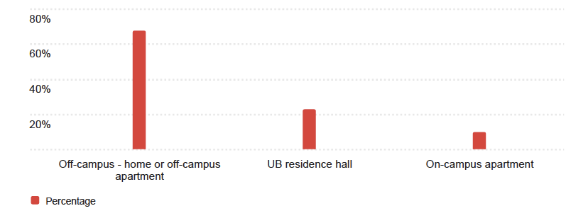

Question 3: In which UB College or School are you enrolled? – Selected Choice
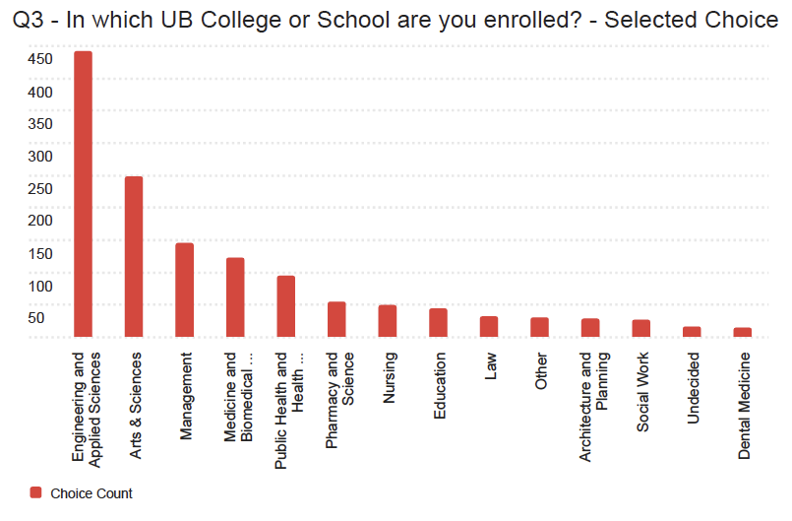

Question 4 – In which department / major are you enrolled? – Selected Choice
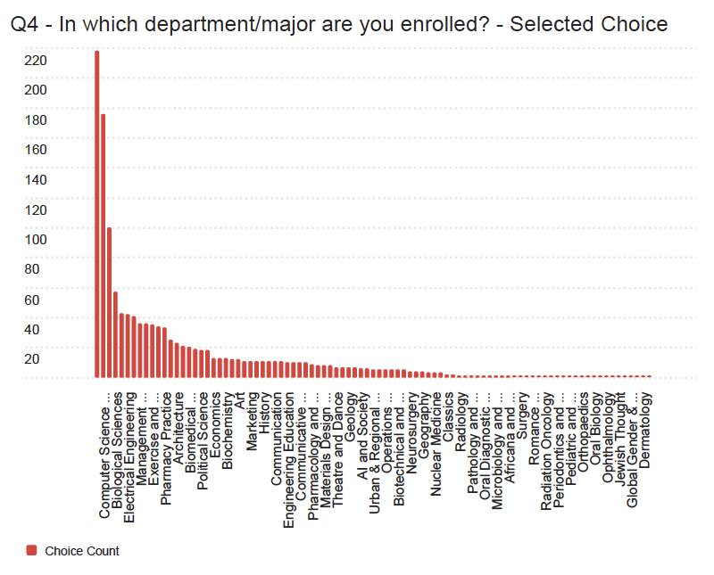

Question 5: Do you use a laptop and / or tablet / iPad? (Select all that apply) – Selected Choice
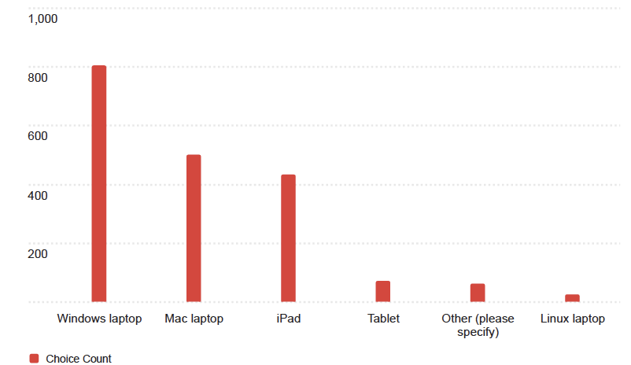

Queston 5_8_TEXT – Other (please specify) – Text
- chromebook
- Chromebook
- ub library computers
- Lenovo Laptop
- Hp laptop
- iPhone
- Chromebook
- apple laptop
- Windows desktop
- Windows PC, iPhone
- Chromebook
- Chromebook
- iPhone
- Dell laptop
- Chromebook
- Windows PC
- Lenovo laptop
- chromebook
- Android phone

Question 6: How old is your laptop and / or tablet / iPad? (Select all that apply)
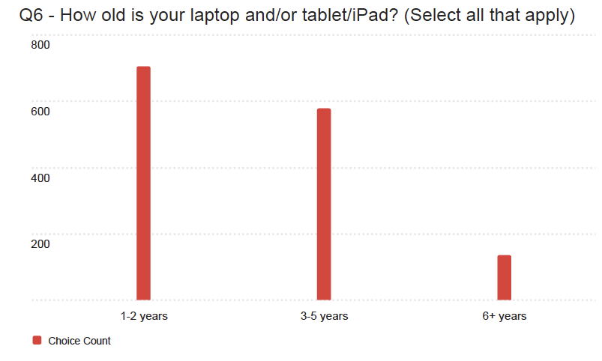

Question 7: Is your laptop / tablet / iPad working well enough to meet the needs of your coursework at UB?
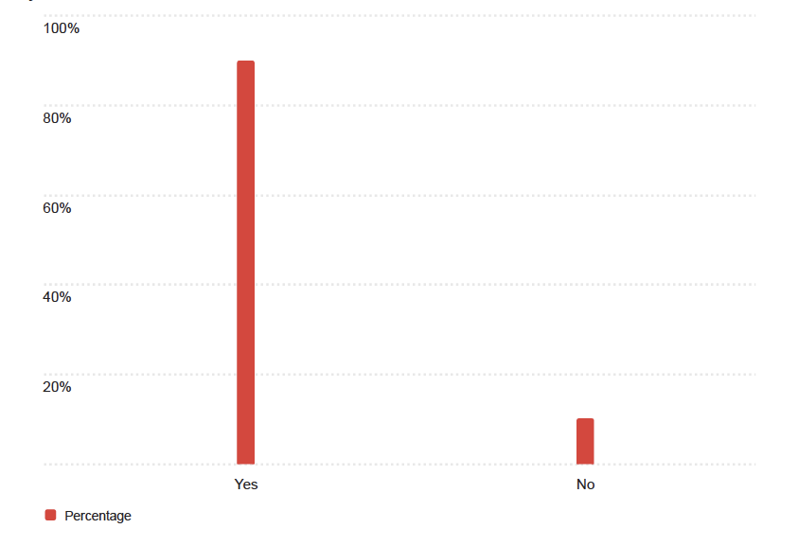

Question 8: Most UB students use a personal laptop / tablet for their coursework. What is the reason you haven’t purchased one? – Selected Choice
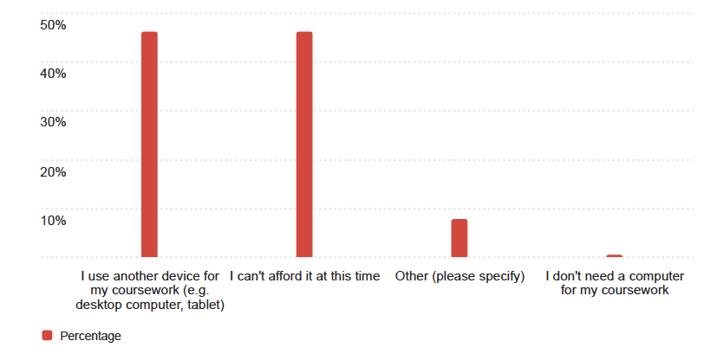

Q8_4_TEXT – Other (please specify) – Text
- I have my personal laptop just for my courseworks.

Question 9 – What other devices do you own? (Select all that apply.) – Selected Choice
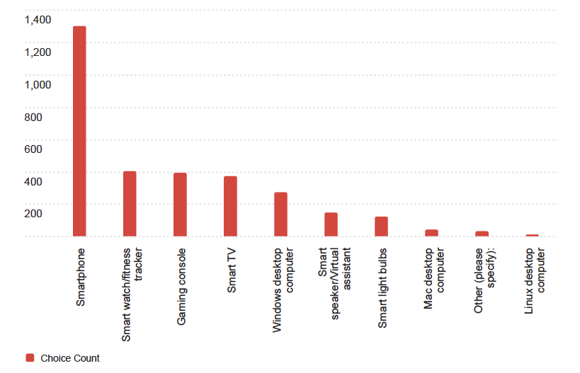

Q9_7_TEXT – Other (please specify): - Text
- ipad
- ipad 10
- Ipad
- phone
- Another Mac laptop for work
- None
- Nonr
- nonwr
- iPad
- Library Desktop
- ipad
- Meta Quest 2
- kindle
- windows laptop
- Samsung tablet
- Monitor
- WiFi based alarm clock
- Beelink media computer, NAS
- TV, not smart
- projector

Question 10 – From the list of technology services below, please indicate your level of satisfaction
Field | I didn’t know about this (N/A) | I don’t use this (but I am aware of it) | Dissatisfied | Neutral | Satisfied
HUB Student Center | 1 | 222 | 58 | 323 | 851
MyUB | 4 | 18 | 44 | 324 | 853
Navigate app | 93 | 168 | 125 | 417 | 442
Panopto (class recording) | 268 | 182 | 61 | 281 | 455
Public workstations | 243 | 358 | 50 | 250 | 344
Public workstations (accessible) | 278 | 390 | 32 | 225 | 318
Top Hat | 325 | 179 | 91 | 252 | 403
UB Print Anywhere (kiosks) | 43 | 132 | 73 | 232 | 768
UBbox | 119 | 153 | 49 | 294 | 637
UB Learns | 2 | 7 | 111 | 281 | 851
UB Mobile app | 94 | 191 | 196 | 294 | 474
UBIT Help Center/Tech Squad | 44 | 376 | 33 | 302 | 492
UBIT website | 32 | 199 | 56 | 360 | 602
UBmail | 6 | 21 | 42 | 241 | 936
UBITName Manager | 260 | 223 | 36 | 290 | 421
Wi-Fi (eduroam) | 20 | 37 | 399 | 350 | 446
Silverman Library equipment loans | 242 | 497 | 23 | 145 | 340
Silverman Library recording studios | 308 | 576 | 9 | 140 | 216
Zoom | 14 | 151 | 37 | 365 | 682
MS OneDrive | 157 | 253 | 59 | 273 | 503

Question 11 – If you use clicker response technology in your classes, which tool(s) are you currently using? (Select all that apply.) – Selected Choice
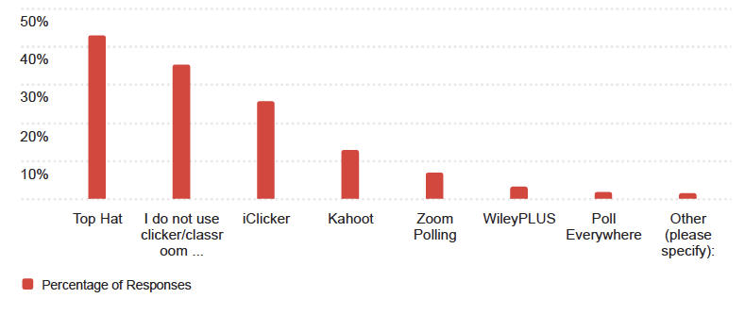

Q11_8_TEXT – Other (please specify): - Text
- Menti
- Learning Catalytics
- we dont
- I’m not quite sure what a clicker response is.
- ZyBooks
- Remote student
- menti, slido
- Have not started classes yet, will be utilizing all virtual programs
- Slido
- Slido
- WebAssign (paid by student)
- Menti
- genio
- Menti
- WebAssign
- Menti
- UbLearns assessments

Question 12: Have you set your security questions and registered your cell or non-UB email to reset your UBITName password 24/7 using the UBITName Manager?
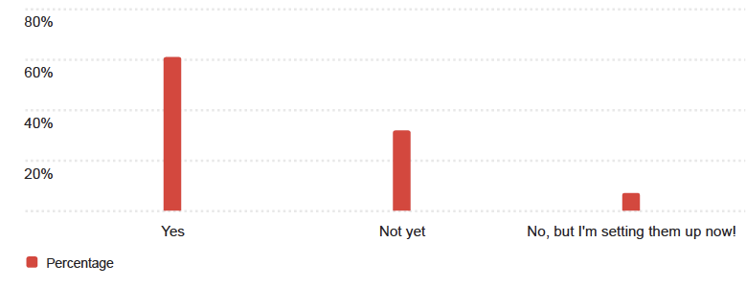

Question 13 – Have you struggled with a slow or disconnected Wi-Fi connection on UB’s campus during the past year?
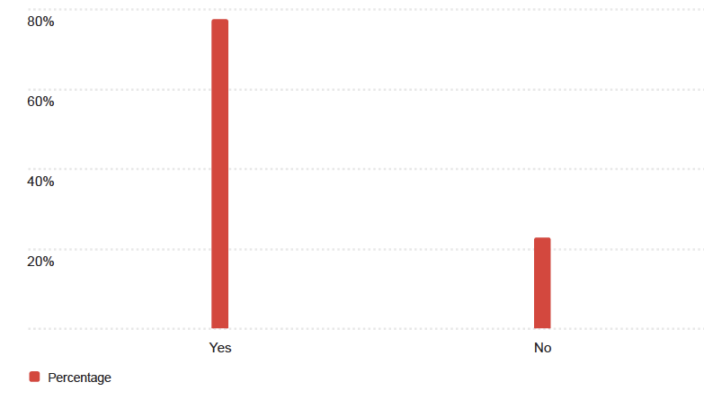

Question 13-a – How did you report your Wi-Fi problem? Selected Choice
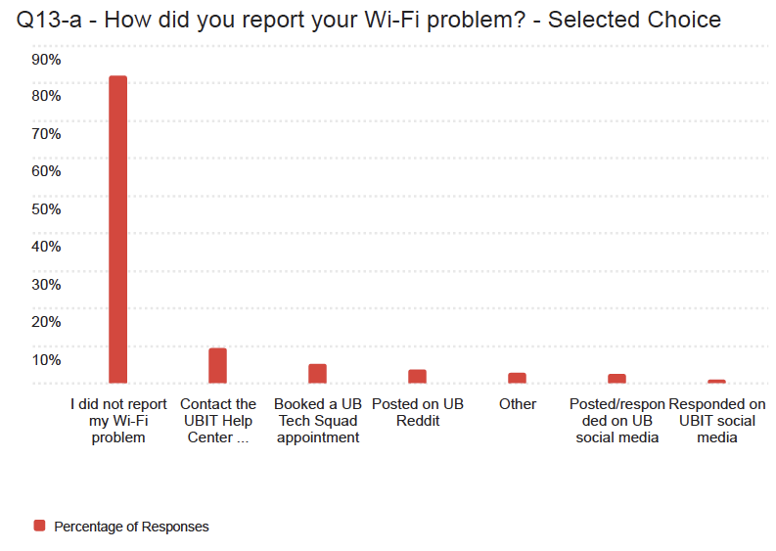

Q13-a_1_TEXT – Contact the UBIT Help Center (How did you contact the Help Center?) – Text
- Got me connected
- in person, then email, it was a while before the issue was fixed (weeks)
- email
- Online
- UBIT
- Silverman
- I did not, ut I should have
- Go to their office at Silverman Library
- the website, I think, it may not have worked bc I didn’t have wifi
- Went to the desk in Silverman
- Email
- yes I did they didn’t help
- I called them
- Via email
- Help ticket
- Submitted a ticket via the TD Client
- create tickets
- Went to silverman
- Walked to their desk
- Call

Q13-a_6_TEXT – Other – Text
- IT help desk in Silverman
- AWS outage so I didn’t report
- spoke with others experiencing similar issues
- I informed at the front desk at Abbott
- my friend works fixing the wifi in buildings so i told him
- I took a survey and told them the problem.
- Email
- Submitted online ticket
- Just waited it out
- reset UB eduroam (over and over x 10000)
- Tell my friends and ask them if they were having a problem too
- Didnt
- I solved it myself
- Sent an email
- It is not my device but rather where i am
- By the time I had noticed an email had already been sent saying that UBIT was working on it
- Used trouble shoot option on the UB website based on the free public WiFi
- Told admin
- Reported to School IT
- It got rectified and connected within minutes

Question 13-b – Why didn’t you report your Wi-Fi problem? – Selected Choice
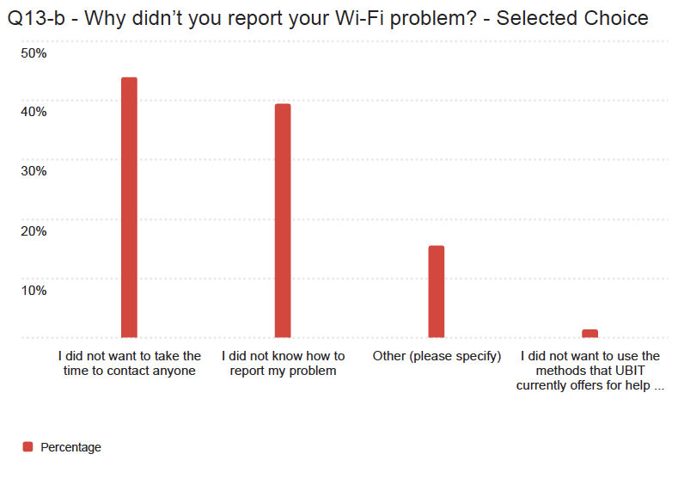

Q13-b_4_TEXT – Other (please specify) – Text
- It was a campus wide problem, or a building specific problem.
- I would have to redownload edurome
- Everyone struggles with the same issues no matter the location on campus
- Typically fixed within the hour
- It just goes occasionally, so I wait for a while
- Lazy
- It happens sometimes when I’m in my dorm in which it would disconnect and for maybe a minute but then reconnect after.
- I didn’t think it could be fixed I just thought it was slow because of all the people who go to school at UB.
- I didn’t want to bother
- My friend contacted them
- Resolved issue myself.
- not sure if it is just my personal laptop or what
- Was temporary, doesn’t happen that much
- Was only for a couple minutes and was able to resolve it
- Already fixed or was notified
- It just wasn’t connecting… I didn’t think that was a big enough problem to report
- The network outage was for a short moment
- the wifi problems are not serious and last a few minutes before working
- Self-fixed or waited
- I figured it was a general outage, not pertaining to my device

Question 14 – Where specifically on campus – such as outdoor green spaces or hallways – would stronger Wi-Fi make the biggest difference for you?
- Hallways
- hallway and between different buildings
- Outdoor spaces, commons
- Basement
- In hallways and libraries; in other words, typical studying spaces
- Student Union
- outdoors
- n/a
- Jacobs School of Medicine study rooms
- Parking lots
- Outdoors while moving block to block. There is no wifi signal to connect.
- in Cooke and Hotchstetter
- Mary Talbert Way (the side of the parking lots)
- Dorms
- not sure
- ‘The outdoor spaces and parking lots
- In the hallways and SU dining areas
- dorm rooms and lower floors academic buildings
- Hallways
- Yes. Especially if I’m a zoom class

Question 15 – Do you use My Virtual Public Site? – Selected Choice
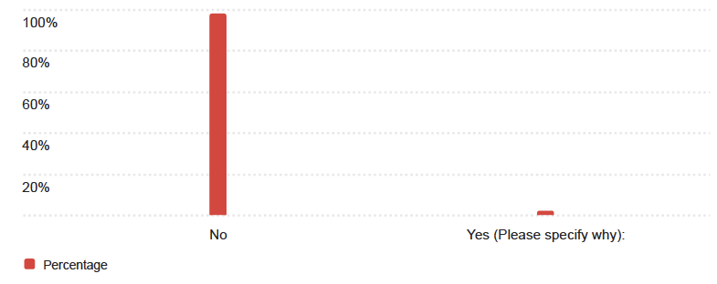

Question 16 – Do you use computers in the public computing sites? – Selected Choice
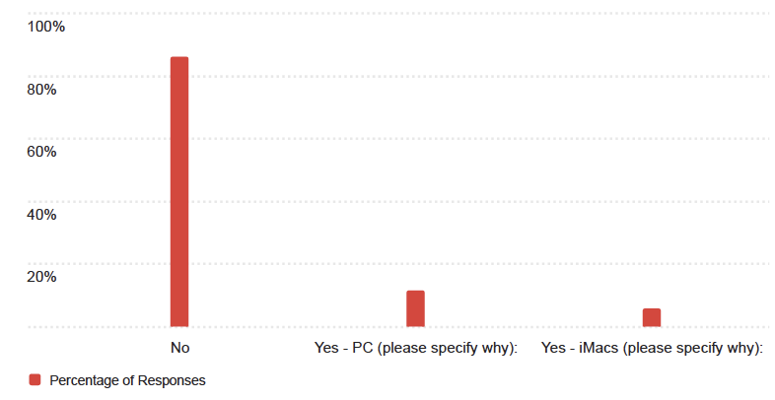

Q16_2_TEXT – Yes – iMacs (please specify why): - Text
- To do my homework
- I need to
- education use
- Only to try them out
- Are fast
- Idk what this means
- autocad
- While my laptop is charging. I use Macs to do my work.
- For access to adobe creative apps
- Wanting to use something other than just my device
- Study
- For studying
- To do stats for class
- for art(photoshop and adobe stuff)
- Silverman
- no
- While my laptop is charging, I use Macs/PCs.
- Occasionally I use this if I forget my laptop charger and want to work on an assignment.
- I have been use Mac system more than 10 years

Q16_4_TEXT – Yes – PC (please specify why): - Text
- My current laptop isn’t compatible
- education use
- faster than the Macs
- I like using a desktop
- to download hw assignments onto my ipad without having to bring my own computer along, also just to look things up
- Mac does not run some software.
- I want to study in the library
- Statistics class
- Work is easier on a second screen. library is a good study place
- Complete coursework, excel, essays
- Good for research
- Better technology
- I have used the conputers in Abbott library to log hours for my RF Self Service timesheet, however the computers are very slow and old.
- I do not always bring my laptop to school with me.
- To program while also being able to look at my questions/data.
- printing
- I like the gaming room
- Because I need to print using Papercut
- SPSS Application
- when I did not bring laptop

Question 17 – Which of the following productivity software titles do you use for your studies or coursework at UB? (Select all that apply.) – Selected Choice
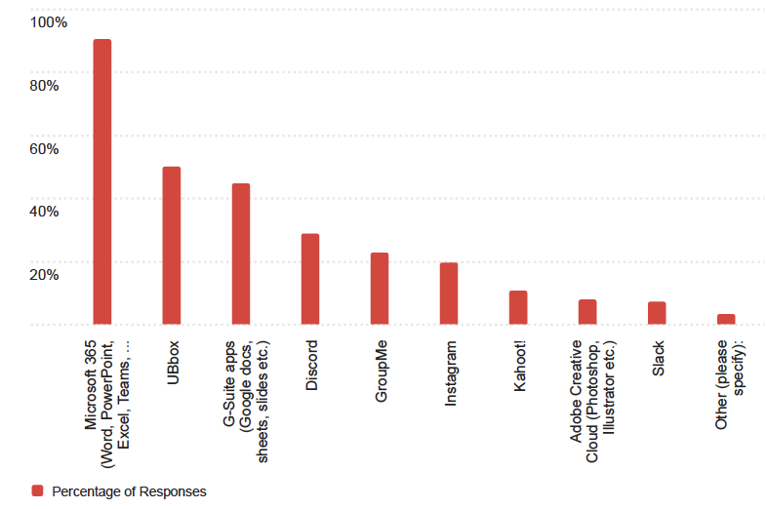

Q17_9_TEXT – Other (please specify): - Text
- Apple Notes (I use it to type on but transfer it to MS Word if I need to submit it). GoodNotes
- Goodnotes
- SPSS
- My computer is a Mac, but I’m unable to use Power BI, which is required for the course, and the UB doesn’t provide free installation access to the software.
- flashcard (quizlet)
- spss
- WhatsApp
- Rhino, AutoCAD
- Twitter/X and Wordpress (both for Digital Journalism)
- Whatsapp
- Canva
- autocad, rhino
- Have not started coursework yet and do not know what I will be utilizing
- Qualtrics
- Quizlet
- WhatsApp
- Quizlet
- Notion
- AutoCAD Rhino
- MatLab

Question 18 – How did you find out about UB collaboration tools and FREE software, such as Microsoft 365? (Select all that apply.) – Selected Choice
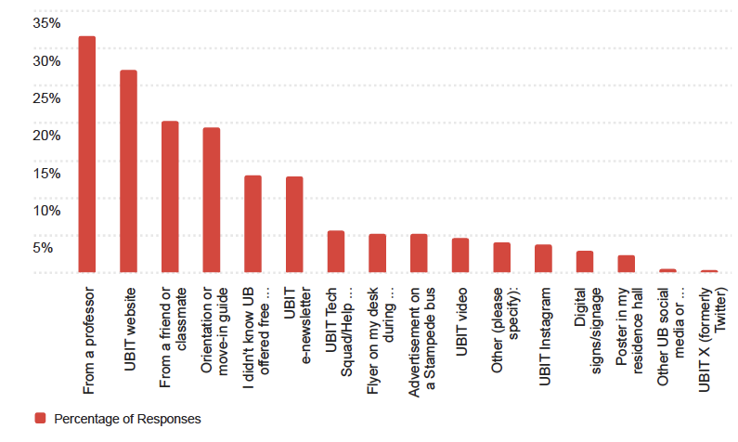

Q18_12_TEXT – Other UB social media or website (please specify): - Text
- reddit
- By searching on google for a specific thing I need and putting UB after it
- A/P school website
- I think it was in an email once
- posters in hallways

Q18_14_TEXT – Other (please specify): - Text
- Just figured it out on my own, trial and error
- I didn’t know and had to figure out myself by asking I didn’t see it anywhere
- My old school (ECC) offered it so I just assumed UB did as well
- UB Endnote
- Welcome weekend
- Idk
- google
- Just checked the MS365 subscriptions page for active products list
- i… just knew the basics most unis offer and expected UB to have the same and I found it
- Assumption
- myself
- poster between capen and knox
- I found out myself
- on my own
- I have a family member who is a professor at another university and she showed me.
- i kinda just already knew then looked it up
- From my supervisor
- I was aware of this before coming to UB
- Google
- I already knew about it

Question 19 – What technologies is UB not using in classrooms that you would like to see?
- n/a
- I enjoyed MTH101 when one of my professors used Youtube to upload their videos instead of Panopto because it was easier to navigate to Youtube and search their name than have to log into UBLearns, navigate to the class, navigate to the recordings folder, navigate to my professor’s folder, and then scroll and aimlessly click on recordings by date and hope it’s the subject I’m looking for.
- I don’t have any examples for this.
- sufficient computer / projector my professors have software issues they cant fix which halts the class
- popcorn making machines
- none
- Nothing that I’m not aware of.
- I think UB is on top of the technologiesm
- nothing in particular
- N/A
- Nothing I’m satisfied
- Google classroom
- N/A
- nothing
- Canva
- All the lectures should be recorded!
- NA
- N/a I’m pretty satisfied on what they do offer
- n/a
- Better hardware websites like TinkerCAD, not wokwi

Question 20 – Which, if any, classrooms have technology problems that impact your learning? – Selected Choice
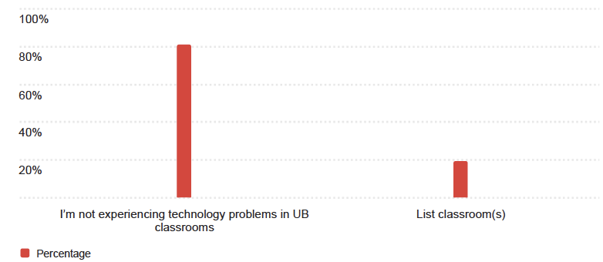

Q20_1_TEXT – List classroom(s) – Text
- Student Union lecture halls
- cooke 420
- NSC 225 Screen doesn’t work occasionally
- I
- Clemens 2nd floor. O’Brian hall
- Wende hall
- None
- Knox 20
- Jacob’s Management and Alumni Arena not having wifi
- No
- Academic Center 328 & 352; Crosby 109; Baldy 105
- N/A
- NSC 225, knox 20, fronczak 341
- NSC 220
- Pharmacy building 190 and 183
- Probably in the school of management. Some of the screens have a glare because of the light
- Every class room just depends on the time of day some days the connection is stronger than others
- The projector in CFA136 is finicky
- gre
- Academic center 170, Academic center 355, Alumni 97

Question 21 – What technology problems are you experiencing in the classroom? (Choose all that apply) – Selected Choice
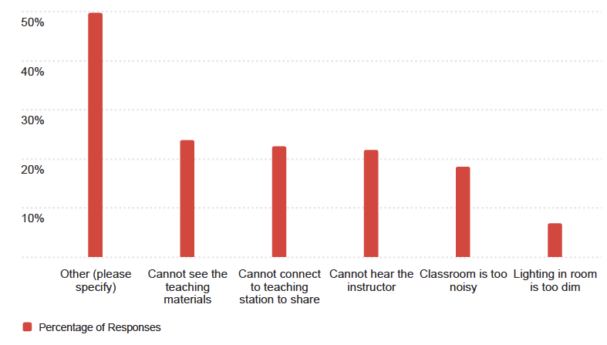

Q21_6_TEXT – Other (please specify) – Text
- Wifi issues
- None
- Not enough seating in chem 105 and bad wifi in Knox 20
- Wi-Fi connectivity
- Cannot access online
- The wifi occasionally sucks
- can’t connect to wifi, other classrooms Park, Norton, O’brien, Hayes, there have been some difficult connecting to the projectors
- outlets don’t work, clocks stolen
- Wifi cutting out
- outlets in desk don’t work
- no plugs and classroom is tight and ugly
- lack of tables
- I clicker saying I am not in the lecture hall
- Professor often has trouble setting up overhead projector
- The WiFi is slow or doesn’t work sometimes
- Computers won’t load materials for Professor
- Wifi
- Occasionally can’t connect to WiFi
- Wifi is so bad I cannot access assingments or iClicker
- Lights will randomly go up and down during class. Distracting to students and professor.

Question 22 – What platforms do you rely on to get the following types of UB news and updates…
Field | Campus Events | Campus News | Service Disruptions (IT outages, facilities issues, bus delays, etc.) | Health and Safety Updates | Course Informaton | Campus Emergencies
Buffalo.edu website | 454 | 404 | 281 | 242 | 419 | 239
UBIT website | 205 | 197 | 338 | 115 | 287 | 104
Other websites | 201 | 189 | 98 | 88 | 130 | 80
UB apps | 270 | 267 | 171 | 145 | 317 | 146
UB Email | 762 | 757 | 664 | 659 | 684 | 650
UBIT e-newsletter | 241 | 299 | 172 | 93 | 76 | 78
Text alerts | 111 | 130 | 297 | 275 | 85 | 476
Facebook | 131 | 127 | 40 | 34 | 33 | 27
Instagram | 427 | 325 | 91 | 80 | 79 | 67
Instagram Reels | 255 | 200 | 50 | 44 | 39 | 33
Reddit | 179 | 225 | 119 | 85 | 130 | 85
Snapchat | 121 | 103 | 35 | 27 | 23 | 29
TikTok | 130 | 99 | 25 | 17 | 21 | 13
X (formerly Twitter) | 108 | 85 | 31 | 23 | 23 | 17
YouTube | 106 | 80 | 32 | 23 | 34 | 9
YouTube Shorts | 100 | 75 | 20 | 20 | 23 | 11
Campus digital signs | 224 | 167 | 60 | 59 | 45 | 50

Question 23 – What assistive technology do you use, if any? Assistive technology is technology that maintains or improves functional capabilities for people with disabilities. (Select all that apply.) – Selected Choice
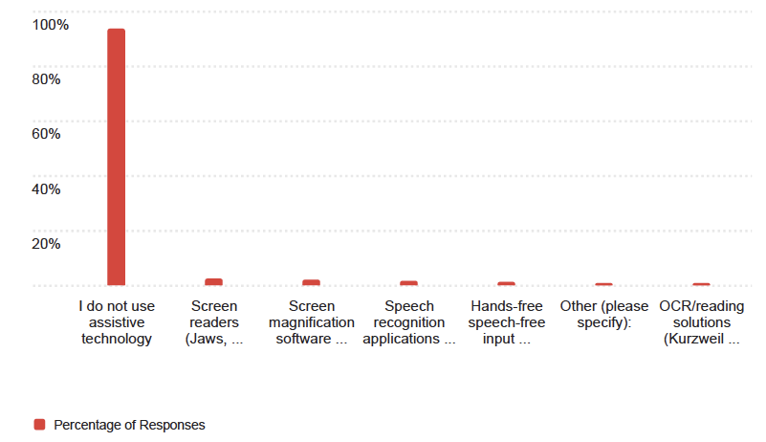

Q23_7_TEXT – Other (please specify): - Text
- Genio notes
- Natural Reader
- Genio Notes
- i use a pen that records while I’m writing. It gets uploaded to my computer and helps w studying (i have adhd and it was recommended by the disability office)
- Whatever reader is on my device, but it’s a struggle
- genio
- Genio (lecture recording and ranscription)
- I use many of the options available within my Mac and MS applications. Enlarging font on my screen is one.

Question 24 – How has your experience been with accessing the following with assistive technology?
Field | Not applicable (N/A) | Frequent Accessibility Problems | Some Accessibility Problems | Often/Always Accessible
Audio and video materials | 17 | 7 | 21 | 38
Classroom technology | 22 | 5 | 21 | 35
Email announcements and messages | 18 | 5 | 16 | 44
HUB Student Center | 17 | 4 | 20 | 41
Microsoft Teams | 29 | 8 | 12 | 30
MyUB | 16 | 6 | 18 | 40
Navigate | 26 | 4 | 14 | 33
Online courses or course materials | 14 | 3 | 25 | 33
Online forms and/or surveys | 19 | 4 | 14 | 38
UB Learns | 14 | 5 | 25 | 31
UB Libraries | 20 | 3 | 12 | 38
UB websites and services | 20 | 5 | 16 | 34
UB websites and services on mobile devices | 21 | 12 | 11 | 29
Zoom | 22 | 6 | 17 | 30

Question 25 – Have you experienced any other problems with assistive technology that was not covered? Please explain.
- No
- Nothing
- nope
- I had a broken wrist at one point, and it would have been very helpful to borrow some kind of vertical or ball mouse.
- No
- none
- Nope
- N/A
- No
- The technology isn’t always the issue. It’s about the person uploading/creating the materials.

Question 26 – What technology information did you learn about before the fall semester started? (Select all that apply.) – Selected Choice
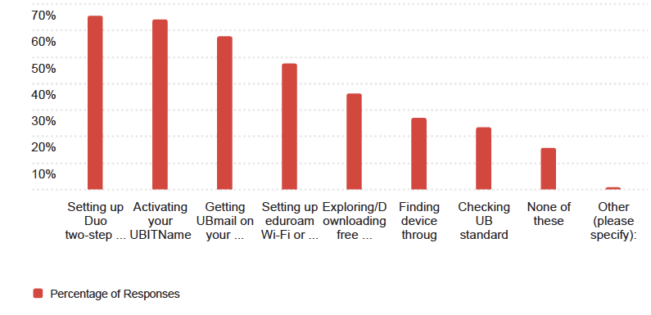

Quesiton 26 – What technology information did you learn about before the fall semester started? (Select all that apply.) - Selected Choice
- Activating your UBITName
- None of these
- Finding device discounts through UB, Activating your UBITName, Getting UBmail on your devices
- Activating your UBITName, Setting up Duo two-step verification
- Setting up Duo two-step verification, Getting UBmail on your devices
- Activating your UBITName, Setting up Duo two-step verification, Setting up eduroam Wi-Fi or ResNet wired connections, Getting UBmail on your devices, Exploring/Dowloading free software and apps (Microsoft 365 and more)
- Activating your UBITName, Setting up Duo two-step verification, Setting up eduroam Wi-Fi or ResNet wired connections, Getting UBmail on your devices
- None of these
- Setting up Dup two-step verification
- None of these
- None of these
- Activating your UBITName, Setting up eduroam Wi-Fi or ResNet wired conections
- Checking UB hardware standards, Setting up eduroam Wi-Fi or ResNet wired connections
- Exploring/Downloading free sofrware and apps (Microsoft 365 and more)
- Checking UB hardware standards, Finding device discounts through UB, Activating your UBITName, Setting up Duo two-step verification, Setting up eduroam Wi-Fi or ResNet wired connections, Getting UBmail on your devices, Exploring Downloading free software and apps (Microsoft 365 and more)
- None of these
- Finding device discounts through UB, Setting up Duo two-step verification, Setting up eduroam Wi-Fi or ResNet wired connections, Getting UBmail on your devices
- None of these
- Finding device discounts through UB

Question 27 – What technology steps did you complete before the fall semester started? (Select all that apply.) – Selected Choice
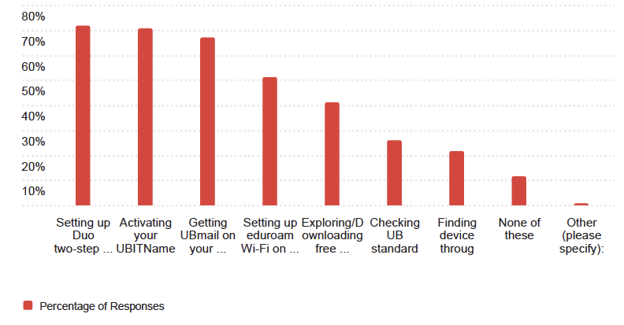

Q27 – What technology steps did you complete before the fall semester started? (Select all that apply.) – Selected Choice
- Activating your UBITName
- Checking UB hardware standards, Setting up eduroam Wi-Fi on my phone, Activating your UBITName, Setting up Duo two-step verification, Getting UBmail on your devices, Exploring/Downloading free software and apps (Microsoft 365 and more)
- Finding device discounts through UB, Activating your UBITName, Getting UBmail on your devices
- Checking UB hardware standards, Activating your UBITName, Setting up Duo two-step verification, Getting UBmail on your devices
- Setting up eduroam Wi-Fi on my phone, Activating your UBITName, Setting up Duo two-step verification, Getting UBmail on your devices
- Setting up eduroam Wi-Fi on my phone, Activating your UBITName, Setting up Duo two-step verification, Getting UBmail on your devices, Exploring/Downloading free software and apps (Microsoft 365 and more)
- Setting up eduroam Wi-Fi on my phone, Activating your UBITName, Setting up Duo two-step verification, Getting UBmail on your devices
- None of these
- Getting UBmail on your devices
- Activating your UBITName, Setting up Duo two-step verification, Getting UBmail on your devices
- Setting up eduroam Wi-Fi on my phone, Activating your UBITName, Setting up Duo two-step verification, Getting UBmail on your devices, Exploring/Downloading free software and apps (Micosoft 365 and more)
- Setting up eduroam Wi-Fi on my phone
- Activating your UBITName, Setting up Duo two-step verification, Getting UBmail on your devices
- Setting up eduroam Wi-Fi on my phone, Activating your UBITName, Setting up Duo two-step verification, Getting UBmail on your devices
- Checking UB hardware standards, Finding device discounts through UB, Setting up eduroam Wi-Fi on my phone, Activating your UBITName, Setting up Duo two-step verification, Getting UBmail on your devices, Exploring/Downloading free software and apps (Microsoft 365 and more)
- None of these
- None of these
- Setting up eduroam Wi-Fi on my phone, Acivating your UBITName, Setting up Duo two-step verification
- Setting up eduroam Wi-Fi on my phone
- Checking UB hardware standards, Finding device discounts through UB, Setting up eduroam Wi-Fi on my phone, Activating your UBITName, Setting up Duo two-step verification, Getting UBmail on your devices, Exploring/Downloading free software and apps (Microsoft 365 and more)

Question 28 – Where did you learn about UB technology information before the fall semester started? (Select all that apply) – Selected Choice
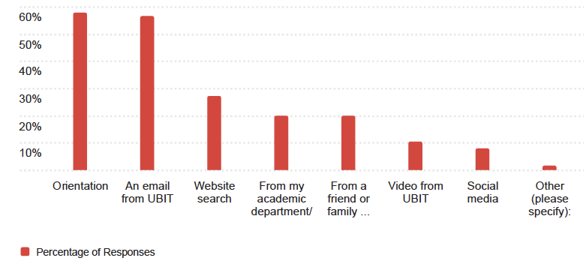

Q28 – Where did you learn about UB technology information before the fall semester started? (Select all that apply.) – Select Choice
- From a friend or family member familiar with UB
- From my academic department/admissions, Social media
- From a friend or family member familiar with UB, Social media
- An email from UBIT, From a friend or family member familiar with UB
- An email from UBIT, From my academic department/admissions, Website search
- Orientation
- Orientation
- Orientation, From a friend or family member familiar with UB, From my academic department/admissions
- Orientation, Website search
- Orientation, An email from UBIT, From a friend or family member familiar with UB, Website search, Social media
- An email from UBIT
- Orientation, An email from UBIT, Social media
- An email from UBIT
- Orientation, From a friend or family member familiar with UB, Social media
- An email from UBIT, From my academic department/admissions, Website search
- Orientation, An email from UBIT
- Orientation, An email from UBIT, Website search, Social media, Video from UBIT
- Orientation
- Orientation, Website search
- From my academic department/admissions, Website search

Q28_4_TEXT – Other (please specify): - Text
- Self exploring/research
- I was working in the library, so I learned during that process
- EOP
- No where until now
- I attended GMP at UB, so I knew most of this stuff
- Exploring the website
- EOP program
- My undergrad years
- Eop!!
- myself
- Working at the library (Lockwood student assistant
- Also contacting via phone and asking
- General research and orientation documents
- EOP Program

Question 29 – Are there any other technology services that you would like to see UB provide? – Selected Choice
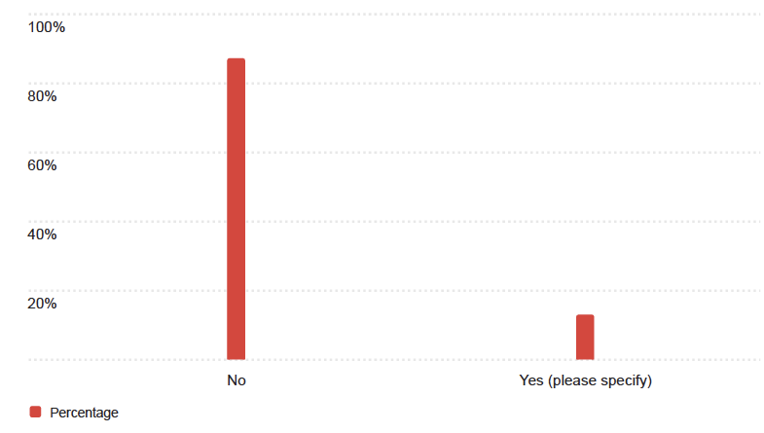

Question 29 – Are there any other technology services that you would like to see UB provide?
- No
- No
- No
- No
- No
- No
- No
- No
- No
- No
- Yes (please specify)
- No
- No
- No
- No
- No
- No
- No
- No
- No

Question 31 – What AI tools are you using for your coursework? (Select all that apply.) – Selected Choice
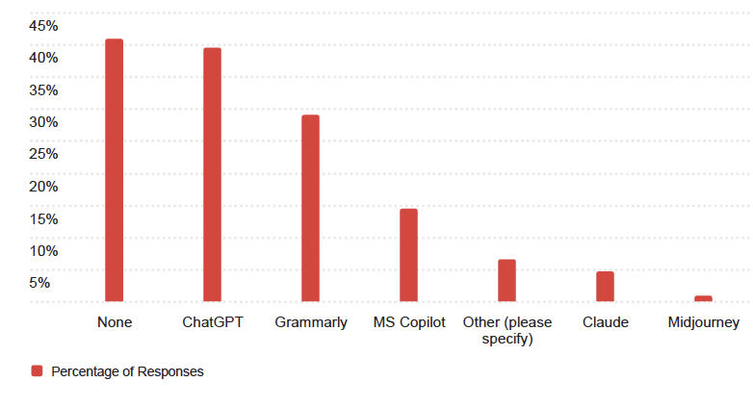

Q31_6_TEXT – Other (please specify) – Text
- open evidence
- Included AI assistant in chemistry homework
- Ban all AI. It is ruining grading
- Achieve AI
- grok
- Google
- gemini
- as part of a research grant I used Copilot, Gemini, and Chat GPT and I’ve used Copilot and Gemini to help me make sense of and get started on two assignments since but its only good for idea generation bc its dumb and I have to redo everything it produces
- Gemini and Perplexity
- Google gemeni
- notebook lm and gemini
- Gemini
- Perplexity
- Power Thesaurus
- DeepSeek
- Notebook LM
- Gemini
- Google Gemini
- Scribbr, Canva
- translation

Question 31 – How frequently are you using AI tools to assist with your course work?
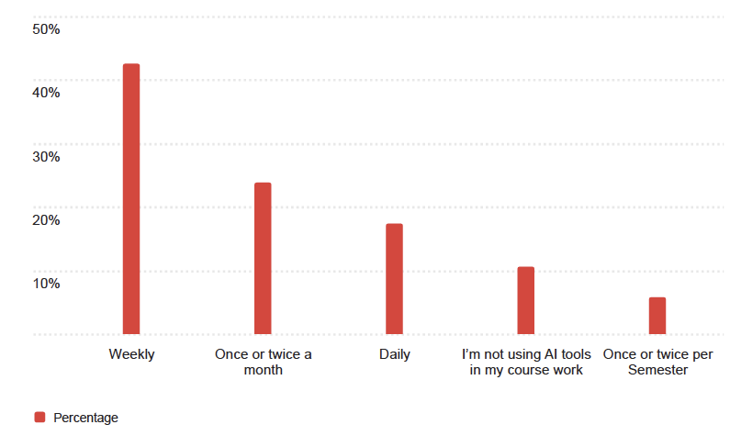

Question 32 – How satisfied are you with how your instructors use technology to engage you in your coursework?
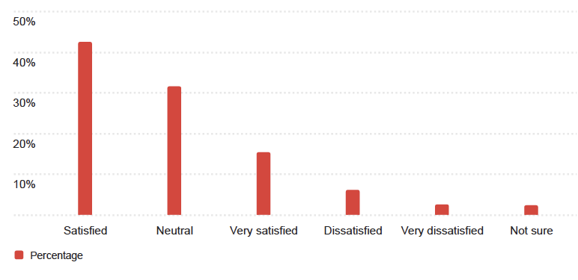

Question 34 – UBIT’s Connection Wizard campaign is intended to raise awareness on how to connect to the campus Wi-Fi network (eduroam). Where, if anywhere, have you seen the Connection Wizard or related 8-bit characters (pictured)?
