

2025 UBIT Student Experience Survey: Executive Summary

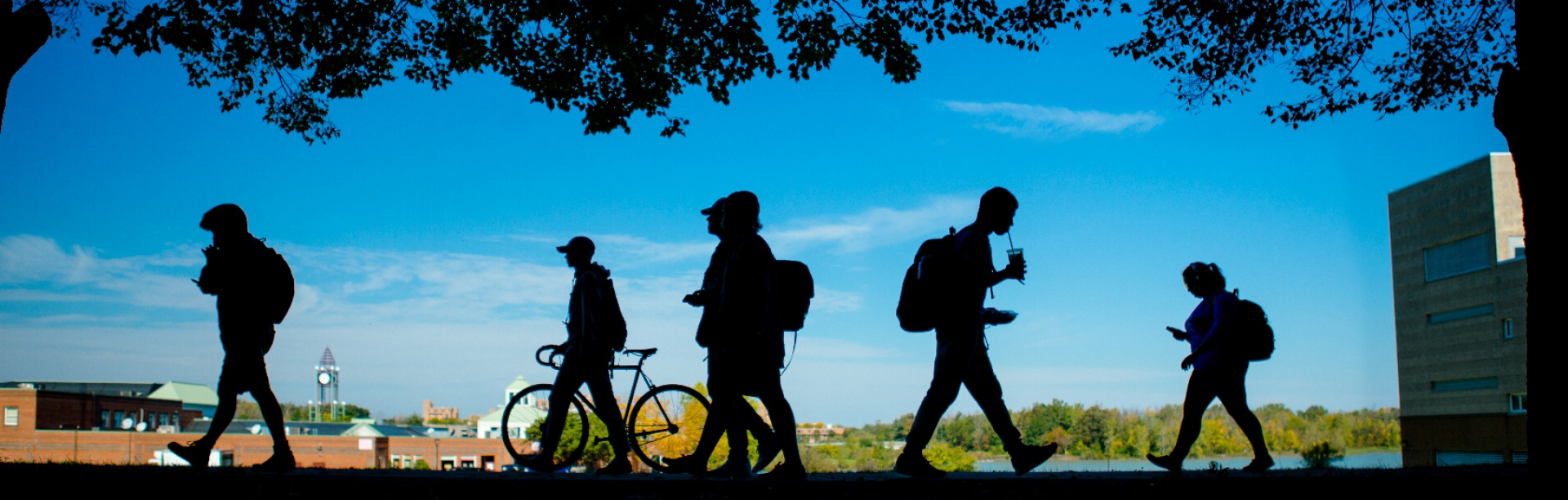

April 2026
UBIT Communication and Engagement
Office of the VPCIO
UB Information Technology

Table of Contents

2025 UBIT Student Experience Survey: Executive Summary 1
Table of Contents 1
Introduction 4
About the Survey 4
About the Student Respondents 4
Survey Results: Highlights and Trends 5
Part 1. Students and the Technology they Use 6
Part 2. Wi-Fi and Technology in the Classroom 13
Part 3. Artificial Intelligence 17
Conclusion 19

Introduction

About the Survey
The 2025 UBIT Student Experience Survey provides a look at how UB students are grappling with the use of AI in education, multiple ways of receiving information and their thoughts on technology on campus, including classroom tech and Wi-Fi around campus.
Now in its 29th year, the survey was open from October 20 through November 3, 2025, and contained 33 questions designed in conjunction with UBIT instructional and support staff, as well as UB’s offices of Student Life, Campus Living, Undergraduate Education, University Libraries, and other campus stakeholders.
Responses were collected using Qualtrics. Students were encouraged to participate through social media, UBIT’s student e-newsletter and the UBIT website.
Where possible, this report compares data from 2025 with previous UBIT student surveys.
While some key questions were required, many were not; where applicable, percentages reflect the number of students who answered that specific question.
The full survey results can be found in a companion document, “2025 Raw Frequencies and comments” on the UBIT website.

About the Student Respondents
1,356 UB students responded to the 2025 survey, representing undergraduates at all levels, as well as graduate students and non-degree seeking students. About 67% of the students who responded to the survey live off campus.
A wide range of UB students participated in the survey. 33% of respondents were enrolled in UB’s School of Engineering and Applied Sciences. Other well-represented areas include the College of Arts and Sciences (18%), School of Management (11%), School of Medicine and Biomedical Sciences (9%), and the School of Public Health and Health Professions (7%).

Survey Results: Highlights and Trends

Part 1. Students and the Technology they Use

Do you use a laptop and / or tablet / iPad? (Q5)
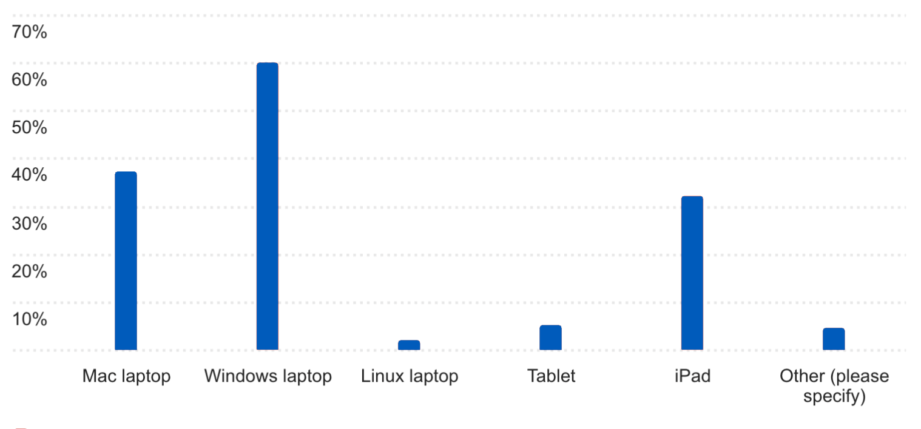In the 2025 UBIT Student Experience Survey, students were asked about the primary computing devices they use for coursework. The results continue to show a strong reliance on traditional laptops, with Windows and Mac devices dominating student computing habits.
Windows laptops (used by 60% of responding UB students) remain the most commonly used device, with a clear majority of students indicating they use a Windows-based laptop for their coursework. Mac laptops (37%) continue to be the second most popular option, reinforcing that most students rely on these two platforms to meet academic computing requirements. Additionally, 32% of students reported using an iPad.
Use of Linux laptops (2%) and tablets (5%) remain limited, accounting for only a small share of overall responses. This suggests Linux continues to serve a niche audience, likely students with specific technical or programmatic needs. Similarly, tablets appear to supplement coursework rather than serve as a primary computing device, indicating they are generally not viewed as a full replacement for a laptop in an academic setting.

How old is your laptop and / or tablet / iPad? (Q6)
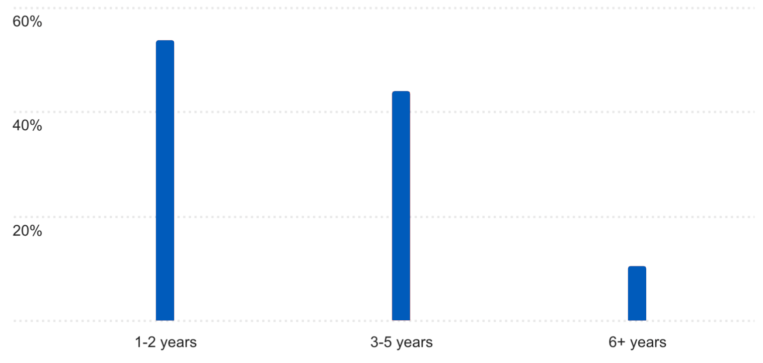This year’s survey also examined the age of students’ primary computing devices. Results show that the largest share of student-owned devices is 1–2 years old (54%), indicating that many students are using newer hardware. A substantial portion of respondents also reported using devices that are 3–5 years old (44%), showing UB students with a near even split of newer and aging technology.
Notably, 10% students reported using devices that are six years old or older. Devices of this age may present challenges related to performance, battery life, and compatibility with newer software and course requirements. However, this number is a significant 10% decrease from 2024, where 20% of students reported their device being over six years old.

Is your laptop / tablet / iPad working well enough to meet the needs of your coursework at UB? (Q7)
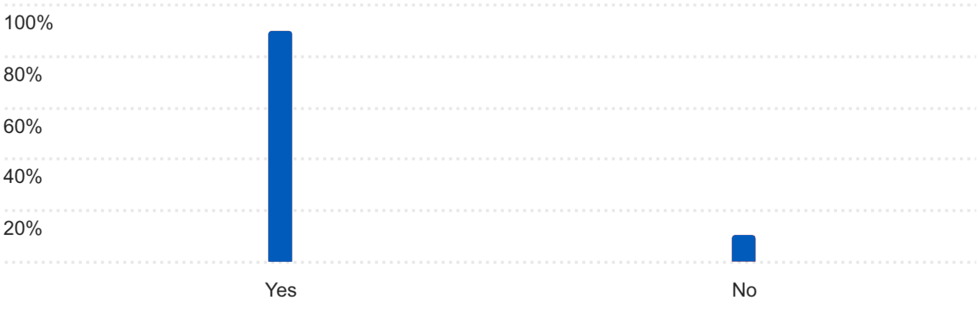
As in last year’s survey, students were asked whether their devices adequately meet the demands of their coursework at UB. Nearly 90% of students reported that their devices perform well enough to support their academic needs, while about 10% indicated performance problems that could impact coursework.
This represents a substantial improvement from 2024, when only 65% of students reported that their devices were sufficient for their academic work.
Most UB students use a personal laptop / tablet for their coursework. What is the reason you haven’t purchased one? (Q8)
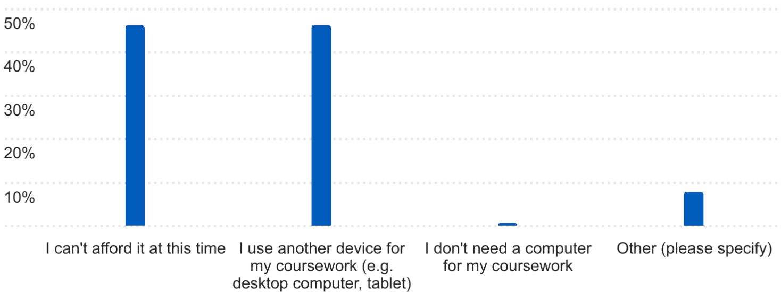Just under half (46%) of the respondents who do not use a laptop or tablet for coursework stated that they could not afford a computer at this time. In last year’s survey, over 50% of students who didn’t use a laptop for their coursework said they were unable to afford one.
Around 46% of students reported using other devices, such as desktop computers or tablets, for their coursework.

What other devices do you own? (Q9)
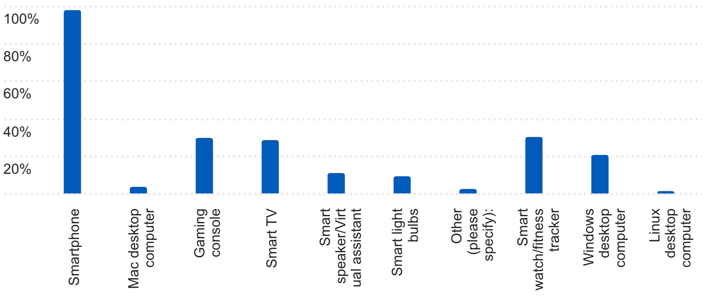
The survey also examined student ownership of various devices. Smartphones remain nearly universal, with 98% of respondents reporting ownership. Other devices, including desktop computers (25%) and smartwatches (30%), were also commonly reported. Smart TVs (28%), gaming consoles (30%), and smart speakers/virtual assistants (11%) also measured.
Which of the following productivity software titles do you use for your studies or coursework at UB? (Q17)
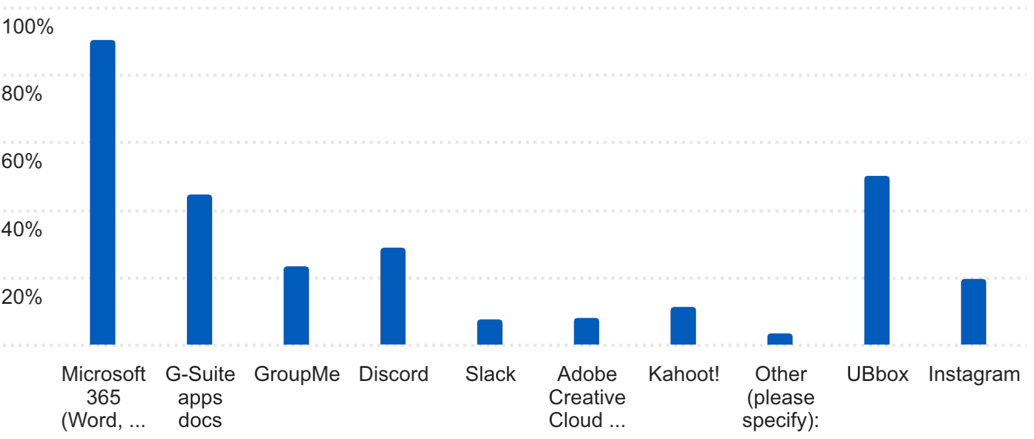Microsoft 365 is by far the most widely used productivity platform among students, with roughly 90% reporting usage. G-Suite apps are also commonly used, with just under half of students (45%) indicating regular use. Microsoft 365 is available to UB students at no cost.
Students continue to rely on third-party communication and collaboration tools. Discord is used by about 29% of students, followed by GroupMe (23%) and Instagram (20%). Other tools—including Kahoot! (11%), Adobe Creative Cloud (8%), and Slack (7%)—are used by smaller segments of the student population.
In addition, more than half of responding UB students (50%) report using UB Box for file storage and sharing as part of their academic work. Other applications mentioned include LinkedIn, WhatsApp, Canva, Apple Pages, and Rhinoceros 3D.
Overall, the results indicate that students rely primarily on institutionally supported productivity and file-sharing platforms for coursework, with usage declining sharply beyond core Microsoft, Box storage, and widely adopted collaboration tools.
How did you find out about UB collaboration tools and FREE software, such as Microsoft 365? (Q18)
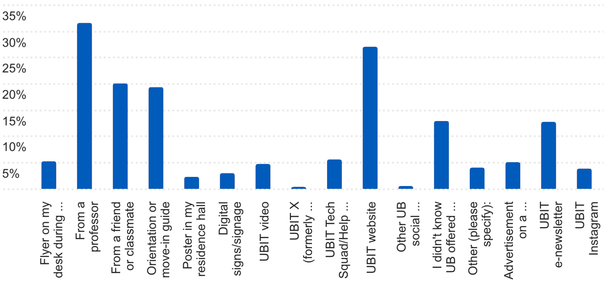Students learn about UB-provided collaboration tools and free software through a mix of academic, institutional, and peer-to-peer channels. Faculty remain the most influential source, with approximately 32% of students reporting they learned about software offerings from a professor. The UBIT website is the second most common channel (about 27%), followed by classmates or friends (20%).
UBIT communications play a meaningful role as well. Approximately 19% learned about software through orientation, and around 14% from the UBIT student e-newsletter, The Monthly Download.
Other channels, including social media (4%), digital signage (3%), posters (2%), and UBIT videos (5%), each inform fewer than 10% of students. 13% of respondents indicated they were still unaware of available software from UB.
Overall, the data indicate that awareness is driven primarily by direct academic interactions and the UBIT website, with institutional communications and marketing channels providing additional reach. UBIT continues to expand and refine outreach efforts to improve student awareness of available software and services.

What technology information did you learn about before the fall semester started? (Q26)
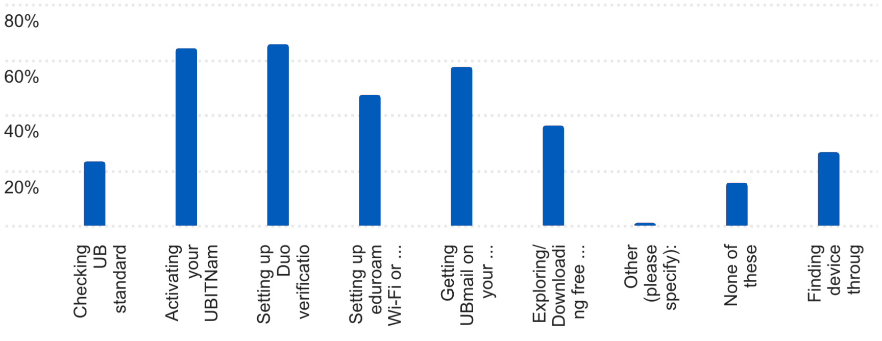Responses indicate that students were most likely to learn about required account setup processes before the semester began. The highest awareness was tied to Duo two-step authentication (65% - a 10% dip from 2024) and activating their UBITName (64%), followed closely by setting up UBmail (57%). Just under half of responding students (47%) learned about eduroam Wi-Fi prior to the semester.
36% of students learning of free software resources prior to the semester, while fewer students indicated they learned about device discount options (27%) or broader technology standards before the semester.
Overall, required onboarding steps are the strongest drivers of early technology awareness, while optional or support-focused services show lower pre-semester visibility.

What technology steps did you complete before the fall semester started? (Q27)
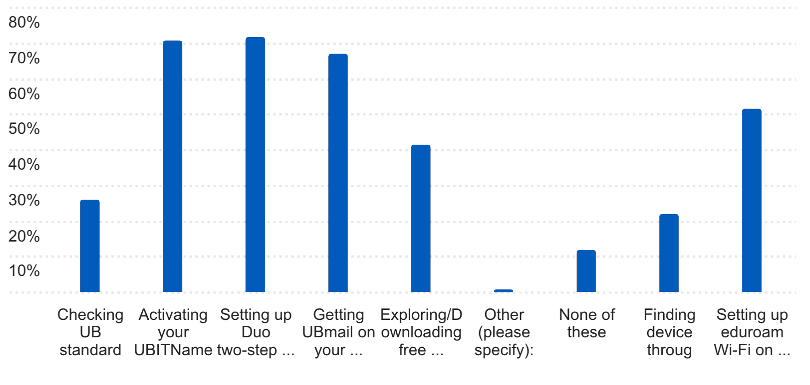Most students reported completing account setup tasks prior to the start of the semester. The highest completion rates were for setting up Duo two-step authentication (72%), activating their UBITName (71%), and configuring UBmail (67%).
More than half also reported connecting to eduroam Wi-Fi (51%), while fewer students explored optional steps such as downloading free software (41%), reviewing device standards (26%), or seeking additional support resources.
Where did you learn about UB technology information before the fall semester started? (Q28)
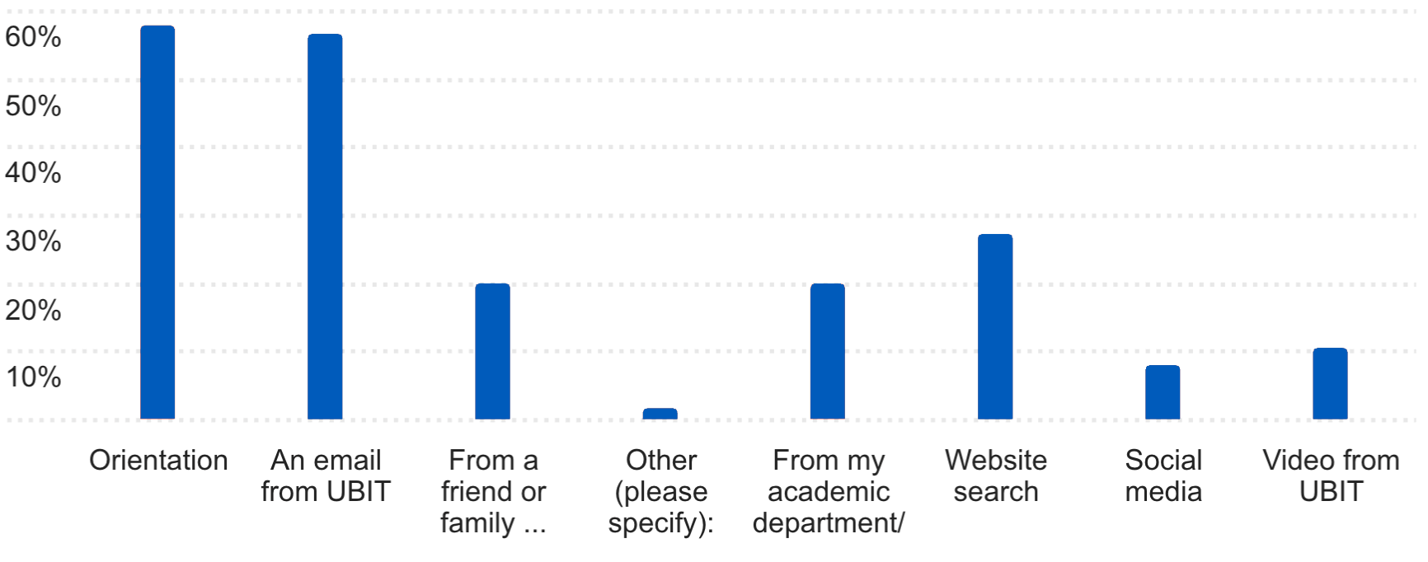
Students most frequently learned about UB technology through Orientation (58%) and an email from UBIT (57%), which were the top reported sources. Secondary channels included website searches (27%) and information shared by academic departments/admissions (20%).
Peer influence also played a role, with some students citing friends or family familiar with UB (20%). Social media (8%) and UBIT videos (10%) were also reported.
Open-ended responses indicate additional exposure through self-directed research, EOP programming, prior enrollment at UB, student employment (e.g., library work), and direct phone outreach. A small number reported not learning about services until after they arrived at UB.

Part 2. Wi-Fi and Technology in the Classroom
Have you struggled with a slow or disconnected Wi-Fi connection on UB’s campus during the past year? (Q13)
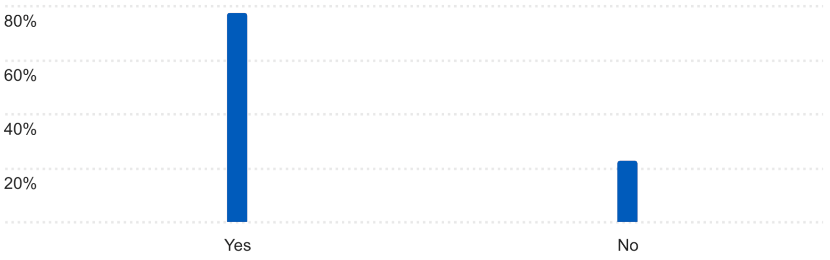Nearly 77% of respondents said they experienced slow or disconnected Wi-Fi on UB’s campus during the past year, while roughly 23% reported no problems, indicating that connectivity challenges affect a majority of students.

How did you report your Wi-Fi problem? (Q13a)
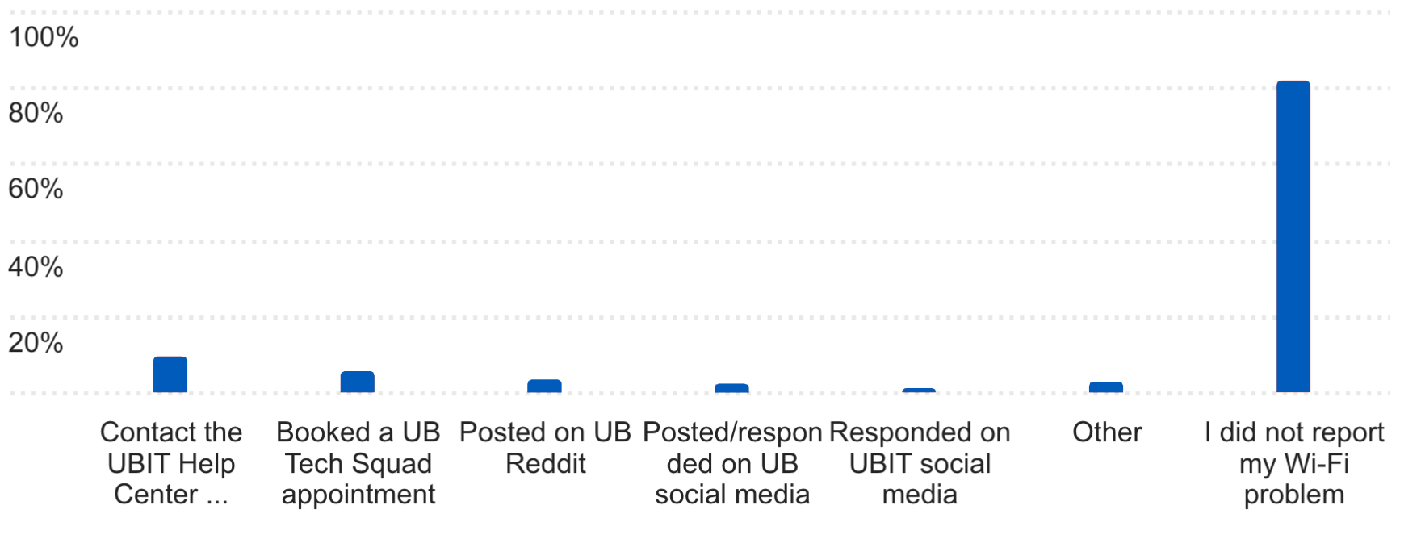An overwhelming number of students, 82%, who experienced a Wi-Fi problem did not report it. Among those who did, 9% contacted the UBIT Help Center, while smaller shares used other channels: 5% booked a Tech Squad appointment, 4% posted on Reddit, and 3% or less used other methods such as social media or UB official channels.
How did you contact the Help Center? (Q13a1)
Students used several different ways to contact the UBIT Help Center. Those who reached out most often did so in person (especially at the Silverman Library desk – mentioned four times), by email (mentioned four times), by phone (mentioned three times), or by submitting an online/help ticket (mentioned three times). Several students said their problem was resolved quickly, but others reported slow fixes (mentioned once) or no resolution (mentioned once).
15 students suggested underreporting or workarounds: some didn’t contact UBIT at all, waited it out, reset eduroam repeatedly, asked friends for help, or solved the problem themselves. Some students noted that lack of Wi-Fi made it harder to report the problem in the first place (three students).
Why didn’t you report your Wi-Fi problem? (Q13b)
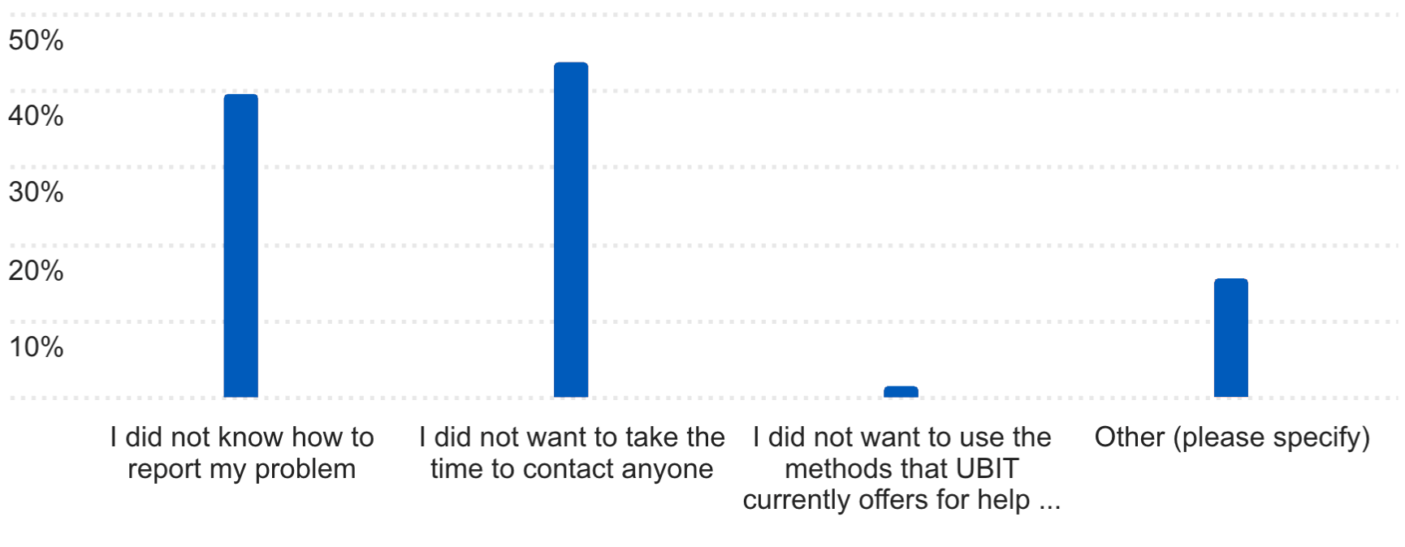When asked why they didn’t report their Wi-Fi problem, 44% of students said they did not want to take the time to contact anyone, and about 39% said they did not know how to report their Wi-Fi problem. Another 17% selected “Other,” citing reasons such as waiting it out or trying to fix the problem themselves. Only 2% of responding students said they avoided reporting because they did not want to use the help methods UBIT currently offers.
Many students believed the problem was campus-wide or building-specific, not device-related, and expected it to resolve on its own within minutes or an hour. Others felt the problem was minor, infrequent, or “normal” given campus usage, so it didn’t seem worth reporting.
Where specifically on campus – such as outdoor green spaces or hallways – would stronger Wi-Fi make the biggest difference for you? (Q14)
Students most frequently identified hallways and transition areas between buildings (mentioned five times) as the top priority for improved Wi-Fi coverage. Many also emphasized the need for stronger connectivity in outdoor spaces, including the Commons, walkways, and parking lots, particularly for students moving across campus or trying to maintain a signal between locations (mentioned eight times).
Other areas included student gathering and study locations such as the Student Union, libraries, dorm rooms, and lower floors of academic buildings (each mentioned twice). Specific locations mentioned were Jacobs School of Medicine and Biomedical Sciences study rooms, Cooke and Hochstetter halls, and Mary Talbert Way. Several students noted challenges in basements and indoor spaces used for Zoom classes, where reliable connectivity is essential for academic participation.
What technologies is UB not using in classrooms that you would like to see? (Q19)
When asked what technologies UB isn’t using, most students said there are no major technologies missing and that they are generally satisfied with what UB offers. A few recurring themes did come up:
- Lecture capture and access: Students want all lectures recorded and easier ways to find them. One specifically preferred YouTube over Panopto, citing simpler navigation and search.
- Classroom reliability: Some students expressed frustration with software problems on classroom computers that disrupt class time.
- Instructional tools and platforms: A small number mentioned interest in tools like Google Classroom, Canva, and better hardware simulation websites (e.g., preferring TinkerCAD over Wokwi).
Overall, student satisfaction with technology offerings appears high, with improvements mainly desired around ease of access, reliability, and consistency.
Which, if any, classrooms have technology problems that impact your learning? (Q20)
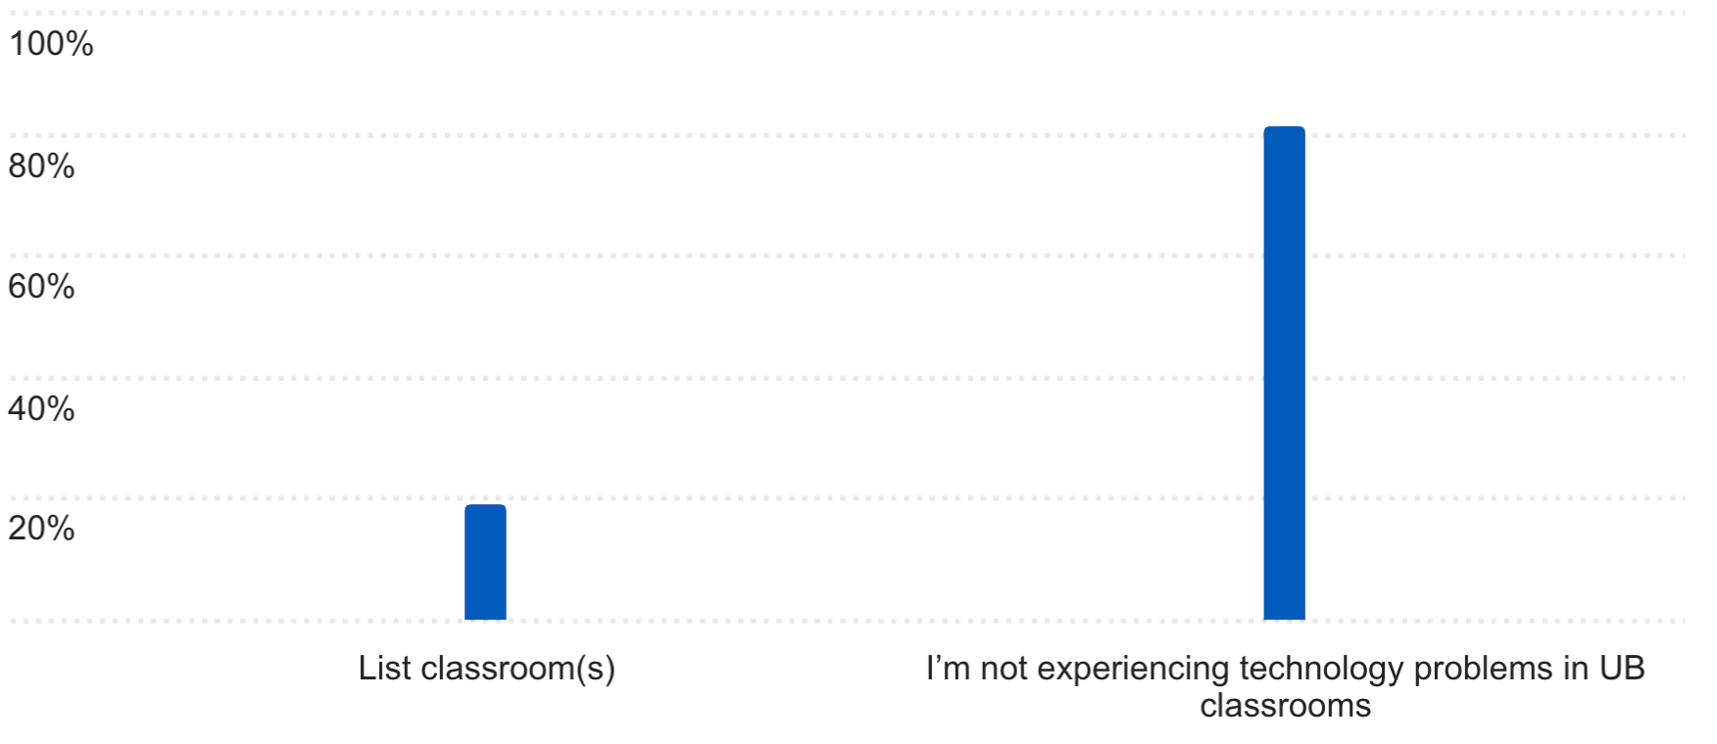The vast majority of students (81%) reported not experiencing classroom technology problems that impact learning. However, a smaller segment (19%) identified specific rooms across multiple academic buildings (e.g., NSC, Knox, Academic Center, Clemens, Wende, CFA, Pharmacy) where they experienced problems.

What technology problems are you experiencing in the classroom? (Q21)
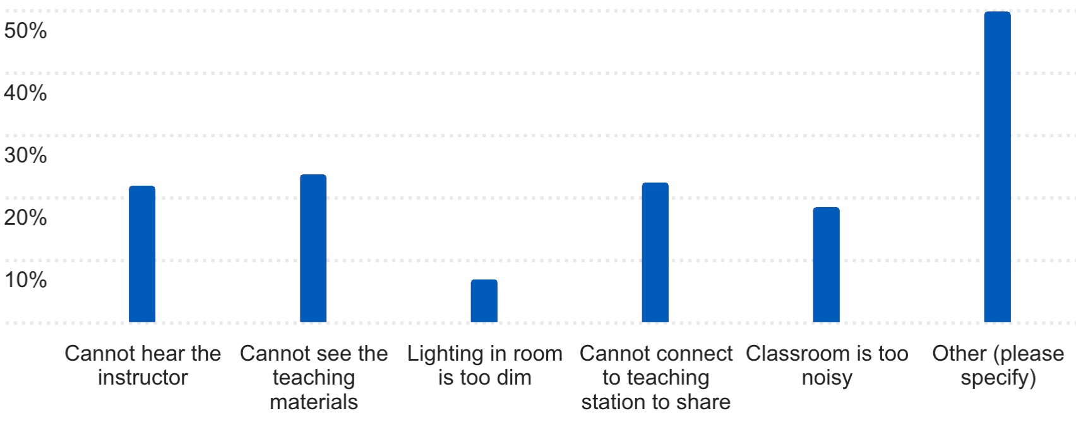The most frequently selected response was “Other (50%),” with open-ended comments overwhelmingly pointing to Wi-Fi connectivity problems, including slow speeds, dropped connections, and inability to access assignments or iClicker.
Among listed options, students most often reported:
- Inability to see teaching materials (24%)
- Difficulty connecting to the teaching station to share content (22%)
- Trouble hearing the instructor (22%)
- Classrooms being too noisy (18%)
A smaller number (7%) cited lighting being too dim.

Part 3. Artificial Intelligence

What AI tools are you using for your coursework? (Q31)
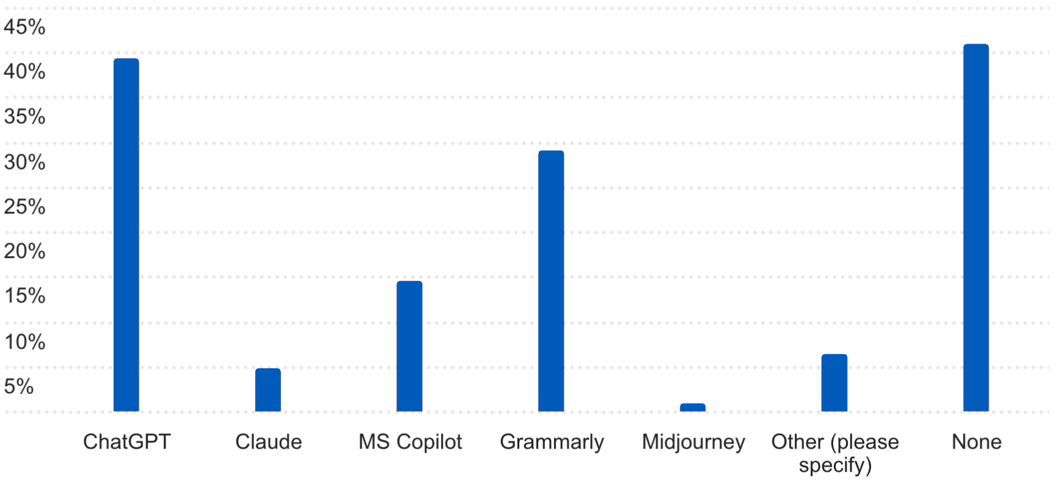Student use of AI tools is widespread but uneven. The largest share of students (41%) reported using no AI tools for coursework. This is down from 47% in 2024. Among those who do report using AI, ChatGPT (39%) and Grammarly (29%) were the most common, followed by Microsoft Copilot (14%). Smaller numbers reported using Claude (5%) and Midjourney (1%).
Open-ended responses show additional tools, with Google Gemini (eight times) and Perplexity (two times) mentioned most frequently. Other tools mentioned included NotebookLM, DeepSeek, Grok, Achieve AI, Scribbr, Canva, Power Thesaurus, translation apps, and discipline-specific AI assistants. Comments reflected mixed attitudes. Some students use AI mainly for idea generation and comprehension, while others expressed concern that AI is hurting learning and grading integrity.

How frequently are you using AI tools to assist with your course work? (Q32)
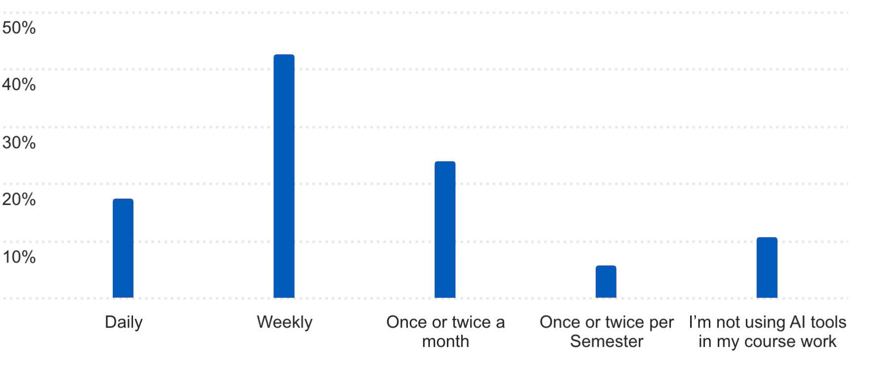AI is becoming routine for many students who use these tools. Nearly half (43%) reported using AI tools weekly, up from 36% in 2024. Another 17% of students use AI daily, up 2% from 2024 and indicating that AI assistance is now part of regular academic workflows for students who use them. About 24% use AI only once or twice a month, up 12% over 2024. Six percent rely on it once or twice per semester. Approximately 11% of students said they were not using AI in their coursework, a 2% decrease from 2024.

How satisfied are you with how your instructors use technology to engage you in your coursework? (Q32)
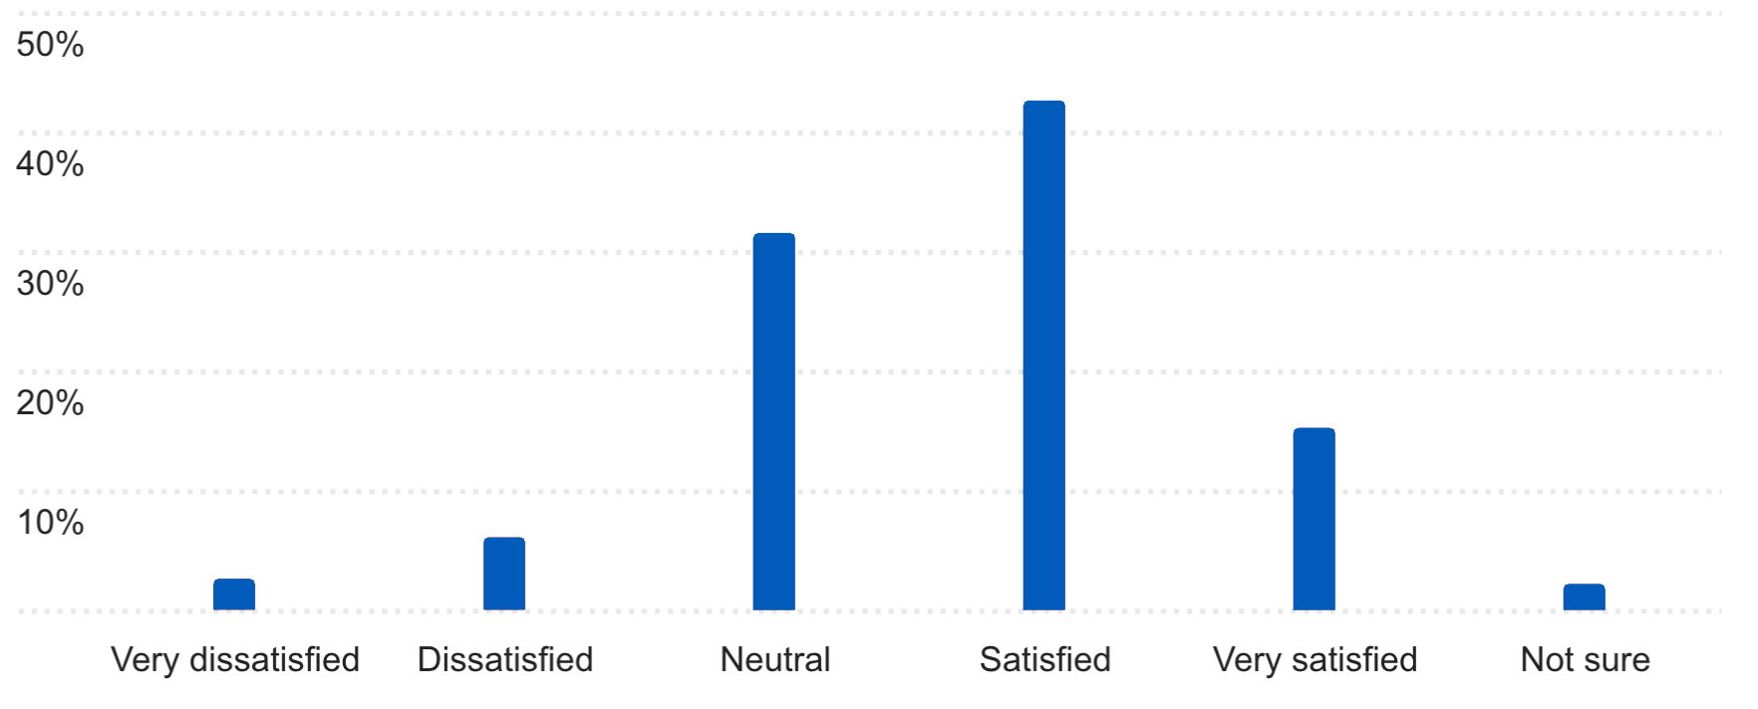Most students report a positive experience with how instructors use technology in coursework. The largest share indicated they are either very satisfied or satisfied (58%), followed by a substantial group who feel neutral (31%). A smaller portion dissatisfaction (about 9%).

Conclusion

The 2025 UBIT Student Experience Survey provides valuable insight into how students are using and experiencing technology across campus. AI usage is widespread, with many students incorporating tools such as ChatGPT, Copilot and Gemini into their coursework on a regular basis. As adoption continues to grow, UBIT will monitor usage trends and ensure students have access to responsible, effective tools that support academic success.
Students report generally positive experiences with classroom technology and instructor engagement, though Wi-Fi reliability remains the most consistent concern. UBIT remains committed to strengthening core infrastructure while continuing to provide essential resources such as laptop discounts, Microsoft 365, video conferencing through MS Teams and Zoom and other academic technologies. Ongoing student feedback plays a critical role in refining services and ensuring UB’s technology environment supports learning, accessibility and long-term success.
As always, UBIT wishes to thank the students who responded to this survey for their contribution to our work.
Visit the UBIT website to see full results and analysis from previous years’ surveys.

