Raw Frequencies
2019 Student Experience Survey
November 5th 2019, 12:20 pm EST
Q4 - What is your class standing?
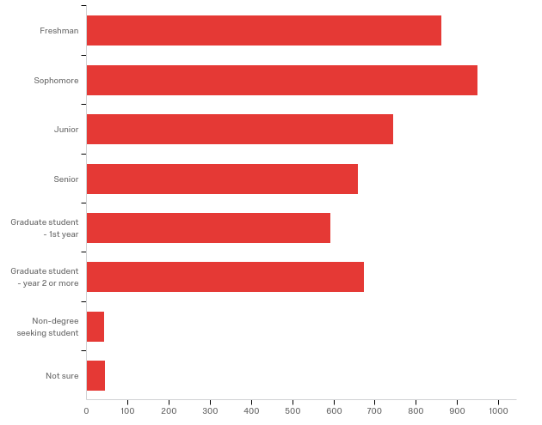

# | Field | Minimum | Maximum | Mean | Std Deviation | Variance | Count
1 | What is your class standing? | 1.00 | 8.00 | 3.35 | 1.79 | 3.22 | 4571

# | Answer | % | Count
1 | Freshman | 18.88% | 863
2 | Sophomore | 20.78% | 950
3 | Junior | 16.32% | 746
4 | Senior | 14.44% | 660
5 | Graduate student - 1st year | 12.95% | 592
6 | Graduate student - year 2 or more | 14.75% | 674
7 | Non-degree seeking student | 0.92% | 42
8 | Not sure | 0.96% | 44
 | Total | 100% | 4571

Q5 - In which UB College or School are you enrolled?
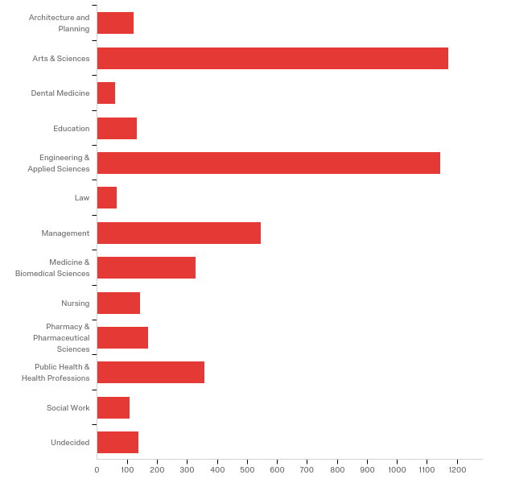

# | Field | Minimum | Maximum | Mean | Std Deviation | Variance | Count
1 | In which UB College or School are you enrolled? | 1.00 | 13.00 | 5.74 | 3.31 | 10.96 | 4490

# | Answer | % | Count
1 | Architecture and Planning | 2.69% | 121
2 | Arts & Sciences | 26.08% | 1171
3 | Dental Medicine | 1.34% | 60
4 | Education | 2.96% | 133
5 | Engineering & Applied Sciences | 25.50% | 1145
6 | Law | 1.45% | 65
7 | Management | 12.16% | 546
8 | Medicine & Biomedical Sciences | 7.35% | 330
9 | Nursing | 3.21% | 144
10 | Pharmacy & Pharmaceutical Sciences | 3.79% | 170
11 | Public Health & Health Professions | 8.00% | 359
12 | Social Work | 2.41% | 108
13 | Undecided | 3.07% | 138
 | Total | 100% | 4490

Q66 - Where do you live?
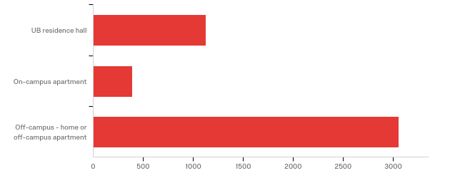

# | Field | Minimum | Maximum | Mean | Std Deviation | Variance | Count
1 | Where do you live? | 1.00 | 3.00 | 2.42 | 0.86 | 0.74 | 4571

# | Answer | % | Count
1 | UB residence hall | 24.63% | 1126
2 | On-campus apartment | 8.53% | 390
3 | Off-campus - home or off-campus apartment | 66.83% | 3055
 | Total | 100% | 4571

Q9 - Please indicate which of the following devices you have used since the beginning of the semester. (Select all that apply.)
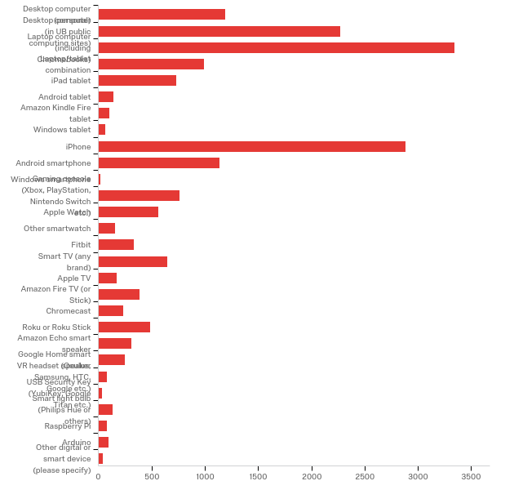

# | Answer | % | Count
1 | Desktop computer (personal) | 6.77% | 1195
2 | Desktop computer (in UB public computing sites) | 12.86% | 2272
3 | Laptop computer (including Chromebooks) | 18.93% | 3343
4 | Laptop/tablet combination | 5.63% | 994
5 | iPad tablet | 4.16% | 735
6 | Android tablet | 0.79% | 139
7 | Amazon Kindle Fire tablet | 0.58% | 103
8 | Windows tablet | 0.39% | 68
9 | iPhone | 16.31% | 2881
10 | Android smartphone | 6.43% | 1136
11 | Windows smartphone | 0.11% | 20
12 | Gaming console (Xbox, PlayStation, Nintendo Switch etc.) | 4.34% | 766
13 | Apple Watch | 3.18% | 561
14 | Other smartwatch | 0.87% | 154
15 | Fitbit | 1.87% | 330
16 | Smart TV (any brand) | 3.65% | 645
17 | Apple TV | 1.00% | 176
18 | Amazon Fire TV (or Stick) | 2.19% | 387
19 | Chromecast | 1.32% | 233
20 | Roku or Roku Stick | 2.77% | 490
21 | Amazon Echo smart speaker | 1.78% | 314
22 | Google Home smart speaker | 1.42% | 250
23 | VR headset (Oculus, Samsung, HTC, Google etc.) | 0.47% | 83
24 | USB Security Key (YubiKey, Google Titan etc.) | 0.19% | 34
25 | Smart light bulb (Philips Hue or others) | 0.77% | 136
26 | Raspberry Pi | 0.44% | 78
27 | Arduino | 0.54% | 95
28 | Other digital or smart device (please specify) | 0.24% | 43
 | Total | 100% | 17661

Q9_28_TEXT - Other digital or smart device (please specify)
xbox
HP prolient server
bluetooth earpods
Oneplus
Normal kindle - not fire tablet
wemo smart plug
ps4
Drones
Jbl speaker
Monitor
Cell phone
Airpods
Garmin
External Hard Drive 1TB
Amazon Kindle paperwhite
Smart plug/cleaning robot
rca tablet
Smart plugs
Google Home
Sonos speakers
wacom
Smart plugs for the wall
Apple HomePod
projectors
beats headphones
Playstation TV
Apple HomePod
printer
Garmin watch
Nintendo Switch
Smart Plugs
Kindle Paperwhite
ReMarkable
Samsung notebook
Smart plug
Kindle
Beats

Q12 - Please indicate which DIGITAL devices you primarily use for the following activities:

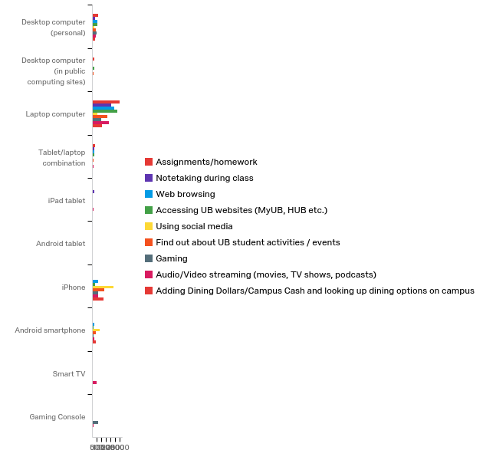

# | Field | Minimum | Maximum | Mean | Std Deviation | Variance | Count
1 | Assignments/homework | 1.00 | 10.00 | 2.77 | 0.94 | 0.87 | 4195
2 | Notetaking during class | 1.00 | 10.00 | 3.12 | 1.17 | 1.37 | 2985
3 | Web browsing | 1.00 | 10.00 | 3.63 | 1.95 | 3.79 | 4135
4 | Accessing UB websites (MyUB, HUB etc.) | 1.00 | 8.00 | 3.19 | 1.52 | 2.31 | 4140
5 | Using social media | 1.00 | 10.00 | 6.18 | 2.03 | 4.11 | 4056
6 | Find out about UB student activities / events | 1.00 | 9.00 | 4.66 | 2.33 | 5.43 | 3980
7 | Gaming | 1.00 | 10.00 | 5.48 | 3.22 | 10.37 | 2976
8 | Audio/Video streaming (movies, TV shows, podcasts) | 1.00 | 10.00 | 4.74 | 2.68 | 7.16 | 4006
9 | Adding Dining Dollars/Campus Cash and looking up dining options on campus | 1.00 | 10.00 | 5.12 | 2.38 | 5.68 | 3102

# | Question | Desktop computer (personal) |  | Desktop computer (in public computing sites) |  | Laptop computer |  | Tablet/laptop combination |  | iPad tablet |  | Android tablet |  | iPhone |  | Android smartphone |  | Smart TV |  | Gaming Console |  | Total
1 | Assignments/homework | 15.52% | 651 | 4.53% | 190 | 71.70% | 3008 | 6.17% | 259 | 1.12% | 47 | 0.14% | 6 | 0.72% | 30 | 0.07% | 3 | 0.00% | 0 | 0.02% | 1 | 4195
2 | Notetaking during class | 10.89% | 325 | 1.57% | 47 | 69.58% | 2077 | 7.94% | 237 | 6.67% | 199 | 0.60% | 18 | 1.81% | 54 | 0.90% | 27 | 0.00% | 0 | 0.03% | 1 | 2985
3 | Web browsing | 12.99% | 537 | 1.77% | 73 | 58.89% | 2435 | 5.22% | 216 | 1.69% | 70 | 0.31% | 13 | 14.37% | 594 | 4.67% | 193 | 0.05% | 2 | 0.05% | 2 | 4135
4 | Accessing UB websites (MyUB, HUB etc.) | 12.44% | 515 | 4.08% | 169 | 67.03% | 2775 | 5.87% | 243 | 1.43% | 59 | 0.17% | 7 | 6.33% | 262 | 2.66% | 110 | 0.00% | 0 | 0.00% | 0 | 4140
5 | Using social media | 5.30% | 215 | 0.86% | 35 | 14.25% | 578 | 1.38% | 56 | 1.21% | 49 | 1.08% | 44 | 57.17% | 2319 | 18.69% | 758 | 0.02% | 1 | 0.02% | 1 | 4056
6 | Find out about UB student activities / events | 8.74% | 348 | 3.09% | 123 | 40.63% | 1617 | 3.42% | 136 | 1.26% | 50 | 0.60% | 24 | 32.14% | 1279 | 10.10% | 402 | 0.03% | 1 | 0.00% | 0 | 3980
7 | Gaming | 14.15% | 421 | 1.01% | 30 | 31.22% | 929 | 2.15% | 64 | 1.71% | 51 | 0.60% | 18 | 21.47% | 639 | 4.74% | 141 | 0.57% | 17 | 22.38% | 666 | 2976
8 | Audio/Video streaming (movies, TV shows, podcasts) | 9.99% | 400 | 0.80% | 32 | 45.08% | 1806 | 3.77% | 151 | 3.62% | 145 | 0.57% | 23 | 15.90% | 637 | 5.92% | 237 | 11.63% | 466 | 2.72% | 109 | 4006
9 | Adding Dining Dollars/Campus Cash and looking up dining options on campus | 8.22% | 255 | 2.45% | 76 | 32.79% | 1017 | 2.22% | 69 | 0.97% | 30 | 0.74% | 23 | 39.26% | 1218 | 12.99% | 403 | 0.16% | 5 | 0.19% | 6 | 3102

Q14 - What operating system is on the computer that you use the most?
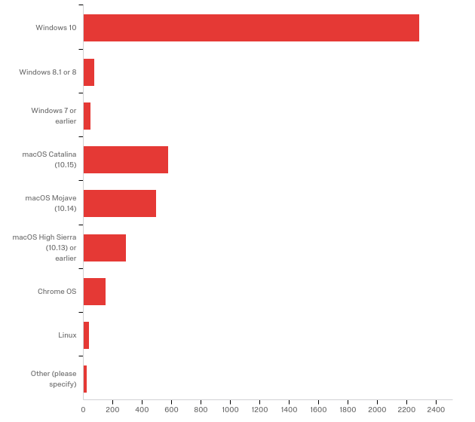

# | Field | Minimum | Maximum | Mean | Std Deviation | Variance | Count
1 | What operating system is on the computer that you use the most? - Selected Choice | 1.00 | 10.00 | 2.68 | 2.15 | 4.63 | 3985

# | Answer | % | Count
1 | Windows 10 | 57.39% | 2287
2 | Windows 8.1 or 8 | 1.88% | 75
3 | Windows 7 or earlier | 1.18% | 47
4 | macOS Catalina (10.15) | 14.55% | 580
5 | macOS Mojave (10.14) | 12.45% | 496
6 | macOS High Sierra (10.13) or earlier | 7.28% | 290
7 | Chrome OS | 3.74% | 149
8 | Linux | 0.95% | 38
10 | Other (please specify) | 0.58% | 23
 | Total | 100% | 3985

Q14_10_TEXT - Other (please specify)
Other (please specify) - Text
Macbook
IOS
ElementaryOS dual booted with Windows 10, or CentOS
IOS
Linux (Elementary OS) and Windows Dual boot
Older mac
lenovo
ios
Safari
macOS Yosemite
Mac OS X
mac OS X El Capitan
Safari
Windows dont know the genration
Ios 13
IPadOS
Mac OS X El Capitan
Samsung
Mac OS 10.11
MacBook air
safari
Mac OS Yosemite

Q17 - eduroam is UB's preferred Wi-Fi network. If you connect to Wi-Fi at UB, are you using eduroam?
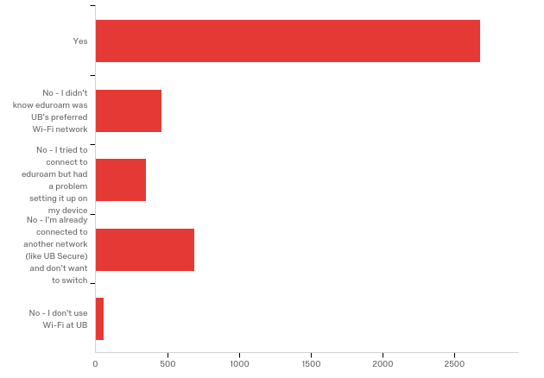

# | Field | Minimum | Maximum | Mean | Std Deviation | Variance | Count
1 | eduroam is UB's preferred Wi-Fi network. If you connect to Wi-Fi at UB, are you using eduroam? | 1.00 | 5.00 | 1.82 | 1.21 | 1.45 | 4243

# | Answer | % | Count
1 | Yes | 63.23% | 2683
2 | No - I didn't know eduroam was UB's preferred Wi-Fi network | 10.86% | 461
3 | No - I tried to connect to eduroam but had a problem setting it up on my device | 8.32% | 353
4 | No - I'm already connected to another network (like UB Secure) and don't want to switch | 16.21% | 688
5 | No - I don't use Wi-Fi at UB | 1.37% | 58
 | Total | 100% | 4243

Q53 - Please describe the problem you had when setting up eduroam, and what device you were using:
Please describe the problem you had when setting up eduroam, and what device you were using:
I try logging in with my UBIT stuff and doesn't work
no
mac laptop, the username and password was not working
l;jk;lk;lk
hp laptop, just says cannot connect sometimes. sometimes it works thoug, i switch between eduroam and ub secure daily if one stops working r wont load stuff when i first open up the laptop
When I use the UBsecure, it works. But when I use edurome, it doesn't work.
Doesn’t work
idk it never works and says everything is unsafe
there were issues when downloading
had to create new username and password and wouldn't allow me to connect only ubsecure would
Connection was really bad, iPhone, laptop
I have registered both my laptop and iPhone but when I try to connect it says unavailable or untrusted network
I have to keep entering in my info and it never connects me
No internet connection- laptop, iphone
It works on my laptop, but not on my phone. My phone is on UBSecure. It kept saying that my username and password were invalid
no\guyfdftdtdtyddtu
too many steps
wont connect to any device I have
it usually won't connect to any of my devices
Couldn't connect to this network
it just says could not connect when trying to select the wifi
it never works to connect to
The password required. i tried to put my UB name and password it didn't work. I tried to do it in my laptop
It wouldn't let me connect on my Samsung phone
cannot connect to
It wouldn’t connect to my iPhone or MacBook.
Unable to connect after entering user name and password, using iPhone
Windows laptop computer
I tried a long time ago. I forgot the problem specifically, but it was about logging in. I can still use UB Secure WIFI so I am always on that one.
my laptop and it says I cannot connect to this network
It just kept saying a problem occurred
could not connect
Wouldn't accept my username and password so I just connected to UBSecure
laptop, I dont remember the issue but UB Secure worked better
Didnt work
Never authenticates my credentials on eduroam
Macbook - entered credentials, doesn't connect.
nothing loads
Laptop, didn't know how
certain apps on iphone wouldnt work while on wifi and it would be slow
it seems can not be connected
Spotty Wi-Fi
Phone and laptop. Wasn’t connecting. Switched to UB Secure
It would log me out of the network periodically, so I would use UB Secure.
Error- couldn't connect to this network; MacBook pro
not sure how
It shows error connecting
Won't allow me to connect
Requires an app to install. Does not connect even after doing so
Won't recognize my device as being on campus/near a UB server. HP Laptop
It wouldn’t connect
Wouldn’t connect
Linux - SecureW2 only supports X and not Wayland
One plus
It usually doesn’t let me log in even if I put in my credentials
Unable to join the network
would not connect to page after setup for eduroam for MAC
It says can not connect to the network
I registered my IP address and it just wont connect
The wifi wouldn't set up correctly
It says I can't connect to network
Edu roam needed an app to install (secureW2). Once installed the app didn't respond
It kept asking my UBIT name & password, but never got past that step
my iphone and the password always incorrect
it does not recognize my ubid and password
wouldn't let resign in
I was using an iPhone and had trouble getting the download to work.
It just doesn't work
It wants me to download a VPN cloud and it never works
It won't connect me to the wifi when I put my ub username and password
Does not recognize credentials.
it wouldn't connect and all of my devices
Could not connect or maintain connection when trying to use it. Went back to UB Secure for the time being.
My phone is a Samsung S8 model, i am not able to use eduroam service
Didn't recognize my UB information
unable to sign in using my UBIT name and person number
Cannot connect to this network
Wouldn't connect
It never signs in so I use UBlearns
My tablet and laptop cannot link eduroam
I can get eduroam to work on my android phone but I have not been able to set it up on my laptop or my iphone.
it always says "could not connect" whenever I put in my username and password.
It would not stay connected
It says no internet acailable and kicks me off to ub secure
It said that logged in information is not correct. Iphone
My phone, it wanted an IP address or some other unique identifier that I didn’t have.
it doesnt connect, ub secure connects faster and easier
It wouldn’t let me connect with my UBIT name and password
I've followed the log in instructions many times but it never works.
It keeps popping up: log in information.
When I insert the information needed for eduroam, it says that it cannot connect to it.
login would not work
works on computer will not connect to phone
my own ub pwd and username was not valid
It does not work on my cell phone.
Unable to setup the eduroam on windows 10 laptop
It would say that I was connected in my settings and had bars but never loads anything and says I have no internet connection when I’m in an ap or browser. For both iPhone and laptop
I have eduroam on my phone but not on my computer
Just couldn't connect that network
I cannot access it when I try to set it up. It won’t give me prompts or pop-ups or a login and I’ve never used it because of that.
Laptop, it connects but doesn’t load anything
Laptop, always have connection error issues
It wouldn't allow me to connect, even with my password and username.
Laptop - didn't know what it was at first, put in my credentials, laptop said it could not connect and that I should try moving closer to the router and running network diagnostics. I gave up.
Couldn’t figure it out-confusing. iPhone
It said it couldn’t connect.
my phone and computer, didnt know the password
The last time I tried setting it up it just failed to connect - using a laptop/tablet - will try again though
I just couldn't get my phone to connect.
I had an old certificate so I tried reconnecting but it can’t reconnect
It would say I was connected but not provide me enough wifi to access any cites.
wouldnt connect
Did not allow me to connect
Slow loading
my laptop and iPhone. they just wouldn't connect to eduroam
I was using my iPhone to sign in after resigning into UBSecure and it said that eduroam could not connect even though I had the correct credentials.
It just won't connect
connection error
easier to use ub secure
neither my iphone nor laptop can connect to eduroam successfully
Laptop - couldn't set it up.
Link to set up eduroam is broken "http://www.buffalo.edu/ubit/service-guides/connecting/wifi/eduroam.html"
my laptop "detects a problem with the server" but can't figure out what the problem is. and my phone just refuses to connect
For my laoptop and iphone it wouldn't log me in when I put my UBname and password in
INCOMPATIBLE WITH MY CELLPHONE
it showed "network error"
wont connect-- wrong username error
Will not connect most times
The connection was spotty and inconsistent. I find UB Secure to work the best, especially because I work in an office on Capen first floor where there is no phone service
It does not let me connect. I use UB secure
My laptop can connect the eduroam but my iphone and ipad cannot connect with it. I do not know why.
Wouldn’t load any webpages, messed up my devices
on my android phone, i don't remember. i think it wouldn't connect
Laptop and phone, password and username won’t go through
Unstable connection, iPhone
The internet is with poor quality.
It says my username and password were not right, but I checked a hundred times and it still wouldn't let me in
Wasn't connecting
Says my UB password is incorrect on both my laptop/tablet and my iPhone
Wouldn't let me sign in
I would use my credentials to log into the internet and it never connected me I just had to keep signing in and it never worked
Couldn’t log in.
wouldn't connect
it didn't connect to my smartphone device
Device would not sync up with wifi
It is not as reliable as the UBSecure that I use.
eduroam won't load my webpage/app on neither my iPhone or Laptop
It didn’t connect.
No connection at first.
Didn't accept my credentials
When it just wont log in, this happened at the end of last year, but honestly it was always slower anyway
I cannot connect to eduroam
Wouldn't connect freshman year
It says that it can’t find eduroam, was using my laptop in NSC north campus
None of my devices would connect
doesn't work
it never connected
On my Mac, it just gives me an error message every time I try to connect.
It just wasn’t connecting to my devices
Macbook Air 2019, wouldn't connect
It always says my username or password is wrong, but actually they are correct.
it would not allow me to connect
it kept asking my computer to allow permission to use eduroam every time I logged onto my laptop computer. So I stopped using it
It wouldn't connect, iPhone
It told me that my info was incorrect, iPhone and MacBook
It would not let me connect and i was using a MacBook.
past 2 Laptops/android smartphone and iphone= all devices said "unable to connect to network" when trying to connect to eduroam
it preferred ub secure
for some reason when I come to school my laptop doesn't automatically connects to eduroam. It always disconnects and tells me there is an error or whatever so I just stick to UBSecure.
It says wrong log in info.
Wouldnt connect on android phone
It keeps telling me that my password is incorrect and will not let me join. UBSecure actually works and lets me use WiFi
cannot connect
wouldn’t allow me to log on... i’ve been using ub secure since
Error in connection
i tried to connect it but connection didnt worked
my mac rejects it
Whenever I try to switch from UBSecure to eduroam it doesn't allow me to switch even when I fully disconnect from any other networks.
I was able to set network up to my laptop but not cell phone
On my HP Pavilion laptop and my Samsung galaxy phone, eduroam would not connect adn UB Secure seems to work better
It doesn’t work on my iPhone or Xbox. Use ubsecure
could not connect
Either I was not able to connect or the wifi was down
It never works when I try to use it at the downtown medical campus. I end up having to use UB Secure. It asks me to make an account and I try to use my in usual unit information and that doesn't seem to work. It's been a while since I've tried because of this. I haven't been trying to use it since I had trouble getting it to work last year.
It doesn’t connect-labtop
It can’t connect because of the old certificate, and iPhone 6
Did not connect
It never works on my laptop or my phone. I will put in my UBIT and password and it doesn’t let me connect.
Unable to connect to eduroam
MacBook Pro, didnt connect or wouldn't stay connected
error message
keeps asking me password again and again
apps on phone wouldn’t work while connected and wouldn’t stay connected
Everytime I put in my UBIT username and password while connecting to eduram, it says ‘ connection unavailable. Happened to both my iPhone and laptop
I had already my devices signed in from my other university, but around the third week it stopped working so I switched to ub secure.
It wouldnt accept any username or password, it said i couldn't connect with my credentials
Android phone, something about a key
Tried setting up eduroam a year ago on my laptop and android smartphone, but was not able to because of a constant error. Hence I connected with ubsecure.
Couldn't connect, didn't know password
Its slow
not sure it just wouldnt connect and using mojave
Cannot log in. I'm using my Iphone, laptop computer.
Default wifi on my lab top is eduroam however, it is not the fastest. Even when I search on google, it would lag and doesn't load the page.
it wouldn't connect so a tech support employee connected my laptop to UB secure instead
Can’t log in
It asks for registration or configuration but my ubit details don't work with it
Lenovo laptop. The computer would connect to Eduroam but would indicate no internet connection.
eduroam connection is not always available
Was able to connect but internet is spotty and less consistent than UB secure
My phone and computer for some reason don’t connect to eduroam and when they do the service is slow
various connection errors on Windows 10, Android, ChromeOS
It won’t connect to it
It is connected but it is very slow so I use UBSecure
No connection to this network. UBSecure works instead
Wants me to reconnect every time and says my login info is incorrect
my UBIT login failed to login to eduroam
It never works. It's the most god awful excuse for a wireless connection, using it is the equivalent of being on airplane mode.
On my laptop, it was saying I couldn’t connect and that the device was not close enough
Always says wrong user id and passeord
Unable to connect to eduroam on gaming console
It would not connect and the other WiFi did
It doesn't connect as easy as ubsecure
My laptop doesn’t always allow me to.
Non
It won’t connect, iphone
I’ve tried following the prompts but my computer fails to connect
It would not except my login on both my iphone and Macbook
cannot connect
I have a lenovo x1 carbon; the wifi would not authenticate my credentials so I logged to ub_secure and use that everytime
Says authentication error
Invalid login
Mac users are facing eduroam issue
it is so slow
It either won't let me log in despite my log in information being correct or the wifi through it is poor
I used to be connected to Eduroam however a few minutes prior to taking this survey it stopped working and made me reautheticate my device. I think it might be because I just set up two-step verification but I'm not sure. When I run the w2 secure program it says something about my credentials beong wrong. For now I will use UB Secure
i'm using laptop and it never gets connected
My credentials were not allowed on eduroam, and my devices were already set on UB Secure
It just didn’t work. UB Secure works better.
wouldn't connect
When i am at work (ellicot) when i am concted to ub wifi (eduroam or secure) it logs me put and males me re sign in everysingle time. I no longer keep my wifi on if i am i ellicot l.
says cannot connect on both laptop and iPhone
would never let my devices connect, but if it did it would randomly disconnect
android smartphone, it wouldn't accept my username and password
My phone tries to connect but it asks for a password. Used to be that it would open the in website when I connected on my phone and I could register it there, but it wouldn't let me do that.
wouldn't let any device (phone, laptop, tv) connect
Laptop, couldn't connect
It was complex to set up, I even needed to download software to connect to UBSecure
IT ALWAYS SAYS ITS NOT WORKING EVEN THOUGH I AM LOGGED IN
I was on UB secure and EduRoam won't connect
It just didn’t connect and automatically connects to UBsecure
When I try to login it says “cannot connect to this network”
It won't allow me to connect and if it does (which is usually doesn't) it is very slow.
Doesn't connect
It wont connect to my iphone
I was using an iPhone XS, and when I try to connect to eduroam, it keeps telling me that my password was incorrect, even thought it was just my UB login.
I've had problem connecting to eduroam with my Toshiba satellite laptop, I even consulted in the library regarding the issue but the ticket was closed even before there any solution to the issue and since then I had been busy and UB_secure has been quite good so I have been using it since then, but would like to switch to eduroam and know where things went wrong
eduroam does not properly connect to any of my devices.
Wouldn't accept my sign in, maybe because I already have it at my home univeristy? They log in pops up sometimes though when it's detected
doesn't work all the time, disconnects randomly, I use Ub secure now
It would not recognize me in its system
I use a MacBook. I had to change my password UB password and ever since then I cannot connect to WiFi easily.
It just doesn't give me access to the internet
I was asked to log in with a username and password and I tried my UB login account but it did not work. Therefore, I do not know what username and password I should use. I am using Macbook Air
Using iPhone, would enter all credentials but never connect
Doesn't work
iPhone: notification pops up that says “unable to connect to network”
It doesn’t want to connect
On both my laptop and iPhone, it refuses to connect. I use UBSecure instead.
tablet/laptop device. it would tell me my username and password are incorrect
I followed all the steps but it didn't work
Work laptop erases configuration
iphone-won’t connect in cfa basement
sometimes there is a disconnection on my devices
How to connect via desktop properly
Said my login didn’t work
I just got confused it brought me to a website idk
Laptop, could not connect
Unable to connect to eduroam on laptop device. only iphone can connect.
Can't connect to it
I don’t remember think it wouldn’t let me log in
Took forever to connect so I just turned WiFi off and used my phones hotspot
I just can't connect with my HP Pavilion laptop when I followed the steps connecting for connecting to the eduroam.
i used the password and username i was told to but it always said it was incorrect or couldn’t join no matter what device i tried signing in on
The internet service of Eduroam is not that fast as other internet such as UBsecure, so I rarely use it. I used iPhone to use the internet service of Ub
Told me wifi was unavailable and made me connect to UBsecure. I always used eduroam up until this semester when it stopped working
Asks for a password and i dont know what it is. i use my laptop.
Tablet/Laptop cannot connect and cannot find the website with instructions to set it up
It just wouldn’t connect. I was using my MacBook Air
It says my password is wrong. MacBook Pro
It would not connect to the internet
Didn’t work
It didn’t work on my laptop or phone when I tried last year. I should probably try again.
Unable to connect to eduroam
It would not connect to my personal laptop.
Gaming console
Does not allow me to log on on my iPhone
It’s slow
Would not log in
It would let me connect, but not stay connected and wouldn't let me reconnect. This was on all of my devices, so now I use UB_Secure
Access key issue
it wouldn’t connect to my lapfop
It doesnt connect " internet not available"
Wouldn’t connect on laptop/phone
Oftentimes eduroam will ask me to log in multiple times and the connection will still fail
Does not connect so I use UB_Secure
It would say I have the wrong password -Iphone 6s and Macbook air
Not available everywhere. I use ubsecure
It kept kicking me off the network
Not bad pretty easy, iPhone
I bymistakely selected guest login when I connected to unconnect and now I can't change it to connect my android smartphone to eduroam
It said my username/password were incorrect and iphone
I've tried on several devices but it doesn't seem to work. UB Secure has already been set up and it's easier to just use that
I was using an iPhone and it somehow cannot connect.
my Dell computer; I downloaded the app but cannot login to wifi through it
I'm not sure how to set it up, it wasn't ever explained to me how to set it up so it never works when I try
It never allows me to connect. Failed connection, along with UB Secure
didn't connect, laptop
It worked on my laptop but it would not work on my iPhone
wouldn't connect
I am not sure what the problem was. It just wouldn't work.
My mac laptop, it never has good internet service so I use UBSecure.
wifi didnt connect
using my phone, i wasnt able to log in, my credentials did not work

Q54 - Is there one place in particular where you have had trouble with lost or "dropped" Wi-Fi connections? If so, where?
Please describe the problem you had when setting up eduroam, and what device you were using:

I try logging in with my UBIT stuff and doesn't work
no
mac laptop, the username and password was not working
l;jk;lk;lk
hp laptop, just says cannot connect sometimes. sometimes it works thoug, i switch between eduroam and ub secure daily if one stops working r wont load stuff when i first open up the laptop
When I use the UBsecure, it works. But when I use edurome, it doesn't work.
Doesn’t work
idk it never works and says everything is unsafe
there were issues when downloading
had to create new username and password and wouldn't allow me to connect only ubsecure would
Connection was really bad, iPhone, laptop
I have registered both my laptop and iPhone but when I try to connect it says unavailable or untrusted network
I have to keep entering in my info and it never connects me
No internet connection- laptop, iphone
It works on my laptop, but not on my phone. My phone is on UBSecure. It kept saying that my username and password were invalid
no\guyfdftdtdtyddtu
too many steps
wont connect to any device I have
it usually won't connect to any of my devices
Couldn't connect to this network
it just says could not connect when trying to select the wifi
it never works to connect to
The password required. i tried to put my UB name and password it didn't work. I tried to do it in my laptop
It wouldn't let me connect on my Samsung phone
cannot connect to
It wouldn’t connect to my iPhone or MacBook.
Unable to connect after entering user name and password, using iPhone
Windows laptop computer
I tried a long time ago. I forgot the problem specifically, but it was about logging in. I can still use UB Secure WIFI so I am always on that one.

my laptop and it says I cannot connect to this network
It just kept saying a problem occurred
could not connect
Wouldn't accept my username and password so I just connected to UBSecure
laptop, I dont remember the issue but UB Secure worked better
Didnt work
Never authenticates my credentials on eduroam
Macbook - entered credentials, doesn't connect.
nothing loads
Laptop, didn't know how
certain apps on iphone wouldnt work while on wifi and it would be slow
it seems can not be connected
Spotty Wi-Fi
Phone and laptop. Wasn’t connecting. Switched to UB Secure
It would log me out of the network periodically, so I would use UB Secure.
Error- couldn't connect to this network; MacBook pro
not sure how
It shows error connecting
Won't allow me to connect
Requires an app to install. Does not connect even after doing so
Won't recognize my device as being on campus/near a UB server. HP Laptop
It wouldn’t connect
Wouldn’t connect
Linux - SecureW2 only supports X and not Wayland
One plus
It usually doesn’t let me log in even if I put in my credentials
Unable to join the network
would not connect to page after setup for eduroam for MAC
It says can not connect to the network
I registered my IP address and it just wont connect
The wifi wouldn't set up correctly
It says I can't connect to network
Edu roam needed an app to install (secureW2). Once installed the app didn't respond
It kept asking my UBIT name & password, but never got past that step
my iphone and the password always incorrect
it does not recognize my ubid and password
wouldn't let resign in
I was using an iPhone and had trouble getting the download to work.
It just doesn't work
It wants me to download a VPN cloud and it never works
It won't connect me to the wifi when I put my ub username and password
Does not recognize credentials.
it wouldn't connect and all of my devices
Could not connect or maintain connection when trying to use it. Went back to UB Secure for the time being.
My phone is a Samsung S8 model, i am not able to use eduroam service
Didn't recognize my UB information
unable to sign in using my UBIT name and person number
Cannot connect to this network
Wouldn't connect
It never signs in so I use UBlearns
My tablet and laptop cannot link eduroam
I can get eduroam to work on my android phone but I have not been able to set it up on my laptop or my iphone.
it always says "could not connect" whenever I put in my username and password.
It would not stay connected
It says no internet acailable and kicks me off to ub secure
It said that logged in information is not correct. Iphone
My phone, it wanted an IP address or some other unique identifier that I didn’t have.
it doesnt connect, ub secure connects faster and easier
It wouldn’t let me connect with my UBIT name and password
I've followed the log in instructions many times but it never works.
It keeps popping up: log in information.
When I insert the information needed for eduroam, it says that it cannot connect to it.
login would not work
works on computer will not connect to phone
my own ub pwd and username was not valid
It does not work on my cell phone.
Unable to setup the eduroam on windows 10 laptop
It would say that I was connected in my settings and had bars but never loads anything and says I have no internet connection when I’m in an ap or browser. For both iPhone and laptop
I have eduroam on my phone but not on my computer
Just couldn't connect that network
I cannot access it when I try to set it up. It won’t give me prompts or pop-ups or a login and I’ve never used it because of that.
Laptop, it connects but doesn’t load anything
Laptop, always have connection error issues
It wouldn't allow me to connect, even with my password and username.
Laptop - didn't know what it was at first, put in my credentials, laptop said it could not connect and that I should try moving closer to the router and running network diagnostics. I gave up.
Couldn’t figure it out-confusing. iPhone
It said it couldn’t connect.
my phone and computer, didnt know the password
The last time I tried setting it up it just failed to connect - using a laptop/tablet - will try again though
I just couldn't get my phone to connect.
I had an old certificate so I tried reconnecting but it can’t reconnect
It would say I was connected but not provide me enough wifi to access any cites.
wouldnt connect
Did not allow me to connect
Slow loading
my laptop and iPhone. they just wouldn't connect to eduroam
I was using my iPhone to sign in after resigning into UBSecure and it said that eduroam could not connect even though I had the correct credentials.
It just won't connect
connection error
easier to use ub secure
neither my iphone nor laptop can connect to eduroam successfully
Laptop - couldn't set it up.
Link to set up eduroam is broken "http://www.buffalo.edu/ubit/service-guides/connecting/wifi/eduroam.html"
my laptop "detects a problem with the server" but can't figure out what the problem is. and my phone just refuses to connect
For my laoptop and iphone it wouldn't log me in when I put my UBname and password in
INCOMPATIBLE WITH MY CELLPHONE
it showed "network error"
wont connect-- wrong username error
Will not connect most times
The connection was spotty and inconsistent. I find UB Secure to work the best, especially because I work in an office on Capen first floor where there is no phone service
It does not let me connect. I use UB secure
My laptop can connect the eduroam but my iphone and ipad cannot connect with it. I do not know why.
Wouldn’t load any webpages, messed up my devices
on my android phone, i don't remember. i think it wouldn't connect
Laptop and phone, password and username won’t go through
Unstable connection, iPhone
The internet is with poor quality.
It says my username and password were not right, but I checked a hundred times and it still wouldn't let me in
Wasn't connecting
Says my UB password is incorrect on both my laptop/tablet and my iPhone
Wouldn't let me sign in
I would use my credentials to log into the internet and it never connected me I just had to keep signing in and it never worked
Couldn’t log in.
wouldn't connect
it didn't connect to my smartphone device
Device would not sync up with wifi
It is not as reliable as the UBSecure that I use.
eduroam won't load my webpage/app on neither my iPhone or Laptop
It didn’t connect.
No connection at first.
Didn't accept my credentials
When it just wont log in, this happened at the end of last year, but honestly it was always slower anyway
I cannot connect to eduroam
Wouldn't connect freshman year
It says that it can’t find eduroam, was using my laptop in NSC north campus
None of my devices would connect
doesn't work
it never connected
On my Mac, it just gives me an error message every time I try to connect.
It just wasn’t connecting to my devices
Macbook Air 2019, wouldn't connect
It always says my username or password is wrong, but actually they are correct.
it would not allow me to connect
it kept asking my computer to allow permission to use eduroam every time I logged onto my laptop computer. So I stopped using it
It wouldn't connect, iPhone
It told me that my info was incorrect, iPhone and MacBook

It would not let me connect and i was using a MacBook.
past 2 Laptops/android smartphone and iphone= all devices said "unable to connect to network" when trying to connect to eduroam
it preferred ub secure
for some reason when I come to school my laptop doesn't automatically connects to eduroam. It always disconnects and tells me there is an error or whatever so I just stick to UBSecure.
It says wrong log in info.
Wouldnt connect on android phone
It keeps telling me that my password is incorrect and will not let me join. UBSecure actually works and lets me use WiFi
cannot connect
wouldn’t allow me to log on... i’ve been using ub secure since
Error in connection
i tried to connect it but connection didnt worked
my mac rejects it
Whenever I try to switch from UBSecure to eduroam it doesn't allow me to switch even when I fully disconnect from any other networks.
I was able to set network up to my laptop but not cell phone
On my HP Pavilion laptop and my Samsung galaxy phone, eduroam would not connect adn UB Secure seems to work better
It doesn’t work on my iPhone or Xbox. Use ubsecure
could not connect
Either I was not able to connect or the wifi was down
It never works when I try to use it at the downtown medical campus. I end up having to use UB Secure. It asks me to make an account and I try to use my in usual unit information and that doesn't seem to work. It's been a while since I've tried because of this. I haven't been trying to use it since I had trouble getting it to work last year.
It doesn’t connect-labtop
It can’t connect because of the old certificate, and iPhone 6
Did not connect
It never works on my laptop or my phone. I will put in my UBIT and password and it doesn’t let me connect.
Unable to connect to eduroam
MacBook Pro, didnt connect or wouldn't stay connected
error message
keeps asking me password again and again
apps on phone wouldn’t work while connected and wouldn’t stay connected
Everytime I put in my UBIT username and password while connecting to eduram, it says ‘ connection unavailable. Happened to both my iPhone and laptop

I had already my devices signed in from my other university, but around the third week it stopped working so I switched to ub secure.
It wouldnt accept any username or password, it said i couldn't connect with my credentials
Android phone, something about a key
Tried setting up eduroam a year ago on my laptop and android smartphone, but was not able to because of a constant error. Hence I connected with ubsecure.
Couldn't connect, didn't know password
Its slow
not sure it just wouldnt connect and using mojave
Cannot log in. I'm using my Iphone, laptop computer.
Default wifi on my lab top is eduroam however, it is not the fastest. Even when I search on google, it would lag and doesn't load the page.
it wouldn't connect so a tech support employee connected my laptop to UB secure instead
Can’t log in
It asks for registration or configuration but my ubit details don't work with it
Lenovo laptop. The computer would connect to Eduroam but would indicate no internet connection.
eduroam connection is not always available
Was able to connect but internet is spotty and less consistent than UB secure
My phone and computer for some reason don’t connect to eduroam and when they do the service is slow
various connection errors on Windows 10, Android, ChromeOS
It won’t connect to it
It is connected but it is very slow so I use UBSecure
No connection to this network. UBSecure works instead
Wants me to reconnect every time and says my login info is incorrect
my UBIT login failed to login to eduroam
It never works. It's the most god awful excuse for a wireless connection, using it is the equivalent of being on airplane mode.
On my laptop, it was saying I couldn’t connect and that the device was not close enough
Always says wrong user id and passeord
Unable to connect to eduroam on gaming console
It would not connect and the other WiFi did
It doesn't connect as easy as ubsecure
My laptop doesn’t always allow me to.
Non
It won’t connect, iphone
I’ve tried following the prompts but my computer fails to connect
It would not except my login on both my iphone and Macbook
cannot connect
I have a lenovo x1 carbon; the wifi would not authenticate my credentials so I logged to ub_secure and use that everytime
Says authentication error
Invalid login
Mac users are facing eduroam issue
it is so slow
It either won't let me log in despite my log in information being correct or the wifi through it is poor
I used to be connected to Eduroam however a few minutes prior to taking this survey it stopped working and made me reautheticate my device. I think it might be because I just set up two-step verification but I'm not sure. When I run the w2 secure program it says something about my credentials beong wrong. For now I will use UB Secure
i'm using laptop and it never gets connected
My credentials were not allowed on eduroam, and my devices were already set on UB Secure
It just didn’t work. UB Secure works better.
wouldn't connect
When i am at work (ellicot) when i am concted to ub wifi (eduroam or secure) it logs me put and males me re sign in everysingle time. I no longer keep my wifi on if i am i ellicot l.
says cannot connect on both laptop and iPhone
would never let my devices connect, but if it did it would randomly disconnect
android smartphone, it wouldn't accept my username and password
My phone tries to connect but it asks for a password. Used to be that it would open the in website when I connected on my phone and I could register it there, but it wouldn't let me do that.
wouldn't let any device (phone, laptop, tv) connect
Laptop, couldn't connect
It was complex to set up, I even needed to download software to connect to UBSecure
IT ALWAYS SAYS ITS NOT WORKING EVEN THOUGH I AM LOGGED IN
I was on UB secure and EduRoam won't connect
It just didn’t connect and automatically connects to UBsecure
When I try to login it says “cannot connect to this network”
It won't allow me to connect and if it does (which is usually doesn't) it is very slow.
Doesn't connect
It wont connect to my iphone
I was using an iPhone XS, and when I try to connect to eduroam, it keeps telling me that my password was incorrect, even thought it was just my UB login.
I've had problem connecting to eduroam with my Toshiba satellite laptop, I even consulted in the library regarding the issue but the ticket was closed even before there any solution to the issue and since then I had been busy and UB_secure has been quite good so I have been using it since then, but would like to switch to eduroam and know where things went wrong
eduroam does not properly connect to any of my devices.
Wouldn't accept my sign in, maybe because I already have it at my home univeristy? They log in pops up sometimes though when it's detected
doesn't work all the time, disconnects randomly, I use Ub secure now
It would not recognize me in its system
I use a MacBook. I had to change my password UB password and ever since then I cannot connect to WiFi easily.
It just doesn't give me access to the internet
I was asked to log in with a username and password and I tried my UB login account but it did not work. Therefore, I do not know what username and password I should use. I am using Macbook Air
Using iPhone, would enter all credentials but never connect
Doesn't work
iPhone: notification pops up that says “unable to connect to network”
It doesn’t want to connect
On both my laptop and iPhone, it refuses to connect. I use UBSecure instead.
tablet/laptop device. it would tell me my username and password are incorrect
I followed all the steps but it didn't work
Work laptop erases configuration
iphone-won’t connect in cfa basement
sometimes there is a disconnection on my devices
How to connect via desktop properly
Said my login didn’t work
I just got confused it brought me to a website idk
Laptop, could not connect
Unable to connect to eduroam on laptop device. only iphone can connect.
Can't connect to it
I don’t remember think it wouldn’t let me log in
Took forever to connect so I just turned WiFi off and used my phones hotspot
I just can't connect with my HP Pavilion laptop when I followed the steps connecting for connecting to the eduroam.
i used the password and username i was told to but it always said it was incorrect or couldn’t join no matter what device i tried signing in on
The internet service of Eduroam is not that fast as other internet such as UBsecure, so I rarely use it. I used iPhone to use the internet service of Ub
Told me wifi was unavailable and made me connect to UBsecure. I always used eduroam up until this semester when it stopped working
Asks for a password and i dont know what it is. i use my laptop.
Tablet/Laptop cannot connect and cannot find the website with instructions to set it up
It just wouldn’t connect. I was using my MacBook Air
It says my password is wrong. MacBook Pro
It would not connect to the internet
Didn’t work
It didn’t work on my laptop or phone when I tried last year. I should probably try again.
Unable to connect to eduroam
It would not connect to my personal laptop.
Gaming console
Does not allow me to log on on my iPhone
It’s slow
Would not log in
It would let me connect, but not stay connected and wouldn't let me reconnect. This was on all of my devices, so now I use UB_Secure
Access key issue
it wouldn’t connect to my lapfop
It doesnt connect " internet not available"
Wouldn’t connect on laptop/phone
Oftentimes eduroam will ask me to log in multiple times and the connection will still fail
Does not connect so I use UB_Secure
It would say I have the wrong password -Iphone 6s and Macbook air
Not available everywhere. I use ubsecure
It kept kicking me off the network
Not bad pretty easy, iPhone
I bymistakely selected guest login when I connected to unconnect and now I can't change it to connect my android smartphone to eduroam
It said my username/password were incorrect and iphone
I've tried on several devices but it doesn't seem to work. UB Secure has already been set up and it's easier to just use that
I was using an iPhone and it somehow cannot connect.
my Dell computer; I downloaded the app but cannot login to wifi through it
I'm not sure how to set it up, it wasn't ever explained to me how to set it up so it never works when I try
It never allows me to connect. Failed connection, along with UB Secure
didn't connect, laptop
It worked on my laptop but it would not work on my iPhone
wouldn't connect
I am not sure what the problem was. It just wouldn't work.
My mac laptop, it never has good internet service so I use UBSecure.
wifi didnt connect
using my phone, i wasnt able to log in, my credentials did not work

Q56 - How do you connect to the Internet in your on-campus room?
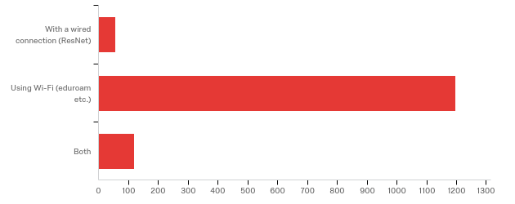

# | Field | Minimum | Maximum | Mean | Std Deviation | Variance | Count
1 | How do you connect to the Internet in your on-campus room? | 1.00 | 3.00 | 2.05 | 0.35 | 0.12 | 1371

# | Answer | % | Count
1 | With a wired connection (ResNet) | 4.08% | 56
2 | Using Wi-Fi (eduroam etc.) | 87.31% | 1197
3 | Both | 8.61% | 118
 | Total | 100% | 1371

Q20 - Have you set your security questions and registered your cell or non-UB email to reset your UBITName password 24/7 at ubidm.buffalo.edu?
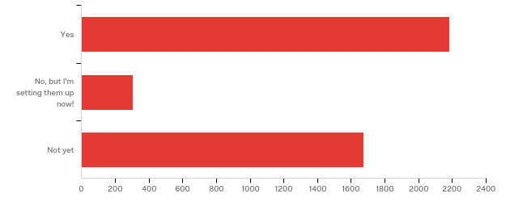

# | Field | Minimum | Maximum | Mean | Std Deviation | Variance | Count
1 | Have you set your security questions and registered your cell or non-UB email to reset your UBITName password 24/7 at ubidm.buffalo.edu? | 1.00 | 3.00 | 1.88 | 0.96 | 0.91 | 4164

# | Answer | % | Count
1 | Yes | 52.47% | 2185
2 | No, but I'm setting them up now! | 7.28% | 303
3 | Not yet | 40.25% | 1676
 | Total | 100% | 4164

Q21 - Two-step verification keeps your online accounts safer by adding a second layer of protection during login--usually a notification asking for approval on your phone, or an extra code you enter along with your password. Two-step verification will be required for students' UBITName accounts by the end of November 2019 (visit buffalo.edu/ubit/duo to enroll and learn more). Which of the following best describes your feelings about two-step verification?
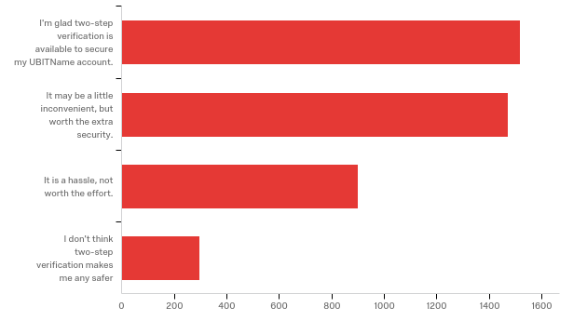

# | Field | Minimum | Maximum | Mean | Std Deviation | Variance | Count
1 | Two-step verification keeps your online accounts safer by adding a second layer of protection during login--usually a notification asking for approval on your phone, or an extra code you enter along with your password. Two-step verification will be required for students' UBITName accounts by the end of November 2019 (visit buffalo.edu/ubit/duo to enroll and learn more). Which of the following best describes your feelings about two-step verification? | 1.00 | 4.00 | 1.99 | 0.93 | 0.86 | 4183

# | Answer | % | Count
1 | I'm glad two-step verification is available to secure my UBITName account. | 36.27% | 1517
2 | It may be a little inconvenient, but worth the extra security. | 35.17% | 1471
3 | It is a hassle, not worth the effort. | 21.52% | 900
4 | I don't think two-step verification makes me any safer | 7.05% | 295
 | Total | 100% | 4183

Q24 - From the list of services below, please indicate your level of satisfaction with each:
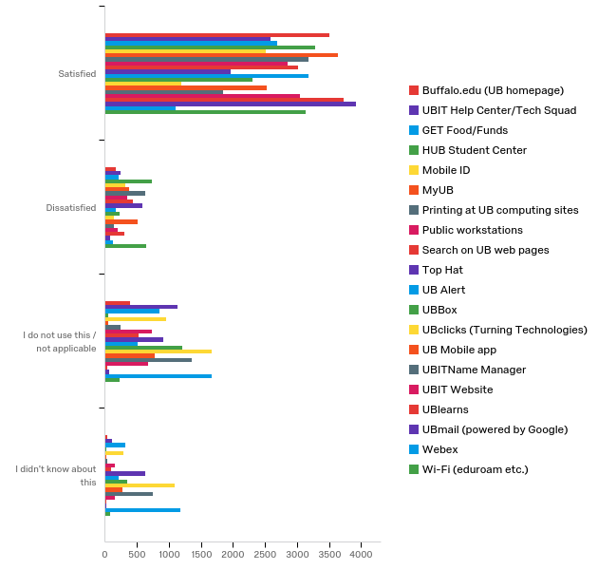

# | Field | Minimum | Maximum | Mean | Std Deviation | Variance | Count
1 | Buffalo.edu (UB homepage) | 1.00 | 4.00 | 1.26 | 0.65 | 0.43 | 4088
2 | UBIT Help Center/Tech Squad | 1.00 | 4.00 | 1.70 | 0.97 | 0.94 | 4088
3 | GET Food/Funds | 1.00 | 4.00 | 1.71 | 1.05 | 1.10 | 4088
4 | HUB Student Center | 1.00 | 4.00 | 1.22 | 0.47 | 0.22 | 4088
5 | Mobile ID | 1.00 | 4.00 | 1.76 | 1.04 | 1.08 | 4088
6 | MyUB | 1.00 | 4.00 | 1.14 | 0.43 | 0.19 | 4088
7 | Printing at UB computing sites | 1.00 | 4.00 | 1.30 | 0.62 | 0.39 | 4088
8 | Public workstations | 1.00 | 4.00 | 1.56 | 0.91 | 0.83 | 4088
9 | Search on UB web pages | 1.00 | 4.00 | 1.44 | 0.80 | 0.64 | 4088
10 | Top Hat | 1.00 | 4.00 | 2.05 | 1.15 | 1.32 | 4088
11 | UB Alert | 1.00 | 4.00 | 1.45 | 0.90 | 0.82 | 4088
12 | UBBox | 1.00 | 4.00 | 1.90 | 1.09 | 1.19 | 4088
13 | UBclicks (Turning Technologies) | 1.00 | 4.00 | 2.65 | 1.16 | 1.34 | 4088
14 | UB Mobile app | 1.00 | 4.00 | 1.71 | 0.99 | 0.99 | 4088
15 | UBITName Manager | 1.00 | 4.00 | 2.25 | 1.21 | 1.45 | 4088
16 | UBIT Website | 1.00 | 4.00 | 1.50 | 0.90 | 0.82 | 4088
17 | UBlearns | 1.00 | 4.00 | 1.11 | 0.37 | 0.14 | 4088
18 | UBmail (powered by Google) | 1.00 | 4.00 | 1.07 | 0.36 | 0.13 | 4088
19 | Webex | 1.00 | 4.00 | 2.72 | 1.15 | 1.32 | 4088
20 | Wi-Fi (eduroam etc.) | 1.00 | 4.00 | 1.33 | 0.67 | 0.46 | 4088

# | Question | Satisfied |  | Dissatisfied |  | I do not use this / not applicable |  | I didn't know about this |  | Total
1 | Buffalo.edu (UB homepage) | 85.57% | 3498 | 4.04% | 165 | 9.64% | 394 | 0.76% | 31 | 4088
2 | UBIT Help Center/Tech Squad | 63.38% | 2591 | 5.87% | 240 | 27.89% | 1140 | 2.86% | 117 | 4088
3 | GET Food/Funds | 65.80% | 2690 | 5.33% | 218 | 20.94% | 856 | 7.93% | 324 | 4088
4 | HUB Student Center | 80.33% | 3284 | 17.98% | 735 | 1.20% | 49 | 0.49% | 20 | 4088
 | Mobile ID | 61.52% | 2515 | 7.90% | 323 | 23.51% | 961 | 7.07% | 289 | 4088
 | MyUB | 88.89% | 3634 | 9.08% | 371 | 1.35% | 55 | 0.68% | 28 | 4088
 | Printing at UB computing sites | 77.59% | 3172 | 15.53% | 635 | 5.94% | 243 | 0.93% | 38 | 4088
 | Public workstations | 69.79% | 2853 | 8.61% | 352 | 17.81% | 728 | 3.79% | 155 | 4088
 | Search on UB web pages | 73.90% | 3021 | 10.86% | 444 | 12.96% | 530 | 2.27% | 93 | 4088
 | Top Hat | 48.02% | 1963 | 14.26% | 583 | 22.21% | 908 | 15.51% | 634 | 4088
 | UB Alert | 77.81% | 3181 | 4.28% | 175 | 12.62% | 516 | 5.28% | 216 | 4088
 | UBBox | 56.36% | 2304 | 5.48% | 224 | 29.67% | 1213 | 8.49% | 347 | 4088
 | UBclicks (Turning Technologies) | 29.16% | 1192 | 3.45% | 141 | 40.85% | 1670 | 26.54% | 1085 | 4088
 | UB Mobile app | 61.74% | 2524 | 12.62% | 516 | 18.91% | 773 | 6.73% | 275 | 4088
 | UBITName Manager | 45.11% | 1844 | 3.40% | 139 | 33.24% | 1359 | 18.25% | 746 | 4088
 | UBIT Website | 74.58% | 3049 | 4.89% | 200 | 16.66% | 681 | 3.86% | 158 | 4088
 | UBlearns | 91.05% | 3722 | 7.53% | 308 | 1.03% | 42 | 0.39% | 16 | 4088
 | UBmail (powered by Google) | 95.89% | 3920 | 1.98% | 81 | 1.52% | 62 | 0.61% | 25 | 4088
 | Webex | 27.15% | 1110 | 2.96% | 121 | 40.95% | 1674 | 28.94% | 1183 | 4088
 | Wi-Fi (eduroam etc.) | 76.71% | 3136 | 15.73% | 643 | 5.48% | 224 | 2.08% | 85 | 4088

Q59 - In general, do you think your instructors have the classroom technology they need to give you the...
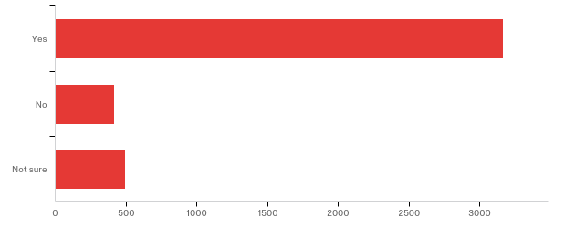

# | Field | Minimum | Maximum | Mean | Std Deviation | Variance | Count
1 | In general, do you think your instructors have the classroom technology they need to give you the... | 1.00 | 3.00 | 1.34 | 0.68 | 0.47 | 4076

# | Answer | % | Count
1 | Yes | 77.72% | 3168
2 | No | 10.21% | 416
3 | Not sure | 12.07% | 492
 | Total | 100% | 4076

Q60 - What changes could be made to classroom technology to provide a better learning experience?
What changes could be made to classroom technology to provide a better learning experience?
Using free alternatives such as Kahoot rather than TopHat
Adding a smartboard so they can actually show problems
more outlets in lecture halls
Can write in a tablet casting to the projector and send the soft copy of notes that was written in the tab to the students
The projector is too old, the color is not correct, sometimes makes it difficult to look at.
i dont know
stop the dual verification
Teach presenters how to make good presentations.
better computers
The classroom technology should be free so more people can afford it and enjoy using it.
Outlets in lecture halls
I think they have a lot of helpful technology available but they dont use it. Ive had teachers here that still write on the board or use projectors instead of powerpoint or tophat. and some dont allow any technology inlcuding laptops in their classroom. this hinders manys students ability to to take notes
Professors who write on board do not upload notes for obvious reasons, but perhaps a technology could capture it
More interactive, like top hat with the questions
Increase tuition by $1000 each and provide each student with an electronic device equipped with all UB apps (ex. ipads, chromebooks, etc.) All students would have a guaranteed way to engage in class.
sometimes, use lesser technology
put garbages in all classrooms.
Technology that teachers know how to use
Stop making me pay for services to teach me. Why am I paying to do homework?
I think Smart Boards go a long way. Additionally, updated computers. One class that I have in Baldy 105, the computer will literally shut down 1-3 times during lecture and its really annoying and time consuming.
smart boards in the small lecture classrooms such as the ones in nsc or talbert
my Native american history teacher could use UB learns, also a better notification system for grades could be utilized
Better computers and software
Have more online classes available for Grad/Ph.D. Education Students. I wish I could enroll in online classes versus in-person because I work and attend. I also live/work an hour away.
Music recording and studio is super outdated
air condition system
Faster network
Professors aren’t properly trained on how to utilize the available equipment.
a double screen
Projector sometimes do not work as intended
It would be great if we can use just one singular website fro doing assignments instead of multiple different websites.
Enhancement in video screens and sound bars
allow technology
free applications for class work
Better load balancing throughout ubit
More interactive software
none
Not sure
Sharing slides with students for lectures
Updates may be needed, ex: outlets
Kahoot - free alternative to top hat
PAPER
They could post hw on the websites
shit that actually works
It's good already
more access to technology assistance
I do not currently attend classes on-campus. I do not feel it is appropriate for me to answer this question.
Some of the older classrooms have problems withe the camera monitor
Provide class notes
better equipment
clicker or voter
Better internet access in all buildings
record all lectures
The teachers need to learn the basics about operating systems and how to navigate though simple software.
Smart boards, better desktop projectors
Currently, my professor using paper with the camera and i would rather see him write his notes on an ipad in a powerpoint.
More interactive and cheaper tech
Better board settings, the projector should not project its image on the board but to a different target wall so that the professor can use the board to solve things on the board.
Training for faculty
More internet speed
Better mic system
better usability
One of the projectors are broken in a classroom and has not gotten fixed yet this semester after many inquiries from my professor.
Accessibility to outlets
Allow phones and laptops in each class
Use alternative apps that are free.
not sure
Ensure that every classroom projector is up to date.
The microphone/speaker in nsc 225 is terrible and I cannot hear the professor even though I sit near the front
better speakers
Idk
Better training with different styles of technology, above and beyond the shared classroom spaces
all professors should be required to use ublearns and post grades regularly.
Professors usually use slides for teaching. Sometimes they need to write equations or sentences inside the slides. So they have to remove the screen that is a hard work and then they use whiteboard in the classrooms. So I believe if they have a electronic pen, they can write these things on the slides and be shown on the screen. Therefore, they don’t need to remove the screen to use the whoteboards
if things were more streamlined and intuitive or if teachers were given training on how to use the technology. Everytime there is a lag on either the computer side (something isn't working correctly) or the instructor can't find what they need.
Smartboards, some classrooms still use chalkboards
Depends on the needs of the professor, and what will enhance learning.
The dance studios do not have good projection screens.
Better WiFi
Interactive with our familiar tech
teach them hhow to use it
Better Wifi
In class related questions
Instructors need to be trained on how to use technology in the classroom.
Allowing Laptops
Holographic Projections
Wifi
Upgrade the GSE computers and technology. The department is so behind in the latest everything.
Using UBlearns rather than Tophat for classroom Technology.
An IT person always in the actual building to quickly troubleshoot
Allow lecture recording in smaller classrooms
more projectors and screens
Doesn’t always connect properly
Smart boards
Faster wifi and less download/upload lag time in many of the south campus classrooms
Cheaper learning tools, that work better with wifi
Instructors explained how to use all the features
If the mics in the lecture halls would work consistently during lecture. Sometimes they work and professors/students are able to engage in a productive Q/A session. Sometimes the room strains to hear what the initial question/statement was, and the professor does not always repeat the question/statement in their response.
Educate the teachers how to better use the tech in the classroom
More hands on models and such
Maybe less time or small breaks to refresh and get ready
N/A
All teachers recording lectures for accessibility purposes
Better microphones
recording in all classrooms
better wifi
Professional development with the faculty members would help.
Please do not let the instructors force us to use smartphones to answer quiz questions.
Instruction on how to use provided to the professors. The nursing facility as a whole is crappy. Medicine gets a new building, nursing sits in baby size seats with baby size desks and worries about COCKROACHES in our lab. Fix it!
Make all the lecure live and should be available later for reviewing purposes
smartboards if the instructor requests. drop down screens for projectors that are not ripped.
Training for professors. They need to know how to use the technology available before new technology is added.
None
Maybe offer some classes for professors on how to use technology? I've had some that admit that they struggle a bit with using technology and have had students help them get things set up for them.
Less technology. It's either powerpoint or it slows down the learning experience
My professors often have trouble getting the technology to work
better projectors in some of the classrooms
MORE DUE DATE REMINDERS
My recitation for chem only has a whiteboard. Everything else is OK.
teach the professors how to use them effectively
Better audio
Have professors use more software like connect and WebAssign
.
n
Less Expensive
For a better learning experience, I think it really depends on the professor.
Record The Lectures
Some smaller rooms could have smartboards for more interactive learning
making it a requirement to post notes online at ublearns
Fast wifi
Better equipment
More interactive
Record all lectures regardless of the class
Add smart boards or have a board that can be connected to the computer.
I'm not sure! There's not much technology-wise, so I'm not sure what the possibilities are.
Provide the proper training for professors/ instructors to use extra tools such as learning catalytics.
More open to internet
Not having to use programs that charge students. We should be able to use free alternatives. For instance, instead of Top Hat, Kahoot
Smartboards in Capen classrooms
USE CHALK BOARD INSTEAD
In big lecture halls, working microphones with extra battery’s
I think it is pretty much it, I do not get it sometimes on class but I can always go back and check the class room recordings.
I've seen professors and TAs use their personal Microsoft Surface books/tablets to freehand notes over slides during their lectures. Professors who do not have these devices often use scrap paper with the document camera and may later scan their work and post it online. Technology similar to the Surface books/tablets should be evaluated for future use
Some Lecture halls are huge yet the teacher still insists to use the chalkboard making it impossible to see
Make better cancellation from microphone back noise so the professors can be more easily understood!
DO NOT require TopHat for future exams.
Replacing the chalk boards with white boards or Ben-Q projectors. This is what my high school had and I'm finding the technology was often better at my public high school in the classroom than a top-tier university.
Recorded lectures
updated material
it could be less random about working
Farber hall 180, The computer and projector need to be checked.
n/a
Making the IT platforms easier to use for projectors etc
I do not know
No suggestions
Less glitches More training for professors
Idk
make it more interactive
easier access
clustered, needs streamlining
Recorded lectures for every class
i am not really sure to be honest
give the teachers laser pointers
Record all classes, especially for hard subjects
TopHat
more efficient clickers
I think the professors just need training on how to use tools other than powerpoint
Classrooms need to be set up like class rooms and not just lecture halls with tinny desks and a single projection monitor that dont allow you to move about and work in groups when asked to, having classrooms with bigger desks and multiple screens so you can view the presentation from any angle would be great
hybrid classes not fully online
top hat sucks
No idea
The class which I took are mostly theoretical and some which requires practical training have labs so I don't think form my perspective I would need any additional technology.
In Baldy the wifi is terrible
All professors should use the same programs so students don't have to pay for multiple accounts. Professors know there are problems with certain programs such as Mastering Chemistry and continue to use them; if there are major issues with a program a professor should not expect their students to use it.
Easy to ready manuals available to instructors to easily learn new tech
Farber 180 the computer constantly disconnects with the monitor. Very distracting for both students and professor.
Smarter professors
no top hat
systems that actually work properly
Better training with given technology
Make the differences in technology between classrooms less prevalent
Better display of notes besides chalk/whiteboards
Recording systems on south campus in Hayes Hall classrooms
I'm only here to tell you that the two-step log in process is a huge inconvenience. I do not carry my phone with me, and I've been locked out of my UB services several times. If we have the option to stay logged in for 7 days, why not make it a month or a year? Or ditch it entirely!!!!!!
improve the pointer and mouse so that professors can actually use it. Fix the mics
New Computer in Baldy 8
They knew more about the technology they are using
not sure
The School of Architecture should have better and more print lab services, and more computers to print from.
Switching to tablets, having all lectures recorded mandatory
Teachers have access to technology to use in the classroom with students.
I don’t know what exactly, but I know that powerpoints are not the best way I learn and every single professors uses powerpoints
Making sure Instructors have a guide to using the technology thats readily available
more use of ublearns
I don’t know about technology,but the class size should be smaller
i feel that there is ample technology in the classrooms
Having every class available for online lectures, more interactive activities
Less chalk
Subtitles in class record
More computer usage
Have clearer directions on the technology and online stuff that you need for classes because most people have no clue
making sure they actually work
More integration with phones, much quicker/easier to use than a laptop
Better internet connection
I have one professor in particular that seem to struggle a lot. One of the hardest parts of learning in her class is that it is a huge lecture hall and she likes to write out additional side notes or do problems out and doesn't have the proper tech. So all we see on the big screen is chicken scratch (kind of like what your signature looks like at the supermarket on the veriphones). If she had a screen that was more interactive set up at the podium that a pen would work well on it would help dramatically.
they can include real life objects to teach
Microphones that work, All classes to be recorded
Clicker learning technology and tophat are inconvenient and expensive to students.
better markers. projectors with adapters, dont make me buy adapters for vga hdmi and so on please.
AutoCAD lectures should be taught in a smaller classroom setting where everyone has access to a computer that has Autodesk downloaded.
I’m not sure I have an answer
More wifi for devices
New Computer
allow us to take exams on laptops but freeze most functionality of the laptop
more opportunity for different technology
Better tech training for teachers
Not sure
Let all teachers be able to record lectures for Panopto
use tophat not pearson questions
no top hat and not proctor U fro exam
For technology to be the same across all buildings so they can setup and access faster
N/A
Projectors and microphones
Systems are not user-friendly. Need to train faculty/staff.
Update the desktops inside the classrom, inform teachers on how to use the tech
Smart boards or white boards at the very least
better wifi connection
I am getting my degree online. The technology is not conducive for classroom setups... specifically WebEx. The professors had to learn the new program which took time away from the curriculum and for the first six months didn't allow the "hand raise" feature among other things. I am getting my degree completely online and in regards to meeting my class online every week = I need the technology to be more user- friendly and classroom-centered not corporate-centered.
Uncertain
Not all professors use UBlearns or sometimes are not sure how to work with the projectors/computers in the classrooms.
more computer labs
Intelligent lighting fixtures for the theatre tech program which is apparently one of the top programs in the country and recently selected students to go to prague as part of an international competition
Not sure
outlets, headphone jackets to hear the prof better, every class being recorded
Install smart boards in classrooms.
Incorporation of better hardware and software to promote digital modeling
ensure that every professor could use ublearns for grades
a system that is easily manageable.
Teachers seem to not know what to do for some of the classrooms
I do not know.
Most professors end up running into technology not working/not working well.
give instructors a stipend each semester to spend on the technology they need for the classroom so it can be tailored to the curriculum and student needs
By allowing more lectures to be recorded
microphone
I feel like the use of Macs/Apple products are detrimental to use, but it gets the job done. I think more classes (design classes in small rooms mainly)need white boards
Nothing this place sucks
tophat should be free
DocuScanner appears to malfunction easily
More training for teachers to help them stay current with learning technologies
Some of my big lectures i cant hear the professor or theyre hard to understand.
Make it more reliable. Technology works sometimes and sometimes doesn't
Some of my teachers do not use any technology which I wish could be allowed.
One of our classrooms has a large TV that the professor has to connect to; it typically fails at least once during the class and there is no other technology available in the room.
Needs to work better, multiple teachers have had in classroom connection issues during classes.
stuff that works and does not take forever to load
I'm not sure.
more activites and interaction
Improve student concentration but keeping distractions minimal such as sudden lots speaker noises when professor plays a video
Computers often are not ready for instructors to use or sound systems don't work, should be improved
Every class should have recording capabilities
teach the teachers to use it properly
Fix the technology
Recording lectures
theres no technology in nsc
go back to old school chalk and black board
not sure
Outlets in nsc
Projectors in every room, sound system improvements, better/any tech training
One teacher with no TAs, a private installation that allows students with disabilities to retain help and proper guidance—a place where students with disabilities can get help in all facets, even students without disabilities
Faster loading time
The technology is fine but no professors actually know how to use it.
Some classrooms in smaller departments arent adequate. Not in terms of space for students or available technologies. Also considering Clemen hall has so much internet dropping it limits access.
Less TopHat
More reliable
More engaging technology
The internet should be improved
The mic should be more clear
More technology does not make a poor instructor better at teaching.
no tophat or anything we have to pay for
Using Panopto automatically (especially for large classes like those in Knox 20)
Stop making kids buy tophat it’s useless
fingerprint login
Computer lab kind of experience for CS students maybe in lectures. laptops available in library for twmporary usage.
Classroom recording
Just a better wifi connection and outlet for every lecture hall to charge labtop
Updated instead of a 90's looking tv used as a monitor on South Campus in Farber
more interactive experience with chromebooks
Actually recording lectures when possible
Not sure
One of our classrooms requires a tablet to connect and present and it just doesn’t work.
more interactive document camera replacement, train professors to use the computer/projectors instead of chalk talk
cannot make changes to computers used for presenting due to admin privileges
It needs to be more digital than it is. Some instructors ask for paper copy of assignments.
Make it all one site l, kinda absurd I have to use tophat, Piazza, ublearns, blackboard, gradescope, GitHub, ubbox, we works, and 4 different course websites for 3 classes
Make it modern
provide better IT support or require professors pass a minimum competency exam before they are allowed to teach
projectors need to be put in the fronzack classrooms. The clocks are broken in a few lecture halls.
Use newer technical advancements
not sure
nothing
I often find my instructors facing technical difficulties dealing with volume, login etc.
unsure
One app for in class questions
Post slides
bring blackboard into the 21st century
The pointer for lectures never works properly
As a TA, some classroom's connector does not work, and not provided.
Teachers using more relevant technology
Recording when i know its already possible in the room
I would honestly rather have a physical text book than pay for an online program that neither I nor the professor know how to use but the department requires.
Have every professor use power point for notetaking instead of just reading from a txtbook
Not charge $50 for a device that is mandated by a professor as part of your grade. Esspecially when you have free serivces like ublearns that can take poles and the iclicker app.
Hook up the classroom lights to the projectors so when the projector is turned on the lights towards the board are automatically turned off.
More digitization of lecture capabilities
Training for faculty, staff, students (especially Webex) and ready IT support
Not sure
many of the instructors don't know how to use a lot of the technology at their disposal
Microphones being charged
Seats in nsc screech a lot creating distractions and sound quality in many classes aren’t good so everyone has to sit closer to professor
I enjoy lectures via tophat more often than not
One of my professors refuses to use the microphone and she speaks very quietly
Better technology for connecting their tablet or laptop to the projector. Also better projectors.
Better tophat experience
Charging stations for graduate students on the desks. Charging stations in different buildings.
Teaching them how to use the technology in the classroom. Basic troubleshooting training.
hg
Charging stations embedded into tables in lecture halls in order to allow us to keep our laptops charged
More professors using the classroom technology
For labs in one of my classes (CSE 116) we are not allowed to use the school computers even though we are in a room with them right in front of us. Instead we are required to do labs on our personal laptops, which can be a hassle if you run out of battery or laptop breaks and so on. I'd like to at least have the option of using a school computer for lab time.
Don’t know
Using a different program other than tophat. Maybe UBlearns
it is so old
Teach instructors how to use it
Use one app for all classes
unsure
Additional hybrid options, auto-recorded lectures with transcripts, VR classroom
Recorded lectures would make studying and revising so much more accessible. I think any lecture with more than 100 students should utilizing recorded lectures.
I don't know
better wifi connectivity
Make TopHat free, or more worth the price.
Better equipment connections, not having trouble with hookup issues
Teachers take a while to get things up and running. They shouldn't have to go through hoops to start class. (These are people who are technically savvy too)
Some classrooms don't have charging docks
Not sure
better mics in large lecture halls
Make it inexpensive and more convenient
updated ublearns and online video for classes especially when some teachers use the full camera and screen cap
Teachers knowing how to use the tech
Because UB still uses pull down projectors it limits both the professor and the students they are instructing to simple computer functions unlike the features on newer smart boards that are updated and allow for white board use and internet access and presentation.
Make classroom technology available to everyone and not just the teachers, so everyone is comfortable with the learning style
Better projectors
dunno
Top Hat needs to work better to be worth using
Crosby Hall still uses chalk boards and only has one small computer lab
tech support to assist with the sound, recording issues, and pointer (it's a new medical building but the current technology is hard to use by professors)
Delete TopHat and clickers
Smart boards. We waste lots of time erasing the chalk
Nothing
Better wifi, reliable tech in rooms, faster tech support.
Include smart boards, more outlets, and or more elmo projectors. They're cleaner and easier to see things written.
More student engagement, showing instead of telling
Overhead projectors
better internet connection as sometimes it gets too crowded and we can’t login to do clicker questions
More screens for students who may have their view skewed
Sometimes there are classrooms that do not have technology
Better tech, Hosh/Cook 114,121 the TV screens need to be updates, Plugs in all classrooms, and good/large projection screens
Better teacher... they suck.., half of them don’t even know how to use the technology. Please give them a demonstration
teachers need to know how to use the equipment and then it also needs to consistently work
Better at not dropping wifi
Smart boards that professors can write on
Teach the instructors how to use it better
Technology is not great in the Ellicott Complex
updated computers, less bulky, more view of students
Better wifi and less programs that students have to purchase every year. In addition sometimes the recording of lectures malfunctions
Better use of chalkboard or whiteboard (sometimes no chalk made available), Microphones properly working or extra batteries on hand
Not sure
Recording technology of screen and audio. Not fair for students to miss classes if they can't help it
charging outlets near seats
Better projectors!!
Making it more integrative with the lecture
N/A
Better lecture recording technology
More tophat, kahoot, and interactive tools because students respond well using technology
not using top hat
nothing
It might be nice if more classes were recorded
Make it more accessible (in terms of cost, for those with disabilities)
Better class structure
A lot of the professors do not know or do not like to use UBlearns
make homework in one file in ub learns, to make it easier and more accessible rather than paying in another website for homework. also homework alerts in ub learns like the ones they have for google classroom.
not sure
Not sure
making it more similar for all areas of campus
New equipments
Professors don't use technology, lectures should be more interactive
N/A
Making sure teachers know how to operate the technology installed in the classrooms and make sure technology is actually working
Better mics and class recording in all classrooms
ability to record lectures right in the classroom; smart boards; not having to pay for top hat
Smart Boards
Every computer turns on
There seems to be continual issues with the networks in various classrooms
a few of my classes have absolutely nothing on blackboard or arent even affiliated with it and it is extremely inconvenient for the student to not have all if my work/syllabus in one spot.
more demonstrations in physics
No top hat
Recording lectures
More online interaction instead of just looking at a powerpoint slide
more resources for theatre performance program
Some app allowing to interact with instructors, maybe.
not using Top Hat
Document cameras in more rooms
Better WiFi connection is needed.
Better people
flipped classrooms
better blackboard
Video recordings for all course!!!!!!
Use slideshows
Make sure the mics work
Make it all one platform. It is overwhelming to use 3 different platforms for 4 classes.
Record lectures
Lighting issues, sound
We need to only use tophat or some other clicker questions. it isnt fair that we have to pay a lot for multiple apps doing the same stuff.
Not sure
Introducing more computer based classwork.
More available technology and printing in the Center For The Arts
Teaching the professors how to use digitation before they make us use it.
Teach professors how to work tech
all teacher should be required to use blackboard/unlearns and post grades on a weekly basis
Classroom involve
Professors are always having difficulty loading PowerPoint or keeping pop ups from coming up
In the art department, there need to be enough computers as there are digital art classes. For example, a web design class schould not have half of their classes without computers.
one single website to answer in class questions opposed to a million different paid subscriptions
sometimes the projectors don't work or theres no mic in big classrooms.
Smart boards and lasers for the power points
Davis 113a's computer is always broken.
Better wifi so we can connect during tophat or learning catalytic questions so we don’t lose points throughout the year
More recorded classes
Either have faster wifi or have a router that can withstand more than 100+ clients
accessibility
Smart Boards
Stop tophat
Less reliance on technology
Can’t hear
Allowing anyone to log onto the computers in classrooms after hours
Apple computers
Outlets for laptops
More video recordings (some courses don’t have that)
faster learning
in Clemens classrooms on the ninth floor the technology is limited and there is nothing to project paper onto the board
Better WiFi in large lecture rooms
n/a
Provide technology that works and does not blink (many projects blink and turn off during class0
No TopHat
Not have to pay for tophat subscription
All the teachers are educated on proper use and how to fix simple problems that may occur
The projector screen has various errors- flickering, freezing in between class, no sound at 180 Farber Hall
Na
Math classes could incorporate technology more.
Video recording of all lectures
n/a
Providing more basic real life examples to relate
No top hat
More technology based learning
Recording some classes, which can br revisited later
I think some older buildings still have chalk board and should be changed to white board or smart board. Every freshmen usually has to take some sort of math class in Talbert or Baldy. These classrooms look very old and worn out.
Sometimes top hat doesn’t let students check in and it would be nice if we didn’t have to go up to the professor after every class because tophat wasn’t working as well as we want it to.
no top hat
Allow note taking to happen on any kind of device for any class. Also posting notes to write on really helps students engage in classes.
Technology in theatre classrooms
Train faculty on WebEx
Not using chalkboards
Always recorded lectures
Every teacher should utilize UBlearns instead of just a 3rd party (Tophat)
Better connevtivity
I’ve had multiple professors struggle to write notes on the tablet which projects to the whole screen. It is visibly very touchy and wastes class time.
Professor Balkundi barely allows laptops. A lot of other professors that are "Old school" do the same. Many do not realize that laptops actually help us learn more than just paper and pen.
Record lectures always
The instructors should get more familiar with the technology.
Teach professors how to use TopHat
Touchscreen whiteboards
Have professors be more tech savvy.
Smart boards. Easier integration .
Recording the lectures. The professor's teach the subject really good. But sometimes if we have any doubt it gets really inconvenient to search for problem online where you can understand it by just watching the lecture recording
Just a pace for everyone to learn and get the information at the same time
Not sure
better document cameras that work
make sure each class has pronotpo
None
A digital blackboard they can write on and display on the screens. Makes it easier to see than the blackboards which aren't visible from the back of the class
Better speakers
Not much. Everythings good
In class usage of technology
maybe making things less expensive so that students can afford to eat and have their textbooks. All those unnecessary "online homework" programs that cost a whole months set of groceries can be just made into paper or a UBlearns submission or something. There is no need for 5 different teachers in the same department to use different software and force the students to get all of them.
SmartBoards for the GSE. It is hard to learn how to teach lessons when we don’t have any access to the technology that we will encounter in our classrooms.
upgrading the system
I like teacher writing on paper, then update it on unlearns.
add top hat more
Microphones in law lecture halls to hear in the back
Better lecture recording camera. Sometimes the recoridngs appear blurry. And sometimes the camera isn’t aim towards the appropriate material being discussed.
Better camera and computer
n/a
Easier access, problems with video chat software
N/A - program is online
All teachers should have their notes and lectures in a digital format online.
For bigger classrooms maybe have TVs so people can see better when they can not get a seat in the front

Q25 - In what ways would you like to use your smartphone or tablet in UB's classrooms? (Select all that apply.)
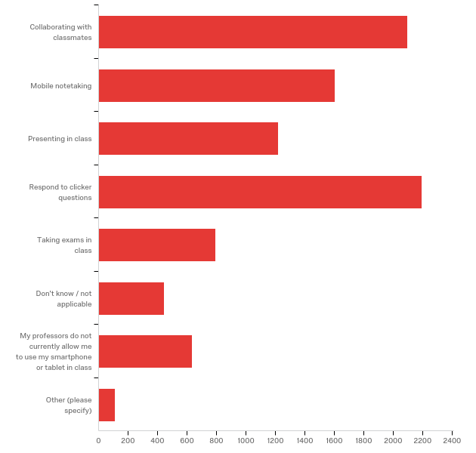

# | Answer | % | Count
1 | Collaborating with classmates | 23.08% | 2099
2 | Mobile notetaking | 17.62% | 1603
3 | Presenting in class | 13.39% | 1218
4 | Respond to clicker questions | 24.12% | 2194
5 | Taking exams in class | 8.73% | 794
6 | Don't know / not applicable | 4.87% | 443
7 | My professors do not currently allow me to use my smartphone or tablet in class | 6.97% | 634
8 | Other (please specify) | 1.22% | 111
 | Total | 100% | 9096

Q25_8_TEXT - Other (please specify)
Other (please specify) - Text
killing time
Procrastinating
none
tophat
Some teachers dont post notes
no
I prefer using pen and paper methods in class, but not out of class
video explination
They really shouldn’t be used
I use my laptop for any classroom work. My phone may be used to record lectures only
Not really looking for my smartphone to be required
Refer textbook material
Better seats and audio
All professors are not tech savvy which is a burden for me.
to open file from dropbox
attendance
Mainly used for note tracking
sometime use dictionary
Instagram and Snapchat
instagram, snapchat
I'd rather not.
Responding to clicker questions using your phone INSTEAD OF BUYING OR RENTING CLICKERS UNNECESSARILY. People who don't have phones should have clickers provided or be instructed to acquire them.
I would prefer not to have my personal devices integrated with school functions
To see the slides that the professor is teaching the
Responding to clicker questions without paying ridiculous service fees. Top hat is stupid, why would I pay for that service PER SEMESTER if I could buy a new clicker for half the price, and a used one for less than a quarter of that??? And for christ sakes, pick one method and standardize it
Calculator if forgotten
Using a smartphone in class literally makes cheating easier as the instructor cannot see all screens at all times even if they're on the table. That's why laptops aren't used for taking tests and many professors don't allow them in class so that students can focus on the material and not whatever is happening on social media or their homework for another class.
Reading the ebook and slides
Mobile note taking is much better as we always text and use our phone
I’ve had online exams and the stress of a WiFi connection not working or cutting out while the test is in progress is not worth it in my opinion
Not having attendance for classes I’m already paying for or at least not have it negatively impact my grades
I wouldn't, and I wish the school would stop assuming everyone wants to use theirs
Viewing notes
I don’t want to use phones in class
No phones - extremely distracting
I wouldn't.
None
it is mostly a distraction for me
Asking Questions
Top Hat
I am an online only student
I don't
translate English to my native language
Wouldnt use them
attendance if they take it
They degrade class experience
Not to be used in class
I attend entirely online
Looking at suplemental materials
no, I prefer hard copies and nondigital
some of my professors don't let me use a device.
I don’t want to use my phone in class- I have a laptop
I would prefer to stick to traditional note taking. Cannot learn well with a screen.
Don't make us take exams on our computer please
only if we have to look something up
Cell phones are a distraction
translate
Why would anybody need to use a smartphone in class? I find this survey's fetishistic preoccupation with technology a bit creepy.
don't use my mobile device for notes
none
Just because I have a phone, doesn't mean I want to use it in a classroom.
I don't
I wish that technology (I.e. Tophat) was not required
STOP using phones! Distracting!
Sometimes I like to look up relevant information on my phone during a discussion or to clear up some information during a lecture.
I don't think this is necessary. It creates a mandate for students to buy technology they may not want/need. In addition, I have found it rarely enhances the experience.
I use my phone alot to just wrote things down quick that I have to remember or to take pictures of notes that I didnt get to finish. Would be nice to not have to hide it when I'm using it for achedemic purposes.
I don't want to use my smart phone in the classroom. Using TopHat means that those of us who have crappy service don't get the points.
looking at readings online
Knowledge about campus resources
Smartphones are distracting
check email
I don't want to use my phone in class
Kahoot
I don’t need to use my smartphone, mostly because I don’t want to pay for top hat.
Top hat
Playing Tetris
I do not find it necessary to use my phone in class
Smartphones shouldn't be used except for clicker questions
I don't like the idea of using clicker questions during class just because I end up being graded on whether the wifi connects well enough. I also don't trust technology enough with quizzes or exams because it might crash
Everything except taking quizzes or exams. Phones can definitely be used for communication and gaining or sharing knowledge but not for proving that knowledge for course credit. That needs to be the student to perform without assistance from a device other than maybe a calculator.
I do not want to use my smartphone or tablet in class.
class streams
These devices only serve as distractions.
I currently utilize these technologies in various ways in all of my classes, and I am relatively happy with the way they are used
I don't want to.
Top hat
None of these are helpful wtf
I like to use paper and pencil/pen for most class related stuff ie note taking, exams, etc. I don't think a tablet would benefit learning in class
taking notes, doing homework
None
I would rather not have them used. They are usually used in a lazy, uninspired way that seems to be designed to kill time.
I do not like using phones in class
I do wonder whether I'm just old-fashioned about this (like adults who get all bent out of shape about the demise of cursive), but my faith in the idea that students ever want to use devices in class for class-related activities is pretty close to zero. Even when they are asked to use devices in class for a class-related activity, they seem to be perpetually at risk of losing foucs and getting on social media, etc.
Designing
I think the less we try to involve cell phones the better. It will promote further texting, web surfing, etc instead of focusing on the lecture. I feel it is rude when students are on their phones when the instructor is trying to teach. I would personally love to be able to fully take notes on pen and paper but there is just too much material being covered in such a short amount of time.
Looking up general information before asking a question.
I dont want to use my phone in class
Reading and annotating materials (instead of printing)
I like paper notes more
Scheduling
I do not want tablets in classrooms

Q26 - Have you ever used classroom response or "clicker" technology (Top Hat, UBclicks/Turning Technologies etc.) in your classes?
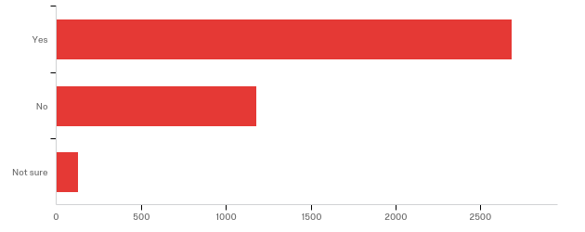

# | Field | Minimum | Maximum | Mean | Std Deviation | Variance | Count
1 | Have you ever used classroom response or &quot;clicker&quot; technology (Top Hat, UBclicks/Turning Technologies etc.) in your classes? | 1.00 | 3.00 | 1.36 | 0.54 | 0.29 | 3996

# | Answer | % | Count
1 | Yes | 67.24% | 2687
2 | No | 29.53% | 1180
3 | Not sure | 3.23% | 129
 | Total | 100% | 3996

Q27 - Which classroom response or "clicker" tool do you prefer using?
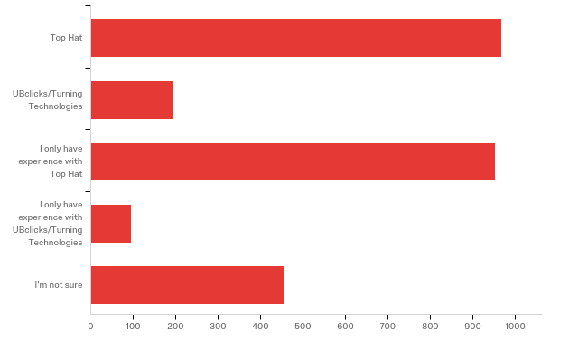

# | Field | Minimum | Maximum | Mean | Std Deviation | Variance | Count
1 | Which classroom response or &quot;clicker&quot; tool do you prefer using? | 1.00 | 5.00 | 2.58 | 1.44 | 2.07 | 2666

# | Answer | % | Count
1 | Top Hat | 36.35% | 969
2 | UBclicks/Turning Technologies | 7.24% | 193
3 | I only have experience with Top Hat | 35.78% | 954
4 | I only have experience with UBclicks/Turning Technologies | 3.53% | 94
5 | I'm not sure | 17.10% | 456
 | Total | 100% | 2666

Q29 - What have your instructors used classroom response systems or "clickers" for in the past? (Select all that apply.)
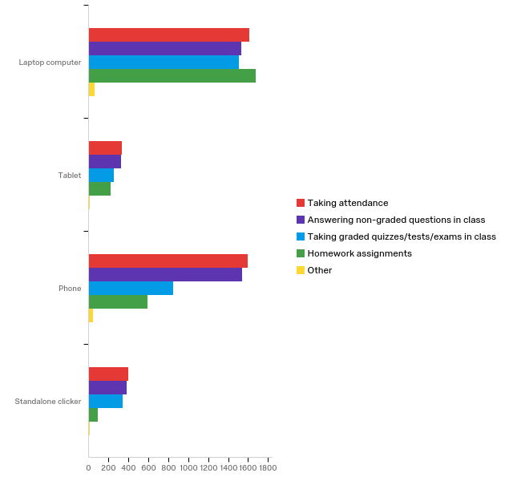

# | Question | Laptop computer |  | Tablet |  | Phone |  | Standalone clicker |  | Total
1 | Taking attendance | 40.90% | 1614 | 8.49% | 335 | 40.52% | 1599 | 10.09% | 398 | 3946
2 | Answering non-graded questions in class | 40.59% | 1536 | 8.69% | 329 | 40.62% | 1537 | 10.10% | 382 | 3784
3 | Taking graded quizzes/tests/exams in class | 51.13% | 1511 | 8.46% | 250 | 28.80% | 851 | 11.61% | 343 | 2955
4 | Homework assignments | 64.86% | 1680 | 8.65% | 224 | 22.90% | 593 | 3.59% | 93 | 2590
 | Other | 47.76% | 64 | 11.19% | 15 | 34.33% | 46 | 6.72% | 9 | 134

Q32 - From the choices below, please drag to order your preferred methods of communication with the UBIT Help Center for assistance with technology (with #1 being your first choice, #7 being your last).
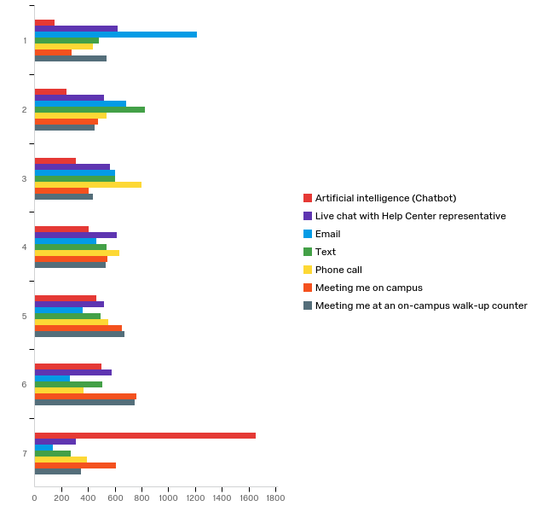

# | Field | Minimum | Maximum | Mean | Std Deviation | Variance | Count
1 | Artificial intelligence (Chatbot) | 1.00 | 7.00 | 5.39 | 1.85 | 3.43 | 3721
2 | Live chat with Help Center representative | 1.00 | 7.00 | 3.77 | 1.91 | 3.66 | 3721
3 | Email | 1.00 | 7.00 | 2.84 | 1.79 | 3.20 | 3721
4 | Text | 1.00 | 7.00 | 3.63 | 1.85 | 3.41 | 3721
5 | Phone call | 1.00 | 7.00 | 3.81 | 1.82 | 3.31 | 3721
6 | Meeting me on campus | 1.00 | 7.00 | 4.49 | 1.87 | 3.51 | 3721
7 | Meeting me at an on-campus walk-up counter | 1.00 | 7.00 | 4.07 | 1.93 | 3.73 | 3721

# | Question | 1 |  | 2 |  | 3 |  | 4 |  | 5 |  | 6 |  | 7 |  | Total
1 | Artificial intelligence (Chatbot) | 4.08% | 152 | 6.37% | 237 | 8.30% | 309 | 10.91% | 406 | 12.47% | 464 | 13.38% | 498 | 44.48% | 1655 | 3721
2 | Live chat with Help Center representative | 16.69% | 621 | 13.92% | 518 | 15.16% | 564 | 16.45% | 612 | 14.03% | 522 | 15.43% | 574 | 8.33% | 310 | 3721
3 | Email | 32.63% | 1214 | 18.33% | 682 | 16.15% | 601 | 12.42% | 462 | 9.76% | 363 | 7.07% | 263 | 3.65% | 136 | 3721
4 | Text | 13.01% | 484 | 22.09% | 822 | 16.23% | 604 | 14.43% | 537 | 13.30% | 495 | 13.65% | 508 | 7.28% | 271 | 3721
5 | Phone call | 11.74% | 437 | 14.43% | 537 | 21.55% | 802 | 16.98% | 632 | 14.81% | 551 | 9.92% | 369 | 10.56% | 393 | 3721
6 | Meeting me on campus | 7.39% | 275 | 12.82% | 477 | 10.91% | 406 | 14.59% | 543 | 17.58% | 654 | 20.40% | 759 | 16.31% | 607 | 3721
7 | Meeting me at an on-campus walk-up counter | 14.46% | 538 | 12.04% | 448 | 11.69% | 435 | 14.22% | 529 | 18.06% | 672 | 20.16% | 750 | 9.38% | 349 | 3721

Q61 - If you have contacted the UB Tech Squad for assistance, which services did you use and find most helpful? (Select all that apply.)
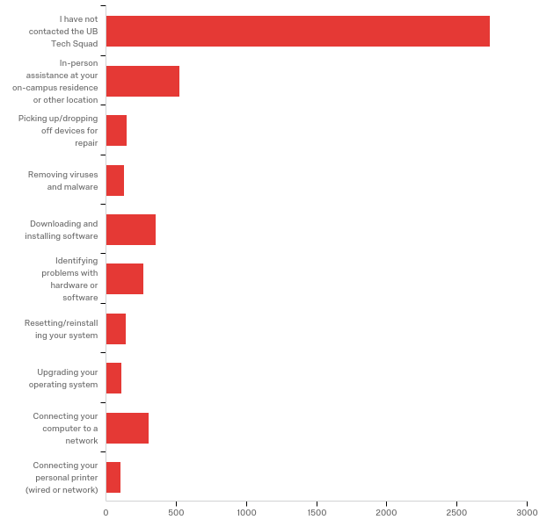

# | Answer | % | Count
10 | I have not contacted the UB Tech Squad | 56.91% | 2737
1 | In-person assistance at your on-campus residence or other location | 10.92% | 525
2 | Picking up/dropping off devices for repair | 3.02% | 145
3 | Removing viruses and malware | 2.62% | 126
4 | Downloading and installing software | 7.36% | 354
5 | Identifying problems with hardware or software | 5.49% | 264
6 | Resetting/reinstalling your system | 2.87% | 138
7 | Upgrading your operating system | 2.27% | 109
8 | Connecting your computer to a network | 6.38% | 307
9 | Connecting your personal printer (wired or network) | 2.16% | 104
 | Total | 100% | 4809

Q33 - Which of the following productivity software titles do you use for your studies or coursework at UB? (Select all that apply.)
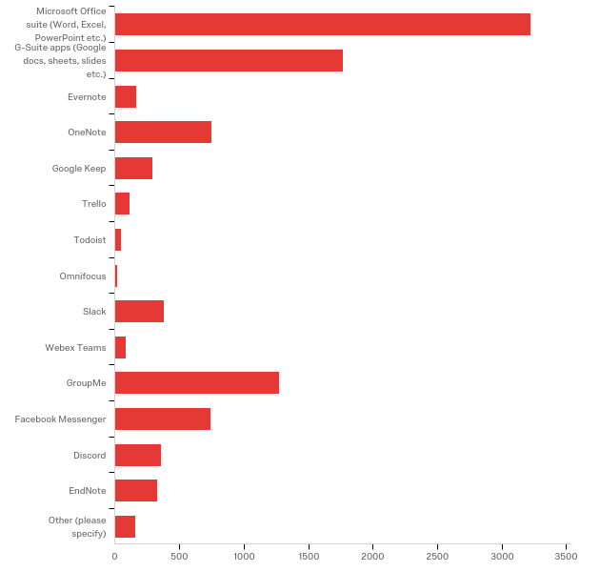

# | Answer | % | Count
1 | Microsoft Office suite (Word, Excel, PowerPoint etc.) | 33.18% | 3223
2 | G-Suite apps (Google docs, sheets, slides etc.) | 18.21% | 1769
3 | Evernote | 1.71% | 166
4 | OneNote | 7.69% | 747
5 | Google Keep | 3.03% | 294
6 | Trello | 1.20% | 117
7 | Todoist | 0.51% | 50
8 | Omnifocus | 0.20% | 19
9 | Slack | 3.93% | 382
10 | Webex Teams | 0.86% | 84
11 | GroupMe | 13.14% | 1276
12 | Facebook Messenger | 7.62% | 740
13 | Discord | 3.67% | 356
14 | EndNote | 3.41% | 331
15 | Other (please specify) | 1.64% | 159
 | Total | 100% | 9713

Q33_15_TEXT - Other (please specify)
Other (please specify) - Text
Notion
GoogleDocs
my own note
Apple Pages, Numbers and Keynote
Google Docs
Apple note
SAS
Notability
GitHub
minitab
Notability
Manifest.Education
Drafting, 3D modelling and respresentation softwares
Eli-Review
microsoft 365
Samsung Notes
Pages
Google docs
Matlab
I would like to use MS products, but UB won't give me access on my Chromebook. I pay a technology fee too.
Flipgrid
Taskstream, Remind
MeisterTask
Notability
SPSS
notability
Adobe
One Drive
Dropbox
Whatsapp
Zotero
drive
Google docs
Whatsapp
Google Scholar
Goodnotes
Notability
Zotero, Adobe Acrobat
Squid
notability
Pdf expert
WhatsApp
Google Docs
Adobe Premier
adobe
SAS, arcGIS
Notability (note-taking)
Zotero; VMWare; XeLaTeX
Whatsapp
Autocad,sketchup,rhino,revit
photoshop
google doc
Adobe Suite
My own notes.
Google Drive
Mendeley
Snapchat
Adobe
LibreOffice and WhatsApp
Dropbox, Skype, WeTransfer
Google Calendar
Joplin
whatsapp
Adobe, Autodesk
Notability
Band
Notes
Zoom
ClickUp
N/A
Sas
Pages
Keynotes and google docs
Microsoft Word, Google Docs
Echo Desktop
notability
MATLAB
Zotero
Box
iWork & Noteability
zotero
IteliJ
Mac—notes app.
Autocad, Revit, Rhino, Vray for Rhino
Goodnote
Google Drive
whatsapp
Habitica
Google Scholar, Google docs, word
Piazza
Adobe
Zotero
SPSS, Stata
WhatsApp
LibreOffice for everything except notes
Zoom (Better than Webex)
Notability
IntelliJ and Atom for Programming, Simlenote for notetaking
PDF
Autocad, adobe Suite, Rhino, Grasshopper
Minitab
Google map, MAtlab
Google Docs
putty
Piazza
Libre Office Suite
google docs
Google docs
Adobe Suite
UB Box
Schoology
Matlab
WhatsApp
Goodnotes
adobe suite
Matlab
Notability
Adobe creative suite
Panopto
pages for Mac lappy
printing
Google drive
Google docs
Whatsapp
Noteability
Cramfighter
Matlab, stata
UB Box
Zotero
Adobe Programs
Zotero
Mathematica
Notability
Zotero
Notability
Notability
Goodnotes
Pages
Telegram
Notability
I have to use a lot of stats programs
Notability
Read&write
Zotero
Google docs, slides, sheets
whatsapp
Matlab
Adobe programs, AutoCAD, Rhino 6
Notability
Notes and Reminders app in iCloud
Goodnotes

Q62 - Which non-UB academic websites have you signed up for during your academic career at UB?
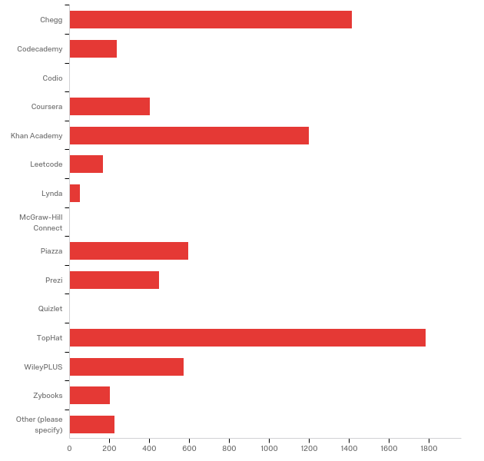

# | Answer | % | Count
1 | Chegg | 19.37% | 1415
2 | Codecademy | 3.23% | 236
14 | Codio | 0.00% | 0
3 | Coursera | 5.53% | 404
4 | Khan Academy | 16.45% | 1202
5 | Leetcode | 2.30% | 168
6 | Lynda | 0.70% | 51
15 | McGraw-Hill Connect | 0.00% | 0
7 | Piazza | 8.13% | 594
8 | Prezi | 6.13% | 448
13 | Quizlet | 0.00% | 0
9 | TopHat | 24.46% | 1787
10 | WileyPLUS | 7.82% | 571
11 | Zybooks | 2.79% | 204
12 | Other (please specify) | 3.08% | 225
 | Total | 100% | 7305

Q62_12_TEXT - Other (please specify)
Other (please specify) - Text
none
edX
none
Pearson
Trueway asl, Webassign
Quizlet
none
None of the above
Research Gate
uDEMY
I did not sign up for anything
Pearson, Cengage
mastering
cengage
none
none
Quizlet
Study, Quizlet
MindTap
None. I do not have any extra money to spend on services like these.
None
Mendeley
Cengage Learning
Fill and Manifest
Webassign
Mastering Chemistry and Mastering Engineering
Eli Review and Pearson Labs
webassign, mastering by pearson
Pearson MathLab
None
Quizlet
quizlet
no
None
Eli Review
Cengage: Mindtap
github
none
no
I used none of them
None
Inside Higher Ed
Eli Review
Research Gate
jblearning
Cengage
None
ClutchPrep
Campus wire
wix.com
Cengage, McGraw-Hill Connect, BVTLab
Grammarly
Coursehero
Connect
Quizlet
iClicker Reef
iClicker Reef
iclicker
cengage
HackerRank, Campuswire
OpenStax
none
Cengage Unlimited
Openstax
Cengage
edX
Mystatlab, Mastering Nutrition
None
Cengage
Mindtap
none
Indeed
none
Mathway
iclicker
academia.edu, Mandalay, Dropbox
Cengage, great river learning
n/a
coursehero, quizlet
Coursehero
none
Iclicker, mastering chemistry, mastering microbiology, late nite labs, sapling
Anyone who needs to make use of these platforms should start making use of their own brain.
None
iClicker
Cengage
Canva
Clutchprep
Grammerly, Mathway, paied quizlet subscription, spotify, paid youtube subscription
coursehero
iclicker reef
None
quilt
Quizlit
None
edX
Pearson learning catalytics. Quora
Academia.com
MasteringEngineering
iClicker
StudySoup
clutchhprep
Quizlet
MindTap
udemy
kahoot
none
Iclicker reef
Webassign
My courses use : Cengage, WileyPlus, Masterung Chemistry.
BRAINLY
Quizlet
Cengage/MindTap, Quizlet
StackOverflow
Mastering Chemistry
mastering, sapling, webwork, connect
quizlet
cengage
ResearchGate
Cengage
Course Hero
datacamp
Udemy
Cengage
Clutchprep
grammarly
YouTube
none
none
Quizlet
Westlaw - TWEN
Pearson
APEX
None
Amboss
WebAssign
None
CourseHero
none
Quizlet
Coding Programs
None
Clutch Prep
Canva
Clutch prep
ValoreBooks
Quizlet
Udemy
Clutchprep
Connect
youtube
EliReview
shopping websites
Wolfram|Alpha
Webassign
Nothing
none
Udemy
Mymathlab
Quizlet
Clutch
zotero
CoursePoint Plus
Udemy
coursehero
Quizlet
None
canva
Web assign and mastering chemistry
Cengage
Safe assign.Eli review
Connect
Simple Nursing
sapling, mastering, cengage
Quizlet
pearson
Iclicker reef
Mindtap (Cengage Unlimited)
Not applicable
Pearson MyMathLab
n/a
Pearson
sketchy Medical
Quizlet
Quizlet
cengage, connect
None
Clutch
westlaw twen
None
Sapling Learning/Mastering Chem
Mastering Chemistry and Mastering Engineering
Quizlet
Clutch
Bartleby
Arkaive
Clutchprep
Pearson for My Math Lab
Quizlet
Quizlet
iClicker Reef
Quizlet
HackerRank
udemy
OnlineMedEd, Osmosis, AMBOSS
Web Assign. Mastering Chemistry. Mastering Engineering.
Quizlet
Na
Udcity
Udemy

Q35 - UBIT is considering locations for new, self-service printing stations around campus. Please drag to order your preferences for where you would like printing available (with #1 being your first choice, and #6 being your last).
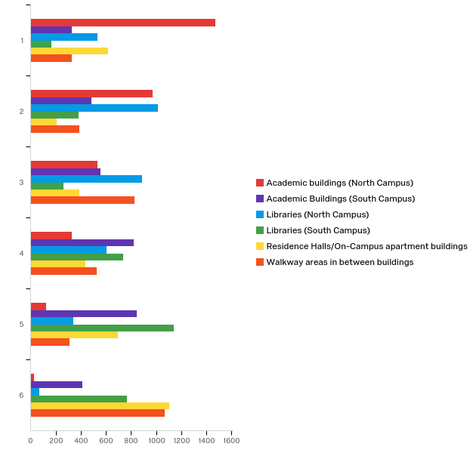

# | Field | Minimum | Maximum | Mean | Std Deviation | Variance | Count
1 | Academic buildings (North Campus) | 1.00 | 6.00 | 2.06 | 1.19 | 1.41 | 3450
2 | Academic Buildings (South Campus) | 1.00 | 6.00 | 3.76 | 1.50 | 2.25 | 3450
3 | Libraries (North Campus) | 1.00 | 6.00 | 2.83 | 1.28 | 1.64 | 3450
4 | Libraries (South Campus) | 1.00 | 6.00 | 4.33 | 1.44 | 2.07 | 3450
5 | Residence Halls/On-Campus apartment buildings | 1.00 | 6.00 | 4.07 | 1.86 | 3.45 | 3450
6 | Walkway areas in between buildings | 1.00 | 6.00 | 3.96 | 1.69 | 2.87 | 3450

# | Question | 1 |  | 2 |  | 3 |  | 4 |  | 5 |  | 6 |  | Total
1 | Academic buildings (North Campus) | 42.61% | 1470 | 28.12% | 970 | 15.36% | 530 | 9.54% | 329 | 3.54% | 122 | 0.84% | 29 | 3450
2 | Academic Buildings (South Campus) | 9.57% | 330 | 14.00% | 483 | 16.09% | 555 | 23.80% | 821 | 24.55% | 847 | 12.00% | 414 | 3450
3 | Libraries (North Campus) | 15.51% | 535 | 29.48% | 1017 | 25.65% | 885 | 17.45% | 602 | 9.86% | 340 | 2.06% | 71 | 3450
4 | Libraries (South Campus) | 4.87% | 168 | 11.10% | 383 | 7.57% | 261 | 21.30% | 735 | 32.99% | 1138 | 22.17% | 765 | 3450
5 | Residence Halls/On-Campus apartment buildings | 17.97% | 620 | 5.97% | 206 | 11.28% | 389 | 12.67% | 437 | 20.09% | 693 | 32.03% | 1105 | 3450
6 | Walkway areas in between buildings | 9.48% | 327 | 11.33% | 391 | 24.06% | 830 | 15.25% | 526 | 8.99% | 310 | 30.90% | 1066 | 3450

Q37 - How did you find out that UB offers free software like MS Office and Symantec Endpoint Protection anti-virus and firewall? (Select app that apply.)
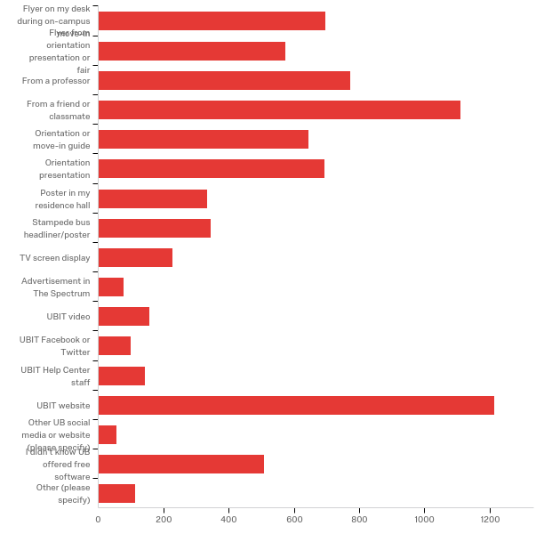

# | Answer | % | Count
1 | Flyer on my desk during on-campus move-in | 8.98% | 697
2 | Flyer from orientation presentation or fair | 7.38% | 573
3 | From a professor | 9.95% | 773
4 | From a friend or classmate | 14.31% | 1111
5 | Orientation or move-in guide | 8.29% | 644
6 | Orientation presentation | 8.92% | 693
7 | Poster in my residence hall | 4.30% | 334
8 | Stampede bus headliner/poster | 4.46% | 346
9 | TV screen display | 2.92% | 227
10 | Advertisement in The Spectrum | 1.00% | 78
11 | UBIT video | 2.03% | 158
12 | UBIT Facebook or Twitter | 1.29% | 100
13 | UBIT Help Center staff | 1.84% | 143
14 | UBIT website | 15.63% | 1214
15 | Other UB social media or website (please specify) | 0.71% | 55
16 | I didn't know UB offered free software | 6.53% | 507
17 | Other (please specify) | 1.46% | 113
 | Total | 100% | 7766

Q37_15_TEXT - Other UB social media or website (please specify)
Other UB social media or website (please specify) - Text
Instagram
e-mails upon admission
saw it on the UB website before I came
It was on a window covering in the hall between Knox and Capen on the lowest floor.
Email I received the first week of class from UBIT
just now
reddit
My UB news section
UB email
emails
email
Wait, do they offer it for student laptops?
instagram
instagram
Previos college explained all colleges offer this feature
UB Email
ubreddit
Dds orientation checklist website
Email
Email

Q37_17_TEXT - Other (please specify)
Other (please specify) - Text
Parents
I am aware many universities offer free sotware
I did not.
My uncle told that some schools usually offers these services and asked the UBIT desk
poster in hallway
Email
Google
UB doesn't offer it to me
on the Microsoft website
Flyers placed in random places in the academic buildings
Faculty syllabus
Family that already went here
Googled ub free Microsoft word
Posters scattered through walkways between buildings
my previous school offer some free software, so I search it here
from a friend
libraries
email
Looked it up
Looking around on the UB website
My brother
I knew from previous experience to look to see what was available so I searched and found the UBIT website
i searched on google
Someone at a different college told me my college probably offered it.
I assumed based on prior schooling and just googled it.
email
Learned from a friend
flyer on wall
Past experience with universities
Co-worker
In class because we needed the software to complete assignments
just now
EAS seminar
My dad works here and we've always gotten software from the UB
I searched for it myself
in my acceptance letter packet
Searched student discounts myself and happened to stumble upon the UB site
Email
From a ubit walk up help desk employee
Email from department
Email Message at Beginning of Year
email
i worked at ubit
Dont remember
Family member
I just assumed myself
Knew about it since my previous university offered free software as well
it's common for a univ to offer this
Email
BlackBoard
Email from the department.
I work in IT
My friends
Stampede ads
Posters around campus
I do not remember
Eop
i think i got an email about it
UB email newsletter
flyers at the printing centers
I just by chance found it one day
email
I knew it even before coming to UB because I trasnferred from Stony Brook so I assumed that UB also must have one.
Google that led to ub site w links to free software
Family
email
UB Alumni friend
Myself
other suny colleges do just assumed you did.
Friend
Required Blackboard course for new LIS grad students (technical competencies)
Email
Walk in and asked
can't remember
Email from UBIT
brother
On website
googling UB + free software for students
Professor mentioned in passing over the summer
Email
Email
Another student
Didn't know UB has free virus protection. I just assumed we got free ms office because all colleges do.
from my siblings
I know it from UB website
Alum
I had to pay a lot of money for Microsoft last year because UB never notified students about this.
I just knew - not entirely sure where I found out first
google search
I don't recall. I have been on campus with awareness of services for a while
I forget, sorry.
I went to undergrad at UB
Orientation e-mail
Best buy worker
I googled it.
I just know
I think I got a UBIT email about it.
google
Email
work at UBIT printing, found out through there
UB Email
A letter was mailed to my house

Q63 - Where do you prefer to go first to find the following information?
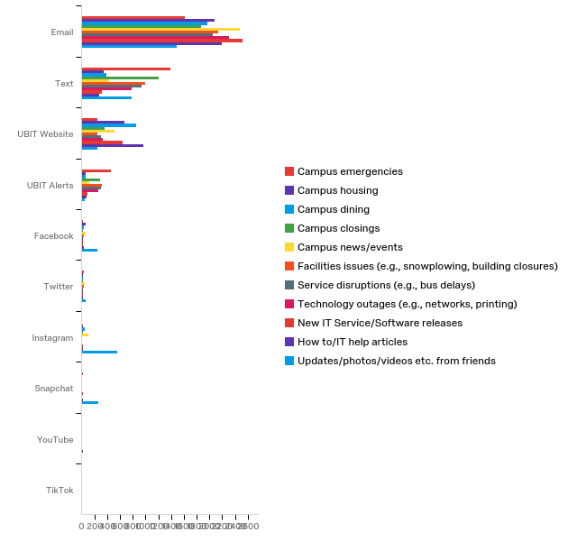

# | Field | Minimum | Maximum | Mean | Std Deviation | Variance | Count
1 | Campus emergencies | 1.00 | 10.00 | 1.99 | 1.23 | 1.52 | 3804
2 | Campus housing | 1.00 | 10.00 | 1.76 | 1.26 | 1.59 | 3286
3 | Campus dining | 1.00 | 10.00 | 1.88 | 1.31 | 1.71 | 3401
4 | Campus closings | 1.00 | 10.00 | 1.85 | 1.16 | 1.34 | 3789
5 | Campus news/events | 1.00 | 10.00 | 1.83 | 1.49 | 2.23 | 3789
6 | Facilities issues (e.g., snowplowing, building closures) | 1.00 | 10.00 | 1.78 | 1.21 | 1.46 | 3785
7 | Service disruptions (e.g., bus delays) | 1.00 | 10.00 | 1.80 | 1.22 | 1.48 | 3691
8 | Technology outages (e.g., networks, printing) | 1.00 | 10.00 | 1.72 | 1.21 | 1.46 | 3758
9 | New IT Service/Software releases | 1.00 | 10.00 | 1.68 | 1.26 | 1.60 | 3664
10 | How to/IT help articles | 1.00 | 10.00 | 1.86 | 1.35 | 1.83 | 3629
11 | Updates/photos/videos etc. from friends | 1.00 | 10.00 | 3.15 | 2.56 | 6.54 | 3702

# | Question | Email |  | Text |  | UBIT Website |  | UBIT Alerts |  | Facebook |  | Twitter |  | Instagram |  | Snapchat |  | YouTube |  | TikTok |  | Total
1 | Campus emergencies | 42.59% | 1620 | 36.41% | 1385 | 6.62% | 252 | 12.01% | 457 | 0.58% | 22 | 0.79% | 30 | 0.29% | 11 | 0.58% | 22 | 0.00% | 0 | 0.13% | 5 | 3804
2 | Campus housing | 63.36% | 2082 | 10.62% | 349 | 20.51% | 674 | 1.80% | 59 | 1.73% | 57 | 0.64% | 21 | 0.67% | 22 | 0.40% | 13 | 0.06% | 2 | 0.21% | 7 | 3286
3 | Campus dining | 57.84% | 1967 | 11.44% | 389 | 25.17% | 856 | 1.88% | 64 | 1.21% | 41 | 0.56% | 19 | 1.29% | 44 | 0.32% | 11 | 0.03% | 1 | 0.26% | 9 | 3401
4 | Campus closings | 49.17% | 1863 | 31.72% | 1202 | 9.37% | 355 | 7.63% | 289 | 0.71% | 27 | 0.53% | 20 | 0.42% | 16 | 0.24% | 9 | 0.03% | 1 | 0.18% | 7 | 3789
5 | Campus news/events | 65.37% | 2477 | 11.32% | 429 | 13.70% | 519 | 3.25% | 123 | 1.77% | 67 | 1.16% | 44 | 2.82% | 107 | 0.34% | 13 | 0.03% | 1 | 0.24% | 9 | 3789
6 | Facilities issues (e.g., snowplowing, building closures) | 56.35% | 2133 | 26.13% | 989 | 6.55% | 248 | 8.48% | 321 | 0.87% | 33 | 0.79% | 30 | 0.26% | 10 | 0.32% | 12 | 0.00% | 0 | 0.24% | 9 | 3785
7 | Service disruptions (e.g., bus delays) | 55.70% | 2056 | 25.58% | 944 | 8.26% | 305 | 8.07% | 298 | 0.62% | 23 | 0.76% | 28 | 0.38% | 14 | 0.38% | 14 | 0.05% | 2 | 0.19% | 7 | 3691
8 | Technology outages (e.g., networks, printing) | 61.39% | 2307 | 20.73% | 779 | 8.81% | 331 | 6.81% | 256 | 0.69% | 26 | 0.56% | 21 | 0.27% | 10 | 0.48% | 18 | 0.00% | 0 | 0.27% | 10 | 3758
9 | New IT Service/Software releases | 68.64% | 2515 | 8.52% | 312 | 17.47% | 640 | 2.48% | 91 | 0.76% | 28 | 0.60% | 22 | 0.74% | 27 | 0.35% | 13 | 0.11% | 4 | 0.33% | 12 | 3664
10 | How to/IT help articles | 60.43% | 2193 | 7.74% | 281 | 26.62% | 966 | 1.96% | 71 | 0.80% | 29 | 0.72% | 26 | 0.52% | 19 | 0.47% | 17 | 0.44% | 16 | 0.30% | 11 | 3629
 | Updates/photos/videos etc. from friends | 40.38% | 1495 | 21.18% | 784 | 6.59% | 244 | 1.19% | 44 | 6.56% | 243 | 1.84% | 68 | 14.91% | 552 | 6.97% | 258 | 0.11% | 4 | 0.27% | 10 | 3702

Q49 - What assistive technology do you use, if any? (Select all that apply.)
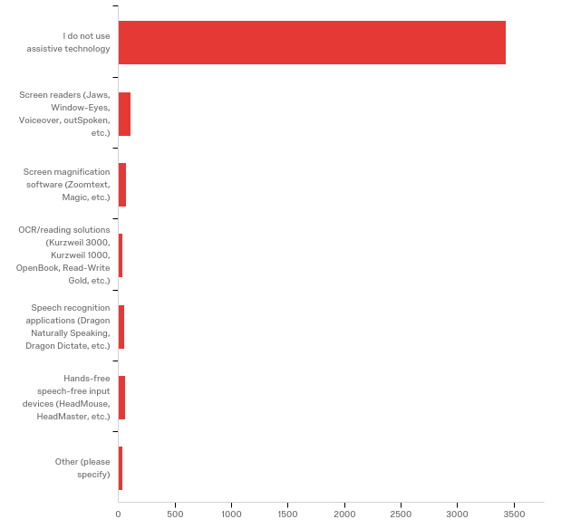

# | Answer | % | Count
1 | I do not use assistive technology | 90.57% | 3429
2 | Screen readers (Jaws, Window-Eyes, Voiceover, outSpoken, etc.) | 2.83% | 107
3 | Screen magnification software (Zoomtext, Magic, etc.) | 1.80% | 68
4 | OCR/reading solutions (Kurzweil 3000, Kurzweil 1000, OpenBook, Read-Write Gold, etc.) | 0.95% | 36
5 | Speech recognition applications (Dragon Naturally Speaking, Dragon Dictate, etc.) | 1.32% | 50
6 | Hands-free speech-free input devices (HeadMouse, HeadMaster, etc.) | 1.64% | 62
7 | Other (please specify) | 0.90% | 34
 | Total | 100% | 3786

Q49_7_TEXT - Other (please specify)
Other (please specify) - Text
livescribe pen
YouTube
I use power point
no
Google slides built in speech-to-text feature
live scribe
live scribe pen
Wacom
I have the live writing pen from accommodations and it's awesome
N/a
doorbell flashers. CART, and captioning
Hearing aids in both ears.
CART and Onenote
Echo smart pen
Read&write

Q50 - Have you experienced problems accessing the following with assistive technology? If so, how often?
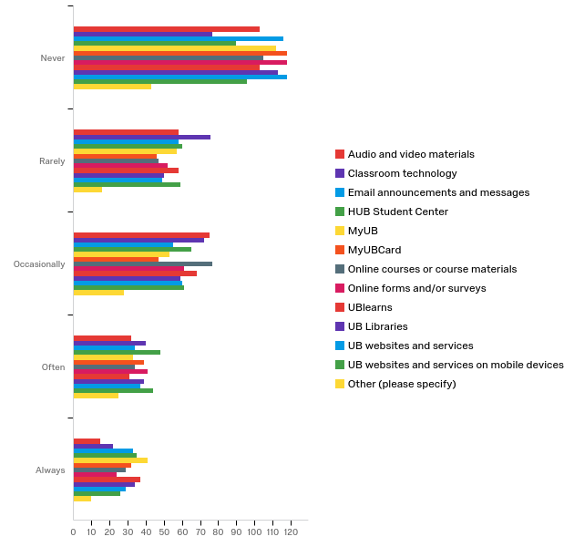

# | Field | Minimum | Maximum | Mean | Std Deviation | Variance | Count
1 | Audio and video materials | 1.00 | 5.00 | 2.29 | 1.22 | 1.48 | 283
2 | Classroom technology | 1.00 | 5.00 | 2.49 | 1.23 | 1.53 | 287
3 | Email announcements and messages | 1.00 | 5.00 | 2.36 | 1.38 | 1.91 | 296
4 | HUB Student Center | 1.00 | 5.00 | 2.59 | 1.37 | 1.87 | 298
5 | MyUB | 1.00 | 5.00 | 2.44 | 1.43 | 2.06 | 296
6 | MyUBCard | 1.00 | 5.00 | 2.37 | 1.42 | 2.03 | 282
7 | Online courses or course materials | 1.00 | 5.00 | 2.43 | 1.34 | 1.79 | 292
8 | Online forms and/or surveys | 1.00 | 5.00 | 2.33 | 1.33 | 1.78 | 296
9 | UBlearns | 1.00 | 5.00 | 2.46 | 1.38 | 1.90 | 297
10 | UB Libraries | 1.00 | 5.00 | 2.43 | 1.40 | 1.97 | 295
11 | UB websites and services | 1.00 | 5.00 | 2.35 | 1.37 | 1.88 | 293
12 | UB websites and services on mobile devices | 1.00 | 5.00 | 2.46 | 1.33 | 1.77 | 286
13 | Other (please specify) | 1.00 | 5.00 | 2.53 | 1.36 | 1.86 | 122

# | Question | Never |  | Rarely |  | Occasionally |  | Often |  | Always |  | Total
1 | Audio and video materials | 36.40% | 103 | 20.49% | 58 | 26.50% | 75 | 11.31% | 32 | 5.30% | 15 | 283
2 | Classroom technology | 26.83% | 77 | 26.48% | 76 | 25.09% | 72 | 13.94% | 40 | 7.67% | 22 | 287
3 | Email announcements and messages | 39.19% | 116 | 19.59% | 58 | 18.58% | 55 | 11.49% | 34 | 11.15% | 33 | 296
4 | HUB Student Center | 30.20% | 90 | 20.13% | 60 | 21.81% | 65 | 16.11% | 48 | 11.74% | 35 | 298
5 | MyUB | 37.84% | 112 | 19.26% | 57 | 17.91% | 53 | 11.15% | 33 | 13.85% | 41 | 296
 | MyUBCard | 41.84% | 118 | 16.31% | 46 | 16.67% | 47 | 13.83% | 39 | 11.35% | 32 | 282
 | Online courses or course materials | 35.96% | 105 | 16.10% | 47 | 26.37% | 77 | 11.64% | 34 | 9.93% | 29 | 292
 | Online forms and/or surveys | 39.86% | 118 | 17.57% | 52 | 20.61% | 61 | 13.85% | 41 | 8.11% | 24 | 296
 | UBlearns | 34.68% | 103 | 19.53% | 58 | 22.90% | 68 | 10.44% | 31 | 12.46% | 37 | 297
 | UB Libraries | 38.31% | 113 | 16.95% | 50 | 20.00% | 59 | 13.22% | 39 | 11.53% | 34 | 295
 | UB websites and services | 40.27% | 118 | 16.72% | 49 | 20.48% | 60 | 12.63% | 37 | 9.90% | 29 | 293
 | UB websites and services on mobile devices | 33.57% | 96 | 20.63% | 59 | 21.33% | 61 | 15.38% | 44 | 9.09% | 26 | 286
 | Other (please specify) | 35.25% | 43 | 13.11% | 16 | 22.95% | 28 | 20.49% | 25 | 8.20% | 10 | 122

Q51 - What would have made it easier for you to get started with Information Technology at UB? (Select all that apply.)
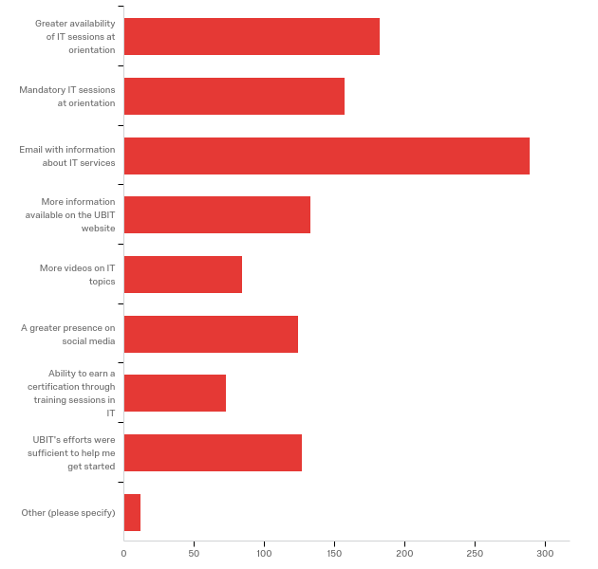

# | Answer | % | Count
1 | Greater availability of IT sessions at orientation | 15.41% | 182
2 | Mandatory IT sessions at orientation | 13.29% | 157
3 | Email with information about IT services | 24.47% | 289
4 | More information available on the UBIT website | 11.26% | 133
5 | More videos on IT topics | 7.11% | 84
6 | A greater presence on social media | 10.50% | 124
7 | Ability to earn a certification through training sessions in IT | 6.18% | 73
8 | UBIT's efforts were sufficient to help me get started | 10.75% | 127
9 | Other (please specify) | 1.02% | 12
 | Total | 100% | 1181

Q51_9_TEXT - Other (please specify)
Make your UI less complicated. Instead of making a ton of uninformative tabs for specific problems, diagnose what the problem is and try to find the best course of action to solve the problem. Also make it easier to navigate between specific tabs because right now its so annoying having to find my way back to a specific place on the HUB.
an easier to navigate website
I couldn't follow along, because my laptop wasn't working, needed upgrade.

