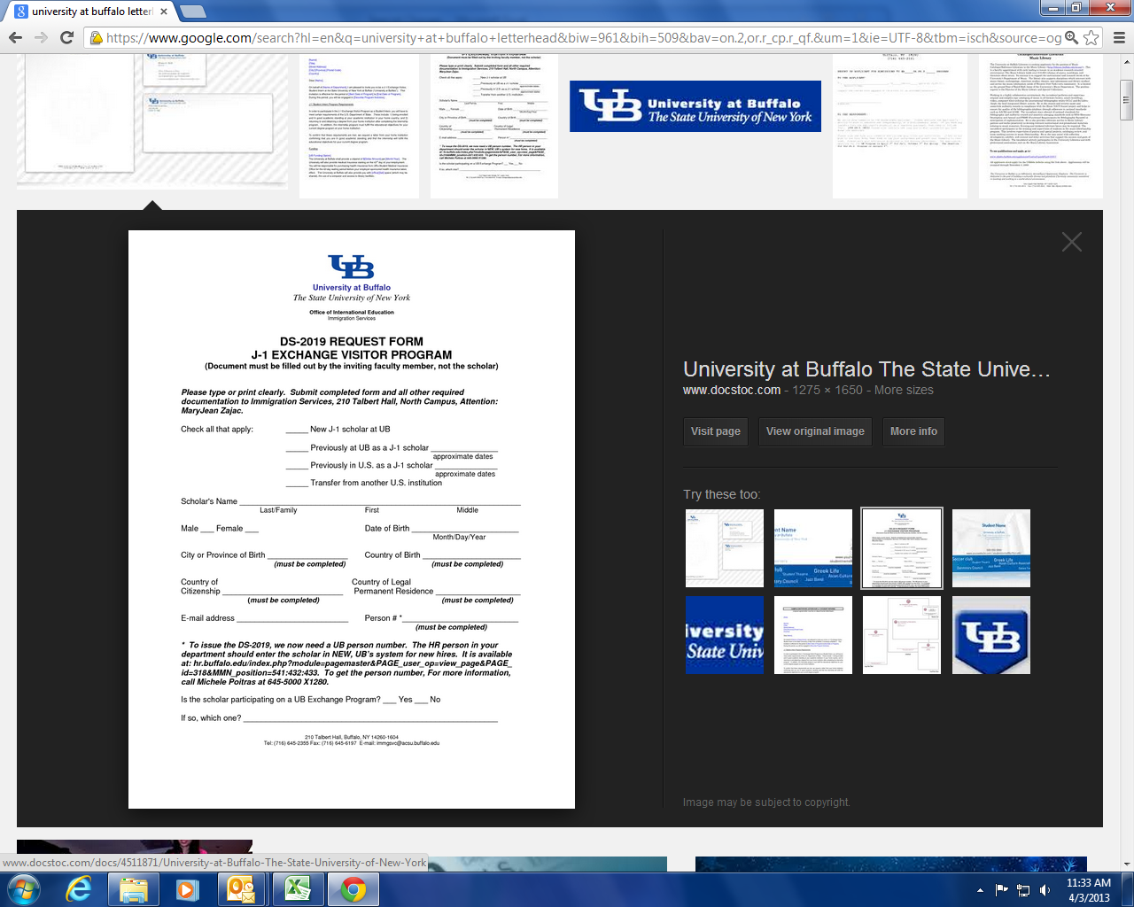
Comparative Medicine & Laboratory Animal Facilities
Rodent Guide for Environmental Enrichment
PI:_________________
Protocol:____________

Any/All Enrichment, or No Preference:

Shepard Shack (Mice) 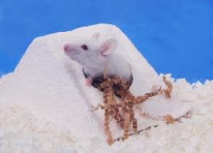 Shepard Shack (Rats) 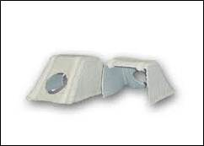
Fat rat hut 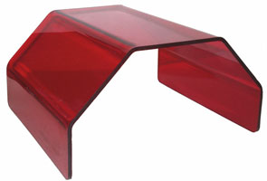 Shower curtain hook (mice) 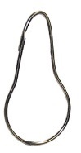
Mouse Igloo 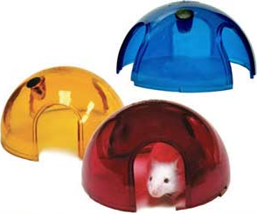 Pvc tube (mice) 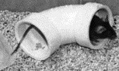
Rat tunnel 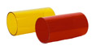 Rat Retreat 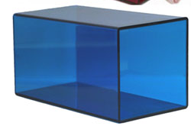
NylaBones (Rats) 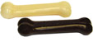 Wood block(Rats, Chinchilla) 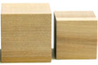
Sunflower seeds (Rats,mice) 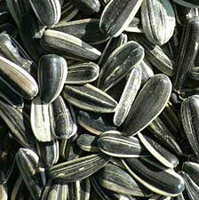 Fruity gems(Rabbits) 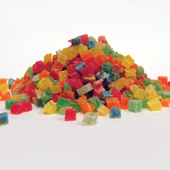
Rodent nesting sheets 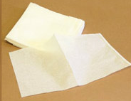 Cotton pads (Mice) 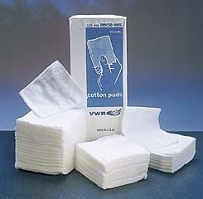
Nestlets (Mice) 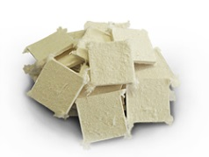 Enviro-dry (Mice) 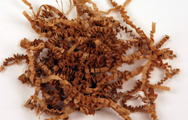
Shavings

