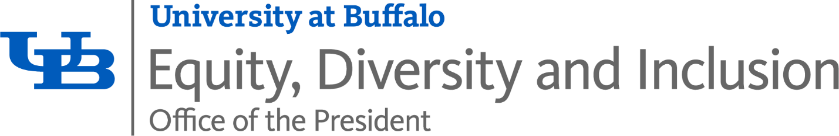
University at Buffalo
2026: Compliance Training - Title VI, Sexual Harassment Prevention, and Accessibility and Accommodations Training Course Instructions
A guide to completing your annual training
Table of Contents
2026: Compliance Training – Title VI, Sexual Harassment Prevention, and Accessibility and Accommodations Training Course Instructions 1
Accessing the Course 1
a. I Am Supporting a Course This Semester 1
b. I Have Been an Employee for More Than a Year 2
c. I Am a New Employee or New Student Employee 3
Continue with the Course 5
Alternative Formats and Accessibility Features 10
Begin the Quiz 12
11. Complete the 2026: Mandatory Sexual Harassment Prevention Training 18
12. Complete the 2026 Accessibility and Accommodations Training 18
Certificate of Completion 18
Mobile Device Support 26

2026: Compliance Training – Title VI, Sexual Harassment Prevention, and Accessibility and Accommodations Training Course Instructions
Follow the instructions below to complete the online training course via UB Learns.
UB Learns Website Link: ublearns.buffalo.edu
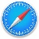



Verify that your internet browser is compatible. To use UB Learns, use a computer that is connected to the internet and the most up-to-date web browser. It is recommended that you use the most current version of:
Chrome Safari
Firefox Microsoft Edge
Brightspace technical support offers a list of certified and compatible browsers, listed by Operating System, for use with UB Learns D2L Brightspace Compatible Browsers (UB Learns).

Accessing the Course
- Go To UB Learns, and select “Log into UB Learns.”
  - Enter your UBIT Name and Password; select ‘Login’.
To look up your UBIT Name, please go to: https://www.buffalo.edu/search/you.
- You may be prompted to verify your identity via UB DUO.
- To locate the 2026: Compliance Training course, please self-identify (a., b. or c.):
  - I Am Supporting a Course This Semester.
If you are supporting a course, go to your homepage in UB Learns.
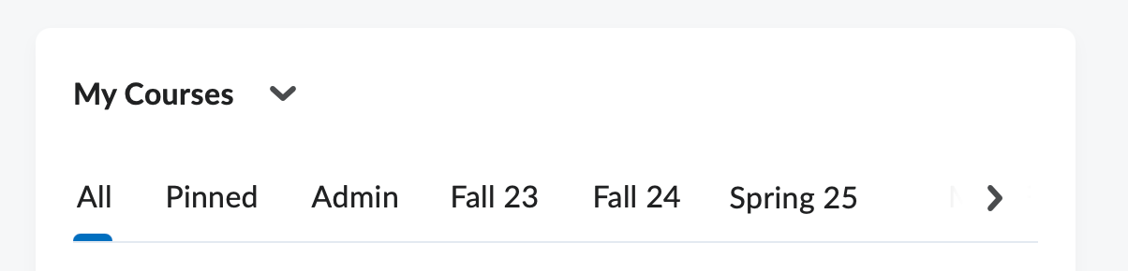
    - Select ‘My Courses’ Admin tab and the 2026: Compliance Training Course will be listed there.
  - I Have Been an Employee for More Than a Year.
If I have worked at UB for more than a year, I will be enrolled in the course.
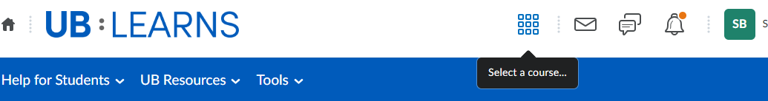
    - Begin at ‘Select a Course’, to the right of the UB: Learns icon:
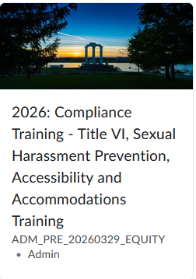
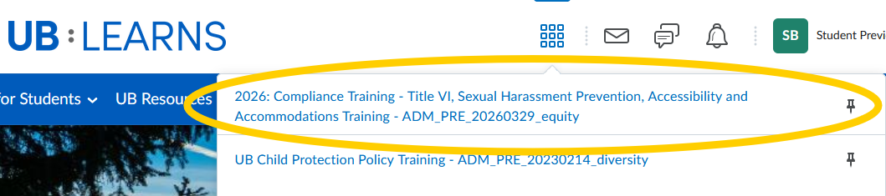
    - Select the 2026: Compliance Training – Title VI, Sexual Harassment Prevention, and Accessibility and Accommodations Training:
You may also access the course in your
‘My Courses’ widget after you have
accessed the course once.
Select the 2026: Compliance Training – Title VI,
Sexual Harassment Prevention, and Accessibility
and Accommodations Training.
This will navigate you to the beginning of the course.
  - I Am a New Employee or New Student Employee.
If you do not see the 2026: Compliance Training – Title VI, Sexual Harassment Prevention, and Accessibility and Accommodations Training course in your ‘Select a Course’ pulldown, you will need to:
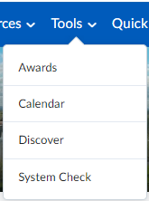
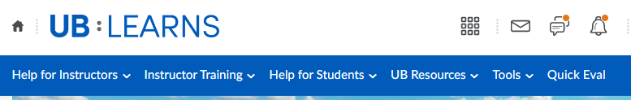
    - Discover the course and Self-Enroll in the course.
From the UB Learns homepage, select Tools
    - Select ‘Discover’:

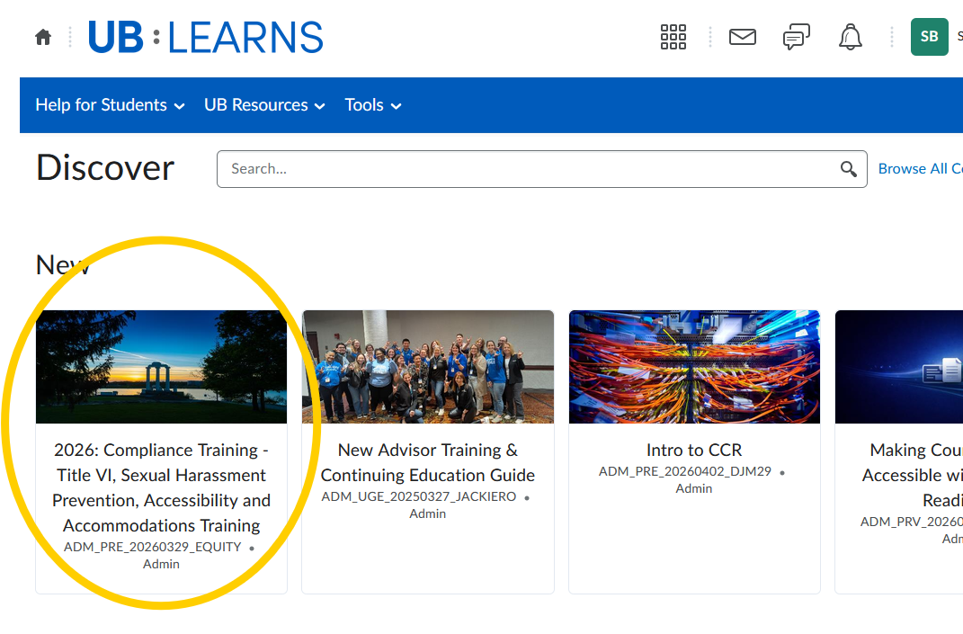
    - Select the 2026: Compliance Training – Title VI, Sexual Harassment Prevention, and Accessibility and Accommodations Training:
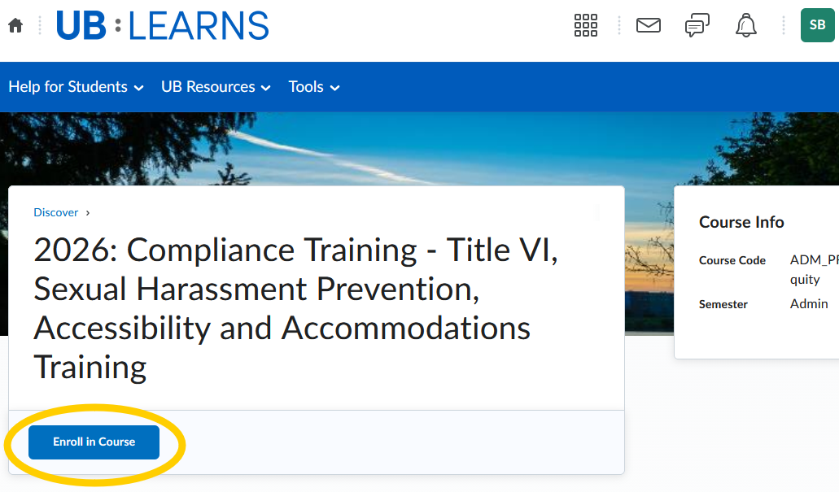
    - Select ‘Enroll in Course’:
    - Select ‘Open Course’.

Continue with the Course

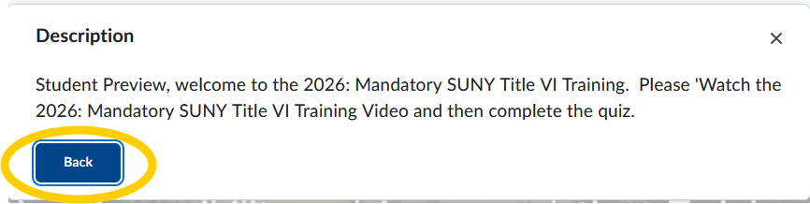
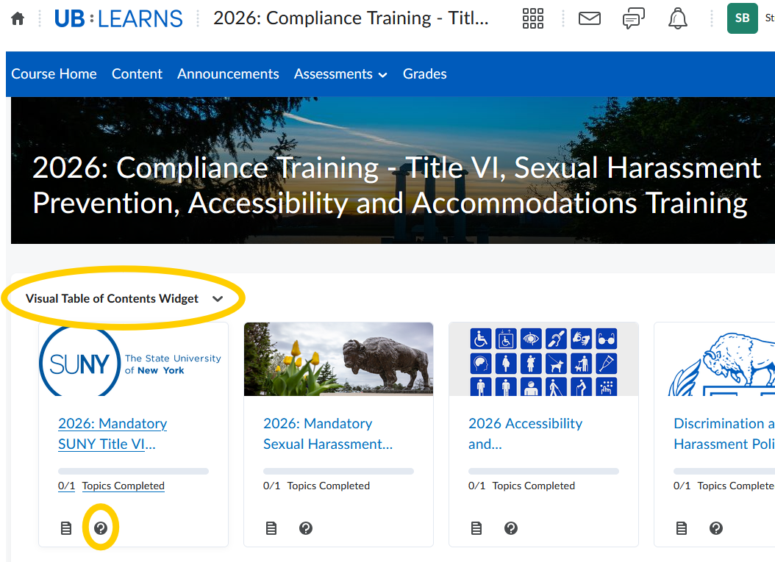
- The Visual Table of Contents Widgets guides you through the course and additional resources available to you outside of the course content. For additional information regarding each Widget:
Select the question mark on the bottom of the individual widgets for a description of the module. The description will provide the tasks required for the module. Some of the modules are for information and resource purposes.
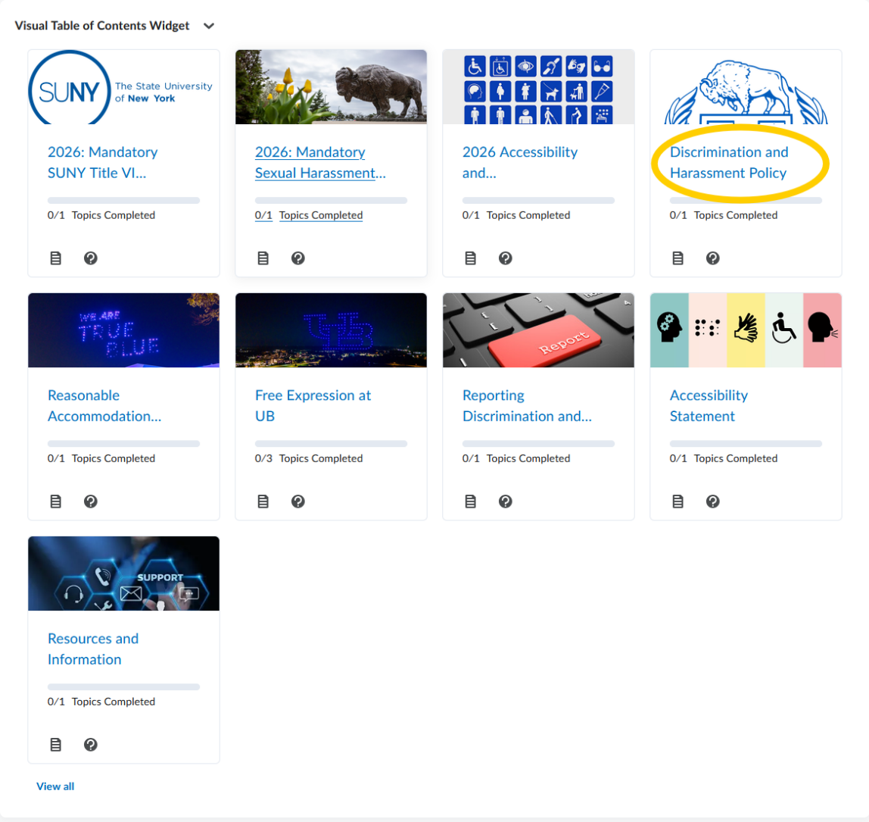
- Select the 2026: Mandatory SUNY Title VI Training module to begin.
The three modules require you to watch a video and complete a short quiz. Review the Discrimination and Harassment Policy, and for further details, review the Reasonable Accommodations Policy and UB’s Commitment to Freedom of Expression Policies and Practices.
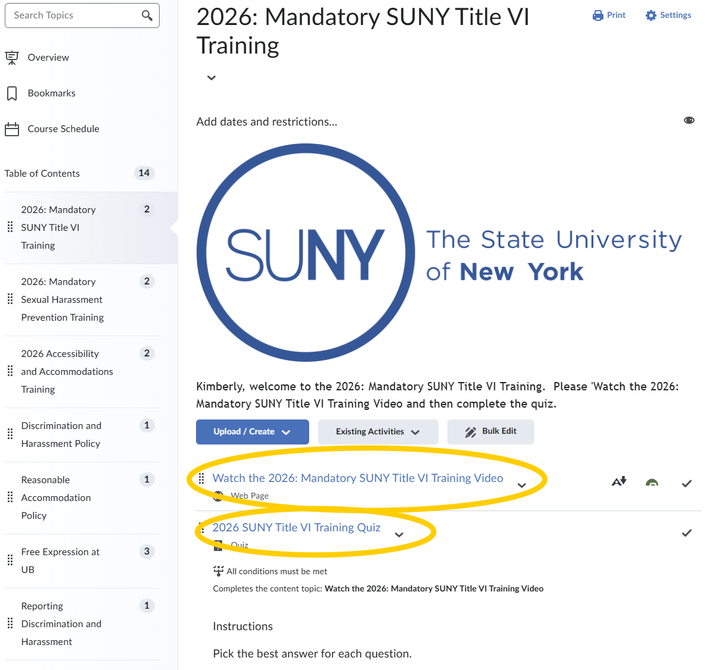
- Select the 2026: Mandatory SUNY Title VI Training:
Video
Quiz: link will appear after watching the video

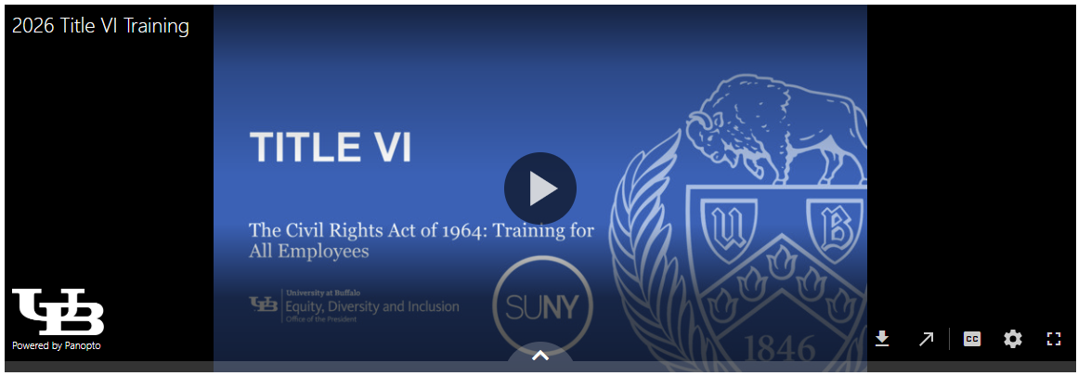
- Select the 2026: Mandatory SUNY Title VI Training Video:
Start the training by selecting the play button in the middle of the screen.
You may choose to watch the video by downloading the video, opening the video in a new window or by making the video full sized:
Panopto is the video platform that was used to create the training video. The software requires your internet browser to accept third-party cookies. The Safari internet browser in particular may require you to change your settings in order to view this type of video file.
If you are using an Apple device (i.e., MacBook, iMac, iPad or iPhone) and the Safari browser, please review the following information regarding Panopto and the Safari internet browser:
How to enable support for Third-Party browsers.
Download
Open video in New Window
Toggle Captions
Speed of Speaking
Full-Size Video Window

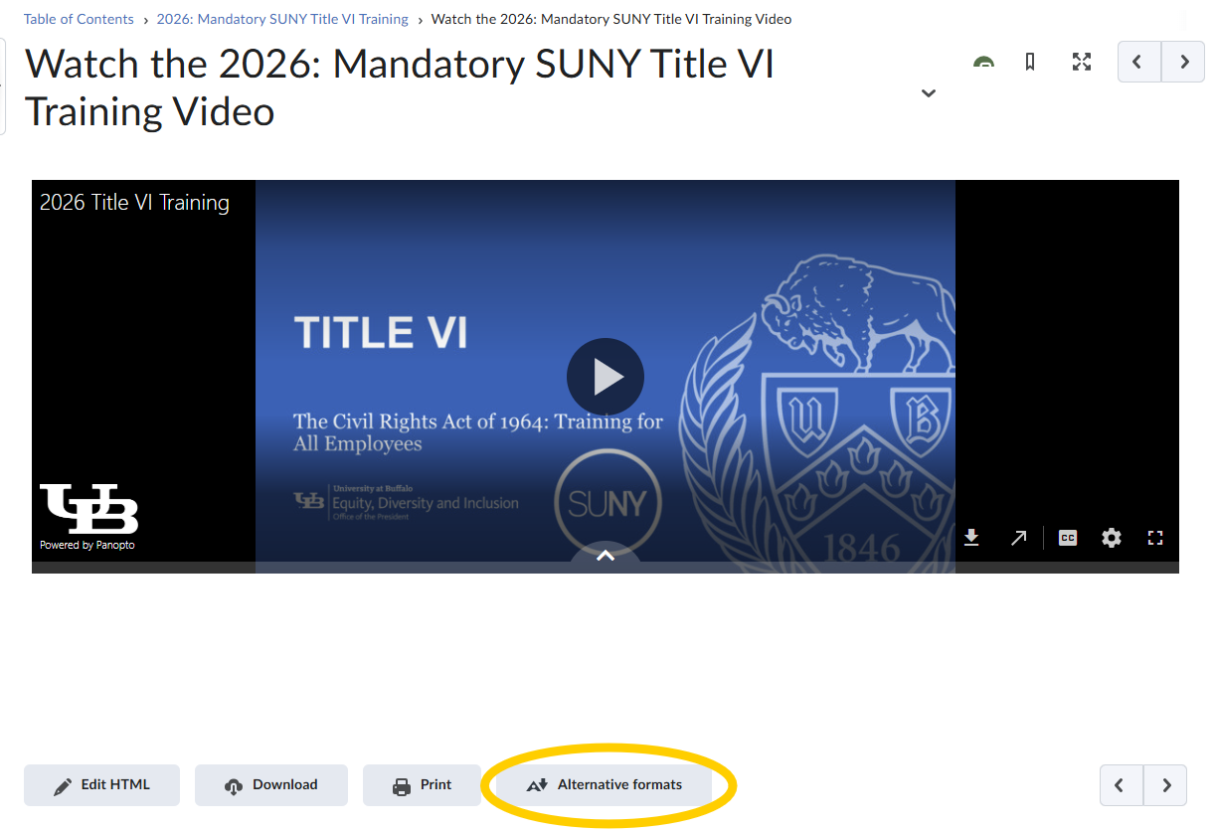
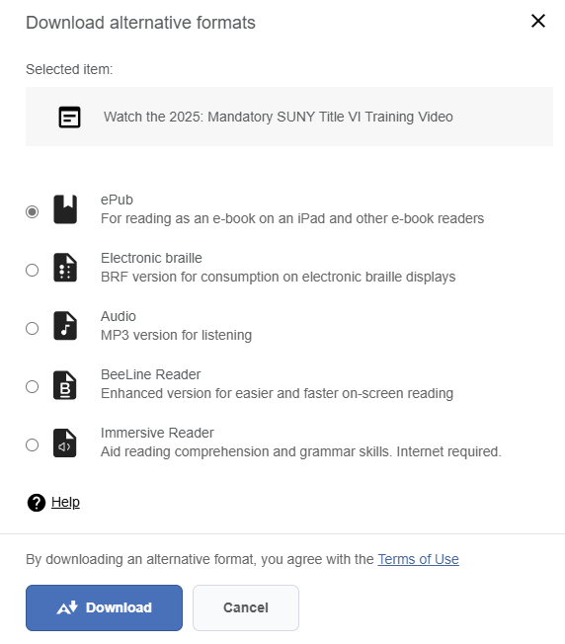
Alternative Formats and Accessibility Features
To access Alternative Formats:
Select the ‘Alternative Formats’ link below the video:
This will bring up the options to select multiple formats to review the training material.
Alternative Formats for the training video
Select the desired format and Select ‘Download’.
Begin the Quiz
- Post-training Quiz
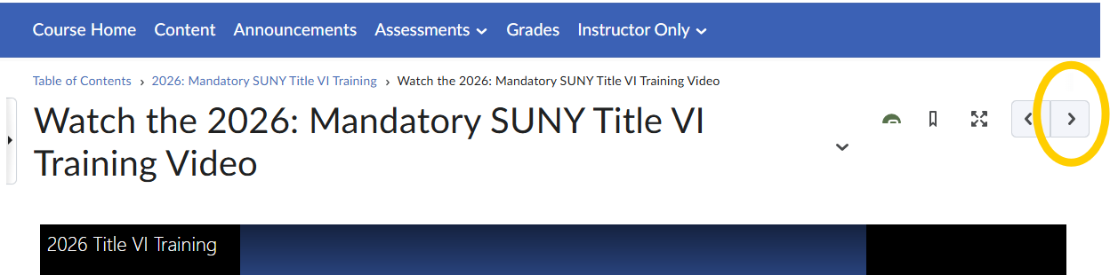
  - Navigation Option I
To begin the quiz, Select the right arrow button above the video:
Select Right Arrow

The next page displays.
Scroll to the bottom of the page and Select ‘Start Quiz!’:
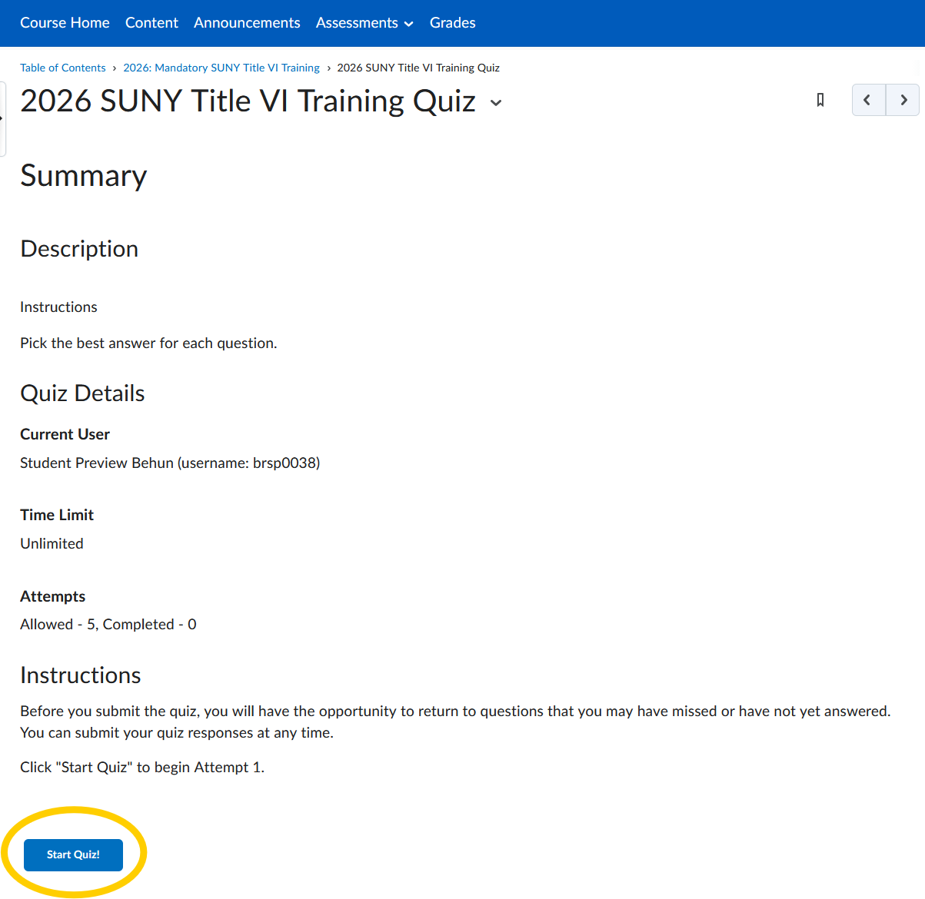
Select Start Quiz!

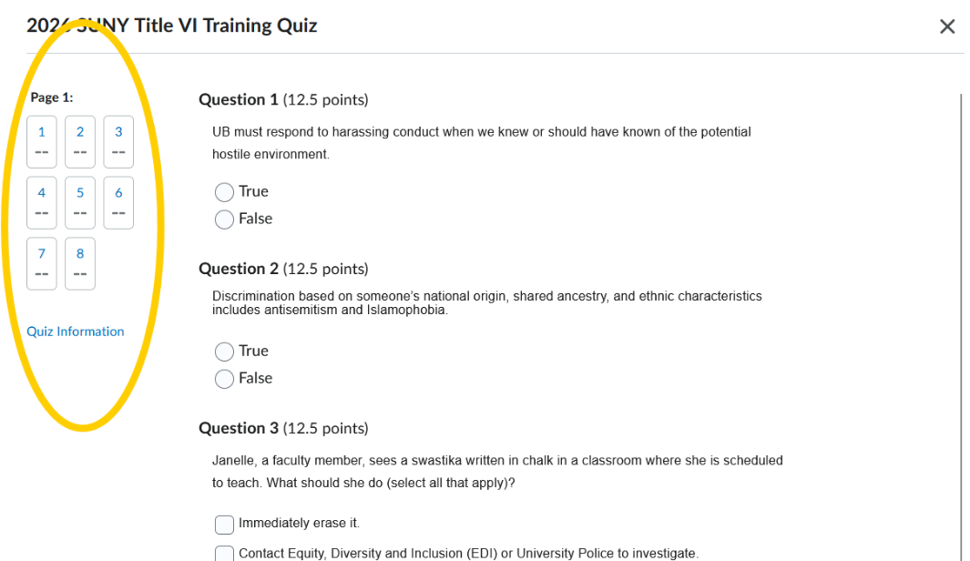
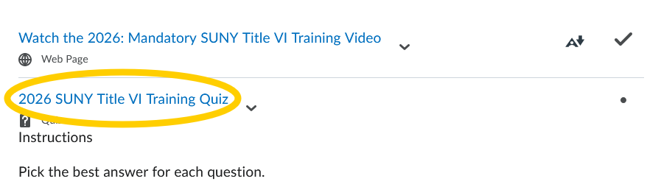
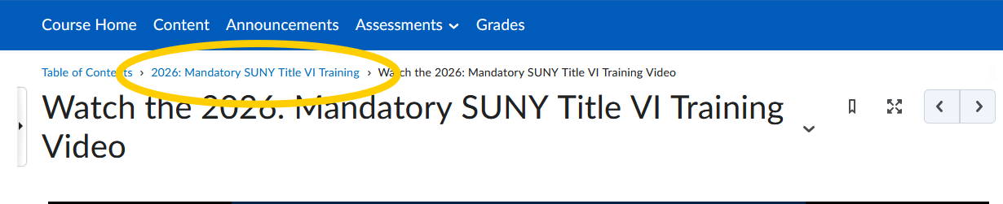
  - Navigation Option II
Navigate to 2026: Mandatory Title VI Training.
Select the navigation link 2026: Mandatory Title VI Training, the breadcrumb navigation, below the horizontal navigation bar:
Select the Complete the 2026 SUNY Title VI Training Quiz link:
Quiz status
Select link to begin quiz.
Breadcrumb Link
- Complete the Quiz.
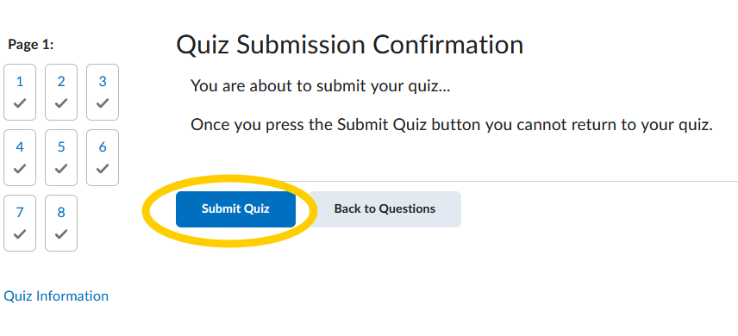
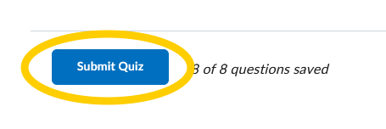
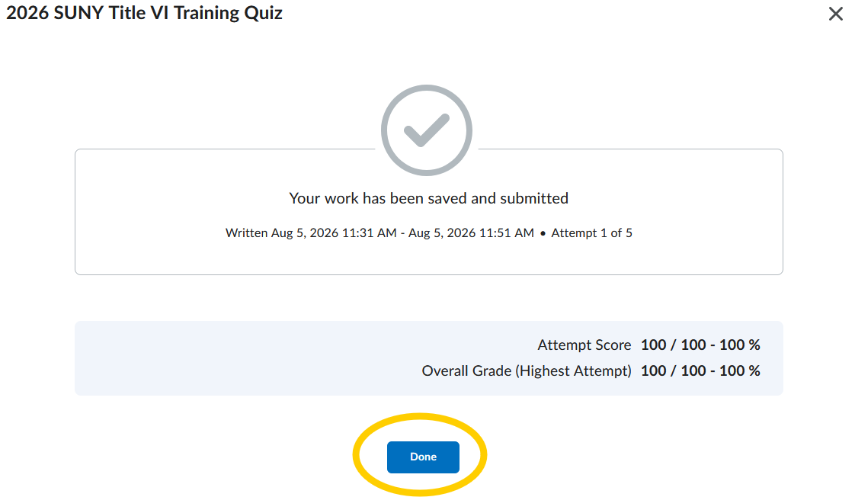
  - Once you answer all the quiz questions, Select ‘Submit Quiz’:
Select ‘Submit Quiz’ a second time:
The following page will appear:
Scroll to the bottom of the page and Select ‘Done’ and you will be taken to the next page.
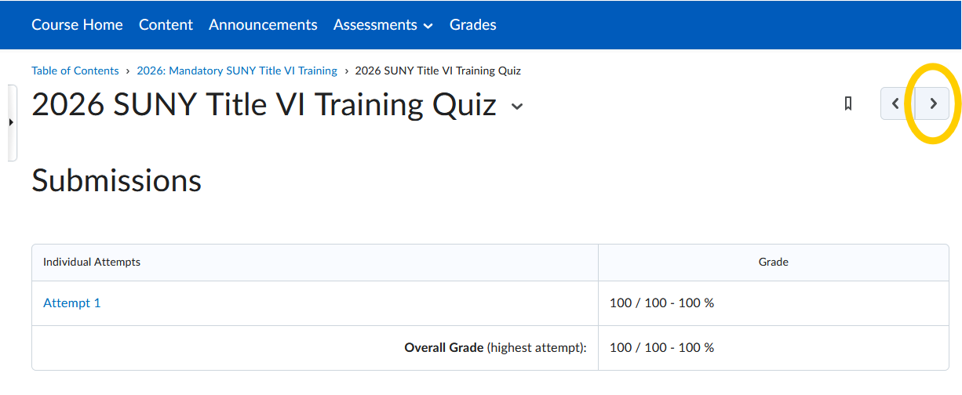
  - You will receive a Post Quiz Summary Page:
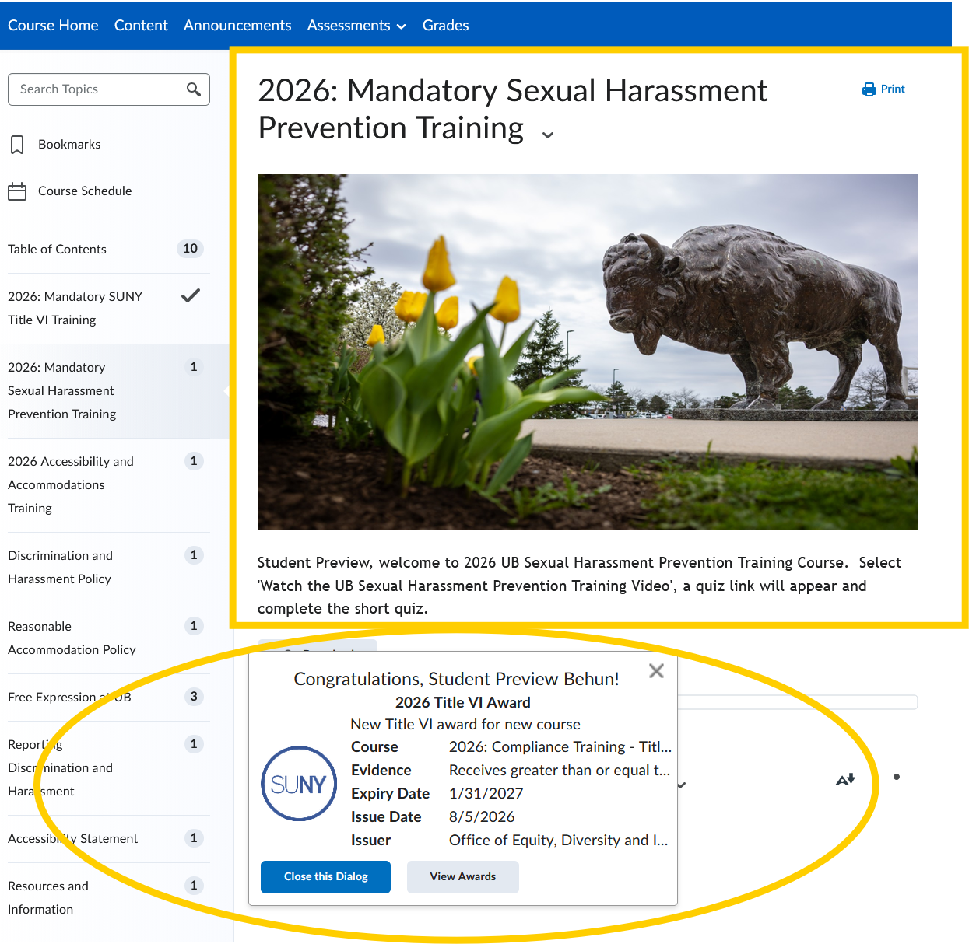
  - Select the right arrow.
You will be taken to the next learning module.
If you pass the quiz with a grade of 70% or more, you will receive a pop-up notification stating you have a Certificate of Completion.
Certificate of Completion
Next Learning Module
- Complete the 2026: Mandatory Sexual Harassment Prevention Training
  - Follow steps 7 through 10 to complete the 2026: Mandatory Sexual Harassment Prevention Training.
- Complete the 2026 Accessibility and Accommodations Training
  - Follow steps 7 through 10 to complete the 2026 Accessibility and Accommodations Training.
Certificate of Completion
- Viewing your Awards/Certificates of Completion:
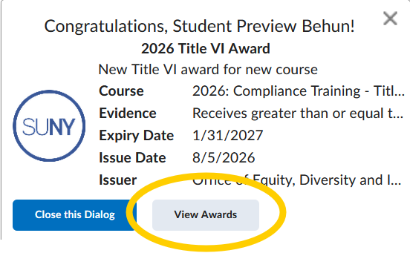
Select ‘View Awards’:
Select View Awards to create a certificate

If you do not receive a pop-up listed above, you may access your certificate by the following:
  - Select the Messaging icon to view the latest updates about the course:
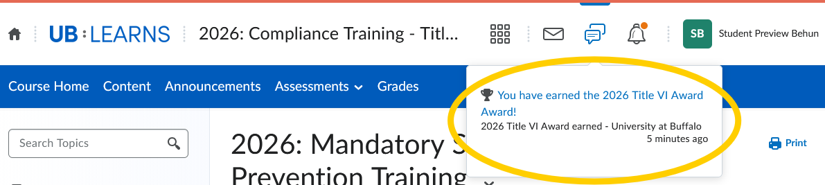
  - Select the Message you would like to view:
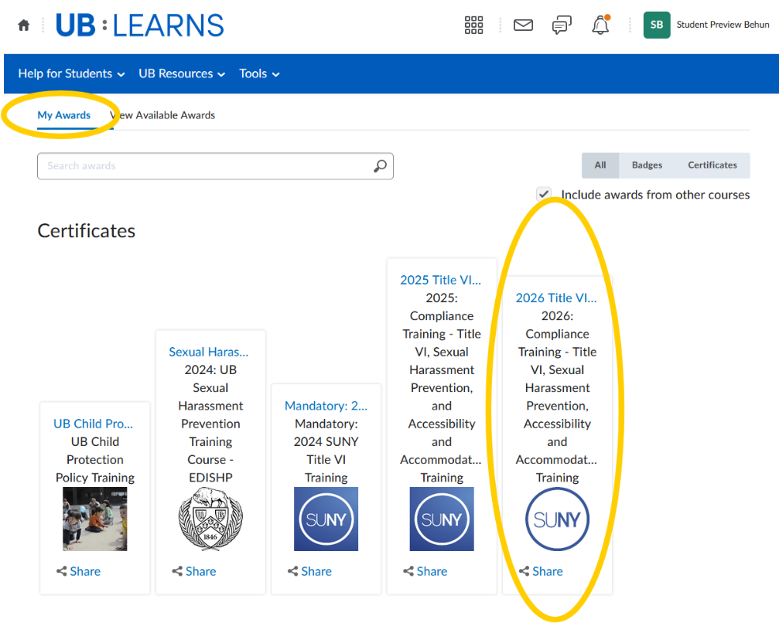
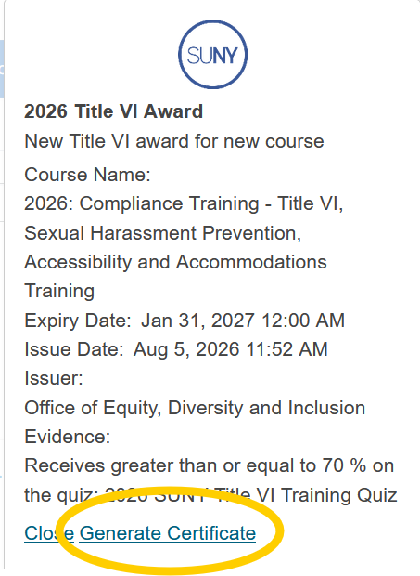
  - You will navigate to the ‘My Awards’ page:
Select 2026 Title VI Certificate
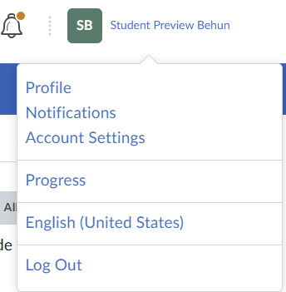
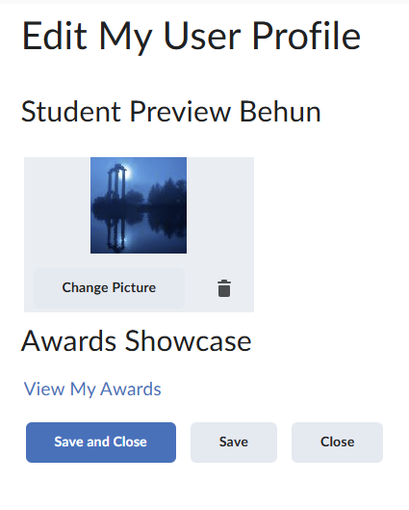
  - The following pop-up appears:
Select ‘Generate Certificate’
to create a PDF certificate:
A PDF file will download to your
computer.
Go To your downloads to view the certificate.
If you do not receive a pop-up or see a message in your message area, you may access your certificate by the following:
  - Select your Profile Name and
Select ‘Profile’:
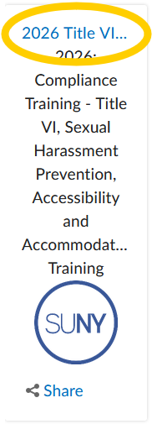
  - Select ‘View My Awards’:
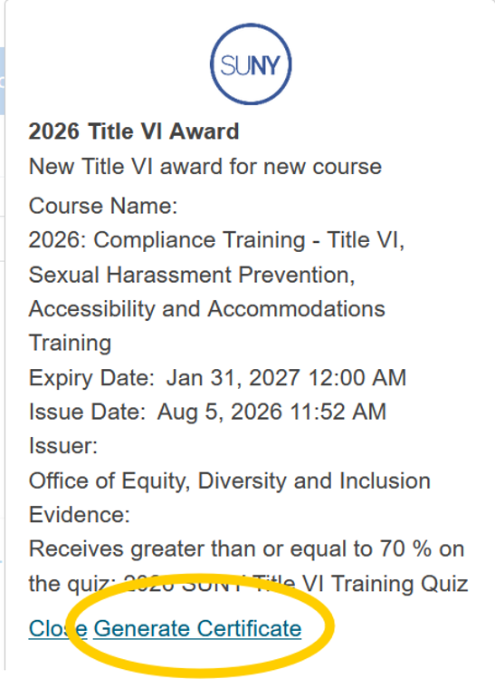
  - Select the 2026 Title VI Certificate link:
The following pop-up appears:
Select ‘Generate Certificate’ to
create a PDF certificate:
A PDF file will download to your computer.
Go To your downloads to view the certificate.
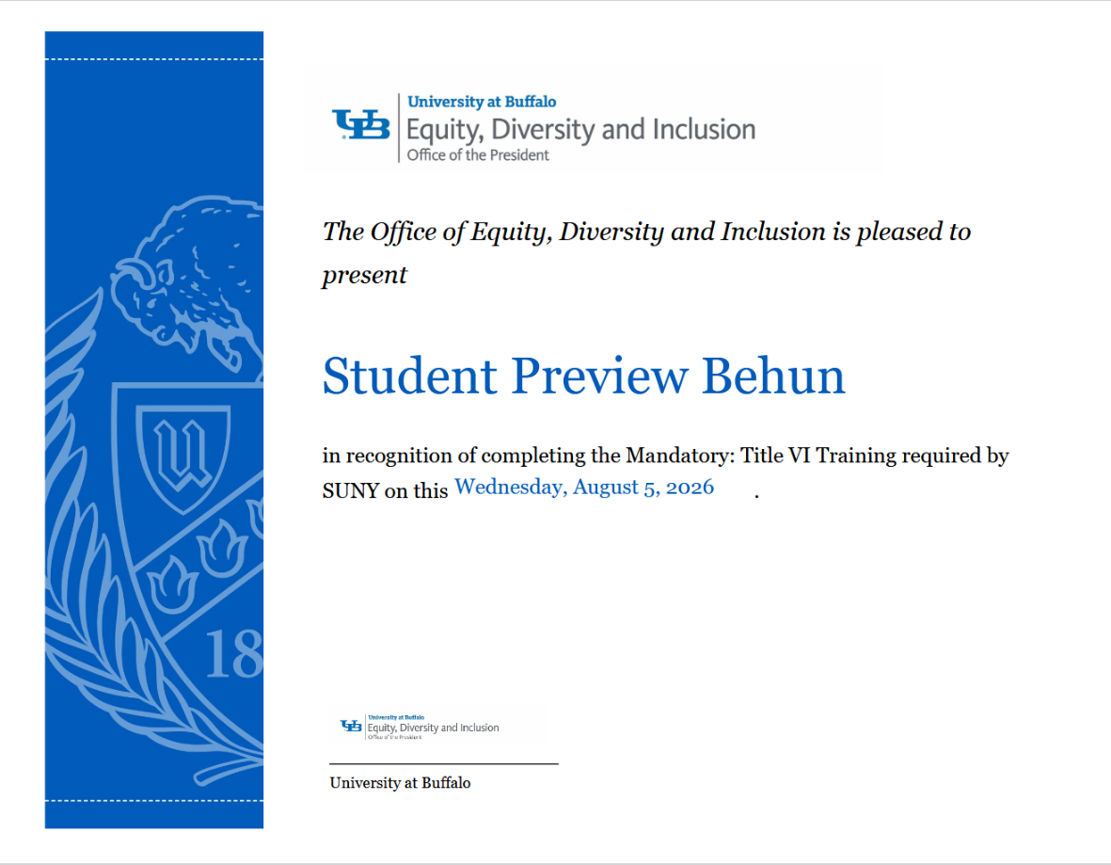
  - To View the Certificate, Open the PDF:
Please DO NOT email EDI with your certificate. We receive your completion information from UB Learns, and this is entered into our official records. Our training liaisons will have access to our official records.
Your certificate is for external organizations who may require your completion documentation.
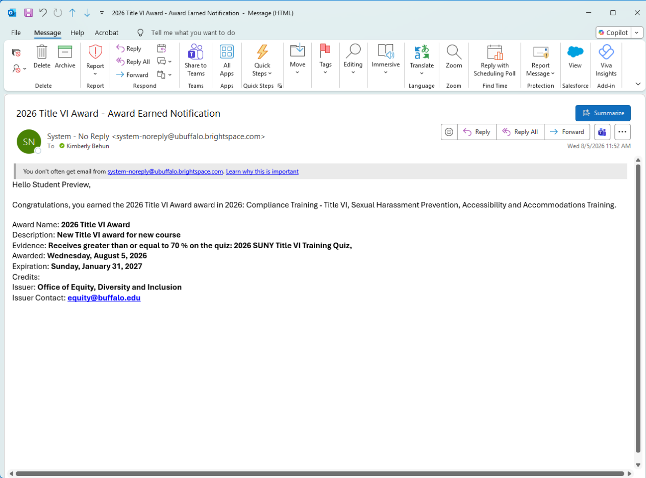
- Course Completion Email
UB Learns Brightspace will email a completion notification to you once you have completed the video and the quiz:
Please DO NOT email EDI with your email notification. We receive your completion information from UB Learns, and this is entered into our official records. Our training liaisons will have access to our official records.
The same process applies to the 2026: Mandatory Sexual Harassment Prevention Training Certificate and the 2026 Accessibility and Accommodations Training Certificate.
If you do NOT see a certificate of completion:
  - Verify your quiz grade meets the minimum requirement for a certificate.
  - Retake the quiz until you receive a passing grade.
  - Retain your completion email.
- Logout of UB Learns Brightspace
  - Select ‘your name’ in the upper right corner of your UB Learns window:
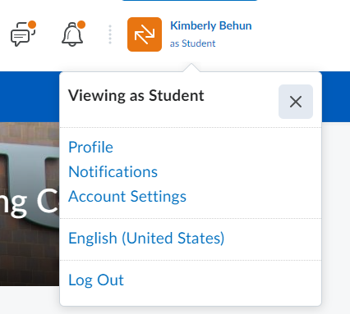
Your Name
  - Select ‘Log Out’.
- Close all internet tabs.

Mobile Device Support
For mobile device support contact EDI at equity@buffalo.edu or by phone at 716-645-2266.

