Abstract Title

(Bold, 12 point, Times or Times New Roman)

First Author¹, Second Author², Other Authors (11 point, Times or Times New Roman)
Author Affiliation and Address (11 point, Italic, Times or Times New Roman)
Different Affiliation and Address (11 point, Italic, Times or Times New Roman)
contact.author@email.address (11 point, Times or Times New Roman)

Camera-ready one-page abstracts (including figures and references) should be prepared on US letter size paper with 20 mm (0.79 in) margins all around. The title, author(s), affiliation(s), address(es) and email address of the corresponding author should appear above the abstract body. Use title case for the title (i.e., capitalize the first letter of every word except articles, prepositions and conjunctions). The title should be separated from the author(s) by a blank line. The main text should be single-spaced and the font size should be 11 point. A list of numbered references should be at the end of the abstract in 9-point font. When referring to references in the text they should be indicated by brackets, such as [1, 2]. The abstract submission deadline is February 15, 2017.
The 20th International Conference on Electron Dynamics in Semiconductors, Optoelectronics and Nanostructures (EDISON) will be held in Buffalo, USA, from July 16 (Monday) through July 21 (Thursday), 2017. Since the first meeting was held in Modena, Italy, in 1973, this series of meetings has been organized regularly: Modena, Italy (1973), Denton, USA (1977), Montpellier, France (1981), Innsbruck, Austria (1985), Boston, USA (1987), Scottsdale, USA (1989), Nara, Japan (1991), Oxford, UK (1993), Chicago, USA (1995), Berlin, Germany (1997), Kyoto, Japan (1999), Santa Fe, USA (2001), Modena, Italy (2003), Chicago, USA (2005), Tokyo, Japan (2007), Montpellier, France (2009), Santa Barbara, USA (2011), Matsue, Japan (2013), and Salamanca, Spain (2015). EDISON 20 will highlight the latest progress in the field of fundamental physics and applications of electron dynamics in semiconductors, opto-electronic devices, and nanostructures.
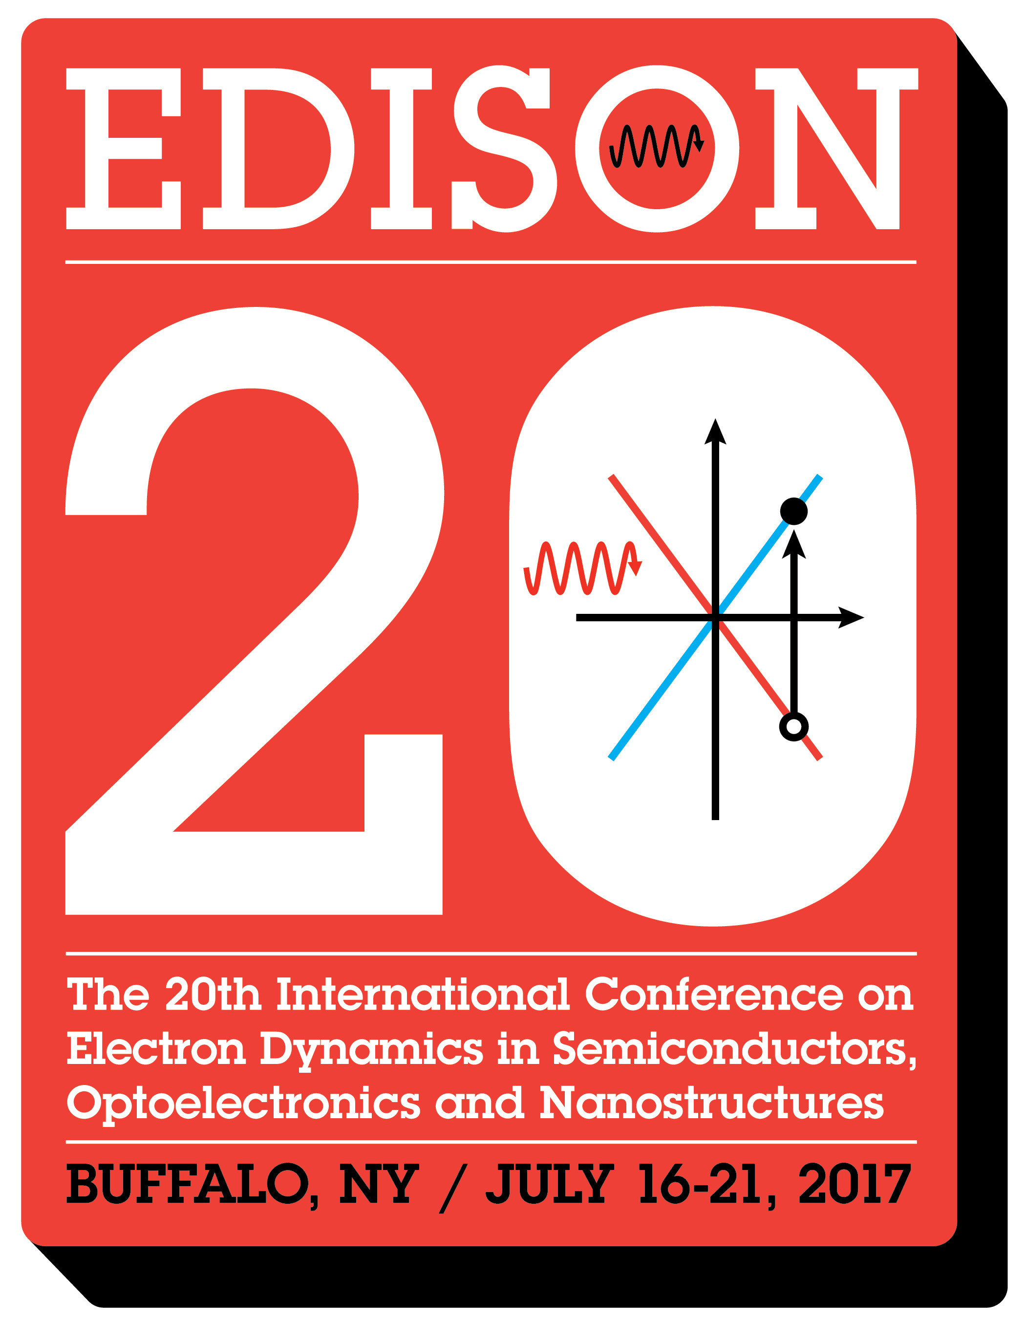
Fig.1. Caption (10 point)
The scope of EDISON 20 covers nonequilibrium and hot carrier dynamics in semiconductors, optoelectronics and nanostructure devices, with emphasis on the physics of transport and optical phenomena, including:
- Nonequilibrium carrier transport in bulk and nanostructured materials
- Nonequilibrium carrier transport in novel devices
- Coherent carrier dynamics in solids
- Coherent/incoherent carrier dynamics and ultra-fast optical phenomena
- Terahertz phenomena in semiconductor materials and devices
- Semiconductor-based spintronics
- Mesoscopic phenomena in nanostructured materials and devices
- Carrier dynamics in organic materials
- Electronic and optical properties of graphene and other 2D materials
- Synthesis and electrical and optical properties of 2D van der Waals solids
- Topological states of matter
- Ultrafast carrier dynamics in energy-conversion processes
- Energy harvesting from nanostructures
- Nonequilibrium thermal transport in devices and nanostructures
- Nonequilibrium carrier dynamics and fluctuations
- Carrier dynamics in phononic and mechanical structures

References
[1] G. He, H. Ramamoorthy, C.-P. Kwan et al., Nano Lett. 16, 6445 (2016).
[2] D.K. Ferry, R. Somphonsane, H. Ramamoorthy, and J.P. Bird, Appl. Phys. Lett. 107, 262103 (2015).

