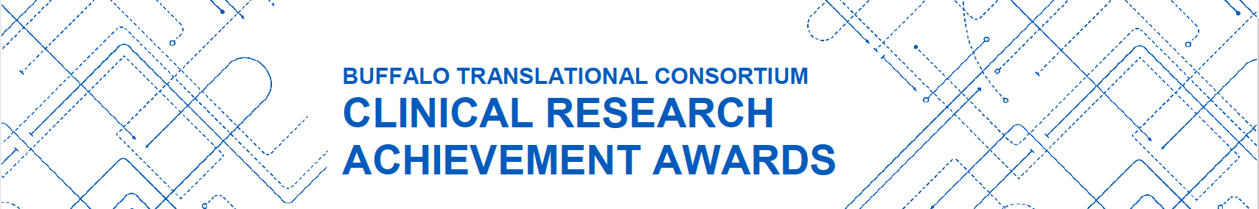
2021 Nomination Form

Journal Article Title:
Publishing Journal:
Full Citation:
Principal Investigator and Institution:
Funding Sources (list all):
Financial Conflicts (if any):

Nominee Contact Information
Name:
Mailing Address:
Email:
Telephone:
Assistant’s Contact:

Additional Materials Required
To expedite the review process, please send a single PDF of the following materials:
- Completed nomination form
- One summary, 300 words total, that outlines the specific biological innovation of the study, and potential impact on patient care and/or how the findings contributed to improved understanding
- Published article
- Published supplemental data (if applicable)

NOMINATION DEADLINE: Friday, October 29, 2021
Submit nomination packet electronically in PDF format to: erinobyr@buffalo.edu.

