Commitments Delivery Tool – Quick Reference Guide

Purpose
Use this guide to enter account distribution and track approved commitment deliveries using the Commitments Delivery Tool.

Approval and Load Process Summary
- Resource Planning approves a commitment for delivery in UPlan.
- Approved commitments are loaded into the Commitments Delivery Tool for account distribution.
- VP/Decanal Units:
  - Enter account distribution details for approved commitments
  - Submit commitments for processing
- Financial Management records the delivery date once transactions are submitted for processing.

Step 1: Open Commitments Dashboard
• Open the Commitments Dashboard. (figure 1)
- The main page displays three tabs:
  - Action Required (default): Commitments requiring VP/Decanal Units to provide account information.
  - Submitted Commitments: Commitments with account information submitted by VP/Decanal Units for Processing.
  - Delivered Commitments: Commitments processed by Financial Management.
Important: Commitments that have already been submitted cannot be modified.
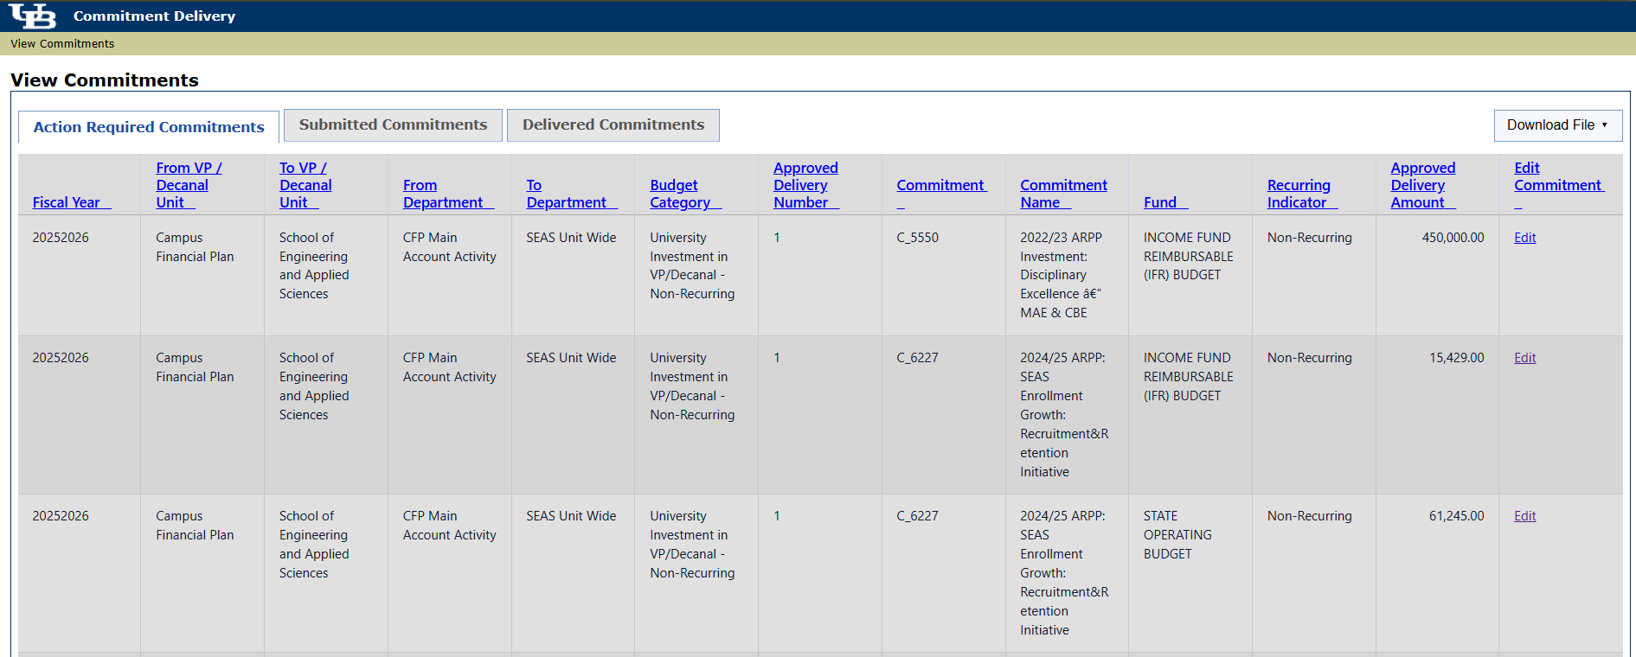
Figure 1

Step 2: Edit Commitment
• From the Action Required tab, select Edit to provide the distribution details (figure 2) for the commitments displayed.
Figure 2

Step 3a: Provide Account Number
- The approved delivery amount may be distributed across multiple accounts.
- Available accounts are limited to those within the fund associated with the selected commitment.
- Only accounts for which the user has SIRI Financial Strategic Security access within the commitments’ VP/Decanal unit will be available.
- To enter an account, you may search by name, select an account from the dropdown list, or enter the account number directly in the dropdown field (figure 3)/ (figure 4).

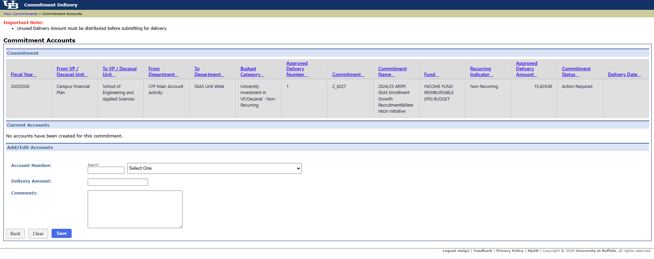
Figure 3

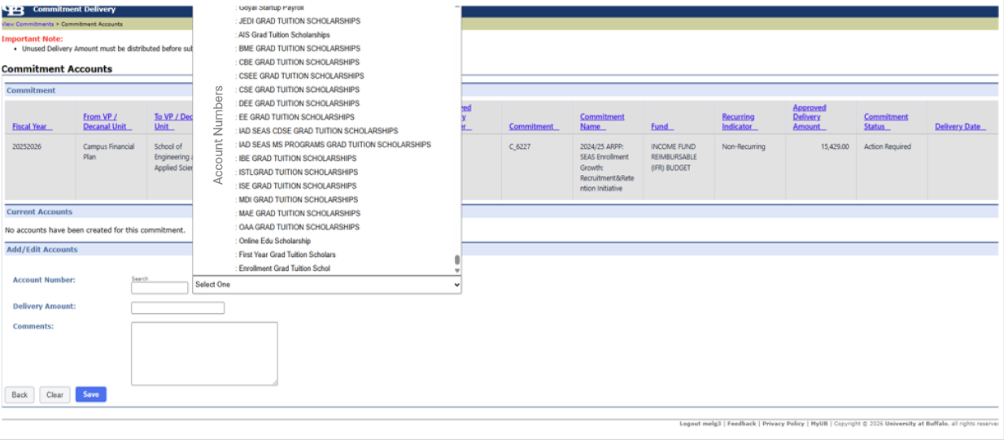
Figure 4
Step 3b: Enter Delivery Amount
- Enter the amount being delivered (figure 5), then click Save.
- Comments are optional for your reference only and do not impact the delivery process.
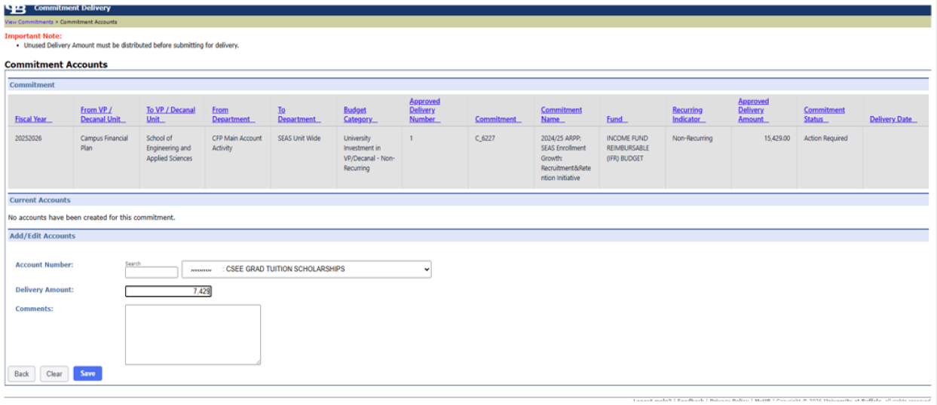
Figure 5
- Additional Accounts - Repeat Step 3 to add additional accounts as needed.
  - A notification will appear in the upper left corner until the Unused Delivery Amount equals $0. (figure 6)
  - The Submit button will not be available until the total amount of the commitment is distributed to accounts. Partial Deliveries cannot be submitted for processing.
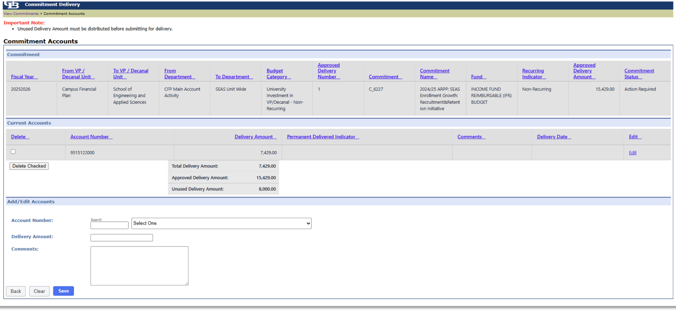
##########
Figure 6
Review the account distribution prior to submitting.
- If changes are needed to accounts or amounts, you may select edit to make changes or select the Delete checkbox to completely remove the row. (figure 7)
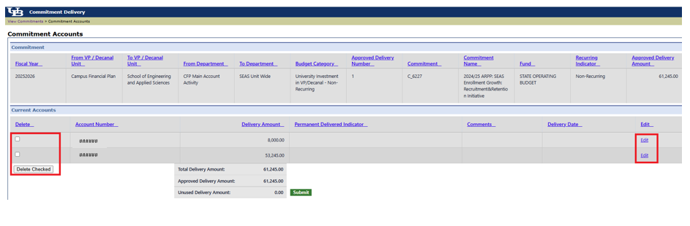
Figure 7

Step 4: Submit for Processing
- Select Submit to advance the commitment for processing.
- The Submit button will not be available until the Unused Delivery Amount equals $0. (figure 8)
- If the user exits this screen prior to selecting Submit, the Commitment Status will remain Action Required.
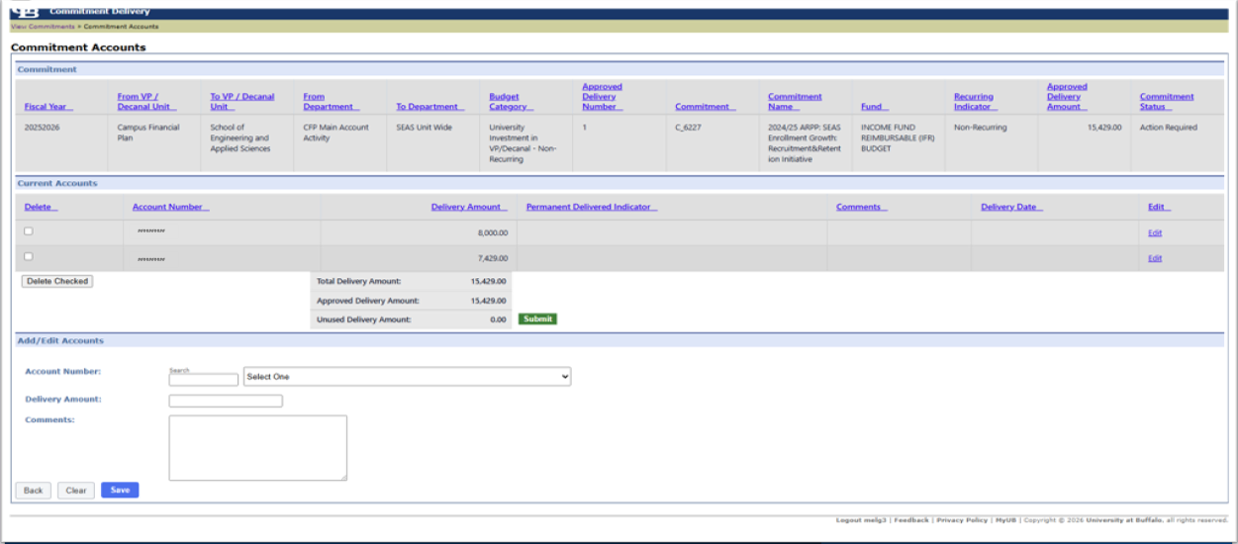
Figure 8

Step 5: Review the Commitment Status
- Select the Submitted Commitments tab on the View Commitments page to review Submitted Commitments.
- Confirm the status updates to Submitted for commitments where account details were provided. (figure 9)
Continue following Steps 1–5 to provide account details for additional commitments with a status of Action Required.
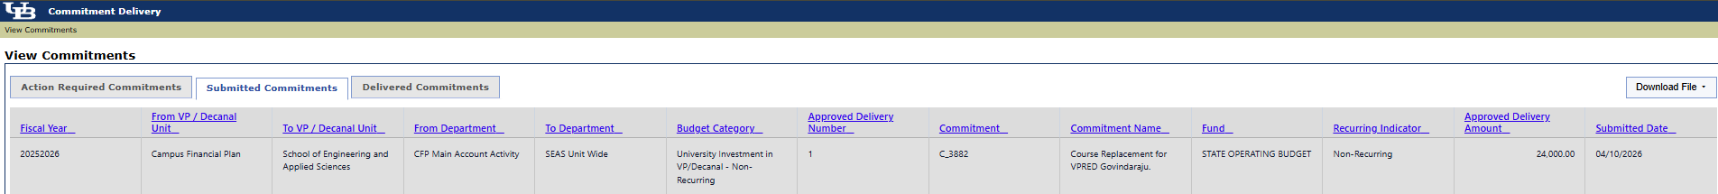
Figure 9
Step 6: Commitment Delivery Transactions
COMMITMENT DELIVERY PROCESS:
- Financial Management will request the necessary transactions for commitments with a status of Submitted and will add a Delivery Date to the commitment.
- Once the Delivery Date is entered, the commitment status will update to Delivered and will appear under the Delivered Commitments tab on the main Commitment Delivery page.
- Please allow 5-10 business days from the Delivery Date (figure 10) for delivered transactions to appear in SIRI.
CHECKING DELIVERED COMMITMENTS:
- Check the Delivered Commitments link in the upper right. (figure 10)

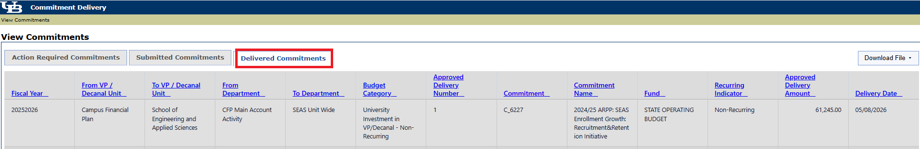
Figure 10

VIEWING REPORTS: (All Tabs)
- Commitment Delivery Tool:
  - Each tab provides an option to download data to Excel. (figure 11)
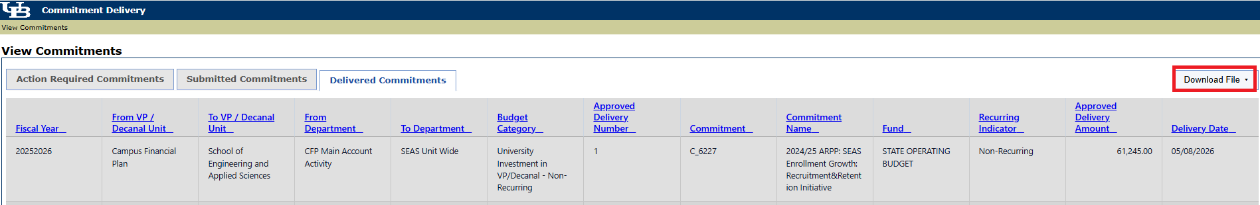
Figure 11
- Delivery details will not be loaded to UPlan. The Commitment Delivery Tool or SIRI reports should be referenced for this information.

