Overview

Bacteriophage lambda (λ) is a small bacteriophage that infects E. coli

Genome size is 48502bp contain ~30 genes and numerous regulatory sequences

The genome is linear when packaged in the phage head and circularizes upon entry into the host cytoplasm

λ undergoes two life choices

lysogeny

lysogenic growth occurs when the λ chromosome integrates into the host’s chromosome

the integrated phage then is replicated along with the host’s chromosome

lysogenic growth requires the function of the cI gene – the λ repressor

cI binds DNA at the O_{R} and O_{L} and prevents transcription of cro and N from P_{R} and P_{L} respectively.

all genes downstream from the N_{UT} left and right sites are therefore not transcribed because transcription terminates at the Nut site

lysogeny requires function of cII and cIII proteins which stabilize each other and activate transcription of cI from the P_{RE} (repressor establishment)

once cI is produced, it stimulates its own transcription from the P_{M} (maintenance) while simultaneously blocking transcription from the P_{R} and P_{L} by binding to the O_{R} and O_{L} respectively

lysis

lytic growth occurs when the cro repressor is produced in sufficient amount to block transcription of cI and allow transcription of all late genes (replication factors and head and tail genes)

lytic growth also requires that cII not be present to activate transcription from P_{RE}

cII is only present if cIII stabilizes cII

cIII only stabilizes cII when the bacterium is under stress conditions

therefore, under favorable growth conditions (for the bacterium), lysis usually occurs

Initial events

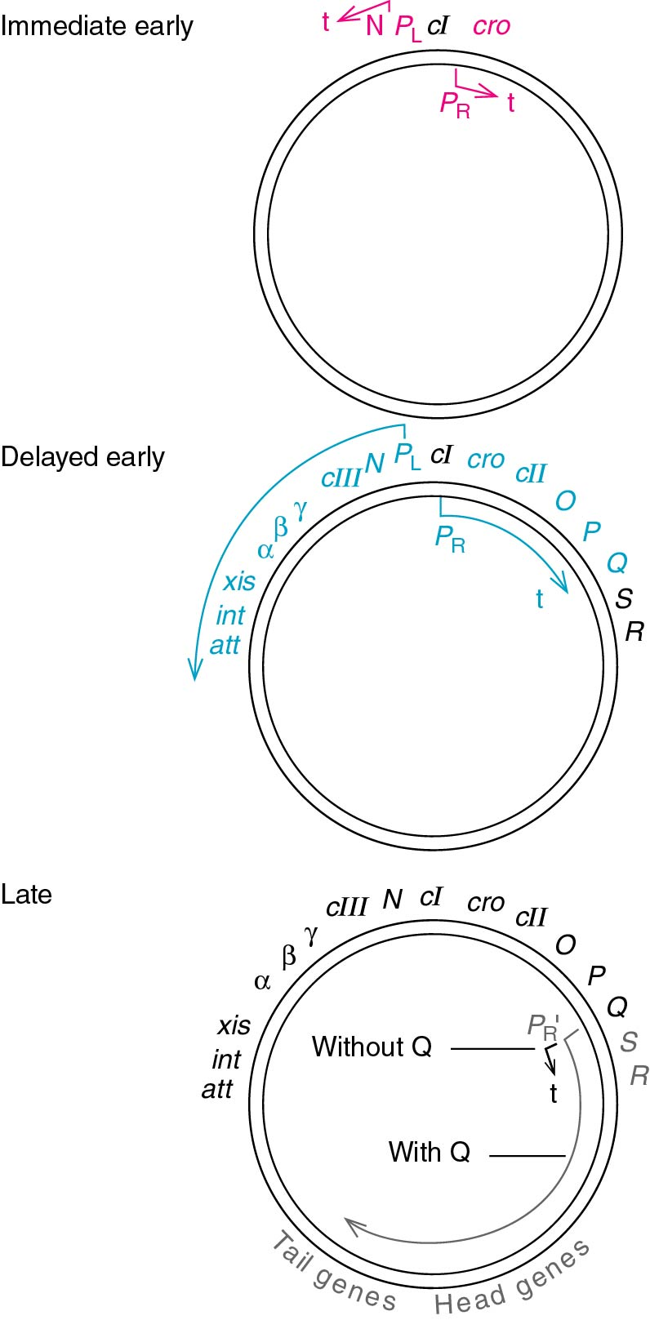
Host RNA polymerase begins transcribing from the P_{L} and P_{R} promoters

P_{L} drives transcription of N

P_{R} drives transcription of cro

Initial transcription from these promoters terminates just past the N and cro ORFs as immediate early genes (see figure at right)

Production of N (antitermination factor) allows for transcription to continue leftward through N to produce a polycistronic message encoding cIII, and other proteins associated with DNA recombination needed for lysogenic growth (see λ genome map at right)

N also allows for rightward transcription past cro to make cII, P and Q

All of these genes are delayed early or middle genes

Rightward transcription terminates just past Q before the late genes (head & tail genes for making phage particles)

Q is another antiterminator that allows transcription to continue from the P_{R'} which is just upstream of Q to make S and R and all head & tail genes

Establishing lysogeny

although cro is produced first after infection, lysogeny often occurs in E. coli even under good growing conditions

lysogeny occurs as a result of transcriptional repression by the λ repressor cI

cI is first transcribed from the P_{RE}

host RNA polymerase has low affinity for the P_{RE}

cII binds to the minor groove on the opposite side of the DNA helix from the –35 box (see sequence of P_{RE} below at left)
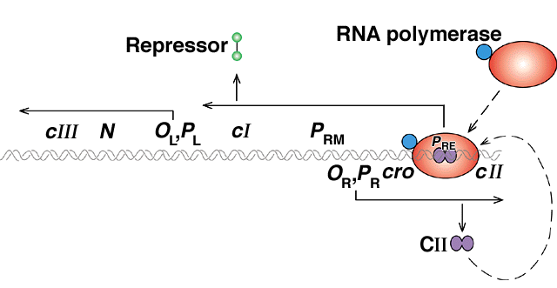
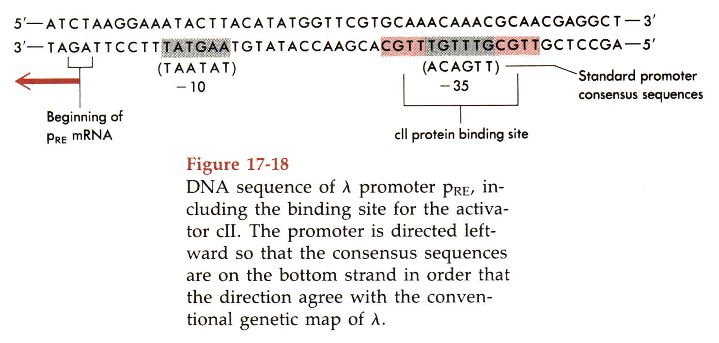

cII then recruits RNA pol to the P_{RE} (see figure above at right)

transcription from the P_{RE} not only makes mRNA encoding cI, but the P_{RE} mRNA is antisense to the P_{R} transcript.

the two transcripts can anneal to form a dsRNA molecule that prevents translation of the cro ORF

this begins to decrease the amount of cro in the cell

cro protein has a short half-life

the cI ORF can still be translated

Maintaining lysogengy

After cI is transcribed and λ repressor begins to accumulate it begins to shut down transcription from both the P_{R} and P_{L} promoters

The λ repressor dimerizes and binds to the O_{R} and O_{L}

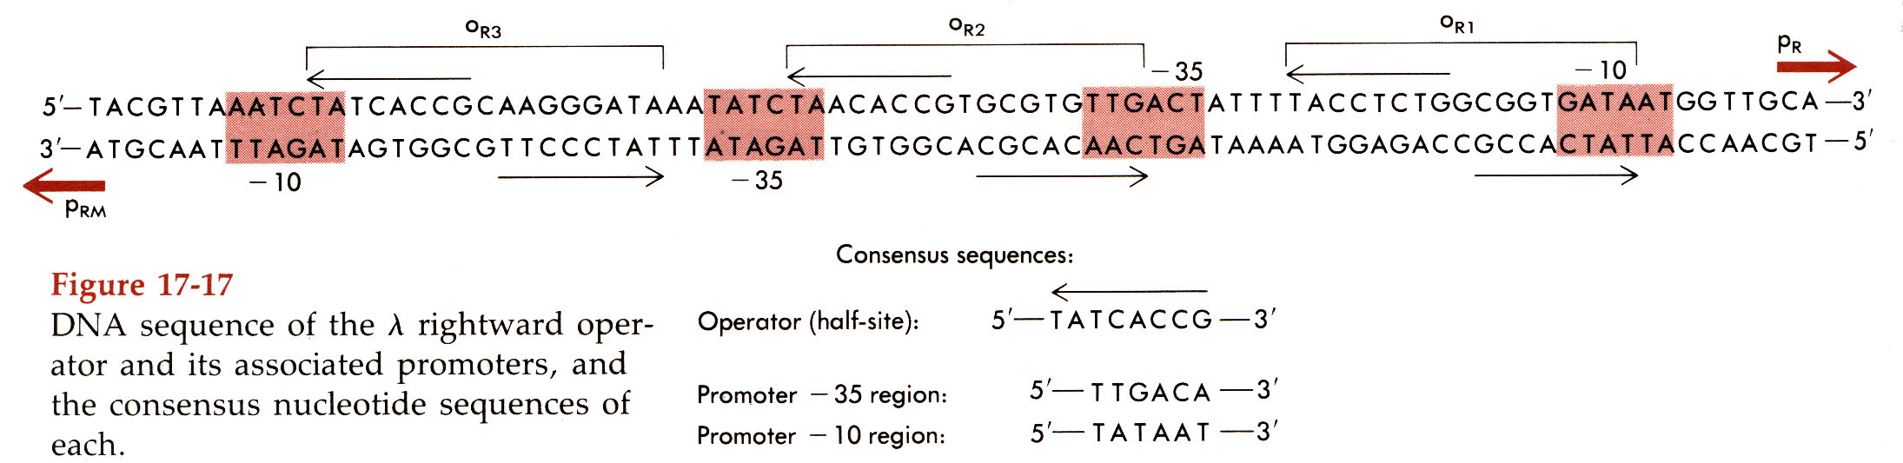
Each operator is actually three separate binding sites side by side (see sequence below)

The O_{R1} O_{R2} and O_{R3} each have differing affinities for λ repressor

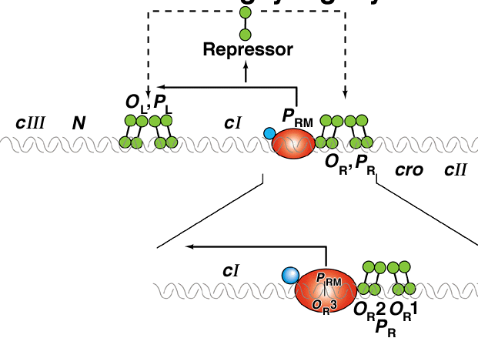
λ repressor binds with highest affinity to O_{R1} then O_{R2} then O_{R3}

binding of λ repressor to O_{R2} is cooperative

λ repressor binds to O_{R1} first then enhances the subsequent binding to O_{R2} (see figure at right)

when O_{R1} and O_{R2} are occupied by λ repressor dimers P_{RM} can be activated

the λ repressor dimer bound at O_{R2} physically contacts the σ factor of RNA polymerase and recruits RNA polymerase to the P_{RM}

transcription then occurs to produce a shorter mRNA still containing the cI ORF

this promoter is continually activated once λ repressor has been made even though transcription from both P_{R} and P_{L} is repressed

eventually, high levels of cI accumulate and can then bind to the very low affinity O_{R3} site which then shuts down transcription from P_{RM}

so λ repressor (cI) autoregulates its own transcription in both a positive and negative manner

Subsequent lysogenic events

cII also activates transcription from a second promoter called P_{I}

transcription from P_{I} encodes the int (integrase) and xis (excisionase) genes

the integrase protein then carries out recombination between the host chromosome and the att sequence of the phage

Lytic events

Activation of cro

cro binds to the O_{R3} site with the highest affinity, it can also bind to the O_{R2} site, but with lower affinity. the O_{R1} site is bound with the least affinity

binding of cro at O_{R3} blocks the P_{RM} and therefore, cI can not maintain its own expression

binding of cro to O_{R3} and O_{R2} ultimately shuts down transcription of P_{R} as well and therefore no more cII is made

without cII, no transcription from P_{RE} or P_{I} occurs and therefore, cI is never transcribed

production of Q (from early P_{R} transcription) allows for transcription from P_{R}’ to occur

P_{R}’ produces R, S, and all head and tail packaging proteins

DNA replication in λ

The accumulation of these proteins allows for DNA replication

The O region it the origin of replication which is activated by the P protein

DNA replication occurs via a rolling circle mechanism

A long, continuous concatemer of phage DNA is produced

the concatemer is made up of several phage genomes linked end to end due to the continual DNA synthesis

the individual genomes are cut apart at a special 12 bp sequence called the COS (cohesive) site

the DNA is ligated at the cos site upon infection of a new host

the cos sequences are used to make a derivative of lambda called a cosmids which is used as a vector for large genomic DNA sequences

the linear λ DNA is then packaged into phage heads and the tails are assembled

the build up of phage particles and the activity of the R and S proteins allows the host cell to lyse and release the new phage

the cos sites are then religate

