Using Digication Within Blackboard Building Block: A Faculty Guide
Mikhail Valentin
October 28, 2016 19:55
Follow
Using Digication within Blackboard Building Block is a bit different from using it on standalone Digication. Here is a rundown of the tool and how to go about accomplishing the needed tasks once you've set is up for use within your course.

Digication Homepage within Blackboard
Upon navigating to Digication within Blackboard, you'll notice that the look and feel of the homepage area are different, however still contain the following options/areas:

My ePortfolios (Shared with this course)
This area is where you'll be able to see all of your own ePortfolios that have been shared with the course.
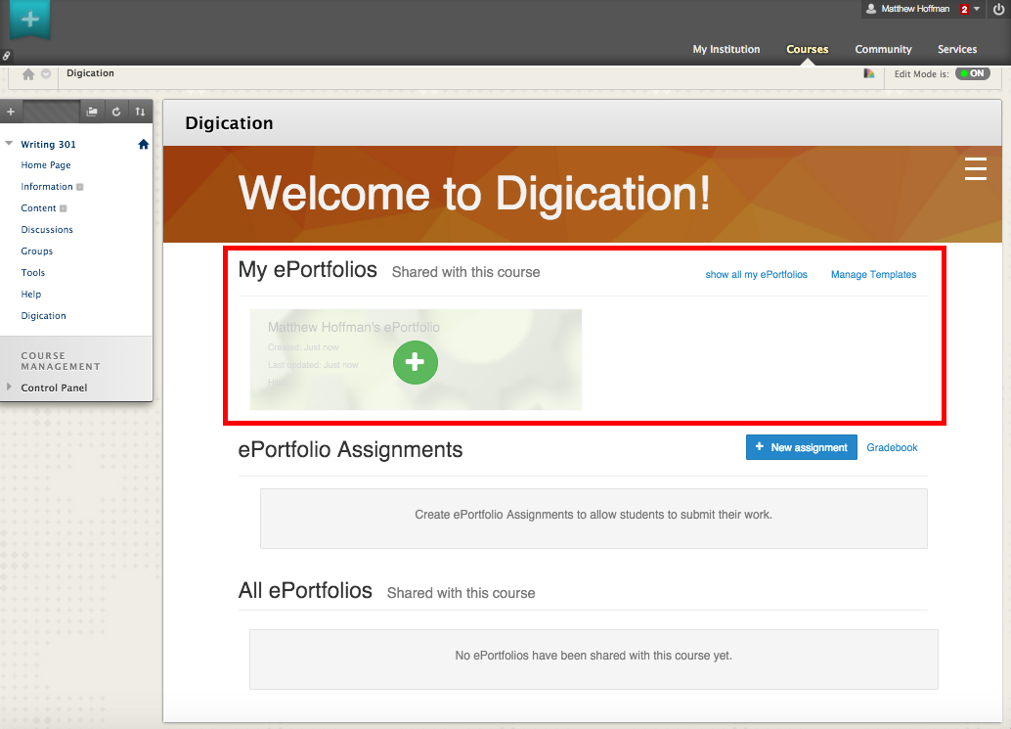

Show all my ePortfolios
This area is where you'll be able to see all of your ePortfolios created to date.
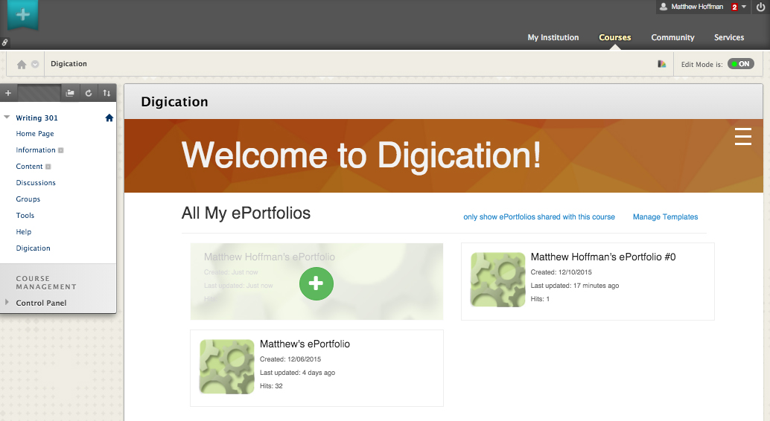

ePortfolio Assignments
ePortfolio assignments is a new area where you have the ability to create assignments within the course for students to submit.
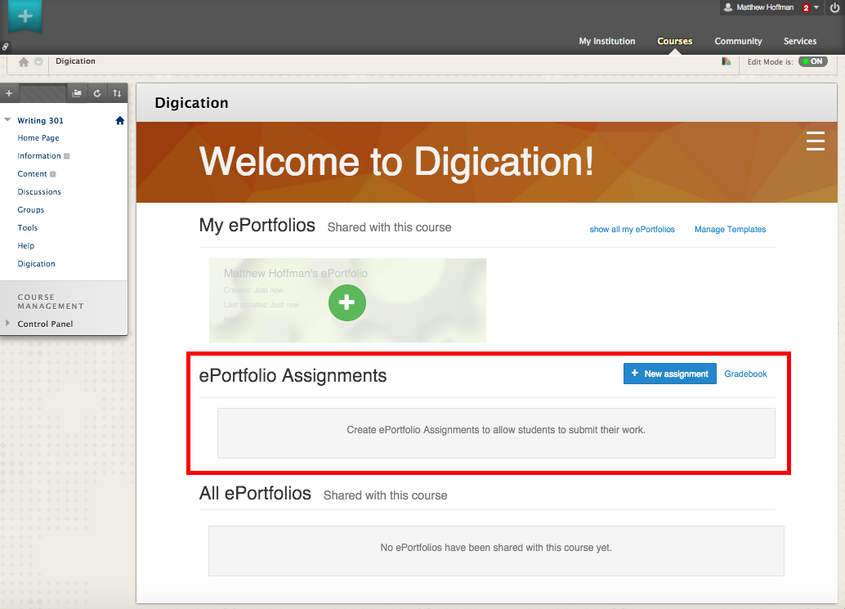

All ePortfolios (Shared with this course)
This is where you'll find ePortfolios created by other users (students) that are shared with the course.
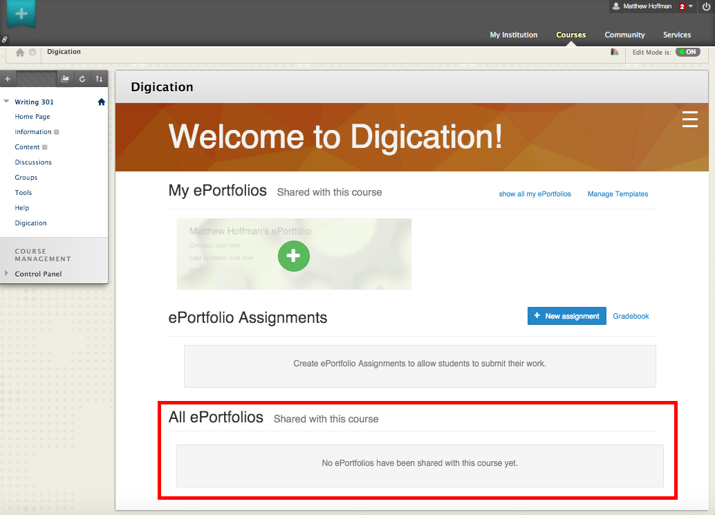

Creating an Assignment
To create an assignment:
- Click on the "+ New Assignment" button and select "Create From Scratch" from the drop-down menu.
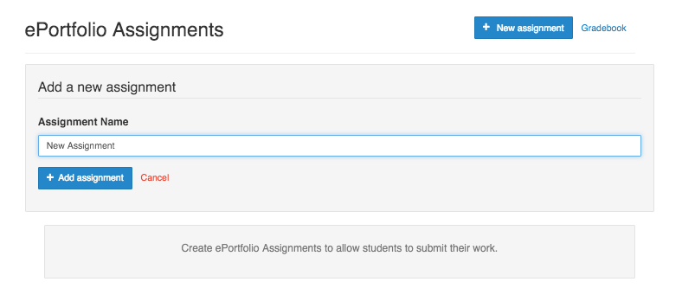
- Enter a name for the assignment and click on the "+ New Assignment" button again for it to appear under "ePortfolio Assignments."
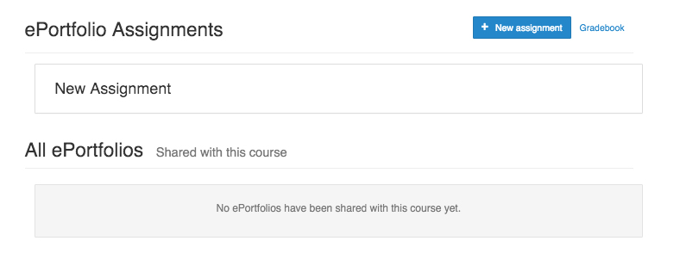
Once this is done, an assignment will be created both for Digication within the course as well as Blackboard and any grades entered will reflect in both systems.

Gradebook
You'll see that in the "ePortfolio Assignments" area next to the "+ New Assignment" button there's a link called "Gradebook." Clicking on this link will bring you to the new "Gradebook" tab within the course externally. From the new Gradebook area, you'll see a roster of all the enrolled students with fields for each assignment placed next to their names.
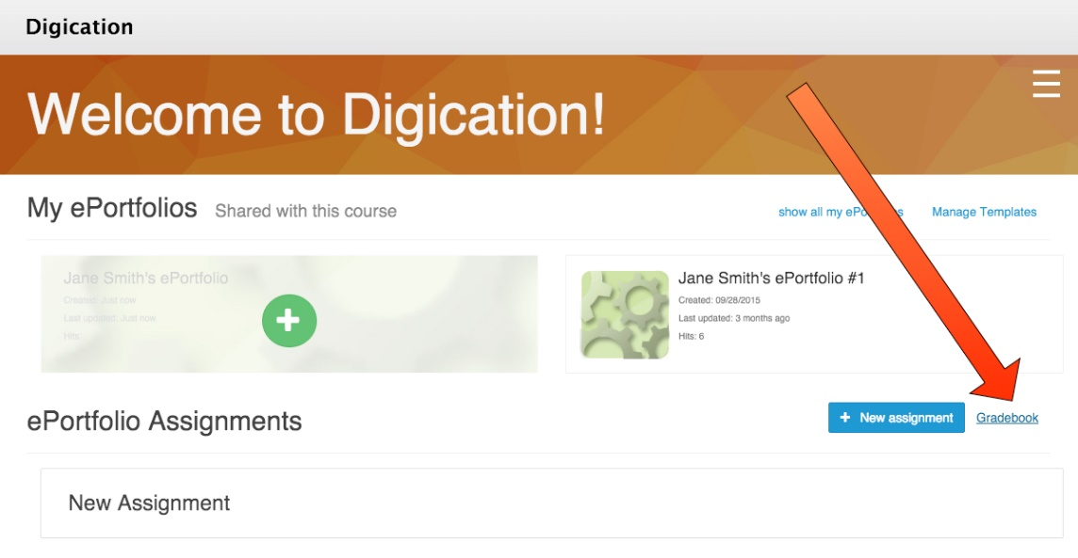

To Enter Grades
Simply click on the cell for the student and grade to be entered. Clicking on the tab key on your keyboard will bring you to the next assignment for that student. For large classes there is a "Search" field that will allow you to filter by a students by name as well, for easy grading.
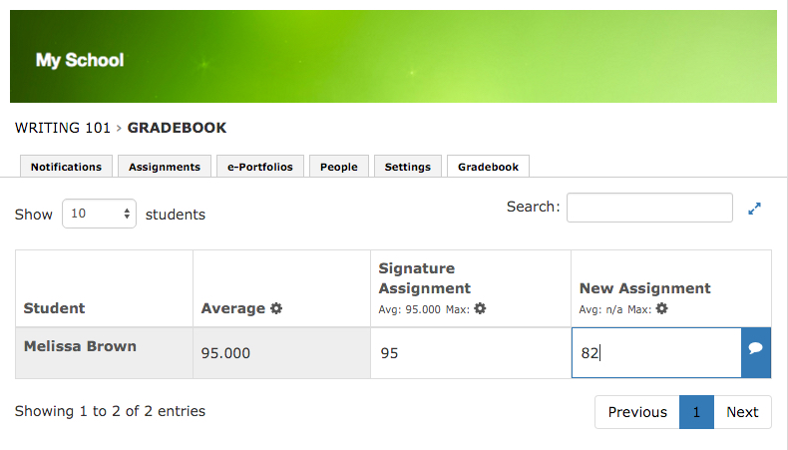

Adding Comments to Grades
A small text bubble icon will appear whenever clicking in a grading field; this is for you to add comments. Clicking on it will give you a pop-up window to enter your comment and click "Save changes" to save it. This can be done and redone as many times as needed.
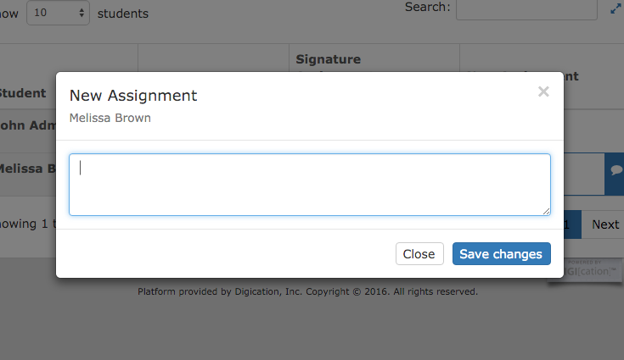

Editing Assignments
You'll also notice a small cog icon underneath the assignment name.
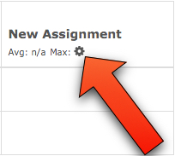
Clicking on it gives you a pop-up that allows you to edit settings for the assignment which include:
- A "Make viewable?" checkbox, which allows students to see their grades.
- A "Maximum Points" field where you can set the maximum amount of points for the assignment.
- A "Relative Weight" field which allows you to assign a relative weight for each assignment. Weight is set to 1 by default.
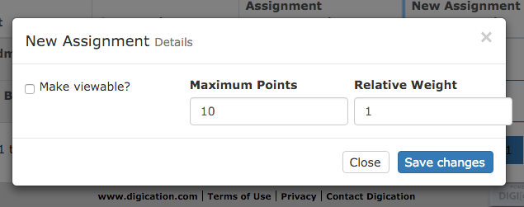
Once all of the necessary changes have been made, you'll need to click on "Save changes" for them to be reflected in both systems. Please note that all grades entered will push automatically to Blackboard.
Warning: If you change the name of an assignment in Digication externally, the assignments will no longer sync with the Blackboard grade book. Please be careful!

Grading in Blackboard
If you'd rather use Blackboards grading functionality instead of the Grade Book within the Digication tool, you can do so easily! Creating an assignment within a course also creates an entry in the Grade Center. This is another way of streamlining the process of grading by allowing users to work in the ways they know best.
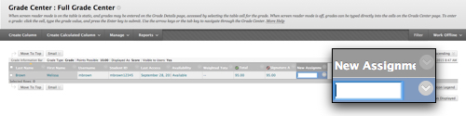

We hope that this new addition to the toolset will make the creating and grading of eP assignments within Blackboard and Digication seamless and enjoyable for faculty and staff. Please try it out and let us know what you think at support@digication.com

