2021 UBIT Student Experience Survey
  - 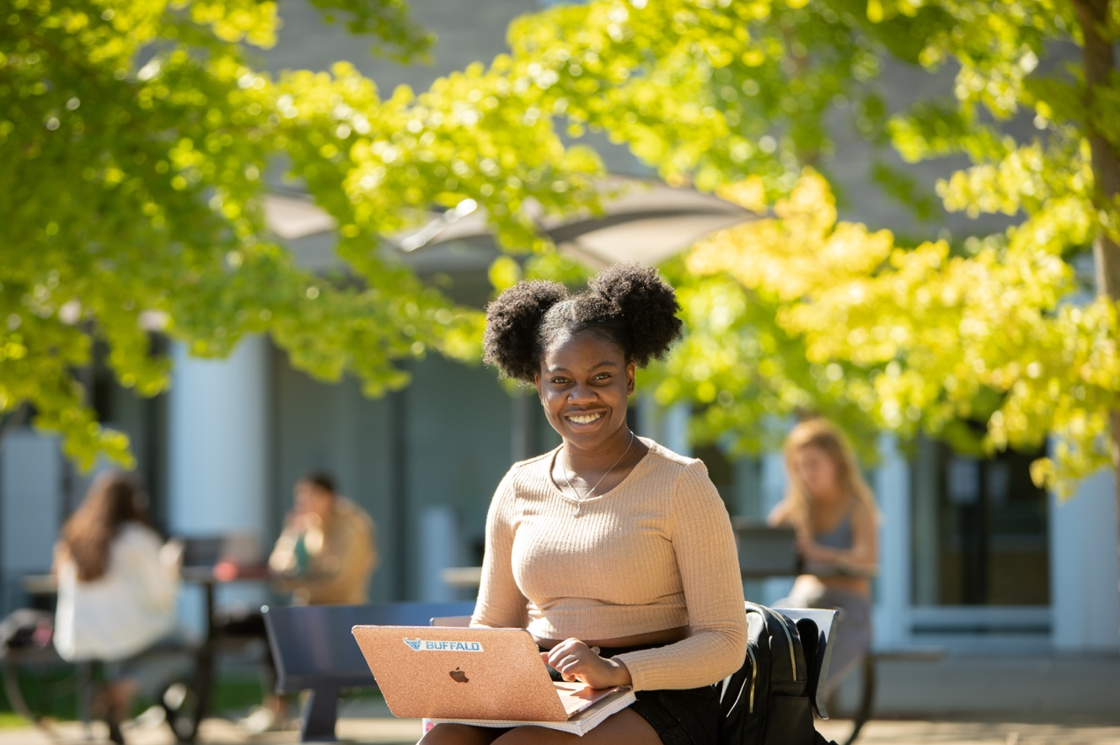
  - Executive Summary
  - 3/14/2022
UBIT Communication and Engagement
Office of the VPCIO
UB Information Technology

2021 UBIT Student Experience Survey
  - Executive Summary

Introduction
Among the many ways the COVID-19 pandemic has reshaped the student experience forever, students are more intimately familiar with the increasingly central role technology plays in that experience.

In its 25th year, the UBIT Student Experience Survey heard from UB students who are better equipped to leverage technology for maximum effect in both their academic and personal lives:
- There has been tremendous growth in the percentage of UB students who use smart devices like TVs, speakers and light bulbs (pg. 4)
- Students rely more on third-party messaging apps, especially Discord, Slack and GroupMe, to coordinate work among their classmates (pg. 5)

Respondents to this survey demonstrated better command and understanding of UB-provided technology, too:
- Respondents were more aware of (and more satisfied with) UBmail, MyUB, HUB, UB Learns and other essential UB tools (pg. 7)
- UB’s new distributed printing kiosks (introduced in 2020) received high marks from students back on campus; dissatisfaction fell 6% while student satisfaction remained constant at 73%. 9% fewer students weren’t using or weren’t aware of the service (pg. 7)
- 81% of respondents said UB’s classroom technology assists their learning at least moderately well (pg. 8)

As always, the students who respond to this survey are UBIT’s compass for improvement. They suggest continued efforts to provide robust and flexible networks, tools for peer collaboration, and security resources to keep them safe by default. Keeping up with the pace of student innovation is not an easy task—but it’s a challenge we’re eager to take on.

About the Survey
2,285 UB students responded to the 2021 survey, representing undergraduates at all levels, as well as graduate students and non-degree seeking students. 76% of respondents reported living off-campus.

The 2021 UBIT Student Experience Survey was open from October 18 to November 1, 2021, and contained 23 questions designed in conjunction with instructional and support IT staff in each technology area surveyed, as well as the UB offices of Student Life, Campus Living, Undergraduate Education, University Libraries and other campus stakeholders.

Responses were collected using Qualtrics. Students were encouraged to participate through social media and online promotions. One winner was drawn to receive $25 Campus Cash.

Where possible, this report compares data from 2021 with 2019, the last year when the majority of students were living and studying on campus.

While some key questions were required, many were not; where applicable, percentages reflect the number of students who answered that specific question.

Pictured on front: A student poses while studying outside of Greiner Hall in October 2021. Photo by Meredith Forrest Kulwicki.

Part I. Personal technology for students
  - What personal technology do students use in their daily lives, both personal and academic? How does this technology empower them?

Which “smart” devices are you using this semester?
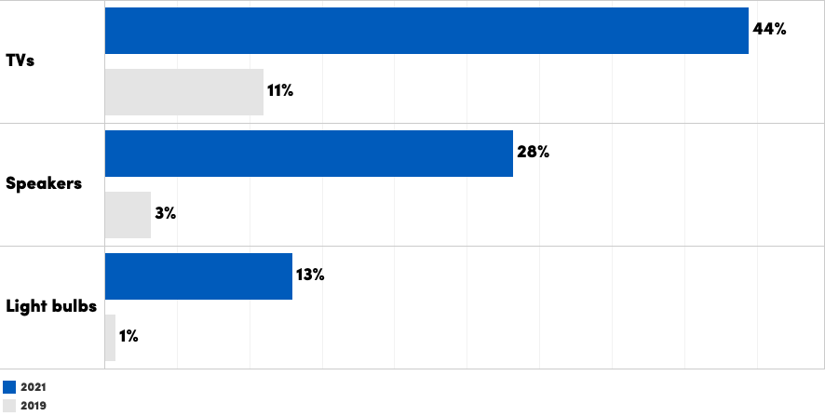

The percentage of UB students using smart TVs, speakers and light bulbs has grown exponentially in the past two years, following a five-year period of steady (albeit more linear) growth.

This trend has implications for UB’s networks. Ensuring network access for popular smart devices, while maintaining UB’s security standards, has strategic value for student satisfaction and retention. In 2021, UBIT added the UB_Devices network to streamline securely connecting devices without a web browser to the internet at UB.

Student use of laptops and smartphones has been predominant (>80%) since at least 2015. This year, the percentage of students who reported not owning a computer was its lowest ever (2%; see pg. 10). To assist students without a personal computer, UBIT partners with UB Libraries to provide laptop loans to students.
Digital tools for academics and productivity
What software do you use for productivity in your work at UB?
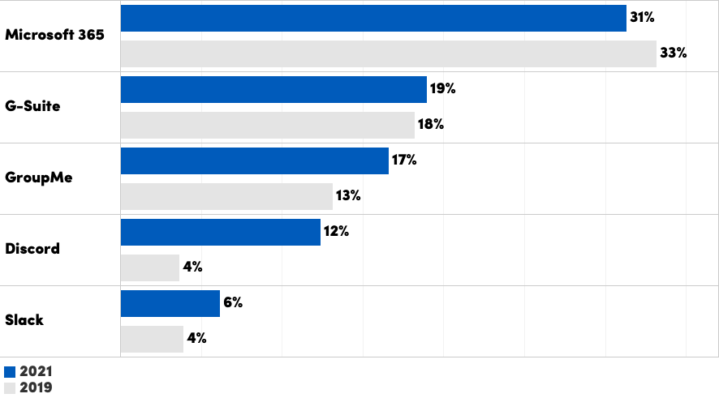

Microsoft 365 and G-Suite apps are both currently offered to students at UB (Microsoft 365 to students who began during or after Summer 2021; G-Suite to those who began prior).

Use of third-party messaging and group work apps (GroupMe, Discord and Slack) are all increasing, with Discord being overtaking Slack to become the biggest gainer (up to 12%, from 4% in 2019).

Which non-UB academic websites have you signed up for?
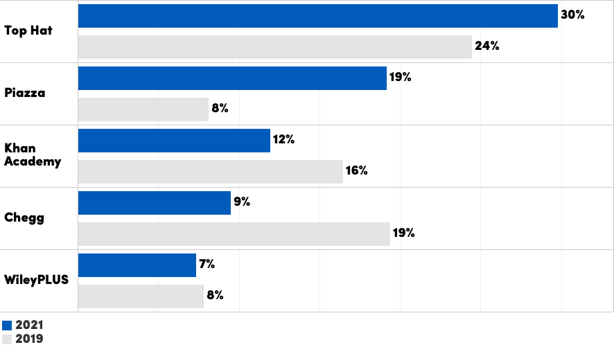

UBIT asks students about third-party academic websites to gauge the need for support, either on the institutional or departmental level, for these tools as they become more widely used. This has been the case with Top Hat (supported university-wide) and Piazza (supported by SEAS departmental IT), both of which were used more widely in 2021.

Use of these sites, especially when not supported by UB and protected by UB’s Single Sign-On, also poses security risks, as students commonly use their UB email address and password as login credentials on these sites.

UB’s Information Security Office monitors for breaches at these sites; one such breach, at Chegg.com in 2019, potentially exposed 4,000 UBITName accounts.

Part II. UB-provided technology for students
Are UB students taking advantage of (and satisfied with) the technology tools UB offers them?

Please rate your satisfaction with UBIT tools and services

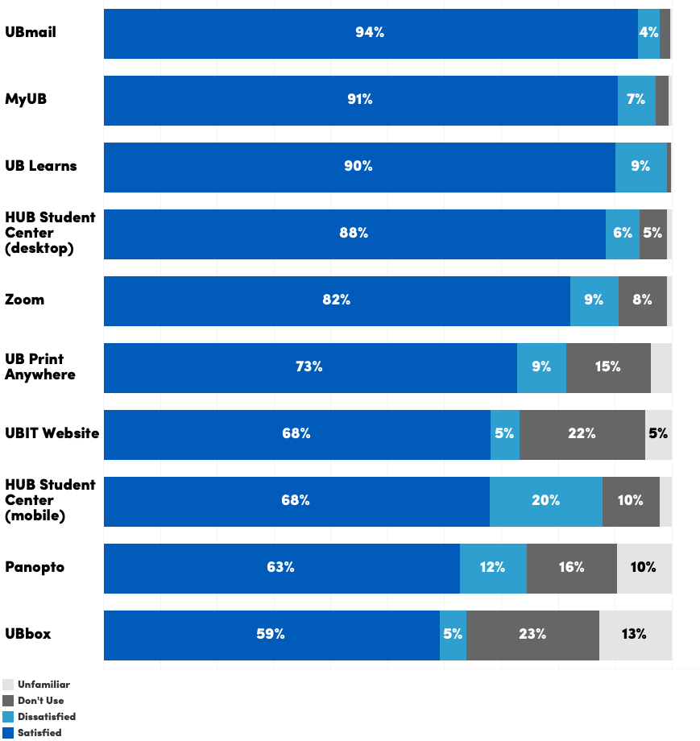

Student-reported satisfaction rates with UBIT services were largely consistent with 2019’s data, in many cases higher by three or four points.

Notably, students responded positively to UB’s Print Anywhere kiosks (introduced in 2020): a smaller percentage were dissatisfied with printing (down from 15% in 2019 to 9%), and a higher percentage were using the service (97%, up from 88%).

How could we improve classroom technology?
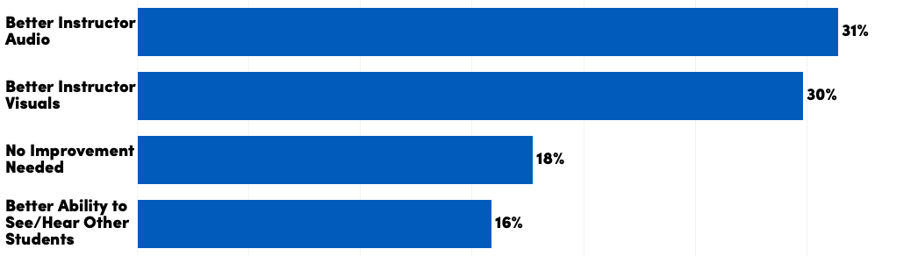

80% of students who responded said that classroom technology aided them at least moderately well in their learning (9% said very well, the most positive ranking).

When asked how UB could improve its classroom technology, most respondents requested better audio and visuals for instructors (around 30% for each category).

In the past two years, UBIT has upgraded central classrooms to incorporate on-demand livestreaming and lecture recording using Zoom and Panopto. In 2021, UBIT completed an upgrade of classroom technology in NSC 201 and 225 to add the following features for enhancing interaction and engagement:
- a 30-foot video display capable of showing two inputs at once
- a dedicated camera to stream chalkboards to the main display (or to a remote source, via Zoom or Panopto)
- microphones at student seats

Rate the following UB Learns features
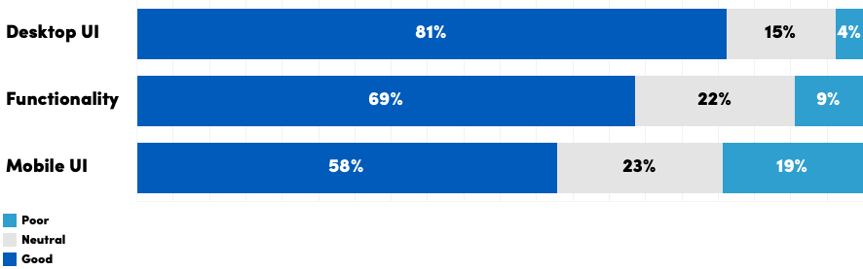

Part III. Supporting students with technology
Are we currently supporting students to the best of our ability? How could we improve our efforts based on feedback from students?

What technology-related problems have you faced this semester?
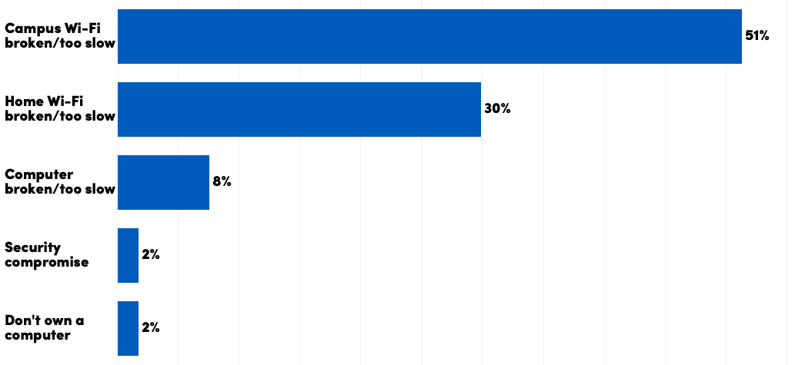

A high number of student respondents cited problems with campus Wi-Fi (51%). This is likely due to a disruption in wireless service during the first week of classes, caused by a bug in vendor which was also reported at other colleges and universities using the same eqiupment.

Nonetheless, UB continued to expand wireless eduroam access on campus, including bolstering outdoor spaces around One World Café and elsewhere. Similar expansions are planned for South Campus in the coming years.

UBIT has invested in promoting the laptop loaner program (which UBIT co-sponsors with UB Libraries) for students who have a broken, or no, laptop.

How did you learn about free software from UBIT, like Microsoft 365 and Zoom?

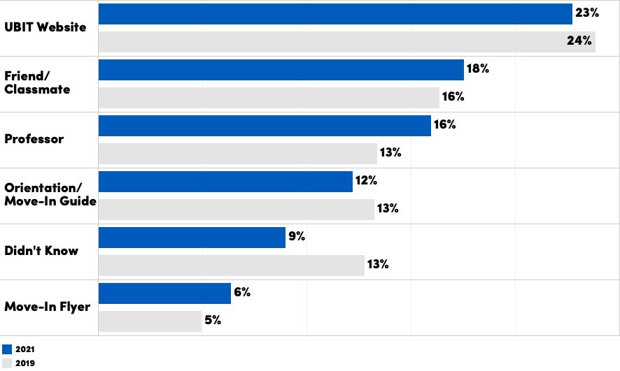

UBIT offers free software like Microsoft Office and Zoom to students, and student awareness of these offerings has long been interpreted as an indicator of the efficacy of student communication and engagement efforts.

The percentage of students who didn’t know about UB’s free software was at its lowest since the question was first asked in 2013 (9%).

For the fifth straight year, the UBIT website was cited as the most common source of information about free software and other IT information for students (23%). In 2020, the UBIT website was redesigned with a new student landing page (buffalo.edu/ubit/students) to help students, especially first-year students, find relevant information faster.

Where did you learn about UB technology offerings before you arrived to campus?
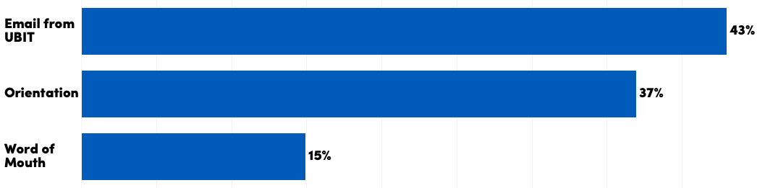

First-year students reported learning about UBITName activation (25%), Duo two-step verification (22%), setting up UBmail (22%) and more before arriving on campus, the result of administrative onboarding and orientation activities, many of which have moved online over the past two years.

In the 2020 Student Experience Survey, a plurality of first-year students (27%) said they would like to receive an email with more information about technology before coming to campus. That year, UBIT began issuing an August edition of a monthly newsletter for students to support remote learning. In 2021, UBIT joined University Communications’ Mailchimp pilot, with the goal of better targeting student emails. An average of 19,000 students now open each edition of the UBIT newsletter.

Orientation events are the next most common source of technology information for first-year students (37%). UBIT participates in orientation programs for first-year and other students, and have contributed materials for both virtual and in-person orientation sessions.

Conclusions
Each year, as new technology and world events shape another generation of future UB graduates, what it means to support them changes. 2021 is no exception.

Hard times yield hard truths, and through the lens of the COVID-19 pandemic it became clearer than ever that, despite the image of the contemporary college student as “digital native” with the world at their fingertips, UB students were not all equally well-positioned to benefit from remote learning.

Here is how UB Vice President and Chief Information Officer Brice Bible described it in a 2021 blog post:

“For students learning on campus, we have precise control over environmental factors, whether physical (classroom seating and lighting) or technological (internet bandwidth, audio/video equipment). But we’ve only ever had a general understanding of environmental factors affecting students outside the classroom.

“These barriers, almost invisible to us before, became critical during the COVID-19 pandemic. Will they continue to matter? I believe so—because whether learning in a classroom or online, students will always benefit from leveraging the flexible learning power afforded them by the latest technology—and not having access to that technology puts them at a disadvantage.”

From providing emergency laptop loans to offering new, more flexible tools like Zoom and Microsoft 365, we continue to focus our efforts on supporting students and bridging this digital divide, helping to realize UB’s ideal as a learning environment where any student can succeed. With feedback and support from our students, the future looks optimistic.

As always, UBIT wishes to thank the students who have responded to this survey and participated in our Student Advisory Group for their contribution to our work.

To see full results or analysis from previous years’ surveys, visit the UBIT website:

buffalo.edu/ubit/about/strategic-initiatives/reports/UBIT-student-experience.html

