Default Report
2020 Student Experience Survey
November 2nd 2020, 3:39 pm EST
Q2 - What is your class standing?
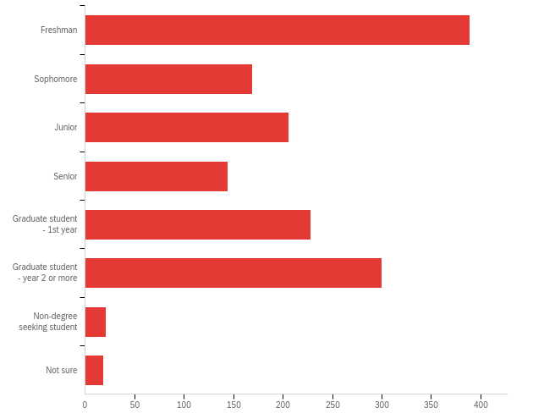

# | Field | Minimum | Maximum | Mean | Std Deviation | Variance | Count
1 | What is your class standing? | 1.00 | 8.00 | 3.49 | 2.00 | 4.01 | 1475

# | Answer | % | Count
1 | Freshman | 26.37% | 389
2 | Sophomore | 11.46% | 169
3 | Junior | 13.97% | 206
4 | Senior | 9.76% | 144
5 | Graduate student - 1st year | 15.46% | 228
6 | Graduate student - year 2 or more | 20.34% | 300
7 | Non-degree seeking student | 1.42% | 21
8 | Not sure | 1.22% | 18
 | Total | 100% | 1475

Q5 - In which UB College or School are you enrolled?
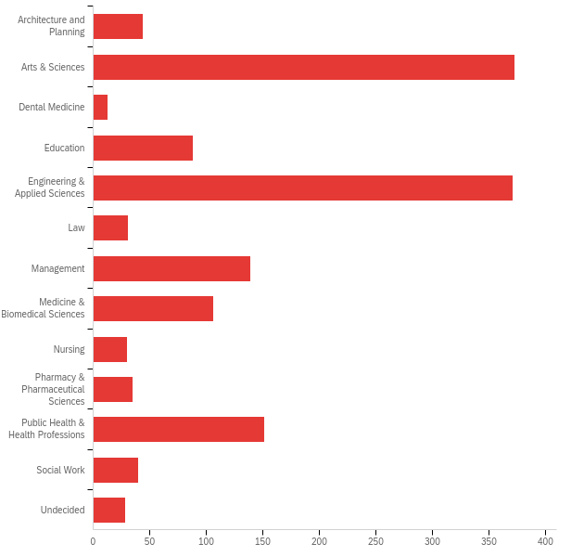

# | Field | Minimum | Maximum | Mean | Std Deviation | Variance | Count
1 | In which UB College or School are you enrolled? | 1.00 | 13.00 | 5.64 | 3.29 | 10.83 | 1449

# | Answer | % | Count
1 | Architecture and Planning | 3.04% | 44
2 | Arts & Sciences | 25.74% | 373
3 | Dental Medicine | 0.90% | 13
4 | Education | 6.07% | 88
5 | Engineering & Applied Sciences | 25.60% | 371
6 | Law | 2.14% | 31
7 | Management | 9.59% | 139
8 | Medicine & Biomedical Sciences | 7.32% | 106
9 | Nursing | 2.07% | 30
10 | Pharmacy & Pharmaceutical Sciences | 2.42% | 35
11 | Public Health & Health Professions | 10.42% | 151
12 | Social Work | 2.76% | 40
13 | Undecided | 1.93% | 28
 | Total | 100% | 1449

Q7 - Where do you live?
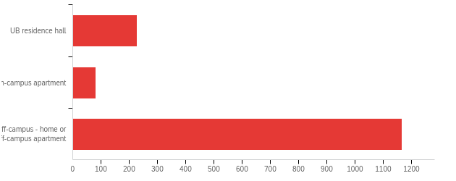

# | Field | Minimum | Maximum | Mean | Std Deviation | Variance | Count
1 | Where do you live? | 1.00 | 3.00 | 2.64 | 0.73 | 0.54 | 1475

# | Answer | % | Count
1 | UB residence hall | 15.39% | 227
2 | On-campus apartment | 5.49% | 81
3 | Off-campus - home or off-campus apartment | 79.12% | 1167
 | Total | 100% | 1475

Q9 - Please indicate which of the following devices you have used since the beginning of the semester. (Select all that apply.)
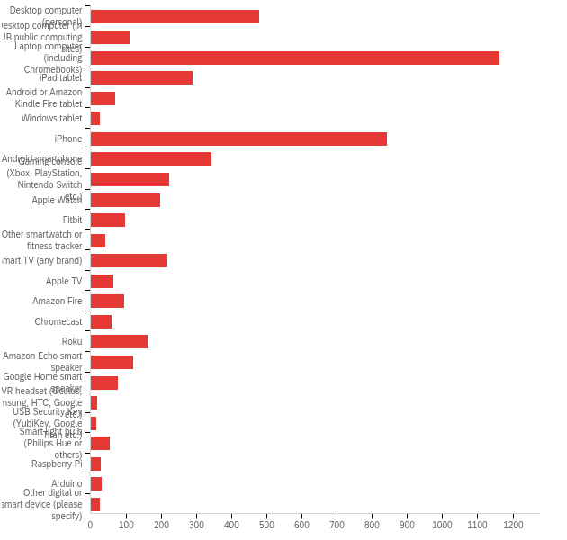

# | Answer | % | Count
1 | Desktop computer (personal) | 9.83% | 479
2 | Desktop computer (in UB public computing sites) | 2.26% | 110
3 | Laptop computer (including Chromebooks) | 23.87% | 1163
5 | iPad tablet | 5.95% | 290
6 | Android or Amazon Kindle Fire tablet | 1.46% | 71
8 | Windows tablet | 0.55% | 27
9 | iPhone | 17.30% | 843
10 | Android smartphone | 7.04% | 343
11 | Gaming console (Xbox, PlayStation, Nintendo Switch etc.) | 4.62% | 225
12 | Apple Watch | 4.04% | 197
13 | Fitbit | 2.03% | 99
14 | Other smartwatch or fitness tracker | 0.88% | 43
15 | Smart TV (any brand) | 4.52% | 220
16 | Apple TV | 1.35% | 66
17 | Amazon Fire | 1.99% | 97
18 | Chromecast | 1.21% | 59
19 | Roku | 3.33% | 162
20 | Amazon Echo smart speaker | 2.50% | 122
21 | Google Home smart speaker | 1.60% | 78
22 | VR headset (Oculus, Samsung, HTC, Google etc.) | 0.39% | 19
23 | USB Security Key (YubiKey, Google Titan etc.) | 0.33% | 16
24 | Smart light bulb (Philips Hue or others) | 1.11% | 54
25 | Raspberry Pi | 0.62% | 30
26 | Arduino | 0.68% | 33
27 | Other digital or smart device (please specify) | 0.53% | 26
 | Total | 100% | 4872

Q9_27_TEXT - Other digital or smart device (please specify)
Other digital or smart device (please specify) - Text
Laptop computer
Nintendo Switch Lite
Zoom
FPGS BASYS3 Board
Wireless headphones
My Laptop
UB printing kiosk
Drawing Tablet
Gosund smart outlets
Apple Airpods
Air pods
Desktop computer (work provided)
no
Bose Home Portable Speaker, Logitech Pop Devices, Samsung Robot Vacuum
Graphing and Scientific Calculator
printer
2nd laptop
kindle ereader
ChroomBook
iPod touch
iPod
Mac
MacBook
Apple Homepod
MAC BOOK
Wireless earbuds

Q10 - You indicated that you used a computer in UB’s public computing sites this semester. What was the reason for using a public computer? (Select all that apply.)
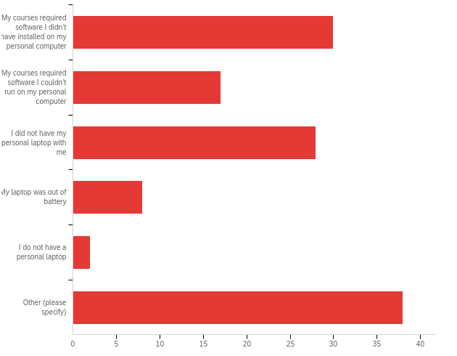

# | Answer | % | Count
1 | My courses required software I didn’t have installed on my personal computer | 24.39% | 30
2 | My courses required software I couldn’t run on my personal computer | 13.82% | 17
3 | I did not have my personal laptop with me | 22.76% | 28
4 | My laptop was out of battery | 6.50% | 8
5 | I do not have a personal laptop | 1.63% | 2
6 | Other (please specify) | 30.89% | 38
 | Total | 100% | 123

Q10_6_TEXT - Other (please specify)
Other (please specify) - Text
Presenting in a class
Printing
Print on campus, no printer at home
print off lectures for classes
To print
print
More convenient
laptop was broken
dual monitor
desktops work better
I needed to print something and I used a ub computer
to print out some documents
for accessing the printer at library
I like using the UB COMPUTERS TO Type
I need two computer screens.
I am a graduate assistant. Its my workstation, was unsure how to list
I come into the office (Farber Hall) for my research work as a doctoral student twice a week so I use my office desktop then.
Printing stuff
My software's free perior ended and I wasn't able to purchase it due to an error which still persists
Did not have my laptop with me at that time
I didn't have a personal laptop at that time, plus I know where to go should something happen to my laptop at least.
For printing materials
printing
Using it to print on-campus
Big Screen, can run laptop seperately.
It’s closer to the printing places and it’s easier to print from them
I needed to print and could not get my phone or laptop to connect to the printers
My personal laptop broke
Printing purposes
Printing
I needed to print and didn't have the new printing software downloaded
I needed to print materials for class
I have to come in person to UB South Campus twice a week for my part-time doctoral research assistant job.
My laptop was away for maintenance
Needed to print
Pront

Q13 - Please indicate which DIGITAL devices you primarily use for the following activities:
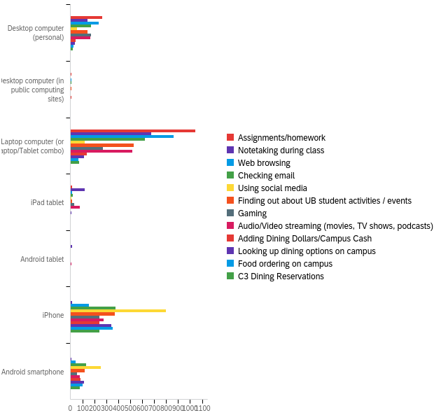

# | Field | Minimum | Maximum | Mean | Std Deviation | Variance | Count
1 | Assignments/homework | 1.00 | 8.00 | 2.65 | 0.92 | 0.85 | 1340
2 | Notetaking during class | 1.00 | 8.00 | 3.09 | 1.30 | 1.69 | 984
3 | Web browsing | 1.00 | 8.00 | 3.30 | 1.84 | 3.39 | 1324
4 | Checking email | 1.00 | 8.00 | 4.39 | 2.37 | 5.62 | 1327
5 | Using social media | 1.00 | 8.00 | 6.50 | 1.81 | 3.29 | 1250
6 | Finding out about UB student activities / events | 1.00 | 8.00 | 4.54 | 2.39 | 5.73 | 1196
7 | Gaming | 1.00 | 8.00 | 4.25 | 2.51 | 6.31 | 779
8 | Audio/Video streaming (movies, TV shows, podcasts) | 1.00 | 8.00 | 4.20 | 2.28 | 5.18 | 1136
9 | Adding Dining Dollars/Campus Cash | 1.00 | 8.00 | 5.53 | 2.36 | 5.56 | 520
10 | Looking up dining options on campus | 1.00 | 8.00 | 6.04 | 2.13 | 4.55 | 620
11 | Food ordering on campus | 1.00 | 8.00 | 6.39 | 1.87 | 3.51 | 554
12 | C3 Dining Reservations | 1.00 | 8.00 | 6.12 | 2.07 | 4.27 | 431

# | Question | Desktop computer (personal) |  | Desktop computer (in public computing sites) |  | Laptop computer (or Laptop/Tablet combo) |  | iPad tablet |  | Android tablet |  | iPhone |  | Android smartphone |  | Total
1 | Assignments/homework | 19.93% | 267 | 0.52% | 7 | 77.84% | 1043 | 0.97% | 13 | 0.15% | 2 | 0.37% | 5 | 0.22% | 3 | 1340
2 | Notetaking during class | 14.84% | 146 | 0.51% | 5 | 68.70% | 676 | 11.89% | 117 | 1.63% | 16 | 1.42% | 14 | 1.02% | 10 | 984
3 | Web browsing | 17.90% | 237 | 0.68% | 9 | 65.11% | 862 | 1.21% | 16 | 0.08% | 1 | 11.71% | 155 | 3.32% | 44 | 1324
4 | Checking email | 12.81% | 170 | 0.53% | 7 | 46.95% | 623 | 1.36% | 18 | 0.23% | 3 | 28.41% | 377 | 9.72% | 129 | 1327
5 | Using social media | 4.64% | 58 | 0.24% | 3 | 9.76% | 122 | 0.80% | 10 | 0.40% | 5 | 63.76% | 797 | 20.40% | 255 | 1250
6 | Finding out about UB student activities / events | 12.21% | 146 | 0.59% | 7 | 44.23% | 529 | 1.42% | 17 | 0.25% | 3 | 31.10% | 372 | 10.20% | 122 | 1196
7 | Gaming | 22.21% | 173 | 0.39% | 3 | 34.66% | 270 | 3.85% | 30 | 0.39% | 3 | 31.45% | 245 | 7.06% | 55 | 779
8 | Audio/Video streaming (movies, TV shows, podcasts) | 14.70% | 167 | 0.26% | 3 | 45.51% | 517 | 7.13% | 81 | 0.97% | 11 | 24.38% | 277 | 7.04% | 80 | 1136
9 | Adding Dining Dollars/Campus Cash | 8.46% | 44 | 1.15% | 6 | 26.15% | 136 | 0.58% | 3 | 0.58% | 3 | 46.73% | 243 | 16.35% | 85 | 520
10 | Looking up dining options on campus | 6.13% | 38 | 0.48% | 3 | 18.23% | 113 | 0.97% | 6 | 0.48% | 3 | 55.32% | 343 | 18.39% | 114 | 620
11 | Food ordering on campus | 4.69% | 26 | 0.18% | 1 | 12.09% | 67 | 0.54% | 3 | 0.72% | 4 | 63.36% | 351 | 18.41% | 102 | 554
12 | C3 Dining Reservations | 5.34% | 23 | 0.46% | 2 | 17.40% | 75 | 0.46% | 2 | 1.16% | 5 | 56.84% | 245 | 18.33% | 79 | 431

Q20 - Are any (or all) of your classes online this semester?
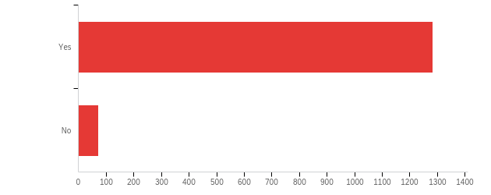

# | Field | Minimum | Maximum | Mean | Std Deviation | Variance | Count
1 | Are any (or all) of your classes online this semester? | 1.00 | 2.00 | 1.05 | 0.22 | 0.05 | 1356

# | Answer | % | Count
1 | Yes | 94.69% | 1284
2 | No | 5.31% | 72
 | Total | 100% | 1356

Q21 - Where are you while completing your online coursework?
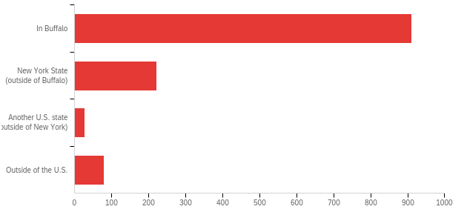

# | Field | Minimum | Maximum | Mean | Std Deviation | Variance | Count
1 | Where are you while completing your online coursework? | 1.00 | 4.00 | 1.42 | 0.82 | 0.67 | 1240

# | Answer | % | Count
1 | In Buffalo | 73.47% | 911
2 | New York State (outside of Buffalo) | 17.90% | 222
3 | Another U.S. state (outside of New York) | 2.18% | 27
4 | Outside of the U.S. | 6.45% | 80
 | Total | 100% | 1240

Q22 - Is the device you use most for online learning adequate for completing your coursework online? (By the way, UB students get discounts on some new devices)
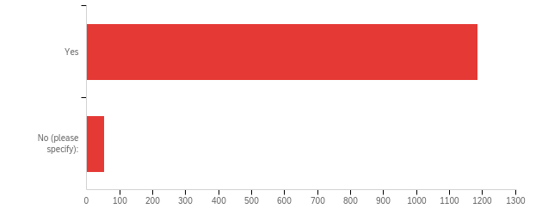

# | Field | Minimum | Maximum | Mean | Std Deviation | Variance | Count
1 | Is the device you use most for online learning adequate for completing your coursework online? (By the way, UB students get discounts on some new devices) - Selected Choice | 1.00 | 2.00 | 1.04 | 0.20 | 0.04 | 1240

# | Answer | % | Count
1 | Yes | 95.65% | 1186
2 | No (please specify): | 4.35% | 54
 | Total | 100% | 1240

Q22_2_TEXT - No (please specify):
No (please specify): - Text
I really wish I could afford an iPad because then I can take more organized notes instead of notes on Microsoft word or google docs. I could type the notes and then draw explanations instead of having to search google for exactly what I’m looking for
I need more desktops
My original was not. I had to spend money on a new one.
My laptop is outdated.
There have been accommodations made since I have a chromebook
My laptop is old and slow and will only charge to 70%, and my desktop has such an old OS I can't get many new programs to run on it.
its broken
My laptop broke, so I had to resort to my iPad and iPhone which is difficult especially since I need my iPad for notes but need it for Zoom (I cannot use both at the same time bc Zoom requires a full screen in order to use the camera).
I face difficulty making notes during lecture class. I mae notes later on.
My laptop is very old and slow.
Laptop is starting to slow down
Many professors expect prompt access to printers and scanners, which I don't have.
chromebooks do not have the lockdown browser
My computer processor can't handle most of the programs that I need so it's too slow and frequently crashes
Laptop
My laptop screen is broken so I require a separate monitor to see the visual screen.
I had to borrow a laptop because my Chromebook could not run all the programs I need for my classes
Slow operating speed
Because some of my professors mandate we have 2 devices for test taking. One to take the online exam and the other to zoom from. This is extremely unreasonable. They are having people buy other devices during a pandemic and recession.
It's very difficult to watch lecture and follow along with a single monitor.
Laptop is old
The laptop I bought at the begining of my accedemic career with 8 GB of ram is starting to have problems with memory exaustion due to the number of stuff I need to keep running on it because of online learning
My laptop is out of date and cannot often support the software required to engage in online schooling
My Microsoft Surface Pro 7 shuts down constantly in the middle of Zoom calls and Microsoft won’t do anything about it.
I use my laptop
Macbook
Need a desktop for more ergonomic setup to accomadate physical disability.
na
Has capabilities of printing but I do not have a printer
internet connectivity issues; shared with other members of the household
The audio on my laptop only works half the time for some reason
I need a laptop to use a writing tablet when teaching online, but it's always crashing. Cannot use writing tablet with my phone.
My computer is very slow. It takes forever for lecture videos to load. It will also just freeze and shut down while Im in the middle of an assignment.
Have had issues where laptop freezes or restart during tests and/or during schoolwork
My device is outdated
My laptop's camera is broken
Need a better computer to run analysis
Need a tablet for note taking
My keyboard is broken
chromebook doesn't have software to download for some classes
personal laptop
many programs do not work on my mac and UB VDI has randomly stopped working
My laptop, which is how I attend lectures, is old and is just now showing signs of the screen breaking (random artifacts on the screen, monitor sleeping randomly despite activity)
It is hard to complete some assignments with the old computer I have.
Yes
I can’t afford a laptop so I’ve been doing everything on my phone/ipad

Q23 - Is the internet connection adequate where you are completing your coursework online?
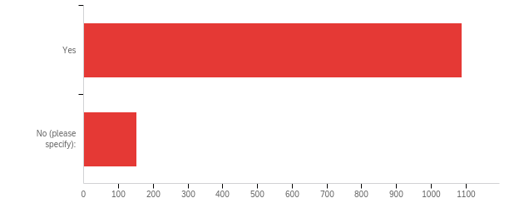

# | Field | Minimum | Maximum | Mean | Std Deviation | Variance | Count
1 | Is the internet connection adequate where you are completing your coursework online? - Selected Choice | 1.00 | 2.00 | 1.12 | 0.33 | 0.11 | 1240

# | Answer | % | Count
1 | Yes | 87.82% | 1089
2 | No (please specify): | 12.18% | 151
 | Total | 100% | 1240

Q23_2_TEXT - No (please specify):
No (please specify): - Text
The internet in UB is very slow
American Campus Communities wifi is very bad
Spotty Connection
most of the time
Our wifi is terrible and our landlord wont fix it
I am currently living in an Airbnb in Tonawanda NY and my poor internet connection causes me a great deal of stress at times.
Due to network restrictions (Chinese government network firewall), students in China need to use VPNs to connect to UB as well as Google.
Wifi shuts down occasionally, I live in Elma so we can get bad weather.
It often lags.
Sometimes I do work on campus and the wifi is slow. The wifi at home is also slow.
At home
spotty at times
terrible internet connection
The internet becomes extremely unstable almost daily, throughout the week, making it difficult to get work done when the internet crashes almost every week.
Slow internet. Lots of buffering.
Internet at my place was very inadequate. Now its stable.
I have to go to a heavy utilized area that is hard to focus because of connection
I do not have access to an ethernet port in my room.
Sometimes the internet goes down
Internet speed is lacking because no job available
I have an inconsistent WiFi connection. There is lag during Zoom meetings and my upload speeds can be slow.
Sometimes the connection doesn’t work properly.
Shit's slow as fuck
Internet goes out frequently
uB internet is trash&gt; plain and simple
WEAK SIGNAL
I have a family of 5 who also uses the internet during the day or when im trying to complete school work so the connection is sometimes poor
Yes it was adequate
I have trouble with the UB wifi often, my phone will disconnect or switch between "eduroam" and "UB_Secure"
Resident hall WiFi is terrible.
Our wifi is horrible and has never worked properly
it constantly cuts out i get disconnected from my classes like at least once a week
The wifi is kind of off.
Sometimes yes and sometimes no. I live out in the country and the internet connection fluctuates.
sometimes it is unstable
It cuts in and out and is slow especially during video conferencing
Since everyone is working from home in my household, internet has been much slower
The internet is never fully reliable. Some professors say if your wifi goes out during a test that’s your fault. We aren’t being graded based on our knowledge. We are being graded on if our wifi is stable that day.
I do have connectivity issues which can interfere with class/homework
Very slow and disconnects leading to multiple issues like crashing during exams.
very poor
sometimes get disconnected in the dorm
It is often very slow
There are times when the wifi connection goes out
I live in a rural area with very spotty Internet.
CV has trash wifi
Spectrum Internet is awful. It would be amazing if UB WiFi could reach university heights. I purchased my house here and would love access both as a UB Grad Student (perpetual...), future adjunct faculty (I hope, not quitting my day job but it would be nice to teach a bit) and forever an Alum
I have spectrum internet that randomly stops working
Mostly not good service. Changed couple of them so far
Horrible wifi, cuts in and out constantly
Rarely, my connection is slow so zoom meetings get laggy for a little while
The answer to this question is yes and no. At my apartment in Buffalo, the internet connection is always adequate. At my apartment in Albany where I will be spending the rest of the semester after Thanksgiving, I have intermittent connectivity problems with my laptop ONLY. Usually the connection is fine but every now and then my connection will slow to a crawl and I cannot determine the source of the issue. When this happens it is extremely disruptive to my work.
The wifi in my apartment is slow and frequently drops out. I bought an ethernet cable that helps a bit, but still has some issues.
I needed to run a 100 ft cable from the router to my room to connect my computer so I can attend zoom lectures without everything constantly lagging or disconnecting.
It sometimes becomes unstable and I can be picked off of Zoom
Sometimes the network can be disconnected
My apartment has bad WiFi
I live with 8 other girls. We all do work at home. We have zooms at similar times and it causes us all to crash.
sometimes my internet goes out in my apartment that is off campus
Internet is spotty and frequently disconnects.
Some databases access is not so convenient out side of ubinternet. Often retrun 400error
It's unstable and sometimes goes unpaid
Internet occasionally cuts out
My wifi drops all the time
slow
Sometimes the internet is very slow
Electricity failure at times
I have 3 roommates not including myself and two of their girlfriends, and my lower floor house mates all on 1 source of wifi. It gets very slow sometimes.
Lots of Internet drops and outages
na
No Sometime the UB Network in the dorms slows down significantly during peak class times
device issues
spotty and slow sometimes.
Sometimes the connection is lost, but it doesn't take that many minutes to respond.
It randomly disconnects sometimes pausing a video or preventing me from using services ie. Google Docs or kicking me out of a zoom lecture due too weak connection
Depends on how many of my family members are on it at the same time
My internet connection slows down during certain times throughout the day when there are multiple people in my house/
Using phone internet as hotspot which is limited
Sometimes it works great, but sometimes it stops working or the signal gets too low to connect
Always disconnects with Zoom and takes forever to do anything when I have to be on Zoom.
sometimes not consistent, freezes
I mostly have difficulty with Zoom meetings, which I have attributed to the internet connection but honestly I'm not sure what's causing it. The sound in Zoom meetings will cut out and I will miss part of the lecture.
Spectrum goes out all the time which is very frustrating.
not fast enough
Home service is spotty.
UB WiFi was good on campus but now I’m home and it’s terrible
wifi can be unstable with fios, cannot be wired due to distance.
It’s a public wifi for my complex and it has failed in the middle of my classes before
wifi cuts off sometimes
Occasionally cuts out
the internet cuts out while working.
I have DSL. It breaks down on occasion.
unstable and slow with no other options available to me
I have to use VPN and have many issues with them
WiFi is unstable because it is not fast enough as I am not able to afford a faster internet service
it kinda sucks
WiFi often cuts out
Rona up and ate all my bandwidth with everyone at school and working from home.
I live in flint 302 and the connection is horrible it cuts off while I’m doing assignments like typing an essay it will pause and reconnect about 3 times. Also the webex connection Is very bad while I’m in lab there’s a lot of static and echo while the teacher talks.
not stable
Wifi goes out a lot
depending on the day or which house I am at, sometimes the wifi is not adequate
Spotty internet connection
I continuously get ejected from the wifi during my zoom calls for class
Most of the time - it works. Occasionally the Zoom connection goes in and out
Zoom lags
The house I live in is old so sometimes the wifi has trouble getting through the walls, especially since I have 5 roommates who are all trying to do school work at the same time which makes it pretty slow.
Most of the time
Often during class the wifi will slow down and freeze up my live lectures
Sometimes disconnects
My WiFi sucks
Signal breaks up while presenting
Zoom needs a really strong internet connection and sometimes disconnects during class
Sometimes the WIFI in my dorm room goes out for 10 minutes and can be during class, which is very frustrating.
spotty
most of the time connection is good but sometimes service drops and in some parts of the dorm building service drops.
Why am I paying a huge technology fee if I am paying for the vast majority of my technology?
My house has wifi but it is not very good, especially for me who lives on the top floor where it doesn't always reach.
it has low connection
It can sometimes crash on me a little bit.
unstable a lot
Mostly adequate, some exceptions based of connection available
spectrum internet drops all of the time and is really unreliable
My internet isn’t working on my laptop so I have to continuously connect to my personal hotspot.
Internet in Buffalo is notoriously bad (spectrum stinks and we can’t get Fios)
In China, I need to use vpn to connect wifi which is sometimes a little slow.
The internet can be very spotty in some areas of the campus, even inside certain buildings
The UB wifi keeps crashing
The internet occasionally goes out creating much anxiety during testing situations
its spotty
I’m on a shared network with multiple other people who are also working from home
My connection gets spotty, spectrum sucks
The wifi in my house is bad depending on where you work from.
WAN sucks in Richmond, LAN only for work, conferencing
It is for now, but after thanksgiving it will not be
Poor wifi leads to frequent freezing during zoom classes and internship meetings, often cutting the audio out before it freezes and takes a bit to come back on even after the visual aspect has fixed itself.
wifi drops a lot, slow
Apartment provided wifi - poor service
Some spots on campus are spotty
UB's wifi sucks and kicks me out of my zoom sessions

Q24 - Have you faced any other technology challenges while completing your coursework online? (Select all that apply.)
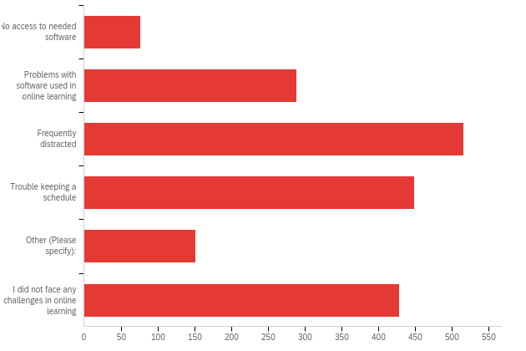

# | Answer | % | Count
1 | No access to needed software | 4.03% | 77
2 | Problems with software used in online learning | 15.13% | 289
3 | Frequently distracted | 27.02% | 516
4 | Trouble keeping a schedule | 23.51% | 449
5 | Other (Please specify): | 7.91% | 151
6 | I did not face any challenges in online learning | 22.41% | 428
 | Total | 100% | 1910

Q24_5_TEXT - Other (Please specify):
Other (Please specify): - Text
Printing system does not work well
Fatigue and eye strain
need VPN for some course work
HAve not started classes yet, will 1/2021
Professors not knowing how to use technology sometimes
Doctoral student/done with courses
Draining to work on a computer all day.
Not able to print at home
Microphone and video often don’t work
Wifi connection problems at first
Internet connection issues at home. However, when on campus the internet connection is great.
Due to network restrictions (Chinese government network firewall), students in China need to use VPNs to connect to UB as well as Google.
Software is expensive and difficult to manage a different type of messaging software for each class.
My laptop was not poweful enough to run necessary softwarr
all professors use microsoft for everything they put out and it makes it difficult for mac users who use pages because theyre incompatible so unless you buy word you have to retype all documents given to you or else you cant save them
Computer freezing
my computer and phone broke
spotty wifi
completing quizes, typing under timed situtation is troublesome
Files on UB Drive were deleted randomly at some point between last semester and this semester and your support did not have an adequate explanation or help.
Yes, sometimes the website/system that is used for some of my classes does not load or crashes, so assignments are sometimes aren't able to be completed on time because of system problems. Note: however the professors are very good on staying on top of this, so if there were problems with the system they do sometimes extend the deadlines.
learning curve; adult student
It’s much harder to make connections with professors and ask questions since everyone else asks too many. Class format changes have also been difficulf
Wifi signal
WiFi is spotty sometimes
Not being able to talk privately with professors and get adequate help.
Privacy concerns. With programs like Respondus browswer, and the new AI "Daily Health Check," UB has not disclosed how student data is being used.
The MyUB site can be difficult to access on different web browsers. My main was FireFox and I could not access the site (error code), so I have to clear cookies/cache... Something I figured out days/weeks later.
still getting familiar with UBLearns, Box etc which is still new for me
Your professors dont know what the fuck they're doing and dont help
Getting my devices hooked up
UBIT Login has been a major issue
Recently, I have been having problems with Zoom not working during my recitation classes.
wifi issues
need ability for multiple people to share screens at the same time. Zoom does not work for this. Discord is too clunky, time consuming, and difficult to use for multiple people at the same time
Sporadic internet outages (usually at 11am and 3pm)
I'm getting distrated because of such email that UB sends to alumni. Why can't they just modify their listserv?
Wi-fi issues at times
Adobe Acrobat
Trouble in grading assignments
It was good
The motherboard in my laptop fried but I got a new one.
small shared space
Many of the computers on campus DO NOT WORK
i just prefer in person classses
My Wifi is mostly adequate but can be unreliable.
Connectivity
My eyes start to feel really tired after looking at a screen all day, I’m looking into blue light glasses to prevent any harm.
cannot get in to ublearn to take test
Very far behind. 20+ hours of lecture to watch I think. No idea what I'm suppposed to be doing.
Hard to hear classmates
teachers using diff teaching methods and sometimes internet spotty
trying to teach myself these classes has hurt my mental health significantly and being recorded during my exams makes me very anxious
matlab learning license expire
Diffuclty finding a good rhythm when all of the online courses start on Monday rather than on different days.
My computer died the first semester we moved online.
Inability to receive answers when asking questions of my department's staff regarding needed paperwork.
Some classes don't go out of their way to make the due dates and requirements for assignments known. Before distance learning this could be remedied by talking to people on campus
Not really; however, I found UB's decision to no longer offer antivirus security an odd choice given we are now essentially required to use a computer of some type in order to attend.
Submissions won’t go through sometimes
Professor not doing a good job informing me of the assignments through ublearns
Zotero requires a third party app for the iPad which is frustrating
rebuilt desktop mid semester
3 hours in Zoom is so much more intense than 3 hours in class
Frequent distractions -&gt; dopamine-like/addictive qualities strengthened -&gt; trouble keeping a schedule -&gt; out of sync circadian rhythm -&gt; easier to be distracted -&gt; repeat
Specifically software being used in courses that is not Linux compatible.
Lockdown browser issues during Quizes
Horrible experience using respondus lockdown browser or any other online test- constant crashing and slow speeds affects test taking
Online learning is challenging, especially for a first semester freshman who has never done 'college' before. I feel lost and hopeless sometimes.
Lost power during an exam once, professor was extremely helpful
Teachers have put a lot more work for us to do. Also they themselves seem very unsure about what to do online when we ask questions.
My computer , turns off at random times
I wish I had Adobe fill and sign provided by UB since everything is remote
Instructions unclear, got foot stuck in cd drive.
The UB learns website on safari presents many issues. The view courses part does not work, the view grades part gives issues
Going crazy from being on my computer all day.
no issues
Spending 10-13hrs a day at my computer
some times
sometimes my wifi connection will cut off in the middle of a zoom session.
my internet connection is horrible
Accessing the programs is expensive for personal computers. Having the programs available as they were during the summer with Adobe was very helpful
Requirements for technology needed ramped up with no significant reduction in tuition for upgrades such as faster wifi, external monitors, computer upgrades
My personal laptop had a few software issues
Microsoft updates have occasionally wreaked havoc on the ability to use even basic functionality on my laptop
There was a period of two weeks where I could not access Zoom or Webex meetings due to internet connection. The router and modem were replaced as a solution.
I feel like I have learned absolutely nothing.
Power line blew out leaving me without internet for a weekend
I live with many housemates so sometimes there is no quiet spot and I don't feel comfortable on campus.
DUO will not remember for 7 days, causing some frustration at times.
Feel the need of multiple screens currently not available to me
internet can slow down or be non-functional when others in my house are using it while I'm in class
My children are also learning at home 3 days a week, which makes it difficult to focus. But I work well on the 2 days they are in school.
Recorded Course Upload so late
Software downloading is so slow remote from school outside US.
student email/student account problems
sometimes have difficulty running multiple programs at once
spectrum sucks
No dedicated time for quiet work(kids)
sometimes I cannot connect the internet
Lab classes have been extremely poorly transferred to distanced learning
Need VPN even when I want to check my email
the software doesn't do some accomodations and that caused huge delays in getting services
Internet not always consistent
Computer constantly freezes/restarts
WiFi issues
im bad at learning this way i like more hands on learning
#%$?! Duo Mobile is still a massive pain especially since safari can remember me for 7 days and I have to do it EVERY TIME!
Not being able to Access help right away. I have to wait for an email back if I have a question on an assignment
a lot more assignments being assigned than usual
Did not feel like I was ever genuinely being taught material or any sort of concept.
it’s a lot harder doing remote learning especially for 4 credit classes
unable to print from home
Internet cuts out during class
Paying for programs such as Pearson to even do homework is a fucking scam.
difficulty keeping track of assignments
It is difficult to see the chalk bord when the instructor writes notes when we have our class via Zoom.
My computer broke. But using the library computers was challenging because of extremely reduced library hours. Respondus lockdown browser also does not work on South Campus computers. There were not enough loaner computers to get one of those.
Reading on a computer.
wifi trouble sometimes
my zoom makes me login constantly and tells me my password is wrong but wont let me reset it
Blackboard issues
The technology fee is absurd. All of my classes are online. I am using my own resources. It is shameful they are refusing to wave the technology fee.
Laptop hardware was not up to date, But I rented a laptop from university.
WiFi is sometimes slow
Times when school internet goes out
the UB system is constantly locking up and causing missed time dealines for completeing exams and quizzes in the course. This has resulted in poorer performance on these tests.
sometimes my wi-fi cuts out but it doesn't happen very often
UBlearns keeps having serious issues.
Distraction, trouble keeping schedule, procrastination
I have zoom crash for me sometimes when it is on full screen but if I exit out of fullscreen to just maximized screen its fine. Hasnt bothered me since I figured that out
there is a lot of work that needs to be done, and without being able to ask questions in person and learn presently it is difficult to obtain knowledge and learn.
MTH141 exam required using a phone to take pictures of written answers to turn into a PDF to submit. My phone's camera randomly rotated each picture, which required me to fix each one individually. I had a time limit of 15 minutes after completing the exam to do all of this, which was nerve-wracking. I did manage to submit on time despite this.
Reading online causes headaches and eye fatigue
Need really good specs for my work and laptop was more expensive than i would have liked
Confusion with understanding how to use websites, Less ability to ask good questions, Inability to see what my lab partners are doing
Myub student hub hardly ever works, clinical resources for pharmacy became much more difficult to get to, and yet my technology bill increased even though my resources were cut
Had to order new modem and router for internet to be fast enough
weak wifi
The interent keeps crashing when i do assignments or when I'm in tests.
Testing expectations are unreasonable and difficult, LapseIt is a terrible way to run a test
Problems understanding professors expectations
Lack of connection and communication with other students and professors
Professor put wrong link of the live streaming of the class
Parents had to buy internet (wifi) because hotspot on phones wasn’t enough data to do classes and homework
Poor internet
Internet disconnection
The app formats don’t show everything on ublearns compared to the desktop version of the site

Q18 - How would you rate your comfort level with the following technology aspects of online learning?
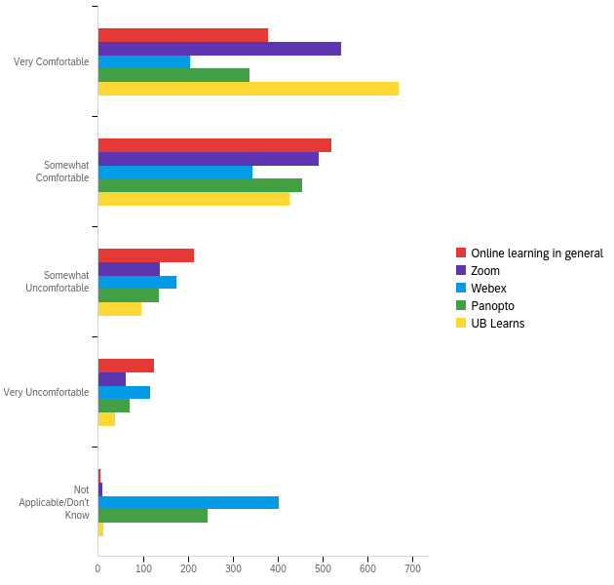

# | Field | Minimum | Maximum | Mean | Std Deviation | Variance | Count
1 | Online learning in general | 1.00 | 5.00 | 2.08 | 0.96 | 0.91 | 1240
2 | Zoom | 1.00 | 5.00 | 1.80 | 0.88 | 0.77 | 1240
3 | Webex | 1.00 | 5.00 | 3.14 | 1.52 | 2.31 | 1240
4 | Panopto | 1.00 | 5.00 | 2.54 | 1.44 | 2.08 | 1240
5 | UB Learns | 1.00 | 5.00 | 1.63 | 0.83 | 0.69 | 1240

# | Question | Very Comfortable |  | Somewhat Comfortable |  | Somewhat Uncomfortable |  | Very Uncomfortable |  | Not Applicable/Don't Know |  | Total
1 | Online learning in general | 30.48% | 378 | 41.85% | 519 | 17.18% | 213 | 10.00% | 124 | 0.48% | 6 | 1240
2 | Zoom | 43.55% | 540 | 39.60% | 491 | 11.13% | 138 | 5.00% | 62 | 0.73% | 9 | 1240
3 | Webex | 16.45% | 204 | 27.74% | 344 | 14.03% | 174 | 9.35% | 116 | 32.42% | 402 | 1240
4 | Panopto | 27.10% | 336 | 36.69% | 455 | 10.89% | 135 | 5.73% | 71 | 19.60% | 243 | 1240
5 | UB Learns | 53.95% | 669 | 34.27% | 425 | 7.82% | 97 | 2.98% | 37 | 0.97% | 12 | 1240

Q20 - What technology services could UB offer (that we don’t already offer) to improve your online learning experience?

What technology services could UB offer (that we don’t already offer) to improve your online learning experience?
I wish our professors new Hoe to use technology better... it makes learning more difficult. For ex; lecture videos should not consist of a video within a video because it causes extremely bad quality, noise issues, lagging etc. also almost blows my speakers every 5 seconds with harsh noises. I don’t get how it’s useful?
Giving the instructions and explaining all steps
get rid of DUO
I don’t really know
None
UBLearns needs to be efficient and duo is a hassle
NIL
More user friendly for mac users in the school of management
Discord for teams to connect outside of class and share resources, links, and audio/video calls
Something to help better organize all my academic and personal matters throughout the semester
Ensure that blackboard opens up and loads my assignments when submitted.
iphone
Less annoying option then DUO authentication
I don't know
Na
idk
No idea
I hope UB offers solutions for students experiencing internet restrictions in some regions, for example Mainland China.
I can't think of any at the moment
Loaner laptops
unclear
Not have a contract with Google, which is a shit company. Safari will not play my course lectures on UB Learns. It's pathetic. Read this one to your colleagues.
N/a
Adobe Acrobat licensed version. we are asked to annotate on the figures given in the assignment pdf. without licensed version of adobe it is difficult to do it.
Currently the technology services that UB offers is sufficient for my online learning
proffesor should standardize where the put things. I feel like I waste type hunting around for assignments and files, and they do not organize these things well nor do they use the scheduling features so I am like, oh is there a quiz today, because when I logged in it said I had nothing due. it is irritating there is no standard
Not letting files get randomly deleted so they cannot be retrieved.
Allowing respondus to be used on iPads.
advice for internet providers in Buffalo area
None
As always, GPU for students.
I would like to have more tech support for programs and software.
I think it would be great to have 27inch or more monitors in libraries so that we can connect our laptops if we need a bigger screen. When coding or testing something where multiple windows are open. External monitor would be really awesome
Easy way to order on campus food with credit card instead of needing a meal plan or dining dollars
Idk
no
n/a
Discussion boards need to be constantly refreshed for updates, it's not ideal for live classes.
more it support hours and modes of help
Standardized software. The single most annoying part of online coursework is the fact that I need to pay for 6 different online services just to be able to complete my homework
N/A
Genuine informed consent and control over our personal data.
Intro to online learning course
I can't think of anything.
it would be easier if things were more organized, and maybe a search bar at top of ub learns so you dont have to keep opening and closing tabs to find what your teacher posted
common templates for grading in all the subjects or clear webpage for grading
An alternative to Respondus would be great. I'm extremely uncomfortable having that type of software on my computer but I had no choice other than to have it on my personal computer or drop out until we're back in person.
Nothing
Tips on how to manage storage on iCloud, especially since it can end up getting full from all the software and documents we have to download for classes.
increase the internet bandwidth
Communication with professors
Workshops on Panopto-I'm not sure what that is.
More Adobe softwares like free Photoshop and illustrator
Email
I don't know.
I am not sure
Unified service for all classes. Currently I have to switch between ~4 websites to check if homework was released.
?
I'm in different institution right now, but I feel like Canvas system is way much better than Blackboard learns.
N/A
There is so much information, on the site, on the trainings, with the baseline knowledge - it is a lot to process on top of a full course load. There are way too many layers on the website, and way too many apps for everything.
VidGrid
Adobe Acrobat
Only in person classes can help me specifically
Discount rates on internet for students living near campus.
Better grading device tor TAs
It is too complex to login with DUO verification. Simplify it!
Nothing
I am satisfied with the service
Remove the security login bc its annoying tbh. Also my broke so i was terrified i wouldnt have neen able to access the school hub.
Free zoom premium
While they are already made available to Arch/Planning students, making sure that everyone has access to the full Adobe suite at the start of the semester would be a great place to begin minimizing distanced learning difficulties
Zoom integration with google calendar
WORKING COMPUTERS
Better phone customer service
n/a
Some type of schedule builder, or an easy way for ublearns assignments to work with google calendar.
Some people like I don't have a printer at home and it seems like the only possible way for students to get one is to buy but it would be difficult for those who don't have the funds to buy one. UB can offer funding for students to buy a printer.
Let ublearns be always logged in to mobile device without the duo login every time.
Netflix access for students who have already had a trial but Netflix is needed for a module, or a VPN to access region-locked material
Better access to materials for class such as readings or films
Free downloadable RAM
Adobe Photoshop software
N/A
better internet
provide better due dates reminders
Upgrade wifi because I often get kicked off UBsecure and eduroam
No, so far so good.
it’s just hard maintaining a schedule when my class is 10 steps away from my bed
access to mac desktops
chat rooms for classes set up in ublearns for students to talk
I would really appreciate if UBL didn't use cross-site tracking to recognize that I'm logged in/verified through Duo. I want to preserve my privacy on other sites, but it means I have to sign in with Duo every time I log into UBL and Panopto does not work when I have cross-site tracking off (Safari is my main browser, sometimes Firefox)
Better alternative to lockdown browser
none
I don't know
Being in person especially for certain classes that require in person experience!
Better ublearns servers during test times
Training faculty on how to use the software, it seems like most faculty are avoiding using any technology or are not able to accommodate student's needs such as increased time for testing through AR, or posting grades oddly on UBLearns.
N/A
Provide professors with high quality recording hardware and training on how to use digital tablets for writing notes. One of my professors is using a 360p webcam in a dim room and is recording his writing in pencil which is hard to read and not easy to follow since he starts writing off screen frequently.
Reduce the amount of irrelevant information on Web pages
More softwares for free for an extended period, since this matters for architec ture students whether classes are held online or in person
None
Get rid of duo it’s a really annoying step
Better servers on UBlearns
Stop making us learn online just close campus or offer a serious discount on tuition. The education you’re giving us for this price is unjust.
Everything is fine!
Antivirus software I suppose.
Truthfully it's more of a case-to-case basis with each professor and class. Every professor has a vastly different way of dealing with online learning and it becomes very confusing and hectic
Better UB related apps
none
N/A
Technology Addiction Awareness Seminars
NA
Classes for proffesors to teach online
Access to programs at home that are available in the on campus labs
Nothing
Placing a time limit (like a day) for viewing panapto lectures so that I can force myself to view them on time
None
I don't know if this is something you can customize but Zoom should have a handraise button on the toolbar with the mute and video buttons. Also Zoom should have a hotkey for giving mouse control during a meeting.
Have UBLearns and others that require the DUO login actually remember a device for seven days when you check the option instead of having to re-verify every hour.
Reducing the amount of platforms to use. One of my classes sues 4 different platforms and it is very confusing.
I cannot think of any
Training
NA
The online classes are not very good and up to the mark. I’ve faced various issues of software crashes on exams and uncountable times login into the UB learns because it doesn’t log in at once. The online system is very different and not something I would take again and again
an ipad
More software available for students like Adobe fill and sign, note taking apps for the iPad
The new UB Learns is silly
Send me a macbook pro with a core i9 and I'll be happy.
Life support
kami subscription, access to desktop monitors to bring home for online semesters
menti.com
Services that work on all web browsers
More free online tutoring. Most of the hours on TASS stay booked
ADOBE
Free access to specific software programs.
So far, UB is providing the best technology services
more access to online databases/research webites
microsoft office
Streamline the current pool of applications and websites. It would be so much easier to have ONE place to see announcements, submit work, talk to the teacher, etc. Slack is fantastic for this.
It appears the Webex has a software problem that it can crash computers that don't have the right processers, (mine included and its not a chrome book). I would ask to have professors not use Webex and only use Zoom.
Get rid of Duo Mobile
Blackboard training, specifically how to email students
na
Free Personal Adobe Creative Cloud, Time Tracking software for time spent completing assignment to properly time block your day
more time!!
Archived tutorials how to navigate these different technology platforms
Gradescope and a replacement for UBLearns
better Blackboard app
in person learning
Don't Know
Actual webinars/tutorials on library skills, EndNote, Word, PPT, Excel, and the numerous other programs other students must utilize.
Adobe Programs
A guided introduction to the resources we can use ie. how to connect to UB secure, all of the apps we can use and how to use them. This can be through zoom, a seemingly more effective method than a youtube video.
Microsoft 365 for easier access to Powerpoints ect. that Professors consistently post to UB Learns
Provide more resources for increased technological needs
I hate the UB learns. I can't navigate it
That is not what but how.
antivirus protection
IT help with computers. Mine is freezing/has problems and it would be great if someone could check it out and help me fix any issues
pdf editor to add to existing online notes
No technology fee for those who are completely remote for the whole semester. I can't afford good wifi because I have to pay for printing at UB and the technology fee that I do not use because I do not come to campus
how to use zoom more effectively - especially for students who host meetings/study groups
none that I know of
If we could have more than 2 hours when using the remote desktop that would be great. That time limit seriously messes up my assignments because I feel rushed to get them done. One time the 2 minute warning came on, I panicked and forgot to save everything and had to redo my assignment all over again.
Adobe Creative Suite
panopto training
stronger wifi
N/A
Teaching incoming freshman how to use UB learns and zoom. I had to play around with it for a few weeks to understand how to even access my assignments
Get rid of online learning and have us in person again.
Use google classroom instead of the Blackboard program. It’s so much easier to use as we can use google docs, slides, drive, etc. which is far better than the microsoft equivalents that a lot of instructors want right now. I think most freshman come from high schools that have already been using google classroom too.
N/A
Make things easier to find.
free software needed for students in every major. For example, we should not be on campus as much but architecture students are not provided with Photoshop, InDesign, etc. They need these things in order to complete their coursework, but the computer labs are not available as often and campus is not exactly the safest place. With the architecture tuition that they pay, they should be provided with these things. Absolutely disgusting that they pay more AND are expected to have their own programs/materials. Look into this department please.
Extend the refresh time on DUO so we can use our devices seamlessly.
desktop computers
Everything UB offers so far as been all I've need.ed to complete my coursework
Ub learns can be made more interactive
I do not utilize UBs technology enough to be able to adequately provide suggestions
Better platforms (with fewer glitched and bugs) than UB Learns for grading of assignments
When teachers finish the zoom or webex lecture, could the system automatically put the recording on the UBLearn system? I mean there is no need to ask the teachers to upload the video themselves, because in my courses, some videos upload so late.
Please bring back the design sections of digication for Portfolios
Discord/Slack
Provide softwares like Revit and Indesign and Photoshop
Unknown
None as of know
Adobe Photoshop for download on personal devices
make teachers learn how to use UB Learns more efficiently.
A software or website where we can work on all of our work in one place instead of multiple websites and apps.
offer it to the teachers to standardize their online classes
UB is doing an amazing job already
Jitsi over zoom and undo the latest updates to ublearn it is much more difficult to use than before with no gains.
Register students' device MAC address and let them to connect easily just by two factor verification
train professors to better use zoom
Free or more reduced cost statistical programs like spss
n/a
ways to fix sound and other issues - esp with professors who are not native english speakers. Ways to have slides and videos more easily downloaded so they can be used as the basis for note taking
Mental Health Services
laptop
i dont know
Nothing
Get rid of DuoMobile. Only thing I took this survey to say.
I hate Online learning.
Better class discussion boards.
N/A
Giving all students an up to date computer in order to ensure fairness.
Better data labs in the social sciences. We need to do research too.
Hardware fixes for computers
I don’t know
Go back to the old notifications system from the old UBLearns
How to set up meetings in Zoom and Webex, how to balance the audio in Zoom and Webex
more virtual workshops
None
Photoshop
in person classes
More e-books through the library web page
Acrobat Professional for everyone
print and mail system for students who want to print things but cant get to campus
Ways to meet other students and make friends
more support for Linux (right now you seem to only support Windows and Mac, and only a smattering of articles mention Linux)
zoom tutorial?
Microsoft Teams
Give more leniency
adequate wifi in off campus living like Block20 and the Villas
On line learning is a band aid approach. It does not come close to replicating F2F learning. I can't wait to return to normalcy
Using Eli Review in conjunction with UBlearns is unnecessary and causes confusion for students. UBlearns is an adequate service in and of itself for online teaching in conjunction with Zoom.
UB could offer school computers that students have access to at all times (e.i. not in the locked library or student union). UB has reduced library hours due to COVID. But with classes being online, if students don't have a personal computer, these hours are very limiting. Saturday hours are abysmal, and while some libraries used to be open 24/7 on the weekdays, they close much earlier now. I used to be able to access computers at all hours in the Clement computer room, but now with COVID non-residents are not allowed in.
get rid of Duo two step login. awful
Adobe Suite, Like Photoshop and Premier Pro
I have a hard time understanding why we pay a technology fee when we pay for ALL of the technology required for online courses.
More information about the technology services provided and while printing being able to have different options for example choosing how many slides wanted on each page.
idk
Overview of what technological services are offered, I only know about UBBox
You could do your own two-step verification instead of relying on that awful, annoying Duo app. Lazy bums.
Waive technology fee for online students
I don't know
Portable wifi devices.
Creative cloud accounts
I personally believe that the offering of a note taking app would be greatly helpful to enable note taking to occur on top of slides directly.
N/a
Better WiFi
As a researcher, I need access to adobe creative suite including illustrator and photoshop. I also need graphed prism for data analysis. Also, international students often need support with writing and grammar, so having an institutional Grammarly license would allow the education to be more inclusive for English as second language student population.
To have test made online so that student don't have to come on campus for test. If the class is online then the tests need to be online as well. NO need to spend 1000s of dollars to come oncapus for tests
Easier viewing of grades
let be able to see all of our grades for all of our classes
VMWare Fusion
With online learning it's hard to sit there and focus through an hour an a half lecture so if there is a way to make a requirement of minutes that professor can't exceed or if they can break up the lecture into different videos that would be better.
Force professors to keep up on calendar and actually have everything posted
I just think UBleans should be the sole place where the online learning is run through. I feel like I have to go to a dozen different places just to find out if I have anything that I am supposed to be attending to.
nothing
Get the connestions right so the system doesnt lock down and cause delays amd poorer performance. I am at the point now where I dont trust it at all and prefer in all in class , no oline at all.
unsure
Better server connections when taking online exams
I have ADHD and tics so staying focused for long amounts of time is very difficult for me, especially during exams. During exams I usually highlight/underline parts of a question but it is not possible in respondus.
Fix UBlearns before you try to branch out.
Adding a printing service near Greiner Hall or the Ellicot Complex.
Better notification settings.
Google "Shared Drive" would be nice for collaborative projects.
im not too sure
Adobe Creative Suite
being able to use panopto in safari
google meet
Effectively communicate what things are and how to use them, as well as not grading online the same as in person
Instead of google mail, we should be using outlook. Outlook has better organizational options and the invites to meetings are often not compatible with google calendar.
stop using programs that only work in on a certain type of computer. stop using multiple different learning websites (like myeducator, connect). if you truly care about students and keeping their costs down. you would make sure programs are inclusive of every kind of computer and that professors may only choose from a couple learning websites to use.
Get rid of Duo Mobile. The double sign in is horrible! I've been locked out of UB learns on multiple occassions because I bought a new phone, or lost my phone. Get rid of DUO Mobile! No One Likes It!
iPads and Apple Pens for students who like to use tablets to take notes.
Subscription to Adobe Creative Cloud
I am not really sure. I am okay personally
assuring everyone has a well functioning computer, because occasionally some websites or things will not work on my computer because it is a 2015 and often says "not UB applicable." I have been using my mothers new HP computer, but I should be able to complete all of my work with my own device.
none
Potentially a better calendar that can interface with google calendar or the apple calendar
You could not charge the students who do not use anything on campus.
UB learns is a very unreliable website, especially on mobile where most of the features are not able to be used.
Most teachers openly admit to not knowing how to use video conferencing technology. They also consitantly condemn UB learns interface as they feel it is extremely user unfriendly and have never learned how to use it.
Na
it would be helpful if a software that could prevent you from looking at certain sites while you studying to help you focus and stay on task.
NA
Wifi - UB connect for my smart TV is awful. Never works.
Facebook Universal Events Page
The font size of answers to quizzes through UBLearns is minuscule, but the suggested answer is huge. Usually as a grader we are more interested in the answers students give than the suggested answer. If it were possible, it would help if the font sizes for these two elements were reversed.
Better ways to connect with lab members and see what they are doing in the in-person section.
It is not technology, but I wish there was service in which a student meet with a faculty member and create a productive schedule.
N/A
Pharmacy students lost their hub for clinical resources and must navigate the school library for them. This is a huge time waster and I have found that the websites are incredibly slow now. They’re basically unusable they’re so slow. I did not have this problem last year when pharmacy students used Hubnet instead of the ub library website. Also, my technology fee increased significantly even though classes are online, so the extra technology fee I’m paying for is useless to me because we shouldn’t be on campus. Waste of my money and time.
A refund. Lectures have always been recorded and one of my professors uses twitch, which is a free service to use. The fees associated with this semester are such a cash grab
I don't currently have any suggestions
VMware Pro License
nothing :)
Free Wifi off-campus
I don’t know
my freshmen friends all struggled at the beginning because they didn't understand how to use UBLearns. I think there should be a webinar of some sort to show transfer and new students how to use UBLearns because it can be challenging at first.
Streamline things. Too many logins and platforms. Have to login & push duo for everything separately.
N/A
Stronger connection on the curve wall from Furnas hall to Governors
Using google classroom instead of blackboard would make it easier
It's never going to be "normal" classroom learning and everyone should stop trying to make it be that. Instead find better ways to use the system we have to use now.
If every professor could use a LIVE lecture instead of pre-recorded lectures. We don’t have an opportunity to ask questions during class to understand the information better, also some of the pre-recorded lectures have a horrible Audio quality. Imagine trying to watch hours of lecture a week with a buzzing noise in the background that’s as loud as the speaker.
improved staff access to microsoft teams
UB Learns needs a student friendly update, its so cumbersome to use. Architecture students also need access to cloud services for work sharing as well as Adobe suite.
Have people there to help aid those having IT issues. Service with a smole please. And have workers know this technology please. Fix computors and equiptment on campus please.
NA
Switch to Google Classroom, UB Learns is awful
None
Panopto because we have to type to interact with professor, we cannot speak.
Help getting WiFi for students who don’t have it. (Discounts through spectrum or something for the length of semester or school year)
Third party learning experiences like Khan Academy or a homework/study help source
NA
It's my own personality that is not suited for online learning. UB has done a wonderful job, but I struggle to maintain a schedule when I do not have to commute to campus each morning at the same time. I'm able to be lazy on certain weekdays (where all of my classes are online) and that bleeds into other days (when I would ideally like to complete coursework).
Internet hotspots, or ways to work with poor internet connections
Upgrade wireless networks
Need better screencasting software, audio transcription software
N/A
For me personally, I just prefer to be in person. There’s nothing that could be changed online in order to make me more comfortable, as I know what I’m supposed to do, but I am just not doing nearly as well as I would be doing in person.
A better Authenticator service for logging in. Current one to be honest kinda sucks.
Offer classes in person
Not make all my tests borderline impossible and not make us try to learn challenging content online
not sure
Possibly a laptop lending/renting service... at a time like this the amount of computers available in the library is limited and there’s never any available.. I also shouldn’t have to choose between going all the distance to the library to take classes for my entire day and just using my phone to avoid someone taking the computer I’d been using in between classes
Considering my wifi is provided by the apartment complex, personal wifi would make significant improvement to learning.
Creative Cloud
Free Adobe Suite
Subtitles generated for lectures
Learning how to download specific software and how to use UBLearns.
Better wifi
Reduce the Technology Fee

Q22 - eduroam is UB's preferred Wi-Fi network. If you connect to Wi-Fi at UB, are you using eduroam?
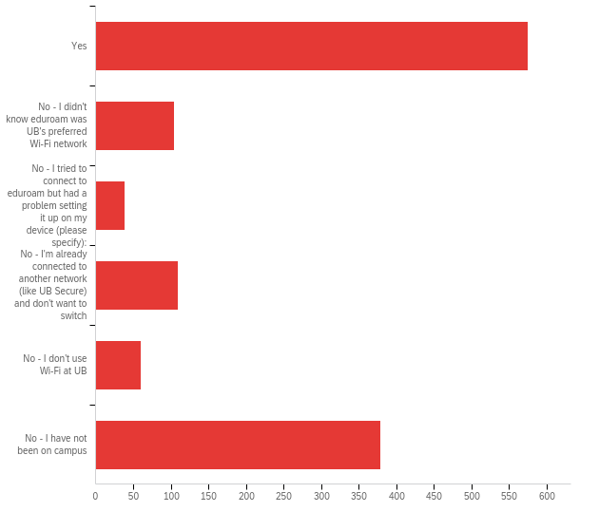

# | Field | Minimum | Maximum | Mean | Std Deviation | Variance | Count
1 | eduroam is UB's preferred Wi-Fi network. If you connect to Wi-Fi at UB, are you using eduroam? - Selected Choice | 1.00 | 6.00 | 3.09 | 2.21 | 4.86 | 1265

# | Answer | % | Count
1 | Yes | 45.45% | 575
2 | No - I didn't know eduroam was UB's preferred Wi-Fi network | 8.22% | 104
3 | No - I tried to connect to eduroam but had a problem setting it up on my device (please specify): | 3.00% | 38
4 | No - I'm already connected to another network (like UB Secure) and don't want to switch | 8.62% | 109
5 | No - I don't use Wi-Fi at UB | 4.74% | 60
6 | No - I have not been on campus | 29.96% | 379
 | Total | 100% | 1265

Q22_3_TEXT - No - I tried to connect to eduroam but had a problem setting it up on my de...
No - I tried to connect to eduroam but had a problem setting it up on my device (please specify): - Text
fail connected
can't open any website
It never has worked for me
idk the sign in
I havent checked to see what wifi i connect to
i use ubsecure
sometimes doesn't accept my credentials or just does nothing
I had to use UB Secure
Cell phone - gave up; was using general wifi but its not like were on campus anymore so hasn't been an issue.
It says it is set up but never works
Eduroam only works on my phone
Didn’t let me register
Everytime I connect it says connect but no internet, so I use whatever UB one I can get to work
Wouldn't log in
Connected to eduroam in the spring, upon fall return it would not let me reconnect. Switched to UB Secure
I started with UB Secure, got kicked out, someone at the desk in Capen library helped set up eduroam for me (which left me standing there for half an hour) but eventually I got kicked off of eduroam so now I'm back to UB Secure.
I've had issues on Zoom with eduroam, and will switch to UBSecure
Would not let me sign in even though credentials are correct
It says my credentials are wrong
Wouldn’t let me connect to it
hasn't worked with my UB log in all semester
I cannot connect to it. I have tried and have to us UB Secure instead
I had trouble connecting with it last year, but it eventually worked, I have not been on campus yet this year for it to be an issue.
it wouldn't let me connect to edu roam. i am on ub secure
It shows successfully connected, but actually has no net work when I try to use.
the connection isn’t stable sometimes, so i switch between ub secure and eduroam
android phone and MacBook Pro
keeps asking for pw and username when i put them in right
It used to work but it stopped this semester

Q24 - If you use Wi-Fi at UB, is there one place in particular where you have had trouble with lost or "dropped" Wi-Fi connections? If so, where?

If you use Wi-Fi at UB, is there one place in particular where you have had trouble with lost or "dropped" Wi-Fi connections? If so, where?
Yes. Allllll the time near the Commons (Subway in partciular) and the front of the dining hall seating area, ANDDD near the bookstore
Everywhere
Elevators, staircases, bus routes
250 Baird hall
Outside around NSC and CFA areas
n.a
In my dorm. Lehman Hall.
dorm buildings
L
UB stadium
no
tunnel from knox to student union
Lockwood Library
My dorm
everywhere
On campus
No
sometimes in governors the wifi is spotty
Student union
Tunnel from SU to Know
Capen Hall and Fronzak paid lot
Kimball tower
its slow most places
No
I don't use Wi-Fi at UB
N/A
cooke hall first floor near the door
Yes, and it can happen anywhere. It happens in the dorms, it sometimes happens in the classrooms (rarely).
No
Greiner Lobby
Ub residence halls
n/a
the sidewalk from govs to capen has weak wifi signal
Between buildings.
Tunnel, elevators in dorms
dorms
Walking between buildings or common areas
outside
capen, several times
Chickmex
Ellicot
Parking lots
Parking lot, but that makes sense since I should already be leaving campus by then.
in the walkways. Governors
Mathematics Building is CONSTANTLY loosing connection!!!
None
Everywhere
No
no
N/A
Parking lots between buildings.
Sometimes the wifi in my bedroom is slow which interferes with zoom calls
N/A
no
Farber Hall
Basement of buildings (NSC, for instance). Travelling between NSC and Bell Hall
no
No
Capen 1
The only places I have noticed losing a connection is in some parking areas as I browse my smartphone, so nothing major
My on campus apartment
Parking lots
No
occasionally on the Richmond Bridge.
Near main office. Capen
Elevators (specifically Ellicott building 7)
Center for the Arts auditorium
the connection between buildings
No
literally everywhere
Near the elevators in Spaulding 7
mostly at greiner but also at silverman
O'Brian
No
I don’t know
no
In the football stadium as I am a football player other than that it is fone
Baird building
elevators
no
Davis Hall sometimes
Stairways
The parking lot in front of the Governor's Complex (Not that this is an issue. No wifi in a parking lot is completely ok lol).
no
Center for the Arts
Off campus bus stop at rensch loop and flint loop
Stairwell in Furnas Hall and UB commons
All parking lots, which means I can't study or work on homework in my car between classes. Parts of NSC and some other parts of campus are cell service dead zones.
capen library
no
Hochestatter hall
Park Hall
N/A
No
Rarely, but on the bus going around North campus
dorm
It’s often very slow everywhere
The only place the Wi-Fi seemed to drop and connect again would be near the parking and the front car acess roads on the campus
No
Student Union
No
Baldy Cafe area
Near the stairwells in Park Hall (it also drops in the stairwells, but connectivity declines as you approach the stairs themselves).
No but whenever I was there in previous years, the cell service/4g is terrible.
It drops in my apartment a couple times a night
N/A
No
No
NA
outside
My room
In the elevator/walking to student union
No
Lockwood Library during the Quizes. It sayd its public wifi and a lit of people are connected go closer to router, which is impossible to find
The Residence Halls
in elevators
restroom of Bonner hall
In the stair cases and kitchen
Cooke Hall study area
The basement in Governors unless in the Lehman Cave
I used to use it, but one time It disconnected at one point on my laptop, while completing an assignment. Once I hit submit, I took me to a different website asking to connect to the WiFi, I connected and then it took me to the UB website and my entire assignment wasn’t saved. So I just used my data when I’m doing assignments to make sure that doesn’t happen again. I was in the UB campus at the library
Walking between the law building and business building
Yes, basement of Clemens has problems sometimes.
Stadium and Alumni
my room for a short while but i fixed the problem
nope
No
none
The fifth floor of Park Hall
The entire campus. Your network sucks, get good son.
Law school classrooms
no
Commons
My dorm room
CFA
Commons, plaza near knox
alumni
No
No
N/A
I have lost connection in my dorm in Dewey Hall at Governors Complex quite often. I usually go to the library to complete classwork because of it.
Outside of buildings
Sometimes in the Atrium in Ellicott
commons
No
Furnas, When lab doors are closed it seems theres no wifi.
no
First floor of Governors
outside
I've lost connection to the wifi while inside my dorm room in the Govenor's Complex Roosevelt Hall in the 203 area.
Yes Quads of south campus behind hayes and parker.
Between buildings
In previous semesters, I lost have lost Wi-Fi connection in The Commons.
Hadley Apartments
na
the library
certain areas in apartment or when at desk in apartment
My dorm (Governors) occasionally
outside of NSC
Park Hall
no
room
In between buildings
no
not that I've noticed
Hayes Hall
my dorm room, the tunnels by ellicott, by capen cafe, in knox
N/A
In my room
To be honest, this is only for specifically my laptop whereas it has spotty connection every now and then, no other devices has this issue so yeah.
No
N/A
No
The Center of Arts basement floor
outside of buildings
Parking lot in between the CFA and SLV apartments. next to the gym.
In the dorm rooms
Commons
Knox Building
Student Union
in the capen library, sometimes it'll say "connected. No internet."
Ellicot complex parking lot and just outside of the buildings.
No
Baldy, Capen, SU, Bookstore, Knox, Norton...the spine, in general just is awful
n/a
Outside of buildings
apartment
Library
not sure
n/a
NA
My dorm
Some areas in capen library
Traveling between buildings, at my apartment in the evenings
Bonner in the corner by the bathrooms and the hallway seating area on the third floor. Makes it hard to use it for work.
I don't use on campus
Honestly though, no and it’s quite remarkable you all deserve a lot of credit for that. There’s like 10s of thousands of people using this network. I feel bad since it works so well and you only hear about it when there’s a problem.
Dorm flint village
No
By NSC going towards the off campus apartment's' bus loop
Walking from the dorms to the student union. Also the walkway from Knox Hall to the Natural Science Complex
The commons and bookstore
In my apartment
the Natural Sciences Complex in North Campus
No
no
Ellicott, outside, parking lots
N/A
On the Stampede near the bookstore.
Outside of halls, in walking areas
No
nope
hallway by Knox
Clemens 7th floor
The periphery of the Student Union by the dining tables.
n/a
There are a lot of dead zones in and around Ellicott. Ellicott WiFi also drops unexpectedly for several minutes at a time multiple times a week.
Parking lots
No
My residence hall (Fargo)
Wilkeson Dorms
upstairs in my apartment at creekside
outside near the NSC bus loop.
In buses
Outside of buildings
On random occasions
No
Flint apartment
Libraries
Down the stairways.
Parking lots
between buildings, outside
commons
None
Elevators
Whenever I leave a building, it's annoying when the wifi disconnects. I still need it.
Dorm room
no
no where
yes see above and it doesnt matter where.
no
hadley village apartments - I have issue to connecting to wifi when I'm standing outside one of the buildings
No
na
Capen
the laundry room in Richmond 6, some times it randomly drops my room, and sometimes in the lounge area of Richmond 6
Almost anywhere outside buildings. Also, the Commons.
The path from Ellicott to Student Union, the wifi never works there. Additionally, the tunnel in the atrium where all the food is on the Ellicott Complex, there's never signal or wifi in that whole area.
In the tunnels
Anywhere outside as well as commons and student union
O’Brian hall
no
All Bathrooms
cfa basement
no
natural science hall and student union
In the parking lot
Baird hall
elevator
NSC- switched to UB Secure
Near capen hall
n/a
The walkway down the Academic Spine next to the Governors Lot B.
I have only used wi-fi on campus at the Lockwood Library, and once finally connected, I didn't have any trouble.
Maybe the elevator.
Mathematics Building
Outside of buildings, corridors
N/A
N/A
no
creekside village east
Most of Slee/Baird
NA
NA
Outside Wilkinson
The tunnels in the dorms
No
Not a specific place but at times WiFi has stopped working
N/A
In the staircases, but thats expected.
No
No
Right at the alleyway traversing between NSC and the Mathematics building
no
Always in the basement of governors, despite there being an obvious WiFi router on the wall
No
Governors Clinton Hall Laundry room
In my dorm room. the Wi-Fi crashes.
Between the end of the academic buildings (Baird, Clemens, etc.) and the CFA/Alumni
N/A
Knox
The elevator and walking in-between buildings
My apartment
parking lots
Parts of Farber hall are really bad. Especially in the basement
between capen and SU
The yard between Crosby and Diefendorf
NA
No
Inside residents room inside the office
Walking between buildings
NA
No
The Commons
No
Richmond Quad, Ellicott
N/A
None as of yet
Basement of Jacobs
outside of buildings such as Fronczak and Slee when i do work outside
Hochestetter Hall 5th floors
Yes, whenever I use lockdown browser for exams. During background checks it always takes forever to load and I didn’t want to lose time so I have to keep exiting and retrying it
Walking through ellicott complex
Some locations in Hochstetter
no
Alumni
my apartment
ALL the time. When you move south campus to north campus. it doesn't recognize. Some Conner in the lab has poor signal, stair case
Student Union, Lockwood Memorial Library
Hadley village
If I keep getting these stupid surveys, I'll keep giving you guys non answers.

Q27 - Have you used the UB VPN (Virtual Private Network) to access UB technology resource from off campus?
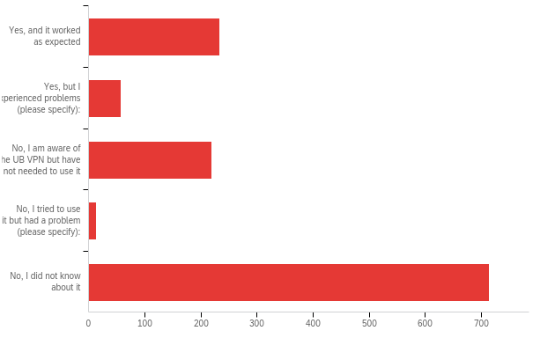

# | Field | Minimum | Maximum | Mean | Std Deviation | Variance | Count
1 | Have you used the UB VPN (Virtual Private Network) to access UB technology resource from off campus? - Selected Choice | 1.00 | 5.00 | 3.74 | 1.60 | 2.57 | 1238

# | Answer | % | Count
1 | Yes, and it worked as expected | 18.90% | 234
2 | Yes, but I experienced problems (please specify): | 4.68% | 58
3 | No, I am aware of the UB VPN but have not needed to use it | 17.69% | 219
4 | No, I tried to use it but had a problem (please specify): | 1.05% | 13
5 | No, I did not know about it | 57.67% | 714
 | Total | 100% | 1238

Q27_2_TEXT - Yes, but I experienced problems (please specify):
Yes, but I experienced problems (please specify): - Text
Its slow
Disconnects a lot
Frequent disconnections
Glacially slow
if its cisco connect I find it gets very glitchy after you been logged off due oto time, and you have to close it and remote desktop to get it to work properly
Couldn't access or submit certain files on the system, resulting in me being unable to submit an assignment
Too complicated
slow
It was really difficult to connect. It wouldn't accept my password, even though it was correct. I got frustrated and just stopped trying to use it.
Multiple times it crashed
I don’t know if Remote Desktop counts but there were too many logged in accounts and sometimes you would steal someone’s session
archlinux
I frequently have problems maintaining a connection with Apollo (virtual slide service for med students)
The UB VPN needs a vpn to get connection from China.
I had to modify my system's software do download it - was a pretty compex process.
Sometimes it will do a captcha thing and I just can't access research articles...it will say that too many attempts have been made but it's my first time connecting to PSYCHinfo via VPN.
It helped nothing, not even help me connecting the online print
slow connection
Frequently booted me out
loss of connection
The duo costs lots longer time when logging in.
Works slow
Could not set up the VPN for a long time but finally succeeded
Interfered with my computure and caused performance issues
don't remember specific haven't used in sometime
Takes forever to load
The server often deletes from my computer and I have to re-input it.
Connection Timeouts
laptop crashes often
I was not able to get SPSS to work so I installed a trial version
Some reasearch articles won't load even when on VPN.
it gets crashing sometimes.
Lost connections
The VPN has crashed multiple times and needed to be replaced by the Cisco VPN
Connecting VPN at one host will force other ones to logout
the speed is so slow
It won't connect
Confusing to access
NSC
Sometimes doesnt allow me to connect, gives an error message
sometimes it disconnects
was pretty confusing trying to set it up
The program kept saying I needed to be on campus but eventually we were able to get it to work
Frequently kicked, convoluted set up
I am always kicked off within the first 5 minutes and have to reconnect
Occasionally it times out.
I have to use a little keychain every time I want to log onto any UB service. It's terribly cumbersome.
Took multiple times to connect
very slow
I don't know how to turn it on. Always fails
In the beginning of the semester the provider switched and it was not working for some time
Struggled to work it
Does not always work and crashes
Sometimes I am not connected when the VPN says I am.

Q27_4_TEXT - No, I tried to use it but had a problem (please specify):
No, I tried to use it but had a problem (please specify): - Text
I was using it for virtual desktop but the software I needed wouldn't open, anyway.
It connected, but it didn't make any difference/ didnt work
It is the definition of malware.
I don't really understand why I need to use it. It doesn't seem to apply to my situation. I found two instructions for two different VPNs through UB. One worked, the other did not. The website said I needed the one that doesn't work, but I haven't been able to figure out what I need it for.
It was too confusing to figure out so I just do work arounds - or my husband set it up and got it working so I don't know it is being used... he is a computer person
Does not connect when I try so I use AnyConnect instead
Webpages don't load at all when the VPN is in use, so I can't really use it
it simply doesn’t make sense. i downloaded it but there is no way to run it
There weren't clear instructions on how to operate it once downloaded and when I tried to remove it to redownload it I was unable to do so.
Erectile dysfunction

Q28 - Which of the following TV/video streaming services do you use on campus? (Select all that apply.)
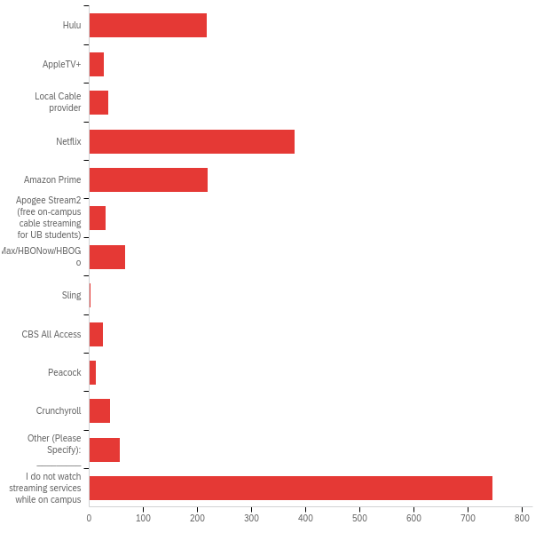

# | Answer | % | Count
1 | Hulu | 11.69% | 217
2 | AppleTV+ | 1.45% | 27
3 | Local Cable provider | 1.89% | 35
4 | Netflix | 20.47% | 380
5 | Amazon Prime | 11.80% | 219
6 | Apogee Stream2 (free on-campus cable streaming for UB students) | 1.67% | 31
7 | HBOMax/HBONow/HBOGo | 3.61% | 67
8 | Sling | 0.11% | 2
9 | CBS All Access | 1.35% | 25
10 | Peacock | 0.70% | 13
11 | Crunchyroll | 2.05% | 38
12 | Other (Please Specify): _________ | 3.02% | 56
13 | I do not watch streaming services while on campus | 40.19% | 746
 | Total | 100% | 1856

Q31 - Have you set your security questions and registered your cell or non-UB email to reset your UBITName password 24/7 at ubidm.buffalo.edu?
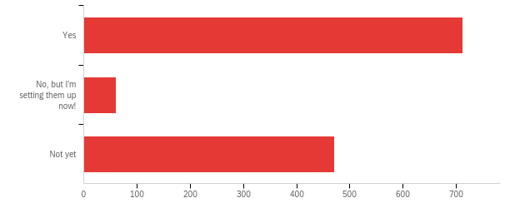

# | Field | Minimum | Maximum | Mean | Std Deviation | Variance | Count
1 | Have you set your security questions and registered your cell or non-UB email to reset your UBITName password 24/7 at ubidm.buffalo.edu? | 1.00 | 3.00 | 1.81 | 0.96 | 0.91 | 1246

# | Answer | % | Count
1 | Yes | 57.22% | 713
2 | No, but I'm setting them up now! | 4.90% | 61
3 | Not yet | 37.88% | 472
 | Total | 100% | 1246

Q33 - From the list of technology services below, please indicate your level of satisfaction with each:
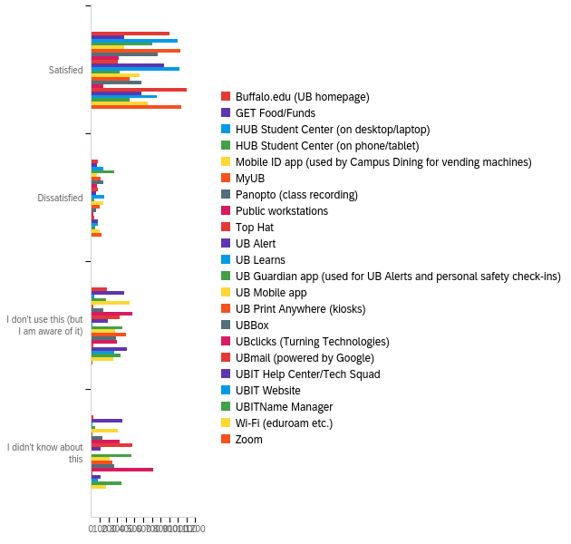

# | Field | Minimum | Maximum | Mean | Std Deviation | Variance | Count
1 | Buffalo.edu (UB homepage) | 1.00 | 4.00 | 1.43 | 0.82 | 0.67 | 1188
2 | GET Food/Funds | 1.00 | 4.00 | 2.61 | 1.22 | 1.49 | 1188
3 | HUB Student Center (on desktop/laptop) | 1.00 | 4.00 | 1.22 | 0.56 | 0.31 | 1188
4 | HUB Student Center (on phone/tablet) | 1.00 | 4.00 | 1.64 | 0.88 | 0.77 | 1188
5 | Mobile ID app (used by Campus Dining for vending machines) | 1.00 | 4.00 | 2.56 | 1.18 | 1.39 | 1188
6 | MyUB | 1.00 | 4.00 | 1.19 | 0.55 | 0.30 | 1188
7 | Panopto (class recording) | 1.00 | 4.00 | 1.70 | 1.06 | 1.13 | 1188
8 | Public workstations | 1.00 | 4.00 | 2.69 | 1.14 | 1.31 | 1188
9 | Top Hat | 1.00 | 4.00 | 2.81 | 1.21 | 1.47 | 1188
10 | UB Alert | 1.00 | 4.00 | 1.64 | 1.05 | 1.10 | 1188
11 | UB Learns | 1.00 | 4.00 | 1.17 | 0.45 | 0.20 | 1188
12 | UB Guardian app (used for UB Alerts and personal safety check-ins) | 1.00 | 4.00 | 2.81 | 1.22 | 1.48 | 1188
13 | UB Mobile app | 1.00 | 4.00 | 2.11 | 1.18 | 1.39 | 1188
14 | UB Print Anywhere (kiosks) | 1.00 | 4.00 | 2.38 | 1.18 | 1.40 | 1188
15 | UBBox | 1.00 | 4.00 | 2.20 | 1.25 | 1.57 | 1188
16 | UBclicks (Turning Technologies) | 1.00 | 4.00 | 3.34 | 1.00 | 1.00 | 1188
17 | UBmail (powered by Google) | 1.00 | 4.00 | 1.13 | 0.50 | 0.25 | 1188
18 | UBIT Help Center/Tech Squad | 1.00 | 4.00 | 2.04 | 1.10 | 1.21 | 1188
19 | UBIT Website | 1.00 | 4.00 | 1.72 | 1.03 | 1.06 | 1188
20 | UBITName Manager | 1.00 | 4.00 | 2.51 | 1.26 | 1.60 | 1188
21 | Wi-Fi (eduroam etc.) | 1.00 | 4.00 | 1.96 | 1.16 | 1.35 | 1188
22 | Zoom | 1.00 | 4.00 | 1.15 | 0.44 | 0.19 | 1188

# | Question | Satisfied |  | Dissatisfied |  | I don't use this (but I am aware of it) |  | I didn't know about this |  | Total
1 | Buffalo.edu (UB homepage) | 75.84% | 901 | 6.99% | 83 | 15.24% | 181 | 1.94% | 23 | 1188
2 | GET Food/Funds | 32.15% | 382 | 5.56% | 66 | 31.73% | 377 | 30.56% | 363 | 1188
3 | HUB Student Center (on desktop/laptop) | 83.92% | 997 | 11.53% | 137 | 3.37% | 40 | 1.18% | 14 | 1188
4 | HUB Student Center (on phone/tablet) | 58.92% | 700 | 22.39% | 266 | 14.65% | 174 | 4.04% | 48 | 1188
5 | Mobile ID app (used by Campus Dining for vending machines) | 31.82% | 378 | 5.47% | 65 | 37.12% | 441 | 25.59% | 304 | 1188
6 | MyUB | 86.28% | 1025 | 9.60% | 114 | 2.53% | 30 | 1.60% | 19 | 1188
7 | Panopto (class recording) | 64.98% | 772 | 11.62% | 138 | 12.04% | 143 | 11.36% | 135 | 1188
8 | Public workstations | 26.85% | 319 | 5.30% | 63 | 39.98% | 475 | 27.86% | 331 | 1188
9 | Top Hat | 26.01% | 309 | 6.82% | 81 | 27.27% | 324 | 39.90% | 474 | 1188
10 | UB Alert | 70.45% | 837 | 4.46% | 53 | 15.91% | 189 | 9.18% | 109 | 1188
11 | UB Learns | 85.35% | 1014 | 12.88% | 153 | 1.18% | 14 | 0.59% | 7 | 1188
12 | UB Guardian app (used for UB Alerts and personal safety check-ins) | 27.36% | 325 | 3.28% | 39 | 30.13% | 358 | 39.23% | 466 | 1188
13 | UB Mobile app | 47.14% | 560 | 12.21% | 145 | 23.06% | 274 | 17.59% | 209 | 1188
14 | UB Print Anywhere (kiosks) | 37.46% | 445 | 8.08% | 96 | 33.50% | 398 | 20.96% | 249 | 1188
15 | UBBox | 48.74% | 579 | 5.13% | 61 | 23.99% | 285 | 22.14% | 263 | 1188
16 | UBclicks (Turning Technologies) | 12.21% | 145 | 2.19% | 26 | 25.42% | 302 | 60.19% | 715 | 1188
17 | UBmail (powered by Google) | 92.76% | 1102 | 3.28% | 39 | 2.36% | 28 | 1.60% | 19 | 1188
18 | UBIT Help Center/Tech Squad | 49.16% | 584 | 6.90% | 82 | 34.43% | 409 | 9.51% | 113 | 1188
19 | UBIT Website | 64.06% | 761 | 6.90% | 82 | 22.22% | 264 | 6.82% | 81 | 1188
20 | UBITName Manager | 37.46% | 445 | 4.12% | 49 | 28.62% | 340 | 29.80% | 354 | 1188
21 | Wi-Fi (eduroam etc.) | 55.30% | 657 | 8.33% | 99 | 21.89% | 260 | 14.48% | 172 | 1188
22 | Zoom | 87.79% | 1043 | 10.19% | 121 | 1.43% | 17 | 0.59% | 7 | 1188

Q34 - In general, do you think your instructors use technology effectively in their courses?
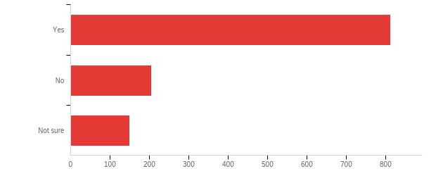

# | Field | Minimum | Maximum | Mean | Std Deviation | Variance | Count
1 | In general, do you think your instructors use technology effectively in their courses? | 1.00 | 3.00 | 1.43 | 0.71 | 0.50 | 1166

# | Answer | % | Count
1 | Yes | 69.64% | 812
2 | No | 17.50% | 204
3 | Not sure | 12.86% | 150
 | Total | 100% | 1166

Q36 - Which of the following productivity software titles do you use for your studies or coursework at UB? (Select all that apply.)
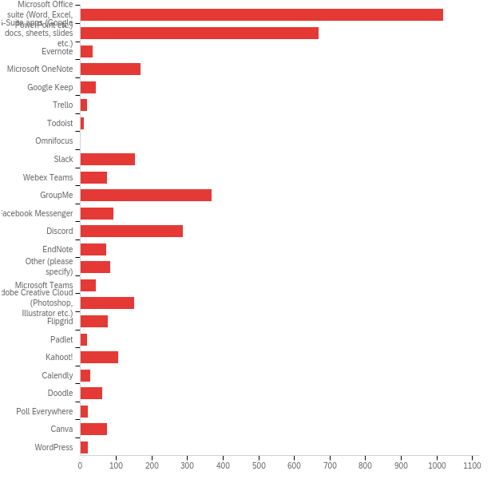

# | Answer | % | Count
1 | Microsoft Office suite (Word, Excel, PowerPoint etc.) | 27.49% | 1019
2 | G-Suite apps (Google docs, sheets, slides etc.) | 18.07% | 670
3 | Evernote | 0.92% | 34
4 | Microsoft OneNote | 4.59% | 170
5 | Google Keep | 1.16% | 43
6 | Trello | 0.54% | 20
7 | Todoist | 0.30% | 11
8 | Omnifocus | 0.00% | 0
9 | Slack | 4.13% | 153
10 | Webex Teams | 2.02% | 75
11 | GroupMe | 9.93% | 368
12 | Facebook Messenger | 2.48% | 92
13 | Discord | 7.80% | 289
14 | EndNote | 1.97% | 73
15 | Other (please specify) | 2.27% | 84
16 | Microsoft Teams | 1.19% | 44
17 | Adobe Creative Cloud (Photoshop, Illustrator etc.) | 4.07% | 151
18 | Flipgrid | 2.08% | 77
19 | Padlet | 0.54% | 20
20 | Kahoot! | 2.89% | 107
21 | Calendly | 0.76% | 28
22 | Doodle | 1.65% | 61
23 | Poll Everywhere | 0.59% | 22
24 | Canva | 2.02% | 75
25 | WordPress | 0.57% | 21
 | Total | 100% | 3707

Q36_15_TEXT - Other (please specify)
Other (please specify) - Text
GoodNotes
pages
quizlet
Notion
Notability
yahoo
Forest, TimeLog (Both Android apps)
Zoom
Google Drive
Whatsapp
Archives Space
Nonenone
paper
Quizlet
Asana
Menti
GoodNote
AnkiApp
Adobe reader
Snapchat
Microsoft Whiteboard
Pages
Not applicable
Autocad, Lumion, Sketchup, V-Ray, Rhino, Grasshopper, etc
Apple Office Suite( Pages, numbers, keynote)
Zotero
Snapchat
Notion
MATLAB, Solidworks
OpenOffice, Emacs, Gimp, VirtualBox
Zotero
Quizlet
Good ol’ paper n pencil
Whatsapp
zoom, rhino, autodesk suite, Vray by chaos group, Grasshopper
Goodnotes, Things3, Spark
FoxitReader
Google Sheets and Google Docs due to convenience
Notibility
Notability
whatsapp
Notabitlity, Good Notes
iClicker
Zotero and Libreoffice mostly
None
Tophat, STATA
Open source alternatives to various media editing and wordprocessing.
Zoom meetings with friends
Mac run Office apps
Google Docs
LibreOffice
SNote
Kritik
LibreOffice suite (Writer, Calc, Impress, etc.), Skype
Quizlet
Zoom
Sonocent
Noteability
Grammarly, GraphPad Prism
overleaf
nitro reader
spss
quizlet
Google drive
I am on a MacBook Air and typically use Apple Based programs (Pages, Numbers, Keynote, Quicktime) and convert to submit assignments. I have a prof that requires Word, so i have downloaded and use the Microsoft programs offered through UB.
Squid (note-taking android app)
notion
I take notes on my notebook, so I study the handwritten work. It is easier for me
Notability
Twitch
respondus, sapling
Notability
For notes I use my notebooks
LibreOffice
Miro
LibreOffice Suite, Latex
Revit
Snapchat (group chat)
Rocketbook
None of these actually
Notion
Pages, Numbers, Keynote, Notability
Pee pee poo poo

Q38 - Which academic websites have you signed up for during your academic career at UB?
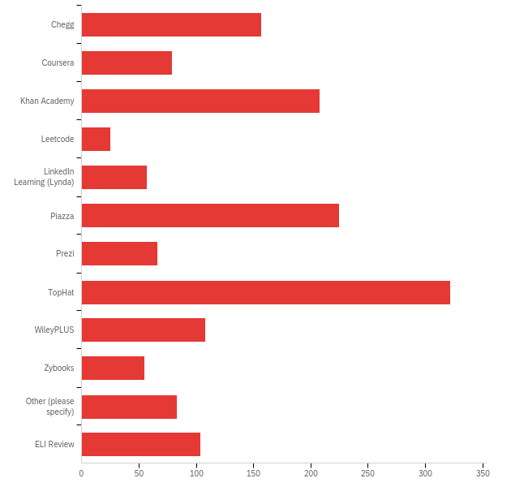

# | Answer | % | Count
1 | Chegg | 10.54% | 157
3 | Coursera | 5.31% | 79
4 | Khan Academy | 13.97% | 208
5 | Leetcode | 1.68% | 25
6 | LinkedIn Learning (Lynda) | 3.83% | 57
7 | Piazza | 15.11% | 225
8 | Prezi | 4.43% | 66
9 | TopHat | 21.63% | 322
10 | WileyPLUS | 7.25% | 108
11 | Zybooks | 3.69% | 55
12 | Other (please specify) | 5.57% | 83
16 | ELI Review | 6.98% | 104
 | Total | 100% | 1489

Q38_12_TEXT - Other (please specify)
Other (please specify) - Text
quizlet
sladder
The Pearson websites for textbooks and Mastering courses system
webwork
STUDOCU
WebAssign, MGConnect
Schoology
Quizzlet
EDx
Mymathlab
Gradebook
None
PhDProofreaders
safari
Mastering
None
LinkedIn
Mcgraw Hill Connect
N/a
Mastering Chemistry and MyMathLab
Tableau
quizlet and packback
MyMathLab
Miro
edX
Loom
course hero
TopHat
Cengage, panapto, labflow
Not applicable
Pearson
Academia.edu
Cengage
Cengage
None
Hackerrank
Cengage
Chegg textbook rental only, NOT chegg Study
Mindtap
UWORLD, Amboss, Onlinemeded
n/a
Webassign
N/A
na
None of these
ESRI
TeachingBooks.net
Qualtrics
Zotero, Stata
MG Connect
None
nothing
Youtube
WESTLAW
edx
Pearson
Vital Source/ Pearson
kritik
pearson
iClicker Reef
McGraw Hill Connect
none
cengage
None
Pearson/MyMathLab
book
Cengage
Mastering Engineering & Kritik
None of these
Pearson, WebAssign
None
McGraw-Hill Connect
Cengage| mindtap
Cengage, Pearson Learning (Mastering Chemistry), LabFlow
Webassign
ScienceDirect
geocities.com

Q39 - In 2020, UBIT added self-service printing kiosks to campus. If you are using them, are you satisfied with their location?
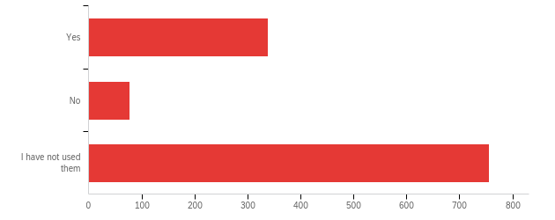

# | Field | Minimum | Maximum | Mean | Std Deviation | Variance | Count
1 | In 2020, UBIT added self-service printing kiosks to campus. If you are using them, are you satisfied with their location? | 1.00 | 3.00 | 2.36 | 0.90 | 0.81 | 1171

# | Answer | % | Count
1 | Yes | 28.86% | 338
2 | No | 6.58% | 77
3 | I have not used them | 64.56% | 756
 | Total | 100% | 1171

Q40 - Where could we add additional printing kiosks to improve your experience?

Where could we add additional printing kiosks to improve your experience?
The printoing stations take too long and are complicated the old way was much better i don't print on campus because of this
Put a 24 hour printer near the residential buildings like near Greiner & Ellicott.
Kimball or Sherman
Student Union
More locations
Basement of Kimball. There used to be a printer there and now there isnt one. Health Sciences Library does not need that many kiosks in one building.
Kimball Tower
I was hoping that there could be a kiosk in my residence hall, but I have to go out of the building to print stuff off.
Easier and clearer steps for the printing kiosks
put them in the resident halls. Flint
Baird Hall
Go back to the original printing centers...
Fronczak hall
Hadley Apartment, all the apartment complexes really.
In the apartments so we don't have to travel to main campus to use the printers
In residence halls
Greiner Hall
There's only one in Ellicott complex
Ellicott
Any location as long as you let us use our printing money and not campus cash!
On campus apartments have NO printing stations. Absurd.
Governor's building, but not in the computer lab
By the mail office or outside the student center in Elicott. The one in the student center closes, limiting when that printer can be used.
Bring back the printing rooms, the kiosks are terrible.
Nsc
Inside the law library
In the residence halls, like Richmond that is available 24 hours
too complicate
Fronczak or NSC
The printer in the Ellicott Complex is not 24/7, can only be used while the Academic center is opened.
HADLEY APARTMENTS AND FLINT and maybe don't put them places that are Locked. Why can't be one in Filmore be in the hallway by the atrium like other ones??
in apartment complexes, on spine/safely outside
I think outside major classrooms or the ground level of all the academic buildings.
more by ellicott, in the residence halls etc
For convenience, can I just print via the website browser instead of having to download a new software on my devices?
idk
The only printing kiosk in Ellicott is in the academic center, which has very limited hours. Putting one somewhere else would help, most people do their work late at night.
SLV, places closer to residence halls/apartments
Greiner and a couple more in the dorms also a couple on several places on campus like putting on in The Nautral science complex
Please add a printing kiosk in the community centers of apartment buildings, add another one in the Student Union and more on the side of campus near Alumni Arena and the CFA.
Outside Blake center!!
The duo mobile is very inconvenient
ground floor popular areas on campus, like 1 capen, baldy, ect
It would be helpful if the printing station in the Clinton Residence Hall was available for more hours of the day, because I have noticed that when I would like to print something, it is rededately closed. If feasible, 24/7 printing station in the dorms would be helpful. would be
hochstetter
Diefendorf ! / a building on South that’s open 24/7
near classrooms
The dorm buildings because its kinda crazy that I have to go all the way to main campus to print a few papers just to come all the way back to my room where i do my work. I dont enjoy going to the library because i try to stay as far away from people as often as i can because of rona.
Outside of printing stations and every floor of the library. There was a long wait to use them inside a small printing station space on UB south campus health sciences library
more in Ellicott, the only 24hr kiosks are on north campus and the only one in Ellicott is not accessible 24/7
On the Ellicott Complex and Greiner Hall
Greiner
greiner! cfa lobby! the blake center has limited hours
More in the dorming areas
In apartment community centers
Anywhere on the east end of campus (Alumni Arena, CFA, etc.)
Ellicott residence
South Lake Village
Creekside Village
closer to the apartments
Hadley village
On the 290

Q44 - How did you find out that UB offers free software like Microsoft Office? (Select all that apply.)
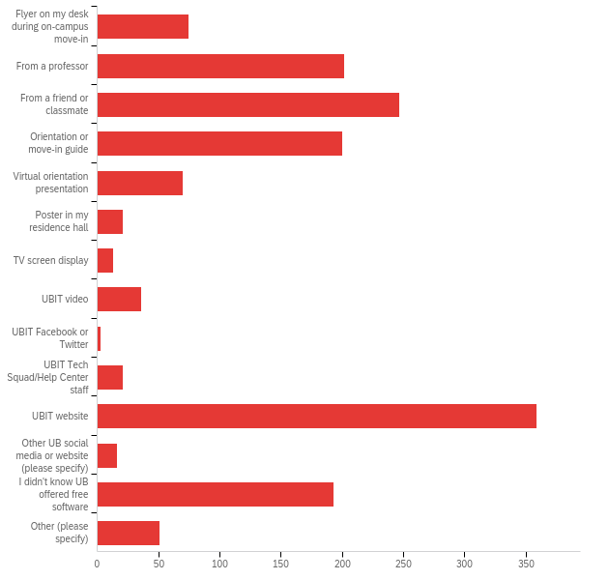

# | Answer | % | Count
1 | Flyer on my desk during on-campus move-in | 4.98% | 75
3 | From a professor | 13.40% | 202
4 | From a friend or classmate | 16.39% | 247
5 | Orientation or move-in guide | 13.27% | 200
6 | Virtual orientation presentation | 4.64% | 70
7 | Poster in my residence hall | 1.39% | 21
9 | TV screen display | 0.86% | 13
11 | UBIT video | 2.39% | 36
12 | UBIT Facebook or Twitter | 0.20% | 3
13 | UBIT Tech Squad/Help Center staff | 1.39% | 21
14 | UBIT website | 23.82% | 359
15 | Other UB social media or website (please specify) | 1.06% | 16
16 | I didn't know UB offered free software | 12.81% | 193
17 | Other (please specify) | 3.38% | 51
 | Total | 100% | 1507

Q44_15_TEXT - Other UB social media or website (please specify)
Other UB social media or website (please specify) - Text
Stumbled upon the information while looking for something else
UBIT email
Instagram
email
I believe I saw it the website before I attended UB
Searching for it online
na
Gmail, Discord
SIP
Poster between NSC and Norton
email
UB email
UB mail
Email

Q44_17_TEXT - Other (please specify)
Other (please specify) - Text
Googled it
Emails
dont remember it was before I got to ub thoguh
MVCC does, so I figured that UB does too
I guessed
I assumed based on my undergrad university offering free downloads
looked it up
Older sister who went to UB
Knew from previous college that did the same
In my computer basics training, but not sure how/where to access
MS Program IT Competency course
Assumed college students get these things for free from their university
figured it out myself
I clicked on an assignment and PowerPoint worked.
Don’t remember
Clicking around
I dont care.
I think I was emailed about it my freshman year
Email
I figured it out on my own by googling.
na
na
My Bio TA
My dad who works at UB
I just signed in with my UB account and saw it was offered
all colleges offer this
I don´t remember
I googled it
Microsoft offers it to any college student.
I didn't know UB offered free software. I have my own subscription.
Email
None
I dunno, it's been years since I set it up
Pitt offered it, so I figured UB did too
I did not see info about this anywhere but another graduate student told me.
My mom
I assumed they did and I was right
My mom told me all suny schools offer free microsoft office utilities.
Google
common sense
Email
People who were previously in college said that colleges offer free Microsoft applications.
Orientation as an undergrad
Google search
Syllabus
Brother
Email
As an Undergrad
Tried using my UB email but Microsoft would let me get the free programs
Email sent to my UBemail

Q46 - Where do you prefer to go first to find the following information?
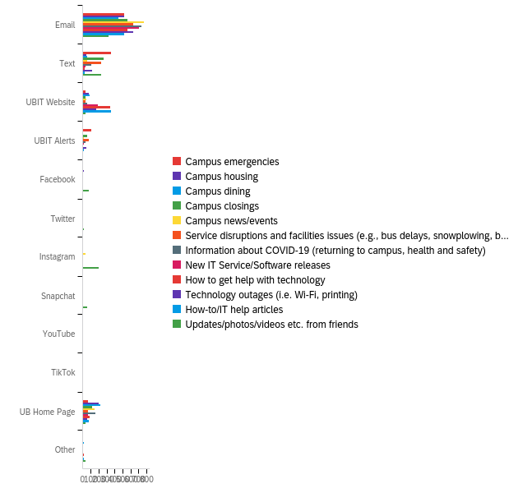

# | Field | Minimum | Maximum | Mean | Std Deviation | Variance | Count
1 | Campus emergencies | 1.00 | 13.00 | 2.48 | 2.78 | 7.74 | 1098
2 | Campus housing | 1.00 | 13.00 | 4.00 | 4.59 | 21.02 | 873
3 | Campus dining | 1.00 | 13.00 | 4.49 | 4.81 | 23.11 | 853
4 | Campus closings | 1.00 | 13.00 | 2.80 | 3.44 | 11.85 | 1056
5 | Campus news/events | 1.00 | 13.00 | 3.00 | 3.90 | 15.23 | 1082
6 | Service disruptions and facilities issues (e.g., bus delays, snowplowing, building closures) | 1.00 | 13.00 | 2.34 | 2.84 | 8.07 | 1067
7 | Information about COVID-19 (returning to campus, health and safety) | 1.00 | 13.00 | 2.98 | 3.87 | 14.97 | 1111
8 | New IT Service/Software releases | 1.00 | 13.00 | 2.29 | 2.87 | 8.24 | 1028
9 | How to get help with technology | 1.00 | 13.00 | 2.84 | 3.21 | 10.29 | 1061
10 | Technology outages (i.e. Wi-Fi, printing) | 1.00 | 13.00 | 2.32 | 2.72 | 7.40 | 1050
11 | How-to/IT help articles | 1.00 | 13.00 | 2.92 | 3.21 | 10.31 | 1027
12 | Updates/photos/videos etc. from friends | 1.00 | 13.00 | 4.07 | 3.42 | 11.69 | 1029

# | Question | Email |  | Text |  | UBIT Website |  | UBIT Alerts |  | Facebook |  | Twitter |  | Instagram |  | Snapchat |  | YouTube |  | TikTok |  | UB Home Page |  | Other |  | Total
1 | Campus emergencies | 46.99% | 516 | 32.79% | 360 | 2.82% | 31 | 9.47% | 104 | 0.18% | 2 | 0.27% | 3 | 0.64% | 7 | 0.00% | 0 | 0.00% | 0 | 0.09% | 1 | 6.38% | 70 | 0.36% | 4 | 1098
2 | Campus housing | 59.22% | 517 | 4.81% | 42 | 8.48% | 74 | 0.80% | 7 | 1.72% | 15 | 0.11% | 1 | 1.03% | 9 | 0.00% | 0 | 0.11% | 1 | 0.00% | 0 | 23.14% | 202 | 0.57% | 5 | 873
3 | Campus dining | 52.29% | 446 | 6.68% | 57 | 10.20% | 87 | 0.82% | 7 | 0.59% | 5 | 0.47% | 4 | 1.17% | 10 | 0.00% | 0 | 0.00% | 0 | 0.00% | 0 | 25.67% | 219 | 2.11% | 18 | 853
4 | Campus closings | 53.60% | 566 | 25.38% | 268 | 3.03% | 32 | 5.49% | 58 | 0.19% | 2 | 0.19% | 2 | 0.76% | 8 | 0.00% | 0 | 0.00% | 0 | 0.00% | 0 | 10.89% | 115 | 0.47% | 5 | 1056
5 | Campus news/events | 70.79% | 766 | 5.08% | 55 | 4.16% | 45 | 1.20% | 13 | 0.83% | 9 | 0.55% | 6 | 2.87% | 31 | 0.00% | 0 | 0.00% | 0 | 0.09% | 1 | 14.05% | 152 | 0.37% | 4 | 1082
6 | Service disruptions and facilities issues (e.g., bus delays, snowplowing, building closures) | 59.04% | 630 | 22.21% | 237 | 3.09% | 33 | 7.31% | 78 | 0.37% | 4 | 0.19% | 2 | 0.75% | 8 | 0.09% | 1 | 0.00% | 0 | 0.00% | 0 | 6.65% | 71 | 0.28% | 3 | 1067
7 | Information about COVID-19 (returning to campus, health and safety) | 66.16% | 735 | 10.17% | 113 | 4.77% | 53 | 3.06% | 34 | 0.27% | 3 | 0.09% | 1 | 0.72% | 8 | 0.00% | 0 | 0.00% | 0 | 0.00% | 0 | 14.22% | 158 | 0.54% | 6 | 1111
8 | New IT Service/Software releases | 68.48% | 704 | 3.31% | 34 | 18.29% | 188 | 1.65% | 17 | 0.39% | 4 | 0.10% | 1 | 0.68% | 7 | 0.00% | 0 | 0.10% | 1 | 0.00% | 0 | 6.42% | 66 | 0.58% | 6 | 1028
9 | How to get help with technology | 53.16% | 564 | 2.73% | 29 | 32.42% | 344 | 0.85% | 9 | 0.19% | 2 | 0.09% | 1 | 0.66% | 7 | 0.00% | 0 | 0.38% | 4 | 0.09% | 1 | 8.29% | 88 | 1.13% | 12 | 1061
10 | Technology outages (i.e. Wi-Fi, printing) | 60.76% | 638 | 11.43% | 120 | 15.81% | 166 | 4.57% | 48 | 0.57% | 6 | 0.00% | 0 | 0.67% | 7 | 0.00% | 0 | 0.00% | 0 | 0.00% | 0 | 5.52% | 58 | 0.67% | 7 | 1050
11 | How-to/IT help articles | 50.24% | 516 | 2.53% | 26 | 34.86% | 358 | 1.07% | 11 | 0.29% | 3 | 0.10% | 1 | 0.78% | 8 | 0.00% | 0 | 0.68% | 7 | 0.10% | 1 | 7.98% | 82 | 1.36% | 14 | 1027
12 | Updates/photos/videos etc. from friends | 31.68% | 326 | 22.93% | 236 | 3.69% | 38 | 0.39% | 4 | 7.48% | 77 | 1.26% | 13 | 19.83% | 204 | 5.15% | 53 | 0.58% | 6 | 0.00% | 0 | 3.89% | 40 | 3.11% | 32 | 1029

Q50 - What assistive technology do you use, if any? (Select all that apply.)
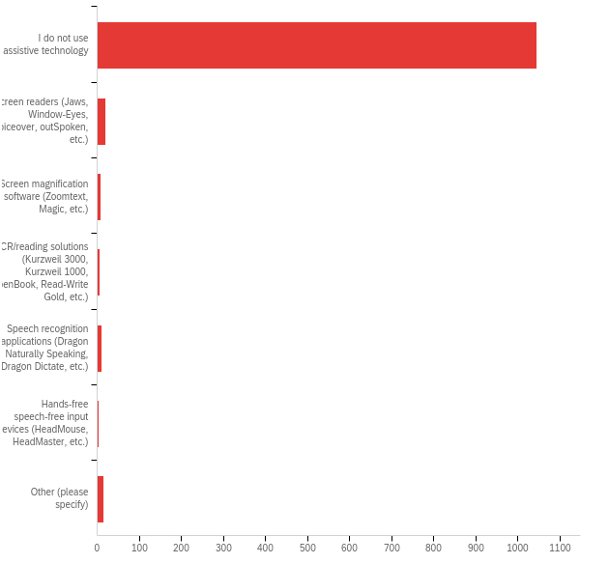

# | Answer | % | Count
1 | I do not use assistive technology | 94.66% | 1045
2 | Screen readers (Jaws, Window-Eyes, Voiceover, outSpoken, etc.) | 1.81% | 20
3 | Screen magnification software (Zoomtext, Magic, etc.) | 0.63% | 7
4 | OCR/reading solutions (Kurzweil 3000, Kurzweil 1000, OpenBook, Read-Write Gold, etc.) | 0.45% | 5
5 | Speech recognition applications (Dragon Naturally Speaking, Dragon Dictate, etc.) | 0.91% | 10
6 | Hands-free speech-free input devices (HeadMouse, HeadMaster, etc.) | 0.27% | 3
7 | Other (please specify) | 1.27% | 14
 | Total | 100% | 1104

Q50_7_TEXT - Other (please specify)
Other (please specify) - Text
zoom captioning
Genius Scan
Siri dictation
a
na
Speech to text application
Dragon didn't work so they send my lectures to a transcription service
Please dont make these surveys so long!
Sonocent
Zoom, didn't know about the others
Grammarly
this technology is already built-into my laptop
Mercury Reader - Text adjustement
Corrective lens glasses

Q52 - Have you experienced problems accessing the following with assistive technology? If so, how often?
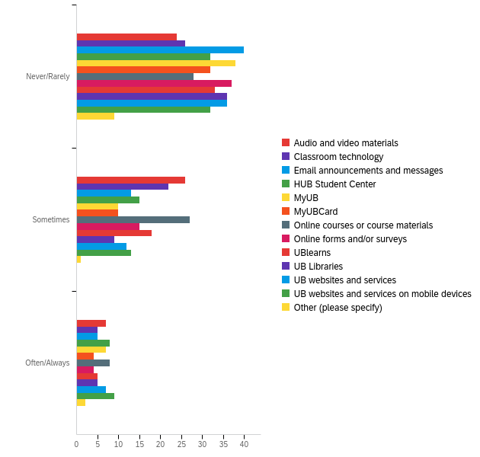

# | Field | Minimum | Maximum | Mean | Std Deviation | Variance | Count
1 | Audio and video materials | 1.00 | 4.00 | 2.28 | 1.14 | 1.29 | 57
2 | Classroom technology | 1.00 | 4.00 | 2.11 | 1.13 | 1.27 | 53
3 | Email announcements and messages | 1.00 | 4.00 | 1.71 | 1.08 | 1.17 | 58
4 | HUB Student Center | 1.00 | 4.00 | 1.98 | 1.20 | 1.44 | 55
5 | MyUB | 1.00 | 4.00 | 1.75 | 1.15 | 1.32 | 55
6 | MyUBCard | 1.00 | 4.00 | 1.70 | 1.08 | 1.17 | 46
7 | Online courses or course materials | 1.00 | 4.00 | 2.24 | 1.15 | 1.32 | 63
8 | Online forms and/or surveys | 1.00 | 4.00 | 1.75 | 1.07 | 1.15 | 56
9 | UBlearns | 1.00 | 4.00 | 1.91 | 1.12 | 1.26 | 56
10 | UB Libraries | 1.00 | 4.00 | 1.66 | 1.09 | 1.18 | 50
11 | UB websites and services | 1.00 | 4.00 | 1.82 | 1.16 | 1.35 | 55
12 | UB websites and services on mobile devices | 1.00 | 4.00 | 1.98 | 1.22 | 1.50 | 54
13 | Other (please specify) | 1.00 | 4.00 | 1.67 | 1.18 | 1.39 | 12

# | Question | Never/Rarely |  | Sometimes |  | Often/Always |  | Total
1 | Audio and video materials | 42.11% | 24 | 45.61% | 26 | 12.28% | 7 | 57
2 | Classroom technology | 49.06% | 26 | 41.51% | 22 | 9.43% | 5 | 53
3 | Email announcements and messages | 68.97% | 40 | 22.41% | 13 | 8.62% | 5 | 58
4 | HUB Student Center | 58.18% | 32 | 27.27% | 15 | 14.55% | 8 | 55
5 | MyUB | 69.09% | 38 | 18.18% | 10 | 12.73% | 7 | 55
6 | MyUBCard | 69.57% | 32 | 21.74% | 10 | 8.70% | 4 | 46
7 | Online courses or course materials | 44.44% | 28 | 42.86% | 27 | 12.70% | 8 | 63
8 | Online forms and/or surveys | 66.07% | 37 | 26.79% | 15 | 7.14% | 4 | 56
9 | UBlearns | 58.93% | 33 | 32.14% | 18 | 8.93% | 5 | 56
10 | UB Libraries | 72.00% | 36 | 18.00% | 9 | 10.00% | 5 | 50
11 | UB websites and services | 65.45% | 36 | 21.82% | 12 | 12.73% | 7 | 55
12 | UB websites and services on mobile devices | 59.26% | 32 | 24.07% | 13 | 16.67% | 9 | 54
13 | Other (please specify) | 75.00% | 9 | 8.33% | 1 | 16.67% | 2 | 12

Q54 - What would have made it easier for you to get started with Information Technology at UB? (Select all that apply.)
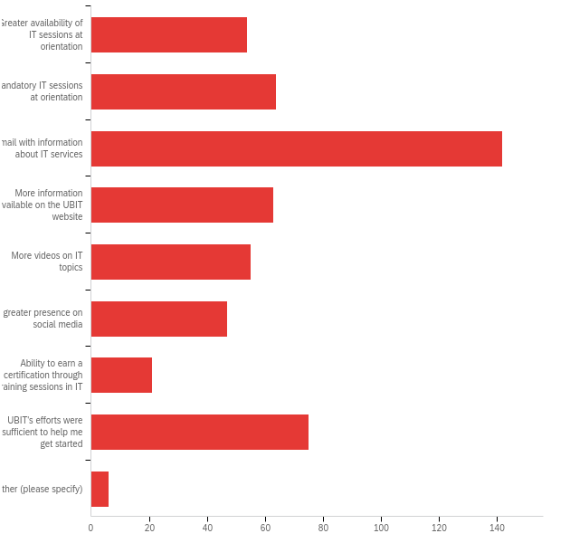

# | Answer | % | Count
1 | Greater availability of IT sessions at orientation | 10.25% | 54
2 | Mandatory IT sessions at orientation | 12.14% | 64
3 | Email with information about IT services | 26.94% | 142
4 | More information available on the UBIT website | 11.95% | 63
5 | More videos on IT topics | 10.44% | 55
6 | A greater presence on social media | 8.92% | 47
7 | Ability to earn a certification through training sessions in IT | 3.98% | 21
8 | UBIT's efforts were sufficient to help me get started | 14.23% | 75
9 | Other (please specify) | 1.14% | 6
 | Total | 100% | 527

Q54_9_TEXT - Other (please specify)
Other (please specify) - Text
I don’t take IT?
a list of available tech emailed at the beginning of the semester

Q44 - How important were UB's classroom environment (including technology and overall experience) in your decision to remain at UB?
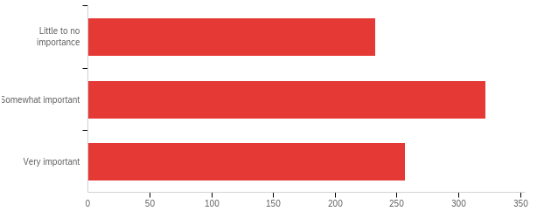

# | Field | Minimum | Maximum | Mean | Std Deviation | Variance | Count
1 | How important were UB's classroom environment (including technology and overall experience) in your decision to remain at UB? | 1.00 | 3.00 | 2.03 | 0.78 | 0.60 | 812

# | Answer | % | Count
1 | Little to no importance | 28.69% | 233
2 | Somewhat important | 39.66% | 322
3 | Very important | 31.65% | 257
 | Total | 100% | 812

