2020 UBIT Student Experience Survey

  - Executive Summary
  - 3/29/2021
UBIT Communication and Engagement
Office of the VPCIO
UB Information Technology

2020 UBIT Student Experience Survey
  - Executive Summary

Introduction

For 24 years, the UBIT Student Experience Survey has asked students to paint a portrait of their university experience. That experience has never looked quite like 2020.

In 2020, the COVID-19 pandemic suddenly, and rapidly, disrupted all aspects of life, including the student experience. As the window of a Zoom meeting became the new classroom for many students, the quality of education became more acutely tied to the quality of available technology than ever before.

UB’s IT staff all across campus worked tirelessly during this time to turn our technology services “inside out,” and prepare for a new way of living and learning:
- Zoom was introduced for the first time at UB
- Printing at UB was overhauled to reduce density on campus and provide a touchless, more sanitary experience
- Public computing sites were virtualized so students could access essential software from home
- Wi-Fi access was expanded outside buildings and into parking lot areas

But this work was just the beginning. To support UB students in 2020, a greater degree of communication and engagement than ever before became necessary. In addition to our annual survey, UBIT surveyed students throughout 2020 about their needs and comfort level with regard to online learning, and held virtual input sessions for students to share their questions, concerns and frustrations.

How fast is your internet connection at home? Does your device have a working webcam? Questions like these suddenly became critical factors defining a UB student’s experience and chances for success. Part II of this report (pg. 7) elaborates on student responses to some of these questions.

The results of this year’s survey are perhaps the most valuable in the survey’s 24-year history. They don’t merely provide a snapshot of the student experience, but provide insight into the challenges and opportunities facing UB students as they move beyond the COVID-19 crisis and into future.

Pictured on front: Aaron Bola poses for a portrait at his apartment in Buffalo on the day of his graduation from the Jacobs School of Medicine and Biomedical Sciences on May 1, 2020. The ceremony was presented virtually because of the COVID-19 response. Photo by Meredith Forrest Kulwicki.

About the Survey

1,573 UB students responded to the 2020 survey, representing undergraduates at all levels, as well as graduate students and non-degree seeking students. At the time this survey was administered, a majority of UB students were not on campus, learning online due to the COVID-19 pandemic. As a result, more students reported living off-campus than in previous years (80%, vs. 65% the previous year; see page 4).

The 2020 UBIT Student Experience Survey was open from October 19 to November 2, 2020, and contains 31 questions designed in conjunction with instructional and support IT staff in each technology area surveyed, as well as the UB offices of Student Life, Campus Living, Undergraduate Education, University Libraries and other campus stakeholders.

Responses were collected using Qualtrics. Students were encouraged to participate through social media and online promotions.

While some key questions were required, many were not; where applicable, percentages reflect the number of students who answered that specific question.

In what UB School or College are you enrolled?
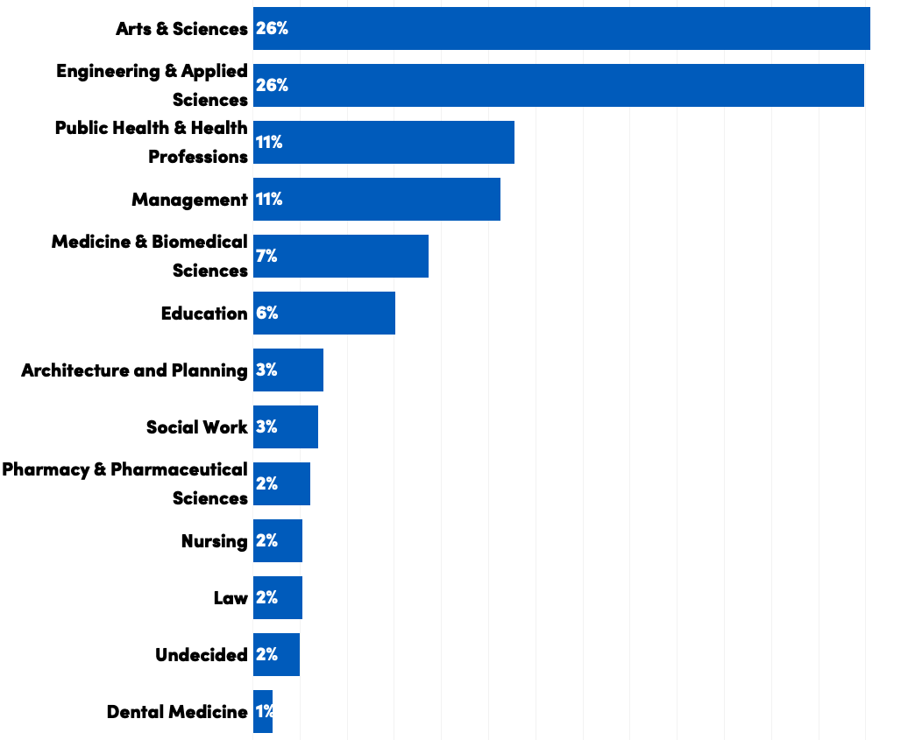

What is your class standing?

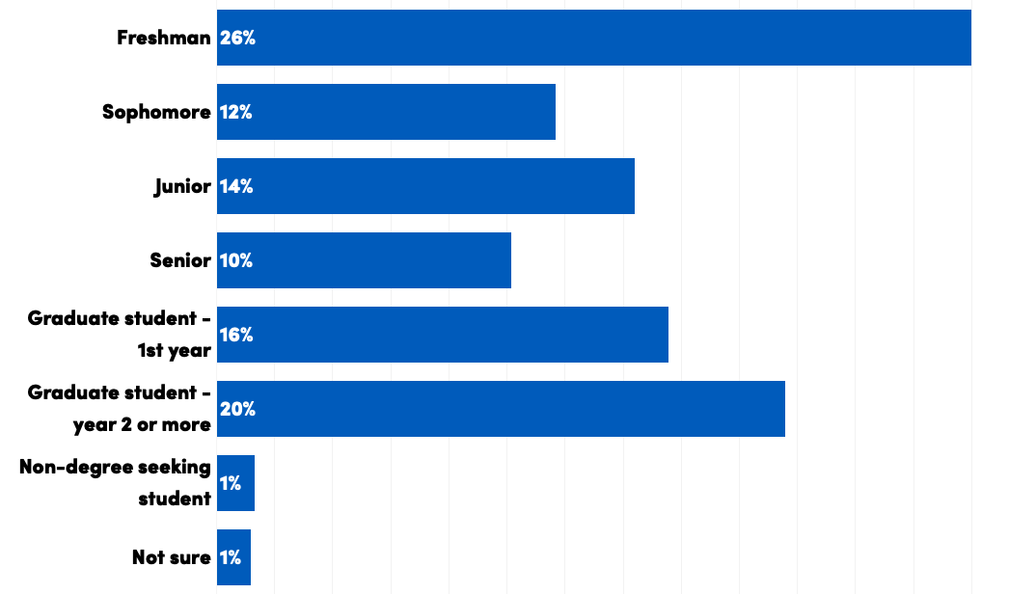

Where do you live?
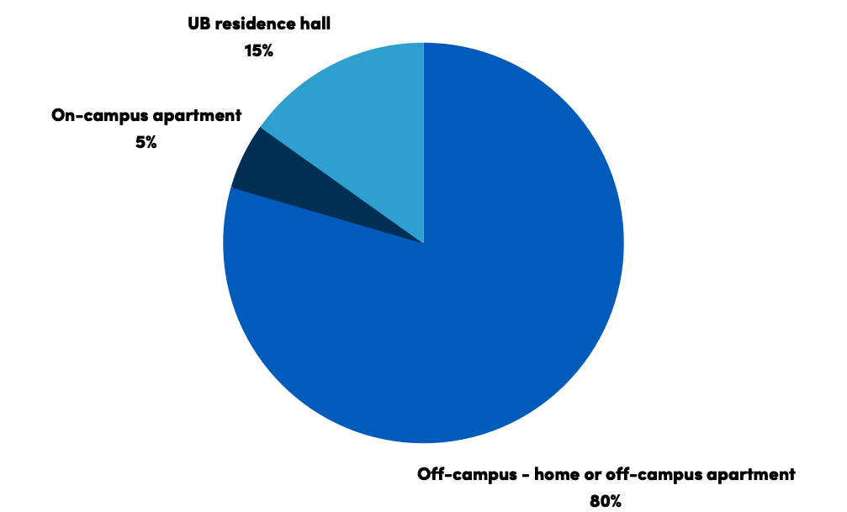

Part I. Students, Technology and Higher Education
  - What devices do students use in their lives, both personal and academic? How do they use technology to stay productive and in touch with the people and institutions around them?

Devices
Which devices have you used since the beginning of the semester?

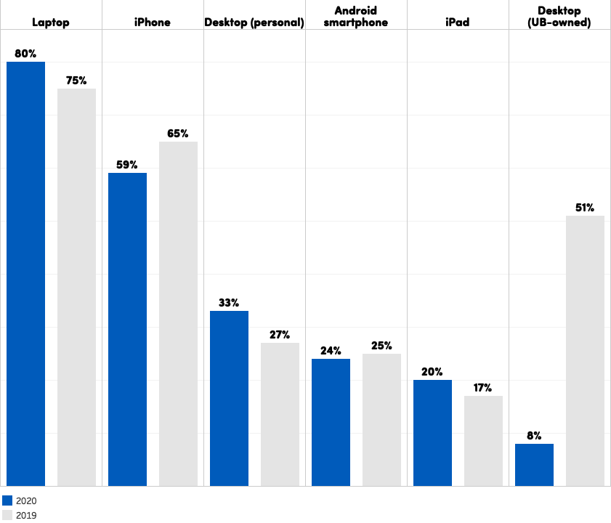

Use of UB computers in public computing sites was down significantly due to the pandemic. Of the 8% of students who used a public computer during the Fall 2020 semester, 45% did so to access UB’s printing services.

Use of personal desktops and laptops both increased in 2020. 96% of respondents rated their personal devices adequate for remote learning (see pg. 8). Students who didn’t were given an opportunity to receive a laptop on loan.
Digital tools for academics and productivity
What software do you use for productivity in your work at UB?

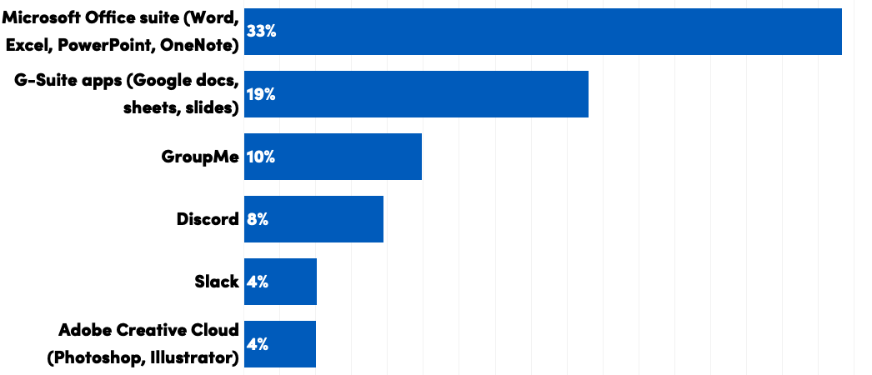

Which non-UB academic websites have you signed up for?

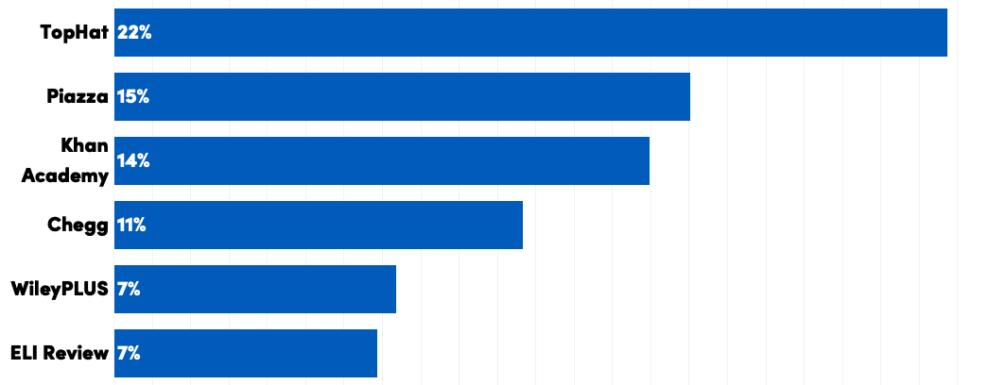

UB students are increasingly relying on a growing portfolio of third-party apps and resources for education.

UBIT has bolstered support for the most popular of these resources. As of 2020, Microsoft 365 is available for students, as well as faculty and staff. UBIT also entered into a formal contract with Top Hat, the most common third-party academic service used in classes at UB, to provide better support and value to students.

Part II. Remote Learning in Response to the COVID-19 Pandemic
Where were UB students learning in 2020? How conducive to learning was their environment? How comfortable were they with the technology required to learn effectively in a remote setting?

Remote learning environments

“Within a ten-day span [in March 2020], UBIT worked closely with UB faculty to transition over 4,000 courses to an online format,” said UB Vice President and Chief Information Office Brice Bible about the shift to online learning in the wake of the COVID-19 crisis.

During the Fall 2020 semester, 95% of UB students who responded to our survey were taking at least one of their classes online, even though most students (73%) were physically in Buffalo.

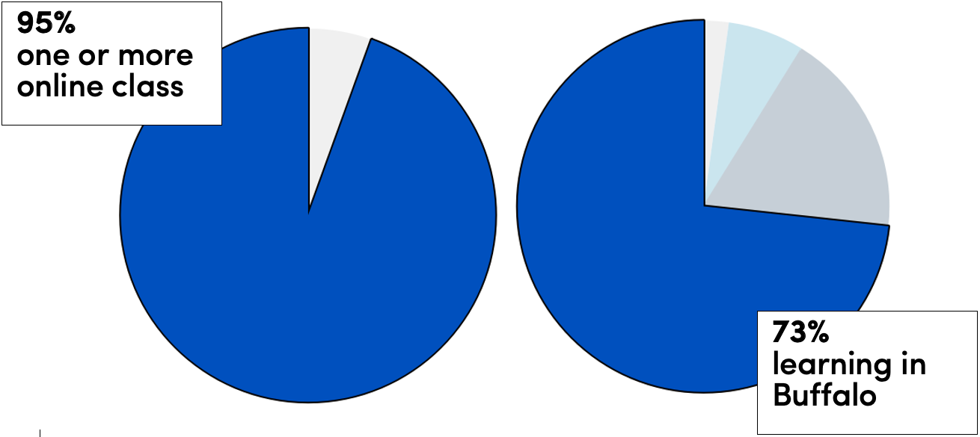

What challenges have you faced learning online?
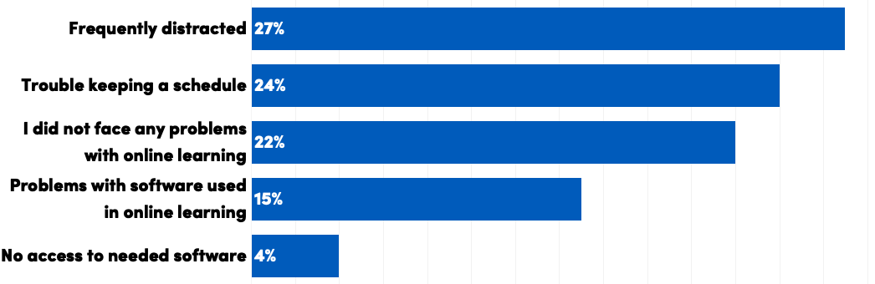

In a traditional classroom environment, UB has acute control over the quality of the learning environment, including the effective integration and use of technology.

When students are learning from home, however, it is no longer possible to guarantee and conducive learning environment for all students. A significant number of students reported frequent distractions (27%), as well as difficulty keeping to a schedule while learning remotely (24%).

Technology and remote learning

In addition to environmental factors, 15% of respondents reported problems related to technology. 4% reported inadequate devices for remote schoolwork, and, critically, 12% reported an inadequate internet connection—a number made more significant by the fact that 96% of students across the U.S. consider Wi-Fi access to be the most important technology factor for studying (EDUCAUSE, 2020).

“This is a level playing field issue,” said J. Brice Bible, UB Vice President/Chief Information Officer. “We don’t have different quality chairs in the classroom, and likewise students with inadequate devices shouldn’t be at a disadvantage. Quality devices and support for students are critical to the mission of higher education.”

In 2020, UBIT worked with partners at UB and SUNY to identify students in need and distribute laptops and Wi-Fi hotspots for loan. Laptops were imaged by UBIT technical staff to include Zoom and other critical software for learning.

How comfortable are you with online learning technology?
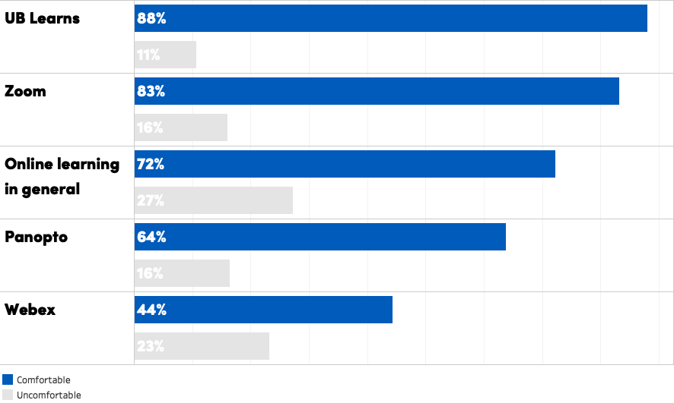

Part III. Students and UBIT
UBIT adds value to the student experience by collaborating with students and their instructors to provide the tools they need. Here is how students rated UBIT services.

Satisfaction with UBIT services
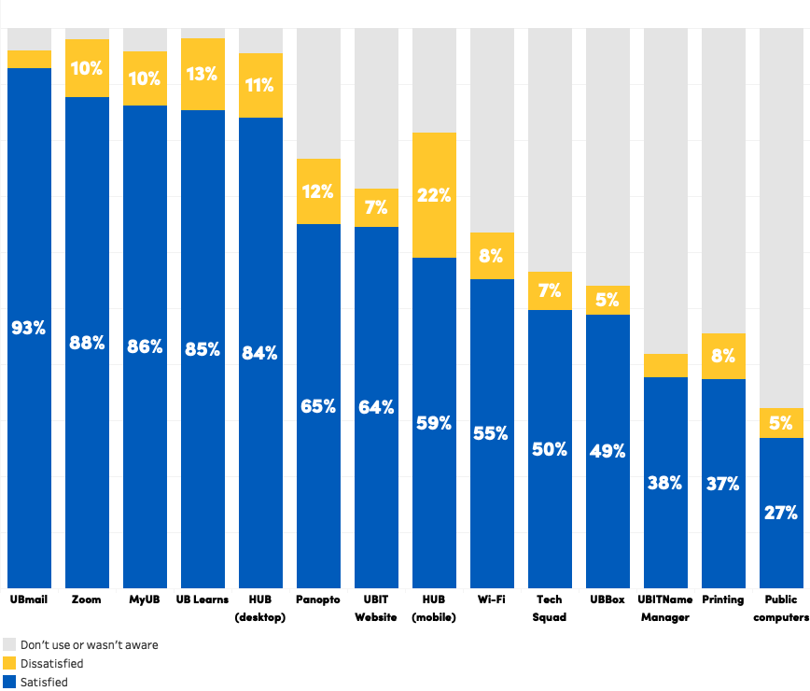

Zoom was introduced in March of 2020 and quickly became one of students’ most-used technology tools; 98% of students reported using Zoom in the Fall 2020 semester, and 88% reported satisfaction with that experience.

In 2020, UB introduced new printing kiosks on campus, which reduce printing waste, make printing more convenient, and offer touchless printing: students can upload documents and release them using the NFC chip in their smartphones. Of the 45% of students who reported using these kiosks during the Fall semester, the majority of those (37%) were satisfied with this new service.
As noted elsewhere, use of on-campus services was down significantly, including eduroam Wi-Fi (63%, vs. 86% in 2019) and public computers (32%, vs. 64% in 2019).

Where do you prefer to go first to find information?
Channel: | Students used it to look for…
Email | information about COVID-19, other campus news
Text messages | campus closings and emergencies
UBIT website | tech support, “how to” IT articles
UBIT Alerts | campus emergencies
Social media (Instagram, Facebook, Snapchat) | updates from friends

Digital communication became more important than ever in 2020. In addition to campus news and emergencies, students looked to UB to communicate information about COVID-19 over email (66%), the UB home page (14%) and via text messages (10%).

How did you learn about free software from UBIT, like Microsoft Office 2019?

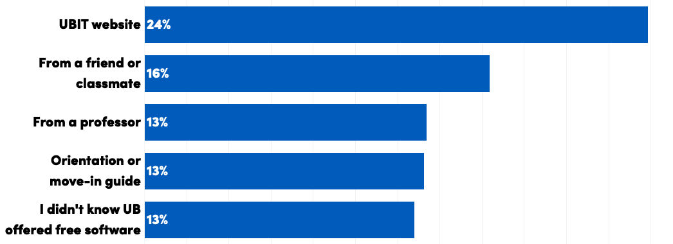

UBIT offers free software like Microsoft Office and Zoom to students, and student awareness of these offerings has long been used as an indicator of the efficacy of student communication and engagement efforts.

The percentage of students reporting they weren’t aware of UB’s free software was 13% for a second straight year, down from the previous five-year average of 14.4%.

The UBIT website remains the single most prominent source of information about free software and other IT information for students. In 2020, the UBIT website was redesigned with a new student landing page (buffalo.edu/ubit/students) so students could find relevant information faster.

Word-of-mouth, as always, is the most powerful tool in spreading awareness, as 29% of students reported hearing about free software from either a friend, a classmate or a professor.
What would have made it easier for you to get started with Information Technology at UB?

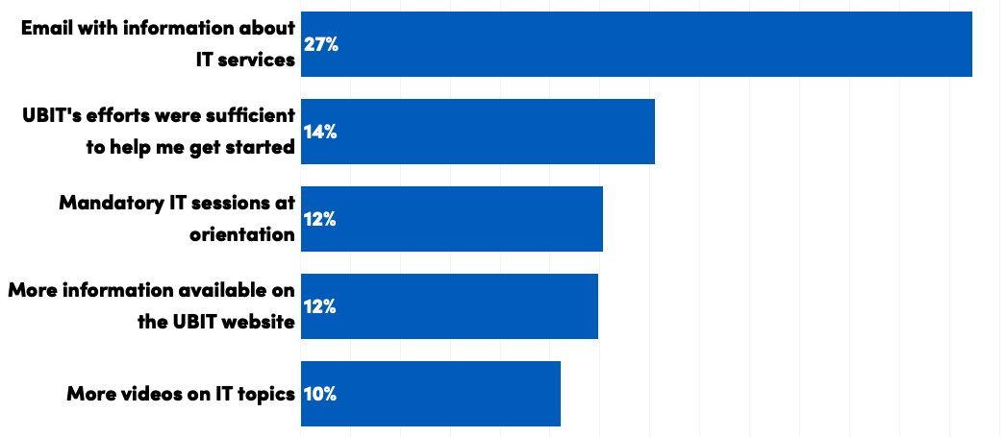
Against what is perhaps considered conventional wisdom, UB students report being highly engaged with email (see pg. 10), and for the third straight year have indicated that receiving IT information via email would have helped them get acclimated to UB’s technology environment.

UBIT circulates newsworthy IT information in an email that students receive three times every fall and spring semester. In 2020, UBIT expanded this to include emails during the summer, to prepare students for online learning in the fall.

UBIT also participated in virtual orientation and move-in events preceding the Fall 2020 semester. Social media engagement during the fall move-in period was up 66% over 2019 (12,695 impressions, vs. 7,658 the previous year).

Part IV. Conclusion

In the 2019 student IT survey report, UBIT projected that UB students would see steady, if palpable, changes to the technology learning landscape in 2020. Instead, UB’s entire technology paradigm was reimagined to support a new way of learning and a new, more liberal definition of the classroom space.

While the events of 2020 were as unexpected as they were unprecedented, UBIT positioned itself in preparation for similar shift for several years. In UBIT’s 2019-2022 Strategic Report and Plan, priorities such as the availability of an “always-on” infrastructure, enabling collaboration anywhere and building customer engagement were outlined.

These priorities laid the groundwork to respond as quickly and thoroughly as UBIT did in 2020. Critically, they allowed IT staff to not just respond to the crises of 2020, but continue building toward an improved everyday classroom experience for students in 2021 and beyond.

In 2020, UBIT began offering Microsoft 365 apps and services to students, as well as faculty and staff. This represents the beginning of a new era in student technology at UB; student services will be more congruent with existing faculty and staff services (particularly by providing students with the same Exchange Online-based UBmail available to UB employees), and more critical tools for school and work will be available from more devices.

Projects like these will make UB technology for students more robust and responsive, and will incentive collaboration by making it easier and more adaptive to diverse learning styles and environments. 2020 showed us how critical these values, which UBIT holds intrinsically through its mission of supporting the university with the innovative and effective use of technology, truly are.

As always, UBIT wishes to thank the students who have responded to this survey and participated in our Student Advisory Group for their contribution to our work.

To see full results or analysis from previous years’ surveys, visit the UBIT website:

buffalo.edu/ubit/about/strategic-initiatives/reports/UBIT-student-experience.html

References:

EDUCAUSE Center for Analysis and Research, 2020 Student Technology Report. 2020. Accessed from https://library.educause.edu/resources/2020/10/2020-student-technology-report-supporting-the-whole-student.

