2022 UBIT Student Experience Survey
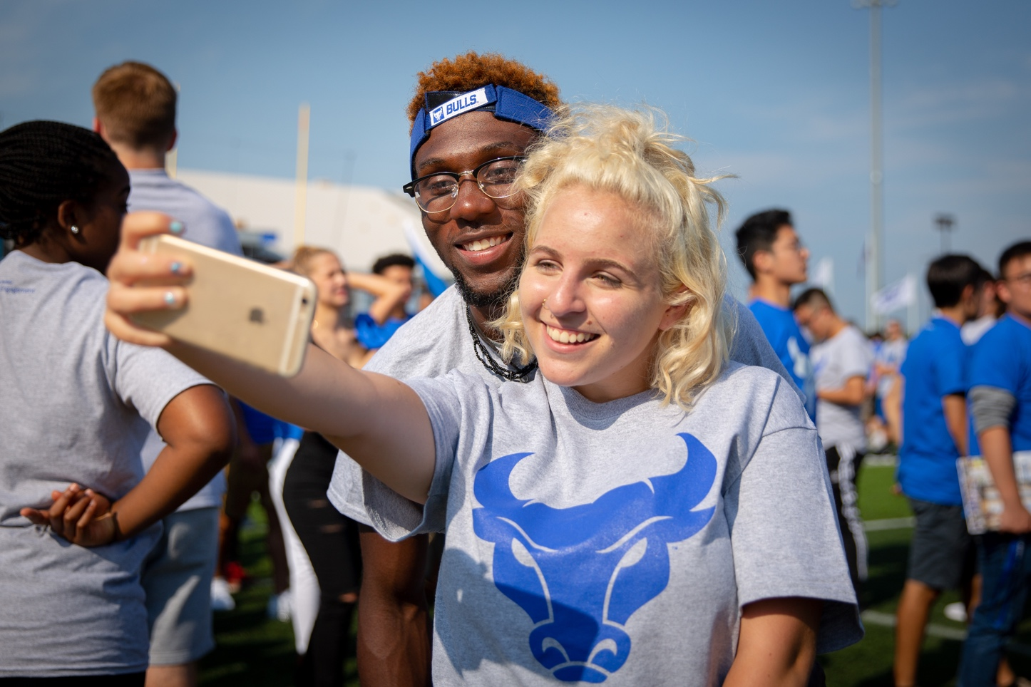
Executive Summary
5/10/2023
UBIT Communication and Engagement
Office of the VPCIO
UB Information Technology

Introduction 1
About the Survey 1
Survey Results: Highlights and Trends 2
Part 1. Students and the Technology they Use 2
Part 2. Wi-Fi and Technology in the Classroom 4
Part 3. Level Up 7
Part 4. Computing Skills and Social Media 9
Conclusions 12

Introduction

The 2022-23 academic year was a return to normalcy for many students. Despite that, students continue to be increasingly aware of the critical role technology plays in their work and leisure activities at the University at Buffalo—an awareness shaped in part by the COVID-19 pandemic.
In its 26th year, the UBIT Student Experience Survey heard from UB students who are increasingly equipped to leverage technology:
- 97% percent of respondents own their own laptop.
- The majority of students (nearly 60%) purchased their laptop in the last two years. Conversely, only 6% of students said their laptop was six or more years old.
- Over 92% of students surveyed said their laptop worked well enough to meet the needs of their coursework, nearly identical to the 2021 survey.
- Among the students who do not own a laptop, nearly 60% said they’re unable to afford their own laptop.
The performance of eduroam Wi-Fi on campus drew a nearly evenly split response from students, with 52% having significant issues with the Wi-Fi, and 48% not having significant problems.
The “How’s the Wi-Fi?” campaign, launched in March 2023 using QR code satisfaction surveys on stickers around campus, will try to pinpoint locations where students have challenges with the Wi-Fi.
98% of students who have used the Level Up computing and gaming site in Lockwood have had positive experiences.
An overwhelming majority (83%) of UB students believe the technology in UB classrooms helps them in their learning.
As in years past, the 2022 UBIT Student Experience Survey provides a roadmap for how UBIT can improve services and products to better meet student needs. Based on the results of the survey, students continue to be tech savvy, and expect UBIT to be as well. While it can be challenging to keep up on the ever-changing world of technology, it’s a goal UBIT is more than prepared to tackle.

About the Survey

1,839 UB students responded to the 2022 survey, representing undergraduates at all levels, as well as graduate students and non-degree seeking students. Nearly 74% of the students who responded to the survey live off-campus.
The 2022 UBIT Student Experience Survey was open from October 25 to November 7, 2022, and contained 34 questions designed in conjunction with instructional and support IT staff in each technology area surveyed, as well as the UB offices of Student Life, Campus Living, Undergraduate Education, University Libraries and other campus stakeholders.
Responses were collected using Qualtrics. Students were encouraged to participate through social media and online promotions.
Where possible, this report compares data from 2022 with previous UBIT student surveys.
While some key questions were required, many were not; where applicable, percentages reflect the number of students who answered that specific question.
The full survey results can be found in a companion document, “2022 Raw Frequencies (PDF),” on the UBIT website.

Survey Results: Highlights and Trends

Part 1. Students and the Technology they Use

The use of smartTVs, speakers, light bulbs, and gaming systems continues to grow exponentially, as it has over the past several years.
This trend continues to have implications for UB’s networks. Ensuring network access for popular smart devices, while maintaining UB’s security standards, has strategic value for student satisfaction and retention. In 2021, UBIT added the UB_Devices network to streamline securely connecting devices without a web browser to the Internet at UB.
Student use of laptops and smartphones has been predominant (>80%) since at least 2015.
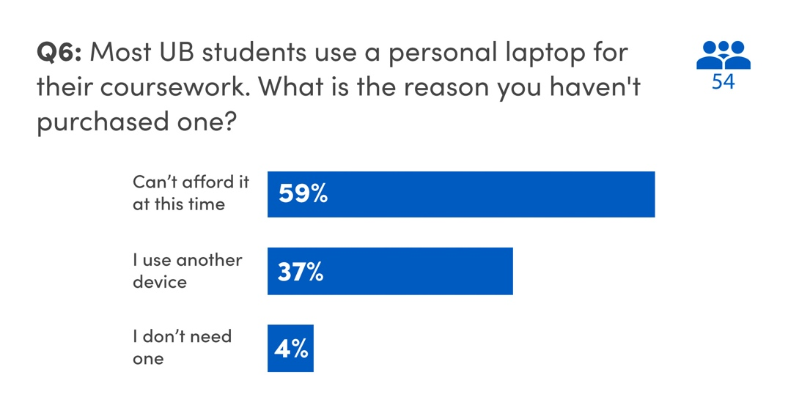
The percentage of students who reported not owning a computer working well enough to complete their coursework (8%) was roughly the same as 2021. The majority of students without a computer reported that they cannot afford one at this time. Others may use another device, such as a tablet or iPad for their coursework, or reported not needing a computer for their classes.
To assist students without a personal computer, UBIT partners with UB Libraries to provide laptop loans to students.
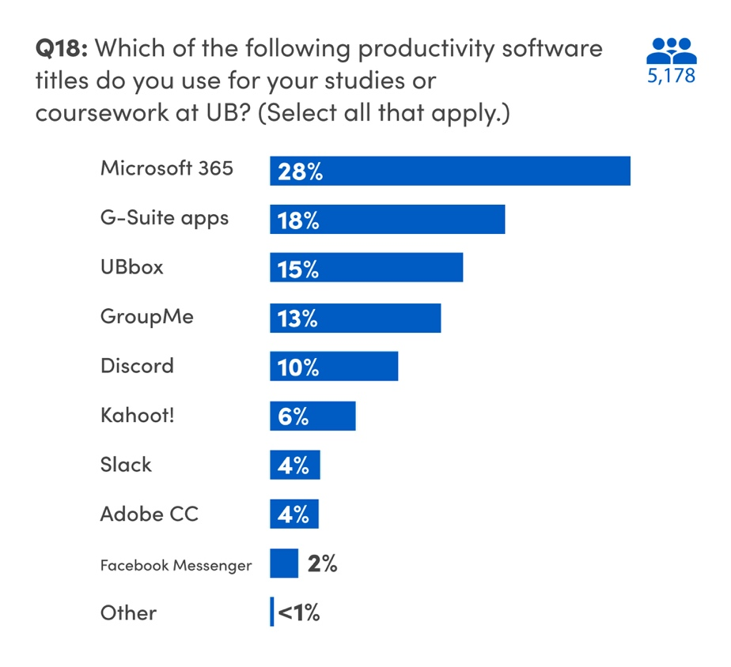
Microsoft 365 and G-Suite apps are both currently offered to students at UB (Microsoft 365 to students who started at UB during or after Summer 2021; G-Suite to those who began prior).
Students continue to use third-party messaging and group work apps (GroupMe and Discord). The use of Discord is up over 4% from 2021 to 10%, while fewer students reported using GroupMe (13% compared to 17% in 2021).
Students also use Slack, Adobe Creative Cloud, Kahoot!, and Facebook Messenger, all to lesser extents. Fifteen percent of students reported using UBbox for their coursework.
Some of the other applications and software mentioned by students for use in their coursework include WhatsApp, Canva, Apple Pages, and Rhinoceros 3D.
There are a variety of ways students learn about UB-provided collaboration tools and free software (like Microsoft Office). For the sixth straight year, the majority of students reported that they learned about UB-provided tools and software through the UBIT website (23%). 17% of students learned about the tools and software from a professor, while 16% were told by a classmate or friend. Orientation or the move-in guide informed 13% of respondents. These numbers are nearly identical to our 2021 data.
On the flipside, 9% of students were unaware that UB offered collaboration tools and free software to students, the same as 2021. UBIT continues to invest in further outreach to students to make them aware of UB-provided software and services.
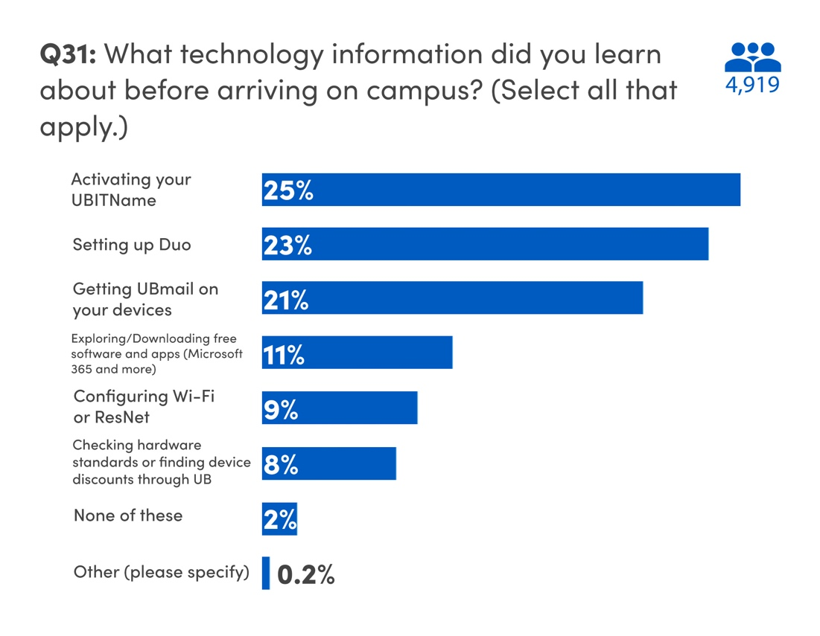
A number of students continue to learn about UBIT software and tools before they arrive on campus, with 25% saying they activated their UBITName before coming to campus. 23% of students set up Duo before arriving on campus while 21% set up UBmail on their devices from home. A lesser number of students explored free software and apps (11%), configured Wi-Fi or ResNet (9%), or checked hardware standards (8%) before coming to campus, but only 2% of students reported that they did not tackle any technology tasks before arriving at UB.
UBIT asks students about third-party academic websites to gauge the need for support for tools, either on the institutional or departmental level, as they become more widely used.
Use of third-party sites, especially when not supported by UB and protected by UB’s Single Sign-On, also poses security risks, as students commonly use their UB email address and password as login credentials on these sites. UB’s Information Security Office continues to monitor third-party vendors for security breaches.

Part 2. Wi-Fi and Technology in the Classroom
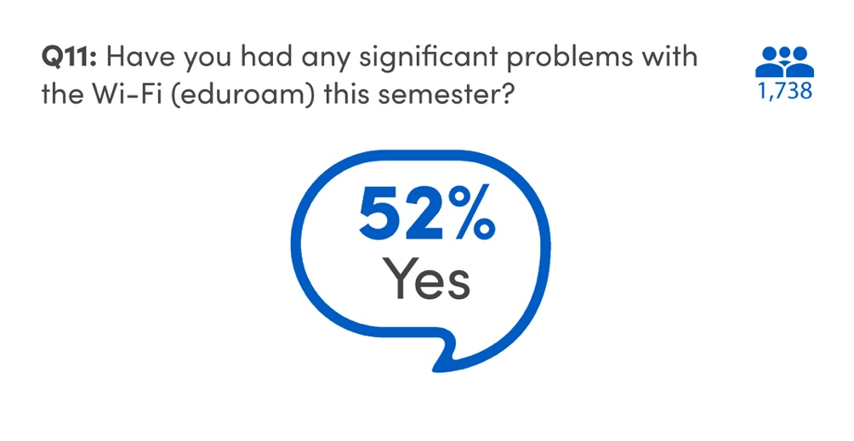
Student opinions on the eduroam Wi-Fi on campus is almost equally divided between those who say they’ve had significant issues (52%), and those who have not (48%).
According to a national survey conducted by EDUCAUSE on technology issues in 2022, nearly 65% of students have encountered unstable Wi-Fi on their campuses.
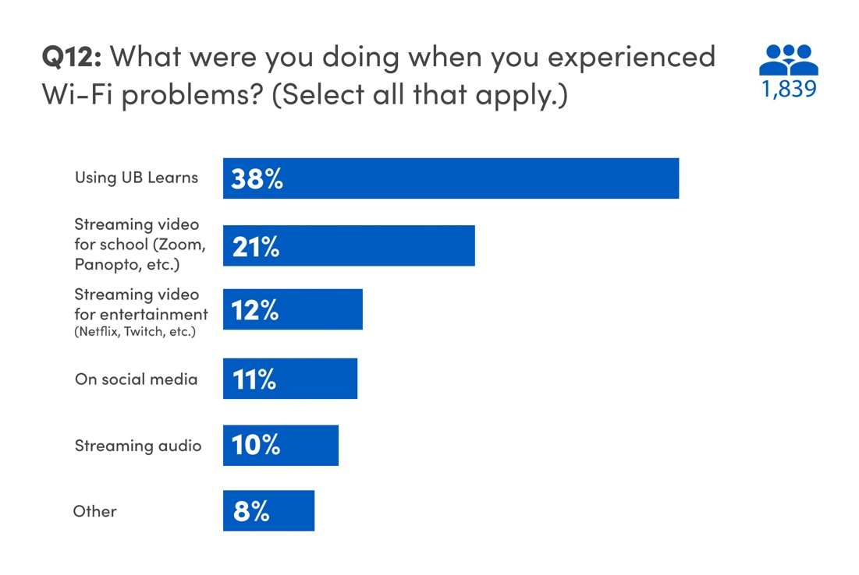
The majority of students (38%) said they experienced Wi-Fi problems while using UB Learns. Streaming video for classes, either by Zoom or Panopto, caused issues for 21% of students, and streaming video for entertainment was a problem for 12%. Students also reported problems while using social media, streaming audio, doing course work on several different platforms, and establishing an initial connection to the Wi-Fi network.
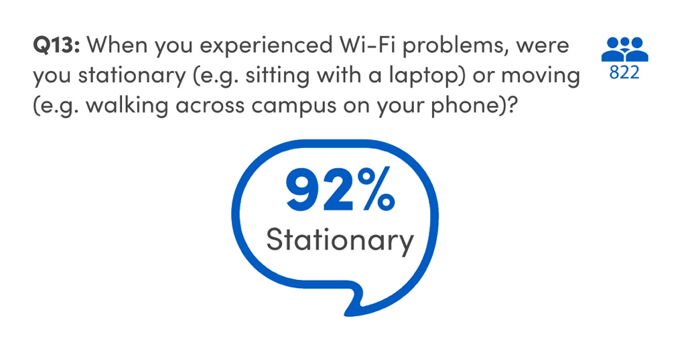
Ninety-two percent of students said they were stationary when they experienced Wi-Fi problems.
As mentioned, the “How’s the Wi-Fi?” campaign launched in March 2023 seeks to address some of the areas where students have problems with the Wi-Fi. Through the campaign, students can scan a QR code from a sticker using their smartphone and let UBIT know If they are satisfied with the Wi-Fi in that location.
Improving and upgrading the Wi-Fi on campus is a constant task for UBIT. Updates are available in the UBIT News section of the UBIT website.
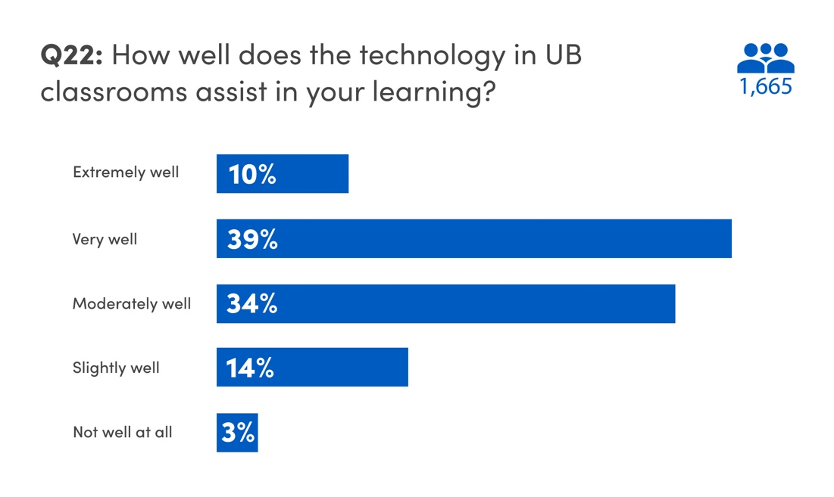
In terms of how well technology in UB classrooms helps students, 39% said it helped them “very well,” 34% said it helped “moderately well,” and 10% said it helped “extremely well.”
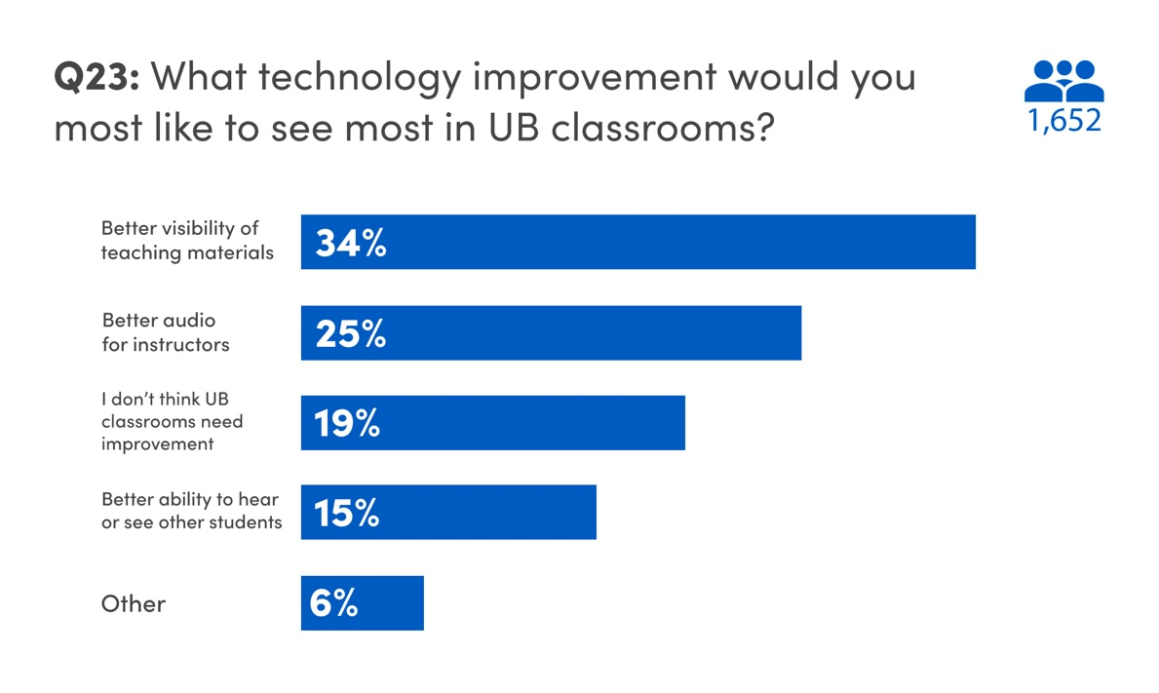
About 34% of UB students said they would like to have better visibility of teaching materials in the classroom, while 25% said better audio for instructors would be helpful. Nineteen percent of students said the classrooms don’t need any improvements.
Over the last several years, UBIT has upgraded central classrooms to incorporate on-demand livestreaming and lecture recording using Zoom and Panopto. In 2021, UBIT completed an upgrade of classroom technology in NSC 201 and 225 to add the following features for enhancing interaction and engagement:
- a 30-foot video display capable of showing two inputs at once
- a dedicated camera to stream chalkboards to the main display (or to a remote source, via Zoom or Panopto)
- microphones at student seats
Students had ideas for technological improvements as well. One suggestion asked that instructors at UB all use the same program (such as UBbox or UB Learns) for course materials, instead of instructors using various programs. Numerous students also reiterated the need for “better” Wi-Fi. The classrooms in NSC (specifically 220, 225) were mentioned repeatedly as a space where it was difficult to hear the instructor, even with a microphone on. Issues with noise in Diefendorf (echoes or loud air conditioning) were noted by about two dozen students. Wi-Fi problems in Knox Hall were also mentioned by over 100 respondents.
Like the Wi-Fi, UBIT is always working to examine and improve the technology in UB’s classrooms. As students have shown from the survey results, the effort is paying off.

Part 3. Level Up

Level Up, a new computing and gaming site located in Lockwood, opened in 2022. The space gives students the chance to use a number of gaming consoles, computer games, an esports arena, public computers, and BYOD widescreen monitors.
34% of the students who used the space reported gaming in the esports arena, while 28% used the public computers for coursework. Over 27% of responding students used the console lounge to play video games.
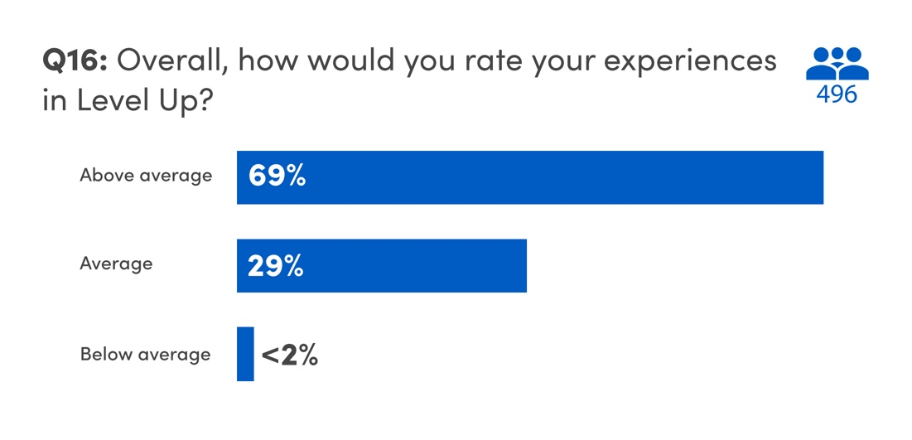
Students who used Level Up overwhelmingly had a positive response to the space, with 69% saying their experiences in Level Up was “above average.” Roughly 29% of students rated their experience at Level Up as “average,” with only 2% saying the experience was “below average.”
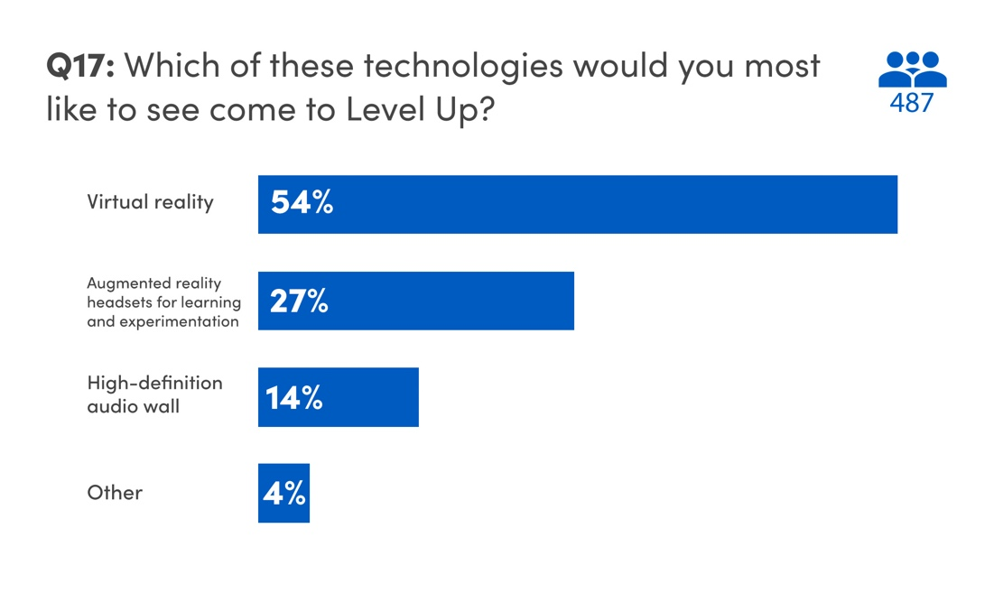
According to the survey, 55% of students would like to have Virtual Reality available in Level Up. Over 27% would like to see Augmented Reality headsets for learning and experimentation, while 14% of students wanted a high-definition audio wall in Level Up.

Part 4. Computing Skills and Social Media
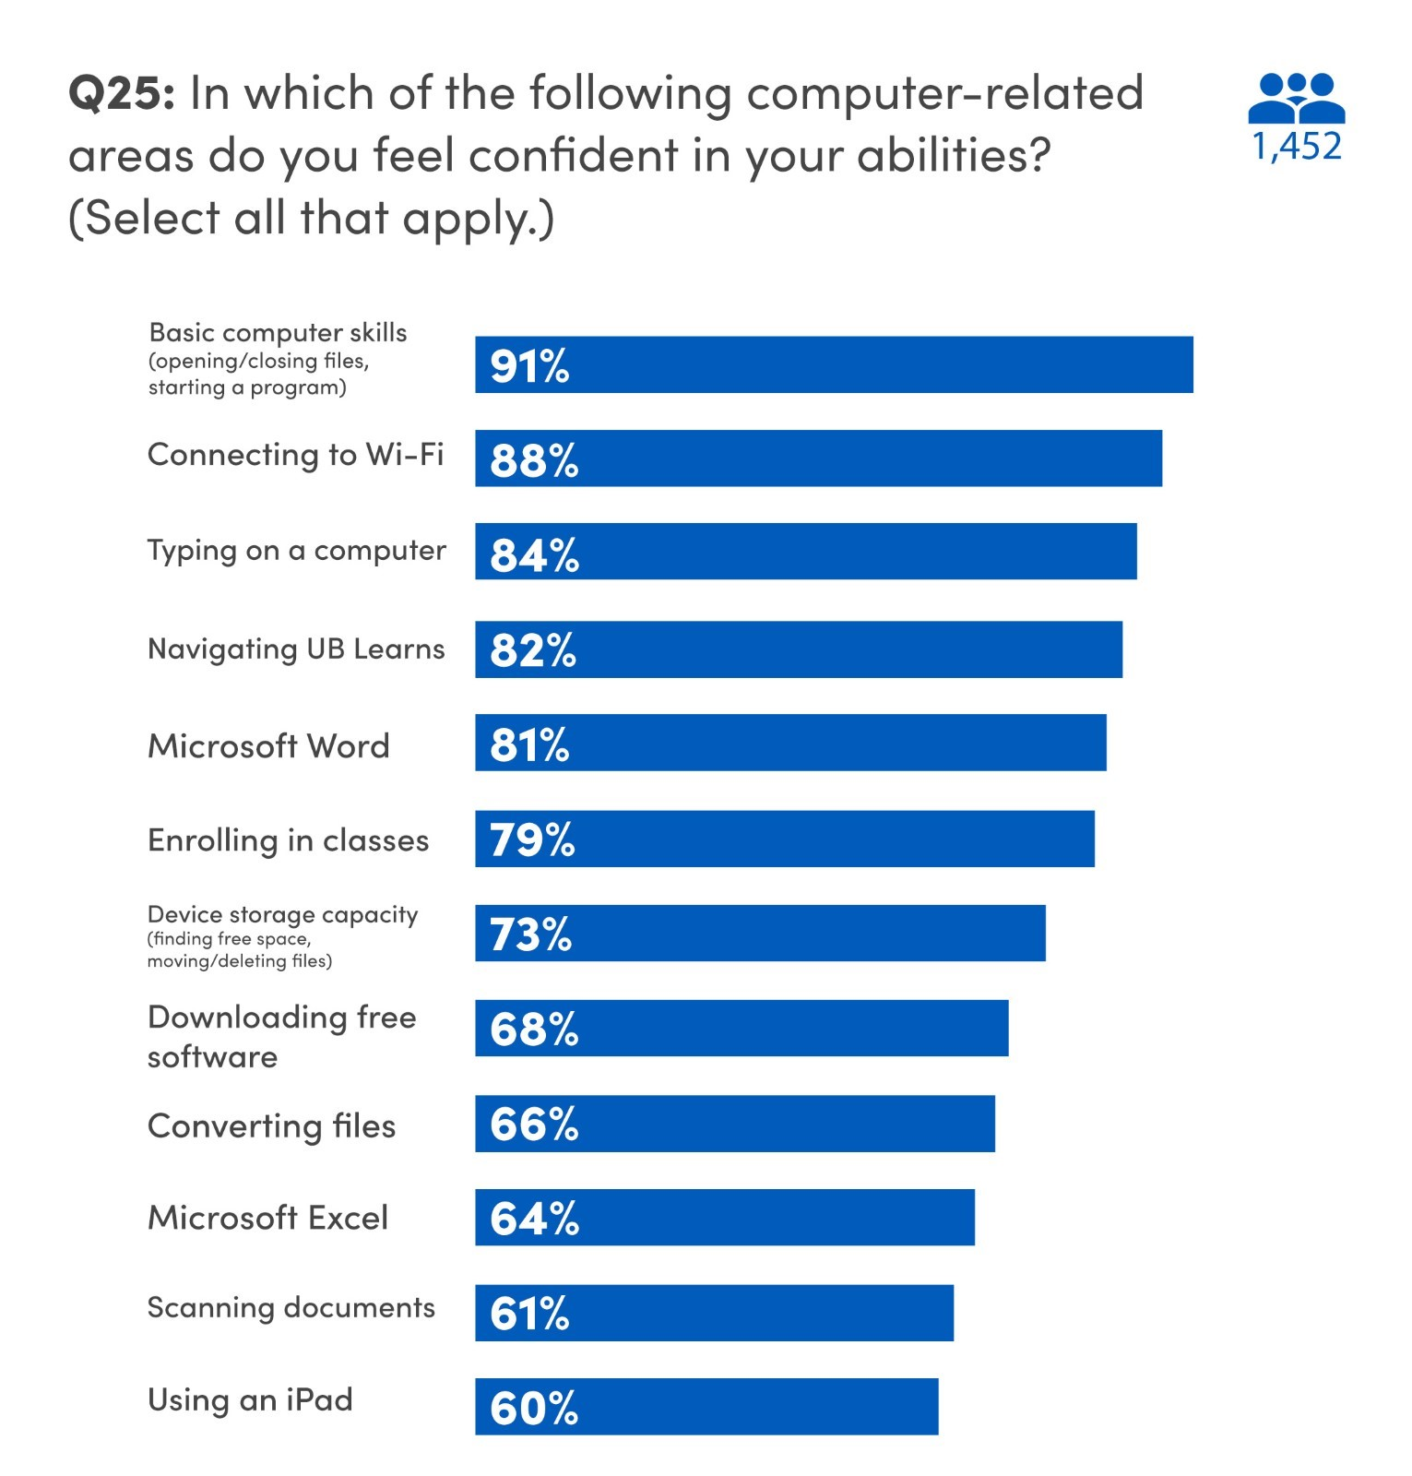
The majority of students who took the survey felt confident in their basic computing skills (91%), connecting to Wi-Fi (88%), Microsoft Word (81%), navigating UB Learns (82%), and typing on a computer (84%).
Students also felt comfortable managing data on their devices (73%) and enrolling in classes (79%). Overall, students were slightly less confident in converting files from one format to another (66%), using an iPad (60%), and scanning documents (61%).
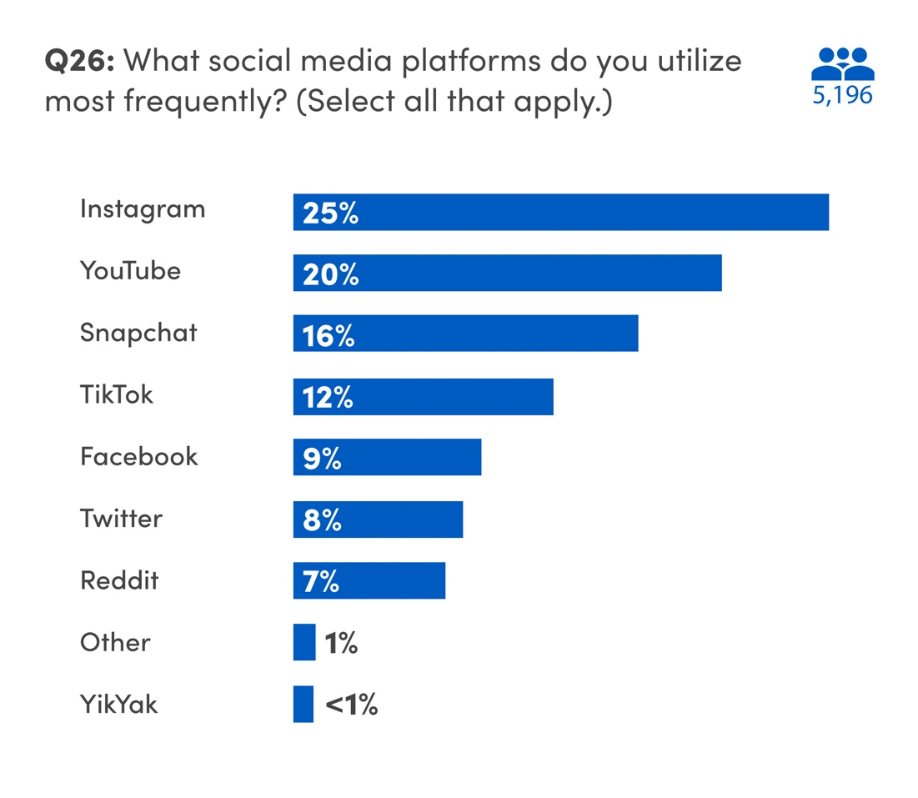
In terms of social media, Instagram was the most frequently used platform among students, with 25% saying they used the platform. YouTube was used by 20% of responding students, with Snapchat (16%), TikTok (12%), Facebook (9%), Twitter (8%), Reddit (7%), and YikYak (1%). In open-ended responses, lesser numbers of students also mentioned LinkedIn, Discord, WhatsApp, WeChat, Tumblr, and Twitch.
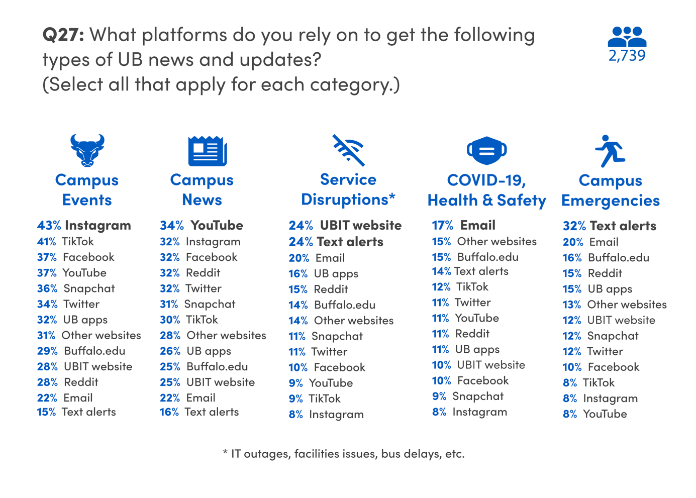
Students have a variety of options to learn about campus news, events, service disruptions, health and safety updates, and campus emergencies, and students use different platforms for different messages. For instance, 43% of students rely on Instagram to follow campus events. For campus news, however, students said they used YouTube (34%), with Instagram and Facebook close behind. The UBIT website (24%) is the platform of choice for service disruptions, and for COVID-19 updates or health information, students preferred to receive an email (17%). Students most often requested text alerts for campus emergencies (32%).

Conclusions
Throughout the 2022 academic year, students, faculty, and staff grappled with what it meant to return to some form of normalcy coming out of the COVID-19 pandemic. After nearly two years of remote instruction, students, faculty, and staff have largely returned to in-person instruction with the accompaniment of the technology tools used during the pandemic.
UBIT continues to offer loaner laptops, Zoom, Microsoft 365, and other tools to ensure students have everything they need to be successful at UB. The feedback and support we receive from students help us to maintain and build the systems they need for success, and the future looks optimistic.
As always, UBIT wishes to thank the students who responded to this survey and participate in our Student Advisory Group for their contribution to our work.
Visit the UBIT website to see full results and analysis from previous years’ surveys.

