BUFFALO FUND: ACCELERATOR | Full Proposal Application

Application Instructions
- The Full Proposal Application must be completed electronically using this form.
- Full Proposal checklist:
√ | REQUIRED | √ | OPTIONAL
 | This Cover Page |  | Optional single appendix page
 | 5 page application |  | Partial Business Model Canvas
 | Two Letters of Support
- Fill in each box following the instruction in the Full Proposal Guide.
- Margins should NOT be changed; Font size should be Calibri, 10.
- The final document must be submitted as a signed PDF. Submit to fund@buffalo.edu.
- Completion and submission of the Partial Business Model Canvas does not count against page limits.
Project Title
Participating Institution
Institution File Number (s)
(Tech Transfer No.)
PI Contact Information
Name
Title, Department
Email
Phone

Acknowledgement
I have read and understand the eligibility and program requirements set forth in the BUFFALO FUND: ACCELERATOR Guide.
I acknowledge that this proposal is eligible for submission based on the criteria set forth therein; that in completing this Full Proposal Application I have taken into account the feedback received from the Pre-Proposal assessment stage; and that although I have been invited to submit this application, there is no guarantee that the Full Proposal will be funded. I also understand that the Full Proposal may be funded in whole or in part, on a milestone-by-milestone basis, based on the determinations made by the External Review Committee.
Principal Investigator (Signature):
Partner Institution Official (Signature):
I hereby endorse submission of this application for consideration.
Empire State Development is supporting UB, Roswell, Jacobs Institute, HWI, and Kaleida Health to help commercialize technologies generated through research.
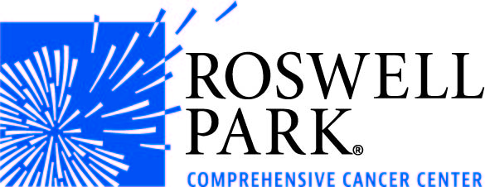
Problem/Need
Please Note: The box size for each section is fixed. Any text entered that cannot be seen in the allowed space will not be reviewed by the External Review Committee.
Solution (Technology) and Stage of Development

Technical Feasibility
Intellectual Property Status

Market Potential

Project Plan and Budget Summary
No. | Milestone/Subtask | Budget | Month
 |  |  | 1 | 2 | 3 | 4 | 5 | 6 | 7 | 8 | 9 | 10 | 11 | 12
1 | First Milestone | $xx,xxx
1.1 | Subtask
1.2 | Subtask
2 | Second Milestone | $yy,yyy
2.1 | Subtask
2.2 | Subtask
3 | Third Milestone | $zz,zzz
3.1 | Subtask
3.2 | Subtask
 | TOTAL BUDGET | $

Detailed Budget
Budget Item (8 point font permitted) | Funds Requested | Cost Share/ Matched | Description
Personnel – Salaries/Wages
PI(Faculty or equivalent) | n/a | $x,xxx | Ex. Institution cost share
Name and Position
Name and Position
Personnel - Fringe
Name and Position
Name and Position
Materials and Supplies
Item
Item
Consultant/Vendor
Testing Services | n/a | $x,xxx | Ex: Provided by industry partner
Item
Other Expenses
Item
Item
TOTAL BUDGET

Project Feasibility
Project Team

Appendix (1-page) OPTIONAL
*Example Feature Benefit Chart
Feature/Benefit | Your Product | Competitor 1 | Competitor 2
Better | +++ | + | +
Faster | ++ | ++ | -
Cheaper | +++ | + | +

